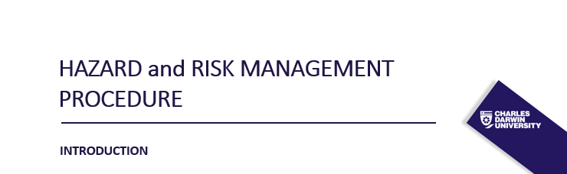

The Hazard and Risk Management Procedure provides overarching roles, responsibilities, processes and templates for the broad management of hazards and risks to health and safety. The CDU WHS Management System provides additional and specific information on other Hazard Management activities to assist those with responsibilities to meet WHS legislative requirements (e.g. Workplace Inspections, Contractor Safety Management, Events Management, Chemical Safety Management, and Plant/Equipment Safety Management)

COMPLIANCE

The aim of the procedure is to prescribe the responsibilities and overarching actions required for the
management of hazards during university related activities to ensure that CDU meets the requirements
of:

- CDU WHS Policy,
- Work Health and Safety Act 2011 (NUL)
- Work Health and Safety Regulations 2011 (NUL), and
- Code of Practice - How to Manage Work Health and Safety Risks
- ESOS Act
- Higher Education Standards Framework (HSEF)

This process applies to all workers who are undertaking CDU related activities (including those working off
campus).

INTENT
To identify and manage the risks to health and safety by eliminating the risk, so far as reasonably practicable, or if not reasonably practicable, to minimise the risk in accordance with the hierarchy of controls [WHS Regulations 2012, Sections 34 - 38]. 3.5.1.2 To ensure risk assessments have been completed for activities identified on the School/College Risk Registers or Hazard Listing(s) where required in accordance with Hazard Management – Risk Assessment Decision Tool (Appendix A).
DEFINITIONS
In the context of this document.
Dynamic Activity
An activity characterised by constant change e.g. once-off activities or unique experiments.
Event
Any programmed activity which changes the environment/venue for which it was otherwise intended; or introduces a foreseeable safety hazard(s) due to the nature of the event/activity/function.
Hazard
Refers to a source of potential harm.
Hazard Listing
A list of all static (i.e. constant/stable) activities where a risk assessment is required, and the activity is performed in the same manner over time. This can be saved electronically or in hard copy but must be readily available to workers. (Note: The Hazard listing(s) is to be included in the local area induction program for relevant workers.)
Hazardous Chemical
A substance, mixture or article that satisfies the criteria for a hazard class in the Globally Harmonised System of Classification and Labelling of Chemicals (GHS), including a classification referred to in Schedule 6 Work Health and Safety Regulations 2011 (NUL), but does not include a substance, mixture or article that satisfies the criteria solely for one of the following hazard classes:
- acute toxicity – oral – cat 5
- acute toxicity – dermal – cat 5
- acute toxicity – inhalation – cat 5
- skin corrosion/irritation – cat 3
- serious eye damage/irritation
- aspiration hazard – cat 2
- flammable gas – cat 2
- acute hazard to the aquatic environment
- chronic hazard to the aquatic environment – cat 1 – 4
- hazardous to the ozone layer.
Hazardous Manual Activity
An activity that requires a person to lift, lower, push, pull, carry or otherwise move, hold or restrain any person, animal or thing that involves one or more of the following:
- repetitive or sustained force
- high or sudden force
- repetitive movement
- sustained or awkward posture
- exposure to vibration and noise
Hazardous plant
Any plant/equipment used for a work/task related activity that:
- has the potential:
  - to entangle, crush, cut/stab/puncture, trap, shear, tear or strike (i.e. safe-guarding is required);
  - for a pinch point to trap any part of the body or catch loose clothing, hair etc (e.g. conveyor, gears, loaders and other moving equipment);
  - for a worker to come into contact with fluids under high pressure;
  - to cause a serious burn/injury;
  - to expose the worker to live electrical conductors;
  - to expose the worker to gases/vapours/liquids/dusts/other substances triggered by the operation;
  - to explode or implode;
  - to exceed safe noise levels;
  - for the worker to adopt poor posture (see definition for a Hazardous manual activity);
  - to overturn, collide with another person or thing (e.g. moving powered plant);
  - lifts or suspends a load;
- is an industrial robot or other remotely or automatically energised plant at the workplace;
- involves non-ionising radiation or high level magnetic fields;
- requires registration in accordance with Schedule 5 of the Work Health and Safety Regulations 2011 (NUL).
Hierarchy of Control
The process to eliminate, or where this is not possible, manage the risks to as low a level as is reasonably practicable. They are listed below in order of most to least effective.
Level 1: Elimination (e.g. remove the hazard from the site)
Level 2: Substitution (e.g. replace the item or substance or activity with a less hazardous one) Isolation (e.g. remove the opportunity of contact with the hazard by distance from work activities) Engineering (e.g. guarding, barriers, electronic guarding such as light curtains)
Level 3: Administration (e.g. Safe Operating Procedure, supervision, training, maintenance programs) Personal Protective Equipment (e.g. gloves, safety glasses, laboratory coats)
So Far As Reasonably Practicable (SFARP)
SFARP is concerned with the adequacy of risk control measures and requires a SFARP judgement to be made by a Managers/Supervisor with the knowledge, skill and experience in managing similar risks. Managers/Supervisor are to eliminate risks, and where it is not reasonably practicable to eliminate those risks, they are to minimise those risks SFARP.
SEW Training
Training is provided at 3 different levels.
- Information, instruction and training. Provides general information to participants. This type of training is suitable where no proficiency, qualification or licence is required.

- Proficiency based training. Provides a higher level of instruction skill and/or risk associated with the activity. It will generally have a practical component to enable the trainee to observe the process from beginning to end, and then demonstrate back to their trainer/assessor that they are proficient/skilled to undertake the task or operate the equipment without supervision.

- Competency based training. (i.e. Statement of Attainment or licence) This type of training is required where the operator must attend formal training by an authorised or Nationally Recognised Training Organisation that will provide the trainee with a statement of attainment, qualification or licence following successful completion of the training. Examples may include: first aid training, forklift training, work associated with rigging, cranes, hoists, confined space entry, scaffolding, dogging, work at height, operation of load-shifting equipment, firearms, electrical, asbestos removal, licence to use or handle a radioactive substance.
Inherent Risk
The associated risk before implementation of risk controls.
Reasonably practicable [WHS Act 2012, Section 18]
“in relation to a duty to ensure health and safety, means that which is, or was at a particular time, reasonably able to be done in relation to ensuring health and safety, taking into account and weighing up all relevant matters including –
- the likelihood of the hazard or risk concerned occurring,
- the degree of harm that might result from the hazard or risk,
- what the person concerned knows, or ought reasonably to know, about;
  - the hazard or the risk,
  - ways of eliminating or minimising the risk.
- the availability and suitability of ways to eliminate or minimise the risk,
- after assessing the extent of the risk and the available ways of eliminating or minimising the risk, the cost associated with available ways of eliminating or minimising the risk, including whether the cost is grossly disproportionate to the risk.”
Residual Risk
The risk remaining after implementation of risk controls.
Risk
The possibility that harm (death, injury or illness) might occur when exposed to a hazard.
Risk Assessment
The process of evaluating the probability and consequences of injury or illness arising from exposure to an identified hazard or hazards.
Risk Control
Acting to eliminate health and safety risks so far as is reasonably practicable, and if that is not possible, minimising the risks so far as is reasonably practicable.
(A control measure minimises the risk either by reducing the likelihood and/or the consequence.)
Safety Procedure e.g. Safe Operating Procedure (SOP) or Safe Work Procedure (SWP)
A document setting out the requirements to carry out the work in a safe and healthy manner and in a logical sequence. It must be able to be easily read by those who need to know what has been planned. It is relevant to the following people:
- the worker carrying out the work, and
- the person who has management and control over the work.
A safety procedure (e.g. SWP), if identified as a control measure, is to:
- identify the work,
- specify/address the identified hazards relating to the work,
- describe the measures to be implemented to control the risks,
- consider the circumstances at the workplace that may affect the way in which the work is carried out,
- consider emergency management arrangements where applicable, and
- be communicated to all workers who carry out the work.
Worker
A person is a worker if the person carries out work in any capacity for a person conducting a business or undertaking, including work as:
- an employee,
- a contractor or subcontractor,
- an employee of a contractor or subcontractor,
- an employee of a labour hire company who has been assigned to work in the person’s business or undertaking,
- an outworker
- an apprentice or trainee,
- a student gaining work experience,
- a volunteer,
- person of a prescribed class.
The person conducting the business or undertaking (PBCU) is also a worker if the person is an individual who carries out work in that business or undertaking.
Note: Higher Degree Research students (PHD) and Academic Visitors are workers under the WHS Act (2011).
PROCEDURE
Hazards
Hazards are likely to be identified during normal work activities and movement around the respective Colleges, Schools and Campuses. Hazards may be in the form of a hazardous or sub-standard condition or an act by an individual and may be identified through a range of activities such as:
- Inspections and Audits
- Meetings, discussions
- Incidents
- Health and Safety planning activities
- Observations
Unless these hazards are dealt with promptly they will continue to pose a risk to the safety and health of all CDU personnel who may be exposed to the hazard. The CDU hazard procedure follows the cyclical guidance provided by AS/NZS ISO 31000 Risk management Process at Figure 1. A Hazard Identification Form is attached as Appendix E. When completed these forms are to be submitted to the respective Manager or Supervisor for action to resolve the hazard and associated risks.
All staff and students are encouraged to proactively identify hazards in work areas. There is a Hazard Report Form at Appendix E that is available for downloading online in the SEW website.

Figure 1: Risk Management Process (AS/NZS ISO 31000)
Communicate and Consult
Internal and external communication and consultation underpins effective risk management and should be developed at an early stage. Manager/Supervisor and key personnel need to involve participants in risk planning wherever practicable to develop a common understanding of the environment, threats, opportunities, and risk controls.
Process Overview
Prior to conducting a task/activity, a process of risk identification must be conducted and steps taken to eliminate, or where this is not possible, minimise identified threats and exploit opportunities so far as reasonably practicable (SFARP). The process of identifying risk (or the hazards from which the risk originates) may be done reactively, proactively or predicatively as follows:
- Reactive. This methodology involves analysis of past outcomes or events. Risks are identified through investigation of safety occurrences. Incidents and accidents are clear indicators of system deficiencies, and therefore can be used to determine the hazards that either contributed to the event or are latent.

- Proactive. This methodology involves analysis of existing or real-time situations, which is the primary job of the safety assurance function with its audits, evaluations, employee reporting, and associated analysis and assessment processes. This involves actively seeking hazards and associated risks in the existing processes.

- Predictive. This methodology involves data gathering to identify possible negative future outcomes or events, analysing system processes and the environment to identify potential future risks, and initiating mitigating actions.
The Right to STOP Work
All CDU staff and students have the right to either STOP work or not commence an activity or task if they feel the activity is unsafe. If this occurs the task or activity Supervisor must revisit the risk management tools with the staff and students and ensure the risks have been managed in accordance with the hierarchy of controls and the principal of SFARP.
SFARP Judgement
On completion of reviewing each risk we must make sure an SFARP judgement is made for each risk. The SFARP judgement is based on a hierarchy of control measures where elimination of risk must always be the first consideration before applying risk minimisation measures. If any of the analysed hazards and risks cannot be eliminated or minimised SFARP, then the activity must be either terminated or referred to a higher authority.
The SFARP judgement is made after considering the following criteria:
- The likelihood of the hazard or the risk concerned occurring.
- The degree of harm i.e. consequence that might result from the hazard or the risk.
- What the person concerned knows, or ought reasonably to know, about:
- the hazard or risk
- ways of eliminating or minimising the risk
- The availability and suitability of ways i.e. risk treatment(s)/control measure(s) to eliminate or minimise the risk.
- After assessing the extent of the risk and the available ways of eliminating or minimising the risk, the cost (in terms of time, money, effort, capability, reputation and morale) associated with available ways of eliminating or minimising the risk, including whether the cost is grossly disproportionate to the risk.
Once all reasonable risk controls have been identified, the responsible person with the subject matter knowledge is able to make an ‘SFARP Judgement’. This judgement is essentially a declaration that all reasonably practicable measures have been identified for each risk associated within the activity. The risk appreciation is then passed to the task or activity manager for a decision to be made as to whether to proceed or not.
The adoption of the SFARP judgement represents a shift in emphasis from the past practice of resolving risk based on achieving a certain risk level, to ensuring that appropriate controls are put in place as a first step without otherwise being distracted by a risk calculation that produces a certain desired level but discourages further treatment. It requires the risk planner to be familiar with the relevant procedures, manuals etc for a activity, and to understand the associated risk controls that will need to be implemented before an activity can proceed. The determination of residual risk level is only made after the decision on the adequacy of controls, relegating the step of establishing risk levels to that of risk prioritisation rather than causing it (the residual risk level) to be the sole basis of making a risk decision.

Risk decision
The residual risk level is estimated using the risk matrix as a function of likelihood and consequence. Note that the risk matrix is to be used primarily as a communication tool - not as a tool to determine whether risk has been sufficiently minimised.
The risk level matrix will enable the risks to be prioritised according to severity so that the priority of effort for review purposes can be applied to those risks that have exceeded, or are likely to exceed the delegated threshold for the activity Supervisor.
Key Hazard and Risk Management Principles
For Hazard and Risk management to be effective, manager and supervisors at all levels are to comply with the following principles:
Do not assume unnecessary risk. An unnecessary risk is any risk that if taken will not contribute meaningfully to the task or activity accomplishment or will needlessly endanger lives or waste resources.
Conduct a task only when the benefits outweigh the costs. CDU cannot and should not be risk averse.
Some risk may be undertaken when there is a well-founded basis to believe that the sum of the benefits exceeds the sum of the costs and we have sound risk management plans in place.
Make risk decisions at the appropriate level. As the level of assessed risk increases, the level of authority required to approve, assume or retain that risk also increases. The level of assessed risk that can be held at a given level of authority is termed the ‘risk threshold’. Where the residual risk level following the implementation of available treatment options is not within a managers or supervisors risk threshold, the risk decision is to be referred to the appropriate level of CDU management for approval prior to undertaking the task or activity.
Risk culture
CDU will continue to develop a proactive risk culture where managers / supervisors at all levels assess and communicate threats and opportunities and implement hazard and risk management strategies. CDU’s risk culture is enabled by:
- leaders who are proactive and are supported by clearly articulated policy and procedural guidance
- Risk training being integrated within existing training systems, and is tailored to meet personnel development and School/College needs
- Risk management processes that become part of normal business
- Clear communication of hazards and risks, mitigation strategies and lessons throughout CDU.
Hazard and Risk management is reinforced by Managers and Supervisors’ risk guidance. If before or during an activity, a risk is likely to exceed an allocated risk threshold, then guidance is to be sought from the next level of management.
Planning at its very core is hazard and risk management. The purpose of planning is to identify and allocate resources to mitigate the risk of an identified threat occurring. Managers and supervisors must invest sufficient time and resources in planning to ensure effective management of risk throughout all phases of activities.

Hierarchy of control measures.
When considering risk controls, the hierarchy of control measures must be applied in the order of most effective to least effective as follows:
- Elimination. The most effective risk controls are ones that eliminate the risk entirely (level 1 control). This can be done by not introducing the hazard or not conducting the associated task. Examples of risk elimination are:

- eliminate risk of falls by conducting work at ground level
- eliminating a phase of an activity for which the risk does not outweigh the benefit of the activity.
If it is not reasonably practicable to eliminate a risk, the risk must be minimised SFARP, by implementing one or more of the following level 2 controls:
- Substituting. Substitute (wholly or partly) the hazard giving rise to the risk with something that gives rise to a lesser risk – for example, substituting a hazardous chemical with something less harmful.
- Isolating. Physically separate the source of harm from people by distance or by barriers – for example ensuring that metal grinding activities are conducted well away from hazardous or combustible chemicals.
- Engineering. An engineering control is physical in nature, including a mechanical device or process – for example, using mechanical devices such as trolleys or hoists to move heavy objects.
If a risk remains following the application of level 2 controls, it must be minimised SFARP using one or more of the following level 3 controls (in order of precedence):
- Administrative. Administrative actions are work methods or procedures that are designed to minimise a risk – or example, checklists, signage, training, and practice or rehearsals.

- Personal Protective Equipment (PPE). PPE limits harmful exposure to a hazard but only if worn correctly and suitable for the task. Examples of PPE include earmuffs, gloves, safety glasses and helmets.
The purpose of grouping administrative actions and PPE under level 3 is to highlight that neither of these risk controls control the hazard at the source. They rely on human behaviour and supervision and, used on their own, tend to be least effective in minimising risks. Being both rated as level 3 does not mean they carry equal legal status or effectiveness – PPE is rated less effective than administrative actions; hence the order of precedence to consider administrative actions before PPE. Note that a variety of risk controls should be used to manage a risk—no single element of the hierarchy needs to operate in isolation.

Figure 2 - Hierarchy of Controls
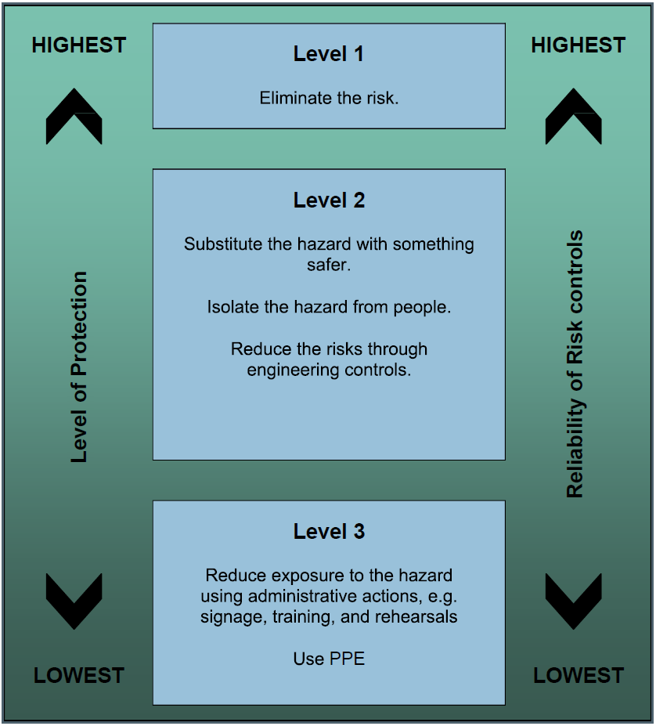

‘

HAZARD AND RISK MANAGEMENT PROCESS
Person Responsible | Hazard Management Actions – PLANNING
Heads of Schools/Colleges | Ensure that the hazards and risks associated with the School/College operations are managed and controlled, following the four-stage hazard management process.  - Stage 1: Identify Hazards  - Stage 2: The level of risk is assessed  - Stage 3: Control Measures are appropriate and they are applied  - Stage 4: Control measures are monitored and reviewed  Ensure there is a process for workers to receive the relevant information on the hazards and associated control measures in their area(s) of work, during their induction or before they undertake the activity.  Ensure that there is a local area/School/College Hazard/Risk Register documented, which:  includes all the activities, where a risk assessment is required in accordance with the Hazard Management – Risk Assessment Decision Tool;  is available in the local area, in either hard copy or electronic copy, and  is included in the local area/School/College induction process (as applicable).  Note: Ensure all workers and students have access to risk assessment templates (i.e. Long Form and Short Form or equivalent template) electronically or in hard copy.
 | STAGE 1 – IDENTIFY HAZARDS
All Workers | Consider the activity/task you are about to undertake and determine if:  - it is a new process, item of plant/equipment or substance,  - you are unfamiliar with the method of work,  - it is to be conducted in a different workplace/environment to normal and modification to the workplace or process is required,  - you have concerns that the activity may place you or any other person at risk of injury/illness.  If yes to any of the above  Do not undertake the activity and proceed to Stage 2.
 | STAGE 2 - ASSESS THE RISK
All Workers | Determine if a risk assessment is required using the Risk Assessment Decision Tool.  Check the local area/School/College Hazard/Risk Register for any existing risk assessments and either:  - implement the existing controls, or  - add any new hazard(s) and control measures to the overarching risk assessment, or  - commence a new risk assessment if not on the Risk/Hazard Register.  - If there are High Risk activities (Section 291 WHS Regulations 2011) such as Confined Space, Working at Heights, use of Scaffolding, disturbing asbestos, working excavations deeper than 1.5m, in an area that may have a contaminated atmosphere, near powered plant, risk of drowning.  - If in doubt then use the attached Safe Work Procedure (SWP) tool to manage the risks.  - The Job Safety Analysis (JSA) tool can be used for tasks or activities where there are no high-risk activities.
 | STAGE 3 – CONTROL THE RISK
All workers, in consultation with your Manager/ Supervisor | Ensure that the control(s) selected provide the highest level of protection and reliability i.e. elimination, but if this is not reasonably practicable, minimise the risk(s), so far as is reasonably practicable SFARP. (See Hierarchy of control measures).  Consult as far as reasonably practicable with the workers who carry out the activity, or are likely to be directly affected, including Health and Safety Representatives (if applicable), when controlling and reviewing the risk.  Check if there are any relevant Approved Codes of Practice or Australian Standards which outline the controls which are to be followed, unless there is another solution which achieves the same or a better standard of health and safety.  Ensure that safety procedures are documented as part of the hazard management process, where specific steps/directions are required to perform the activity safely (e.g. operate hazardous plant/equipment, handle hazardous chemicals) using the Hazard Management – Safe Operating Procedure (or equivalent template).  Check the residual risk rating after control measures have been determined.  For any risk assessments where the residual risk is low or medium  Obtain the relevant authorisations on the risk assessment.  Staff created risk assessments  Do not require Manager/Supervisor authorisation for low or medium residual risk.  Student created risk assessment  Require Manager/Supervisor (i.e. a staff member) authorisation for an activity where the residual risk is low or medium. (It is not permitted for another student to authorise the risk assessment.)  Conduct the activity and implement the identified control measures in accordance with the risk assessment.  For any risk assessments where the residual risk is high or very high  Do not commence the activity,  Review the risk assessment, and  Act to minimise the risk further i.e. to medium/low.  If not possible to reduce the residual risk from high or very high  Advise the Manager/Supervisor and Head of School/College and provide a copy of the risk assessment with the rationale as to why the activity should continue.  Do not conduct the activity until the appropriate level of formal authorisation has been given in accordance with the Risk Management Authorisation Matrix at Appendix A .
 | STAGE 3 - CONTROL THE RISK Continued
Head of School/College  and if applicable  Managers and  Vice-Chancellor and President | Where the residual risk is high or very high:  - Review the risk assessment.  - Determine additional controls which will reduce the risk and advise the Manager/Supervisor.  If it is not possible to reduce the risk:  Determine if the activity is to proceed or cease.  If the activity is to cease:  Advise the Manager/Supervisor accordingly.  If the activity is to continue:  Ensure the following authorisations are recorded on the risk assessment template:  - High - Authorisation by the Head of School/College is required.  - Very High - Authorisation by the Head of School/College and PVC and/or Vice-Chancellor are required.  Note:  The cost of controlling a risk may be considered in determining what is reasonably practicable, but cannot be used as a reason for doing nothing to address the risk. You may select short-term control measures pending a long-term solution. (Gross Disproportionate Test)  Where a signature is required, an email authorisation from the relevant Manager/Supervisor/Head of School/College is acceptable. Attach the authorisation email to the Risk Assessment template.
 | STAGE 4 – MONITOR AND REVIEW CONTROL MEASURES
Manager/ Supervisor for the area or responsible for the activity | Ensure that control measures are and remain:  - fit for purpose,  - suitable for the nature and duration of the work, and  - installed, set up and used correctly.  Review the control measures if:  - a new/previously unforeseen hazard has been introduced,  - requested by a Health and Safety Representative,  - new legislation is introduced,  - new information becomes available which could eliminate or minimise the risk.  Ensure that risk assessments and controls are reviewed following an incident to determine if control measures are ineffective in controlling the risk.  Update the Risk Register on a regular basis to ensure they remain current.
 | STAGE 4 – ONGOING MANAGEMNT OF HAZARDS
Head of School/College (Any or all of these tasks can be delegated to School/College staff (e.g. College Manager or activity Supervisor however the Head of School/College must monitor the tasks on a regular basis to ensure they take place.) | Ensure that workers are informed of the relevant hazards and control measures in their area of work as part of their induction program where they are exposed to, or required to complete the activity. This is to include the activities that are recorded on the School/College Risk Register.  Monitor that control measures are being implemented and provide additional supervision if/where required based on the level of risk and experience of the worker(s).  Ensure that, when there is a change to the work place/work practice which is likely to give rise to a new or different health and safety risk, the activity, plant/equipment or chemical is assessed (using the Hazard Management – Risk Assessment Decision Tool), a risk assessment completed and training provided if required.  Ensure that the School/College Annual Hazard Review Template, which is informed by the Risk Register, is completed when requested by the convenor of the University Health and Safety Committee.  Ensure that, where a control measure requires regular programmed testing or maintenance, the activity is added to the School/College WHS Assurance Activity Schedule, unless this requirement is centrally managed.  Ensure that any training required by a risk assessment (e.g. Proficiency based training) is added to the School/College Training Needs Analysis (TNA) (or equivalent) and training provided to relevant workers.
Workers | Follow reasonable instructions, safety measures (e.g. lab rules) and safe operating procedures (where applicable) for any activity you are required to undertake.  Assist in any hazard management process where required/requested by your Manager/Supervisor or other person with Health and Safety responsibilities (e.g. School/College Health and Safety Consultants or member of the SEW Team.)  Report to your Manager/Supervisor or Health and Safety Representative where you consider that a control measure is not effective in controlling the risks associated with any activity, or you have concerns that the activity may place you or any other person at risk of injury/illness.
 | STAGE 4 – DOCUMENTATION
Head of School/College (Any or all of these tasks can be delegated to School/College staff (e.g. College Manager or activity Supervisor however the Head of School/College must monitor the tasks on a regular basis to ensure they take place.) | Ensure there is a system for retaining static and dynamic risk assessments for the duration of the activity,  Unless:  the activity, plant/equipment or chemical/substance resulted in a notifiable or dangerous incident in which case all records, including risk assessments, are to be kept on file as part of the incident investigation documentation by SEW team.  the activity related to:  - work in a confined space,  - work on energised electrical equipment,  - diving work in which case a copy of the risk assessment must be retained for at least 28 days after the work is completed.  Ensure risk assessments pertaining to any item of registered plant is kept for the life of the plant and transferred to any new owner of the plant.  Ensure workers have access to current risk assessments, other guidance material, Safe Operating Procedures (where applicable) and the Risk Register either electronically or in hard copy.

Performance Measures
The SEW Team will use the performance measures listed below to assist in identifying areas of success and/or where corrective action is required to meet the objectives and targets of this process. The level of compliance with the Procedure and effectiveness will be determined during the internal audit process.
Measure | Objective Evidence | Frequency | Indicator of Success
All risk assessments identify the hazards associated with the activity, and the control measures address and manage each hazard identified, in accordance with the hierarchy of controls | Risk Assessments for Static and dynamic activities as applicable | As per the Internal audit plan | Success = 100% Less than 100% = Corrective action
A Hazard Listing(s) or risk assessments (if control banding is applicable) are held for each School/Branch area of work (as applicable) and include activities determined as static | Hazard Listing(s) (if required) Risk assessments  Note – If a School/Branch does not have any static activities requiring a risk assessment then a Hazard Listing is not required. | As per the Internal audit plan | Success = 100% Less than 100% = Corrective action

Appendixes:

- Risk Matrix and Risk Management Authority Matrix
- Hazard Management – Risk Assessment Decision Tool
- CDU Safe Work Procedure (Template)
- Job Safety Analysis (Template)
- Hazard Report Form (Template)

Document History and Version Control
Last amendment: |  | August 2018 |  |  | Next Review: | August 2019
Sponsor: |  | Manager SEW
Contact Officer: |  | Manager SEW
Version | Date Approved |  | Approved by | Brief Description
1.00 | June 2018 |  | Manager SEW | Creation of original document and upload to CDU website.
Version | Date |  | Title | Click or tap here to enter text.
Version | Date |  | Title | Click or tap here to enter text.

Likelihood |  | Consequences
 |  | Insignificant  A | Minor  B | Moderate  C | Major  D | Catastrophic  E
5 | Almost Certain | LOW | MEDIUM | HIGH | VERY HIGH | VERY HIGH | 5
4 | Probable | LOW | MEDIUM | HIGH | HIGH | VERY HIGH | 4
3 | Occasional | VERY LOW | LOW | MEDIUM | HIGH | HIGH | 3
2 | Improbable | VERY LOW | VERY LOW | LOW | MEDIUM | MEDIUM | 2
1 | Rare | VERY LOW | VERY LOW | VERY LOW | LOW | LOW | 1
Rating | Consequence Description
Catastrophic | - Multiple / Single fatality/Permanent Disability  - Irreversible health damage without loss of life
Major | - Lost Time Injury (>1 week) (STAFF Only)  - Multiple / single major injury  - Permanent (full or partial) disabling injury  - Workplace modifications required
Moderate | - Lost Time Injury (<1 week) (STAFF Only)  - Temporary (full or partial) disabling injury or health effect  - Injury that temporarily alters a person’s future\  - Suitable duties in accord with injury management guidance
Minor | - Medical Treatment Injury (MTI)  - Injuries/health effects requiring Medical Treatment at a Clinic or Hospital Emergency facility or rehabilitation treatment. Not admitted to hospital. No lost time.
Insignificant | - First Aid Injury  - Slight injury of health effect requiring first aid treatment only  - Does not affect work performance or require adjustment to work duties
Rating | Likelihood Descriptor
Almost Certain | - Can be expected to occur once or more during the next year. There is a history of regular occurrences at CDU or other Universities  - Can be expected to occur 75-99%  - More than 1 event per year
Probable | - Is known to occur or “It has happened”  - Can commonly occur 50% - 75%  - Expected to occur every 1-2 Years
Occasional | - Could occur or” I’ve heard of it or seen it happen” as there have been infrequent occurrences at CDU or other Universities  - May occasionally occur 25-50%  - 1 event per 1 to 5 Years
Improbable | - Not likely to occur very often.  - May infrequently occur 10-25%
Rare | - Conceivable but not known to occur at CDU or other Universities  - May occur in exceptional circumstances 0% – 10%
Risk Matrix and Risk Management Authority Matrix Appendix A

Risk Management Authority Matrix
Risk Level | Risk Index | CDU Risk Management Authority | Guidance
Very High | D5, E4, E5 | VC or PVC or Head of School/College | A considerable potential for multiple fatalities, Task failure of strategic significance, or serious long-term degradation of CDU reputation.
High | C4, C5, D3,  D4, E3 | Head of School or College | A considerable potential for serious degradation of an CDU capability, fatal injury, major asset loss, task or activity failure of significance, or significant degradation of reputation.
Medium | B4, B5, C3,  D2, E2 | School / College Manager or Supervisor responsible for the task or activity | A moderate potential for serious degradation of an CDU capability, serious injury, major asset damage/loss, activity or task failure of tactical significance, or short-term impact to reputation.
Low | A4, A5, B3, C2, D1, E1 | Task Activity Supervisor | Has the potential to degrade CDU capability, injure personnel, damage equipment or  compromise the task or activity.
Very Low | A1-A3, B1,  B2, C1 | Task Activity Supervisor | Minimal potential for impact to capability, personnel, equipment, the activity or task or public image.

Notes:
- A risk management authority may delegate their authority but will retain overall responsibility for the risk(s) associated with the task/activity.
- Where the residual risk is greater than the delegated threshold, the risk decision is to be transferred to the higher-level manager consistent with their risk management authority.
- Supervisor means a person employed into a position description with the title of Supervisor at CDU

Hazard Management – Risk Assessment Decision Tool Appendix B
- Check the criteria listed in column A. If the criteria is applicable to the activity, then a formal (documented) risk assessment is not required. Complete the activity as outlined.
- If column A is not applicable, then one or more of the hazards/criteria in column B will be relevant and a formal risk assessment is required. You will need to determine the nature of the activity (i.e. Static or Dynamic), complete and follow the instructions on the relevant risk assessment template.
COLUMN B
A FORMAL RISK ASSESSMENT IS REQUIRED
- The item of plant/equipment or chemical is used in a different way to how the manufacturer intended, or a chemical being used
differently to the Safety Data Sheet; and/or
- The activity is an event or an activity which requires the co-ordination of several tasks which could impact on the safety of the
workers or others in the vicinity of the activity; and/or
- The activity involves one or more of the following hazards:

- Animal handling (unpredictable behaviour – kicks, bites)  - Biological (pathogens, body fluids)  - Boating, risk of drowning  - Confined space entry  - Diving work  - Electrical work on energised electrical equipment  - Excavation (tunnel, shaft that could collapse)  - Explosives or Firearms  - Fall from work at height which would result in injury  - Fatigue (work related mental or physical exertion affecting function)  - Hazardous chemicals  - Hazardous manual activity  and / or | - Hazardous plant  - Hidden pipes, cables, wiring  - High risk travel (DFAT 3 - Reconsider Travel or Level 4 Do Not Travel)  - Hot work/potential for uncontrolled fire  - Isolation (work in a remote area, or on your own  in an unfamiliar environment, rescue would be difficult.)  - Noise/sound levels greater than safe exposure standards  - Personal Threat (e.g. threat of harm or injury by  another person)  - Psychosocial hazards  - Radiation  - Temperature extremes
Note: The Risk Assessment must be done by a competent person
- There is uncertainty about the impact of, or what would occur by combining hazards, or known risks (e.g. water and power); and/or
- There is an incident/injury trend identified for the activity; and/or
- There is a change in a work practice or the work environment and there is uncertainty about how a hazard(s) may result in injury or illness.

COLUMN A
1. Is it an item of plant/equipment which is manufactured and being used in the way it was intended and is not defined as hazardous plant? (see definitions)
Or
2. Is it a chemical which is being used and managed in accordance with the Safety Data Sheet and not defined as a hazardous chemical? (see definitions)
Or
3. An activity which is considered low risk:
• There is no expectation that an injury/illness will occur.
• If there was an injury/illness, treatment would be very minor/negligible e.g. first aid treatment requiring a band aid.
If you have answered yes
to the above criteria
NO FORMAL
RISK ASSESSMENT IS REQUIRED

Appendix C
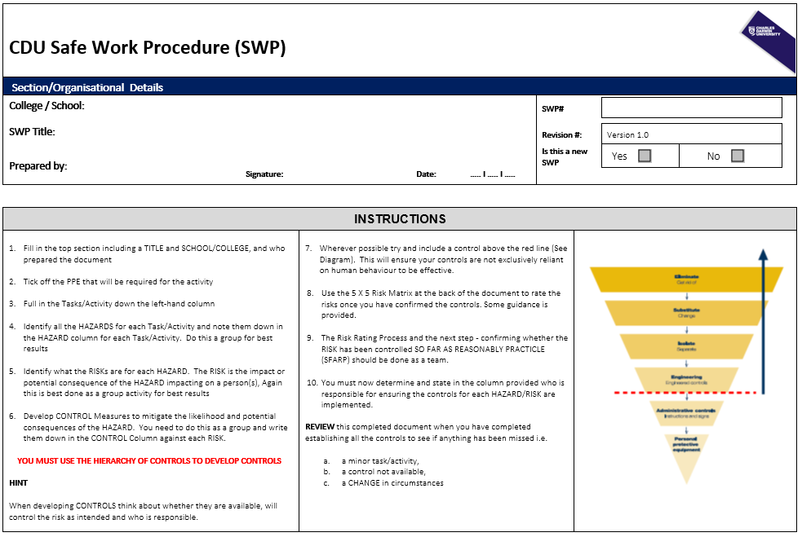

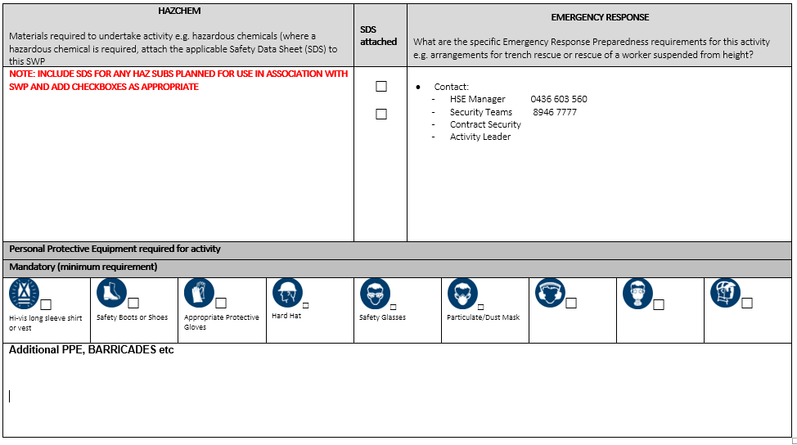

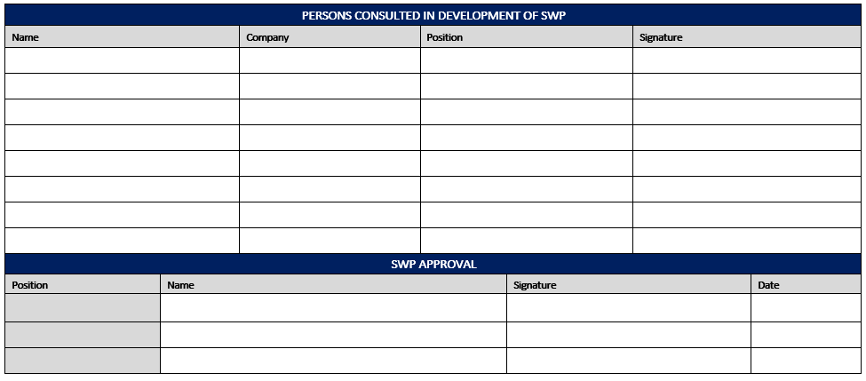
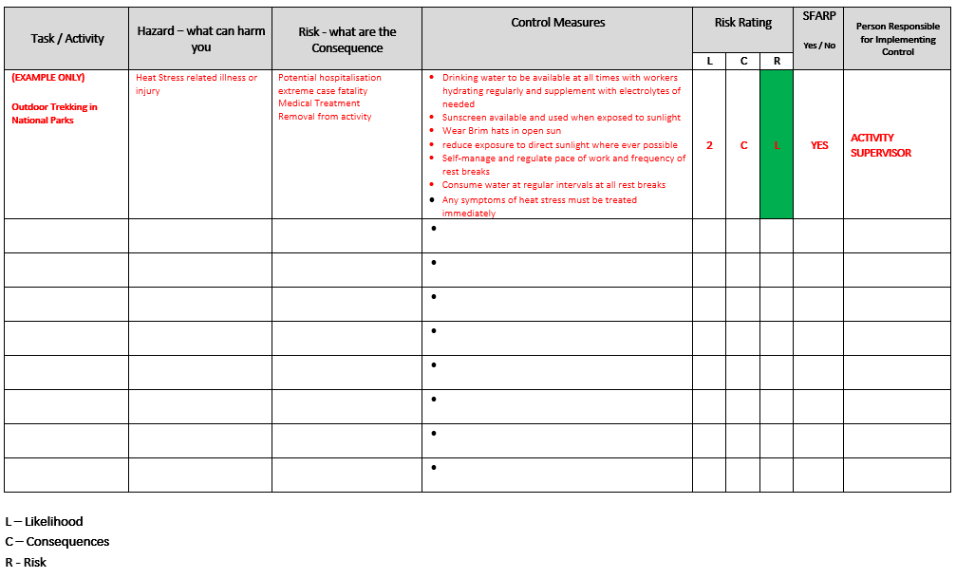
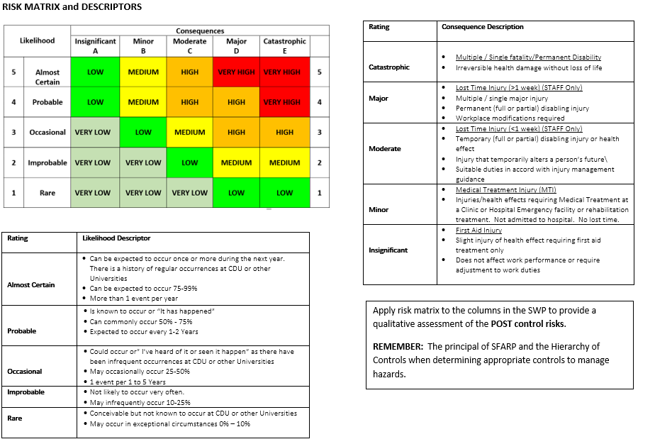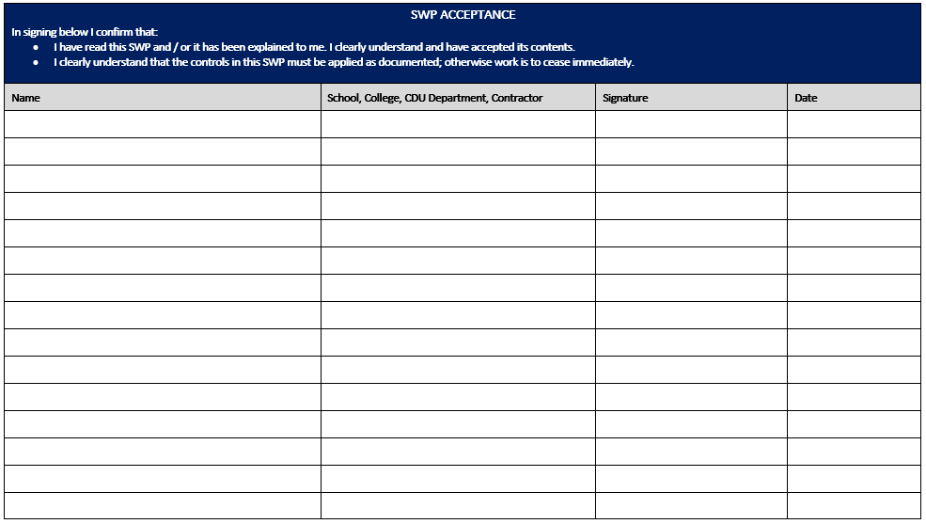


CDU Job Safety Analysis (JSA)
CDU Section/Organisational Details
School / College: |  |  |  |  |  |  | Activity Dates
JSA Title: |  |  |  |  |  |  | Revision #: |  | Version
Prepared by: |  |  | Signature: |  | Date: | ….. I …. I …. | Is this a new JSA |  | Yes |  |  | No

JSA review completion
Review Sign-off:
Supervisor / Manager or (Delegate): ………………………………………….…… Signature: ………………………………… Date: .... I.…. I ….
Task Supervisor (Delegate): …………………………………………………... Signature: ………………………………… Date: .... I.…. I ….

  Hi-vis long sleeve shirt or vest |  Appropriate Protective Boot |   Appropriate Protective Gloves |  |  | 

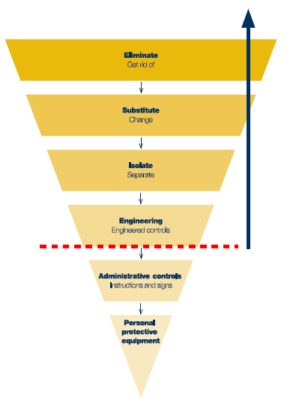
# | Task / Activity | Hazards  what could cause injury/damage to people, equipment or the environment? | Risk  What Is the impact of the hazard | Proposed Control Measures  apply Hierarchy of Risk Controls | Person responsible for implementing control
1
2
3
4
5
6
7
8
9
10

JSA APPROVAL / ACCEPTANCE
In signing below, I confirm that:
- I have read this JSA and / or it has been explained to me. I clearly understand and have accepted its contents.
- I clearly understand that the controls in this JSA must be applied as documented; otherwise work is to cease immediately.
- I have the required and current competencies and qualifications to undertake this activity.
- I have received training sufficient to enable me to undertake this activity.
Name | Position | Signature | Date

