CDU Safe Work Procedure (SWP) |  |  |  |  |  |  |  | 
Section/Organisational details
College/School: |  | ……………………………………………………………………………………………………………………………………………..….. |  |  |  |  | SWP#
SWP Title: | ……………………………………………………………………………………………………………………………………….…. |  |  |  |  |  | Revision #: |  | Version 1.0
Prepared by: | ………..……………………………….. |  | Signature: | …………………………………. | Date: | ….. I ….. I ….. | Is this a new SWP |  | Yes |  | No

INSTRUCTIONS
- Fill in the top section including a TITLE and SCHOOL/COLLEGE, and who prepared the document.  - Tick off the PPE that will be required for the activity.  - Fill in the Tasks/Activity down the left-hand column.  - Identify all the HAZARDS for each Task/Activity and note them down in the HAZARD column for each Task/Activity. Do this as a group for best results.  - Identify what the RISKs are for each HAZARD. The RISK is the impact or potential consequence of the HAZARD impacting on a person(s). Do this as a group for best results.  - Develop CONTROL measures to mitigate the likelihood and potential consequences of the HAZARD. You need to do this as a group and write them down in the CONTROL column against each RISK.  YOU MUST USE THE HIERARCHY OF CONTROLS TO DEVELOP CONTROLS  HINT  When developing CONTROLS think about whether they are available, will it control the risk as intended and who is responsible. |  |  |  | - Wherever possible try and include a control above the red line (see diagram). This will ensure your controls are not exclusively reliant on human behaviour to be effective.  - Use the 5 X 5 Risk Matrix at the back of the document to rate the risks once you have confirmed the controls. Some guidance is provided.  - The Risk Rating Process and the next step - confirming whether the RISK has been controlled SO FAR AS REASONABLY PRACTICLE (SFARP) should be done as a team.  - You must determine and state in the column provided who is responsible for ensuring the controls for each HAZARD/RISK are implemented.  REVIEW this completed document when you have completed establishing all the controls to see if anything has been missed i.e.  - a minor task/activity  - a control not available  - a CHANGE in circumstances
HAZCHEM  Materials required to undertake activity e.g. hazardous chemicals (where a hazardous chemical is required, attach the applicable Safety Data Sheet (SDS) to this SWP |  |  |  |  |  | SDS attached | EMERGENCY RESPONSE  What are the specific Emergency Response Preparedness requirements for this activity e.g. arrangements for trench rescue or rescue of a worker suspended from height?
NOTE: INCLUDE SDS FOR ANY HAZ SUBS PLANNED FOR USE IN ASSOCIATION WITH SWP AND ADD CHECKBOXES AS APPROPRIATE |  |  |  |  |  |  | - Contact:  - SEW Manager - 0436 603 560  - Security Teams - 8946 7777 (this is different for each region)  - Contract Security  - Activity Leader
Personal Protective Equipment required for activity
Mandatory (minimum requirement)
  Hi-vis long sleeve shirt or vest |   Safety boots or shoes |  Appropriate protective gloves |   Hard hat |  |   Safety glasses |  |  |   Particulate/dust mask |   Hearing protection |  |  | 
Additional PPE, BARRICADES etc

PERSONS CONSULTED IN DEVELOPMENT OF SWP
Name |  | Company | Position |  | Signature
SWP APPROVAL
Position | Name |  |  | Signature |  | Date

Task/Activity | Hazard − what can harm you | Risk - what are the consequences | Control measures | Risk Rating |  |  | SFARP  Yes/No | Person responsible for implementing control
 |  |  |  | L | C | R | SFARP  Yes/No | Person responsible for implementing control
(EXAMPLE ONLY)  Outdoor Trekking in National Parks | Heat stress related illness or injury | Potential hospitalisation extreme case fatality  Medical treatment  Removal from activity | - Drinking water to be available at all times with workers hydrating regularly and supplement with electrolytes of needed  - Sunscreen available and used when exposed to sunlight  - Wear Brim hats in open sun  - reduce exposure to direct sunlight where ever possible  - Self-manage and regulate pace of work and frequency of rest breaks  - Consume water at regular intervals at all rest breaks  - Any symptoms of heat stress must be treated immediately | 2 | C | L | YES | ACTIVITY SUPERVISOR
L – Likelihood
C – Consequences
R - Risk

Rating | Consequence Description
Catastrophic | - Multiple/Single fatality/Permanent Disability  - Irreversible health damage without loss of life
Major | - Lost Time Injury (>1 week) (STAFF only)  - Multiple/single major injury  - Permanent (full or partial) disabling injury  - Workplace modifications required
Moderate | - Lost Time Injury (<1 week) (STAFF only)  - Temporary (full or partial) disabling injury or health effect  - Injury that temporarily alters a person’s future  - Suitable duties in accord with injury management guidance
Minor | - Medical Treatment Injury (MTI)  - Injuries/health effects requiring Medical Treatment at a Clinic or Hospital Emergency facility or rehabilitation treatment. Not admitted to hospital. No lost time.
Insignificant | - First Aid Injury  - Slight injury of health effect requiring first aid treatment only  - Does not affect work performance or require adjustment to work duties
RISK MATRIX and DESCRIPTORS
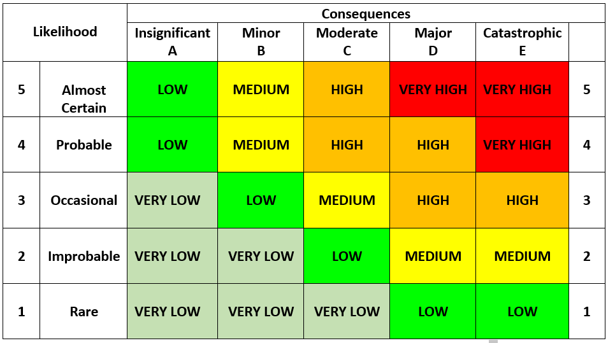
Rating | Likelihood Descriptor
Almost Certain | - Can be expected to occur once or more during the next year. There is a history of regular occurrences at CDU or other Universities  - Can be expected to occur 75-99%  - More than 1 event per year
Probable | - Is known to occur or “It has happened”  - Can commonly occur 50% - 75%  - Expected to occur every 1-2 Years
Occasional | - Could occur or” I’ve heard of it or seen it happen” as there have been infrequent occurrences at CDU or other Universities  - May occasionally occur 25-50%  - 1 event per 1 to 5 Years
Improbable | - Not likely to occur very often.  - May infrequently occur 10-25%
Rare | - Conceivable but not known to occur at CDU or other Universities  - May occur in exceptional circumstances 0% – 10%

Apply risk matrix to the columns in the SWP to provide a qualitative assessment of the POST control risks.
REMEMBER: The principal of SFARP and the Hierarchy of Controls when determining appropriate controls to manage hazards.

SWP ACCEPTANCE
In signing below I confirm that:
- I have read this SWP and / or it has been explained to me. I clearly understand and have accepted its contents.
- I clearly understand that the controls in this SWP must be applied as documented; otherwise work is to cease immediately.

Name | School, College, CDU Department, Contractor | Signature | Date

