Charles Darwin University’s Capability to serve the Territory and Wider Region

Overview
Charles Darwin University (CDU) is a “dual-sector” and “research-intensive” institution with 11 campuses and connected world and aims to be a provider of transformative skills and learning with a major focus on quality, access and growth. centres throughout Australia. From its base in the Northern Territory and as the Australian university closest to Asia, CDU is ideally placed to prepare graduates for success in an increasingly complex, diverse and

Over the next ten years, CDU will also further develop its world class and emerging research strengths in areas critical to the sustainable and prosperous development of Northern Australia and the region, particularly Indigenous and tropical health, environmental science, public policy, engineering, information technology and Indigenous knowledges.

Through the growth strategy Connect, Discover, Grow, CDU aspires to become:

- A provider of transformative skills and learning
- Globally recognised for Indigenous leadership
- A critically engaged university of the region
- A truly international university
- A successful research intensive university

Research and Innovation
CDU’s research and innovation portfolio has real world impact, well beyond northern Australia. The majority of CDU’s research is conducted through its three flagship research institutes. However, CDU’s research expertise spans a wide range of fields including: education, business, creative arts, psychology and clinical sciences, engineering, and vocational education and training.

Higher Education
Organised in six colleges, CDU’s higher education offerings complement and are strengthened by its research capability including strengths in: health, human sciences, business, law, indigenous knowledges, education, engineering, nursing and environmental sciences.

Vocational Education and Training
CDU VET delivers training in more than 150 locations across the Northern Territory and combines practical, hands-on experience, as well as online training. VET’s proximity to industry and business means it can stimulate innovation through applied research and knowledge stimulation. Thirty percent of the VET population at CDU is Indigenous.

Indigenous Leadership
CDU acknowledges the imperative of Indigenous recognition, inclusion and achievement in the Northern Territory’s and the nation’s future prosperity and the role that education plays in empowering Indigenous people. Through the Australian Centre of Indigenous Knowledges and Education and throughout all its programs, CDU focusses on delivering transformative and innovative teaching and learning, research and community engagement for and with Indigenous Australians.

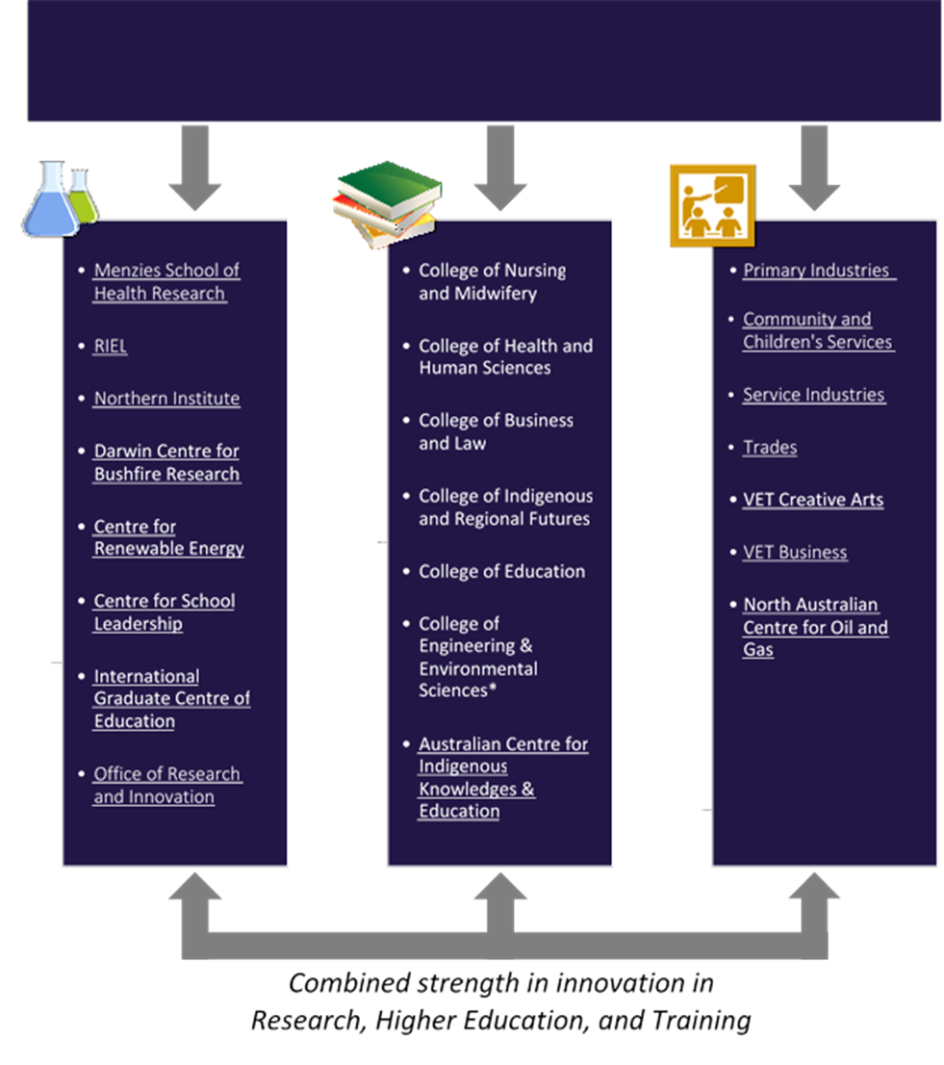
*Working titles are provided for each College as a guide. Discipline configuration and naming may vary depending on the feedback received from staff response during CDU’s restructure consultation process, and is therefore subject to change.

Research and Innovation | Lawrence Cram (DVC)
Institute of Advanced Studies
Menzies School of Health Research | Alan Cass (Director)
- Child Health | Anne Chang
- Global Health | Nick Anstey
- Education and Capacity Building | Heather D’Antoine
- Wellbeing and Preventable Chronic Diseases | David Thomas
Research Institute for the Environment and Livelihoods | Karen Gibb (Director)
- Catchments & Water | Karen Gibb
- Biodiversity | Brett Murphy
- Communities and Livelihoods | Stephen Garnett
- Savanna and arid environments and adaptation | Jenny Davis
- Darwin Centre for Bushfire Research | Cameron Yates
Northern Institute | Ruth Wallace (Director)
- Contemporary Indigenous Knowledge & Governance | Michael Christie
- Demography & Growth Planning | Andrew Taylor
- Evaluation & Knowledge Impact | Emma Williams
- Regional Economic Workforce Development | Rolf Gerritsen
Centre for Health & Wellbeing | (vacant)
Institute for Energy & Resources (in formation) | (TBD)
- North Australia Centre for Oil and Gas | Suresh Thennadil
- Centre for Renewable Energy | Kean Yap
CDU Office of Research and Innovation | Brendon Douglas  (Director of Research)

Higher Education* | Sue Carthew (Provost)
College of Nursing and Midwifery | TBA
- Nursing
- Midwifery
- Health Science
College of Health and Human Sciences | TBA
- Psychology
- Social Work
- Clinical and Medical Laboratory Sciences
- Pharmacy
- Exercise and Sport Sciences
College of Business and Law | TBA
- Business
- Law
College of Indigenous and Regional Futures | TBA
- Indigenous Knowledges
- Public Policy
- Humanities
- Social Sciences
- Creative Arts
- Languages
- Design
- Centre for Emergency & Disaster Management
College of Education | TBA
- Education
- Centre for School Leadership | Jenny Nash
- International Graduate Centre of Education | Sue Shore
College of Engineering & Environmental Sciences | TBA
- Engineering
- Environmental Science
- Information Technology

Vocational Education and Training | Christine Robertson (PVC)
Primary Industries | Danie Luttig
- Agriculture and Rural Operation (Top End) | Alison Haines
- Conservation and Land Management (Top End) | Waleve Jolly
- Horticulture (Top End) | Scott McDonald
- Conservation and Land Management (Central) | Waleve Jolly
- Maritime and Seafood | Chadd Mumme
Community and Children's Services | Kim Hawkins
- Community Services | Peter Hogan
- Children's Services | Denise Horvath
- English as a Second Language | Sharon Gilbert
- Adult Literacy and Numeracy (Top End) | Wendy Kennedy
- International English Language Testing System (IELTS) | IELTS Test Centre
Service Industries | Bharat Desai
- Business (Central) | Sajjad Rana
- Commercial Cookery and Bakery (Top End) | Robert Schwerdt
- Information Technology and Library Studies (Top End) | Anthony D’Orival
- Sales and Personal Services (Top End) | Linda Manning
- Tourism and Hospitality (Central) | Mike Keating
- Tourism, Hospitality and Recreation (Top End) | Tim Francis
Trades | Roy Brandner
- Automotive and Civil | Bruce Kimm
- Building Technology | Luis Espinoza
- Electrotechnology | Brett Willowhite
- Metal Trades and Engineering | Rohan Badenhop
- Trades (Central) | Jamie Finn
VET Creative Arts in HE | Sila Crosley
VET Business in HE | Fran Gusthart

Enquiries:
Janet Russell, Office of the Vice-Chancellor
(08) 8946 6044 janet.russell@cdu.edu.au

