ADMINISTERING SURVEYS :
INTRODUCTION TO QUALTRICS

By Simon Moss

Introduction

Many research candidates and staff need to distribute surveys online. Research candidates and staff at CDU tend to utilize Qualtrics to achieve this goal, because this option is available from the CDU portal. This document offers some guidelines on how to use Qualtrics.

How to activate an account

To utilize Qualtrics, you need to access this tool somehow. To achieve this goal, you should first

- access your portal—at portal.cdu.edu.au—and enter relevant details, such as your password, if prompted
- if Qualtrics is one of the available tiles, simply click this tile.

If Qualtrics is not one of the available tiles, you might need to implement another strategy. For example, you could apply the following instructions. If unsuccessful, contact your supervisor, who might be able to identify someone to assist.

- Only after you have signed into the portal, paste cdu.qualtrics.com into a web browser, such as Chrome, Edge, or Safari.
- You might then be prompted to log in, perhaps with your CDU username and password
- Follow other instructions that might appear

How to begin

To begin a survey,

- Select Qualtrics from the CDU portal.
- Press Login—a button that usually appears on the top right side
- Enter your username, usually your CDU email, and your password
- Press Create project and then Blank Survey Project.
- You could enter a name for this project, such as Trial Survey, and then press Create Project

This sequence of activities should generate a screen that resembles the following screenshot

How to construct multiple-choice questions

To create a multiple-choice question

- Insert the cursor onto Click to write the question text, towards the top left
- Write a question, such as What is your gender?
- Then, click on the three choices to specify options, such as male, female, other
- If you want to add an option, such as I do not want to say, press the + sign on the far right side of the screen, under choices
- You can also change the name of this question from Q1 to something more informative, such as gender. This label will appear in your data file after you collect data.

Then, to create additional multiple-choice questions, click Create a New Question below the first question. Next, repeat the previous activities. Finally, on the right side are various options you can utilize to adapt your question. The following table summarizes these options.

Label | Options
Answers | You can change the alternatives so that  - participants can choose more than one answer for each question  - participants can select an option from a dropdown list
Position | You can choose to arrange options horizontally—that is, across the page—rather than vertically or down the page
Validation options | Questions can be designated as mandatory: Participants cannot proceed to the next page until they complete these questions
Actions | You can utilize this option to  - shift questions earlier or later in the survey  - ensure that questions appear only if participants choose specific responses to previous questions

How to construct other kinds of questions

Besides multiple-choice questions, you can construct many other kinds of questions. Towards the top right of your screen will be a label Change question type. Press the downward arrow alongside Multiple Choice. This procedure will generate the following set of options somewhere along the screen. The following table then describes or illustrates these various kinds of questions.

Label | Description or illustration of the question
Descriptive text | Use this option whenever you simply want to write text—such as the plain language statement
Graphic | Use this option to embed graphics, such as the CDU logo in the plain language statement
Matrix table | This option presents a sequence of questions that correspond to the same rating scale such as
   | Strongly disagree | disagree | Neither agree nor disagree | Agree | Strongly agree
  I like apples | O | O | O | O | O
  I like pears | O | O | O | O | O
  I like plums | O | O | O | O | O
Text entry | This option enables participants to enter text such as
  Please enter your occupation
Slider | This option enables participants to slide a bar to indicate a precise number, such as  What is your age? 0 10 20 30 40 50 60 70 80 90
Rank order | This option instructs participants to order a sequence of statements—such as to order songs from least to most liked
Side by side | This option is similar to a matrix table, but enables you to include more than one rating scale for each row
Other questions | Many other alternatives are available. For example  - you can check whether the participant is a human or robot with reCAPTCHA  - timing permits you to record the time that participants spend on a page

How to arrange questions into blocks

Thus far, you have learnt to construct questions. The next step is to arrange these questions appropriately. To illustrate, most surveys comprise a series of pages. The first page might be the plain language statement. The second page might comprise 20 questions about 2 topics. The third page might comprise 30 questions about 4 topics, and so forth. After completing the questions on one page, participants might need to press a button, labelled Next, to progress to the next page.

Generally, in Qualtrics, each page is called a block. Therefore, to construct pages

- press Add Block
- construct additional questions on this block
- or move questions from another block to this block

To shift the order of pages or blocks, you can utilize several approaches. The best approach is to press Survey flow—an option that should appear near the top of this page. A page that resembles the following photo will appear

In this instance

- the survey comprises four blocks or pages of questions
- to swap the last two blocks, for example, press Move in the last block and then drag this block to the right spot
- press Save Flow

How to randomly allocate participants to conditions

Consider the previous screen. After completing the first block of questions, the researcher may now want participants to complete either the second block of questions or the third block of questions but not both. To randomly allocate participants to complete either the second or third block

- press Add below in the first block of questions
- a series of buttons will appear; press the button Randomizer
- the screen will now resemble the following screenshot

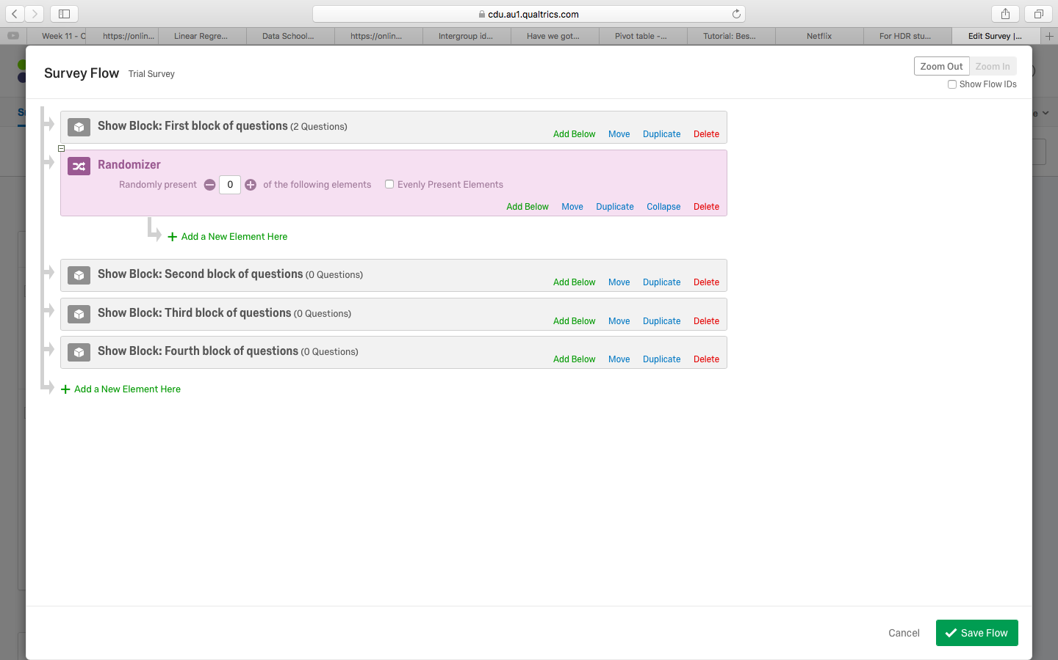

- Press Move alongside the second block of questions
- Drag this second block to the phrase Add a New Element Here, just below the first block
- Repeat with the second block to generate the following screen
- Enter 1 in the box after Randomly present…
- Finally press Save Flow

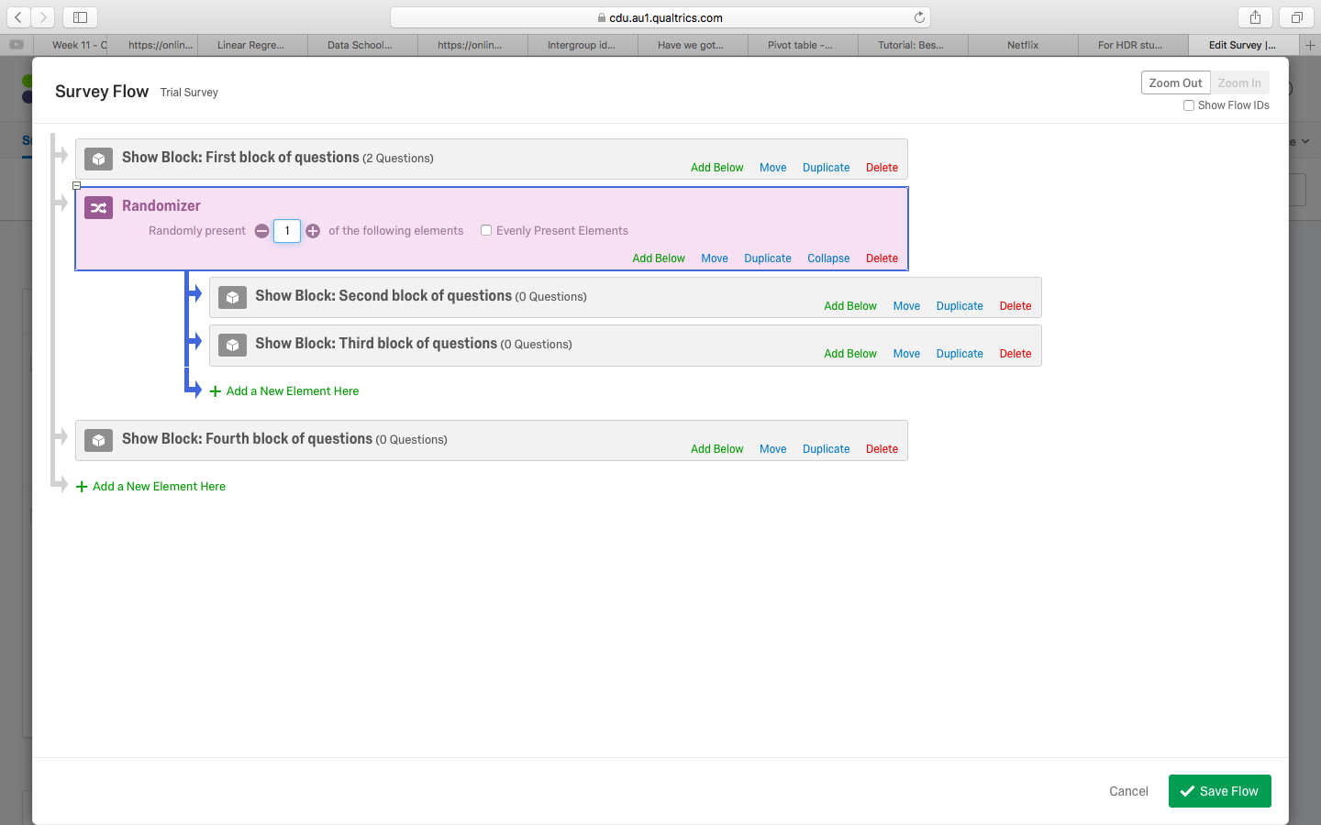

As this screen indicates, after participants complete the first block, Qualtrics will randomly present either the second block of questions or the third block of questions to participants. Consequently, Qualtrics can be utilized to deliver experiments or randomized control designs.

One minor complication is that, in the data file, Qualtrics does not indicate in which condition participants were assigned. If one or both blocks contain questions, you can determine which conditions participants were assigned from which questions participants answered. You should thus

- ensure one or both of these blocks contains questions rather than only text or pictures
- or later, when you download the data, choose More options and then tick Export viewing order data for randomized surveys

How to distribute surveys

After you have constructed the survey, you can apply several approaches to distribute these questions to participants. For example, you could

- click Distributions—an option that appears near the top
- choose Get a single reusable link
- copy and paste the link that appears on the screen, such as https://cdu.az1.qualtrics.com/jfe/form/SV_bEF5IdODbRCMBaR

Thus, to distribute the survey, you could merely need to send this link to potential respondents. For example, you could send these respondents an email like “Hello, we are conducting a survey into the needs of international candidates. The survey can be completed within about 15 minutes. For further information, please copy and paste this website address into your web brower: https://cdu.az1.qualtrics.com/jfe/form/SV_bEF5IdODbRCMBaR”

Other alternatives are available. The following table summarizes these alternatives.

Label | Description or illustration of the distribution method
Personal links | This option is useful when you want to distribute the survey to a list of email addresses but want to differentiate these emails in your data file
Social media | You can distribute the survey using one of your social media accounts, such as Twitter, Facebook, Reddit, LinkedIn, Google+, and Pinterest. In the data file, Qualtrics will record the social media forum from which each participant was recruited.

Downloading the data

After participants have completed the survey, you then want to download the data—to Excel, SPSS, or some other spreadsheet. To achieve this goal

- Select Data and Analysis towards the top
- Press the button Export and Import. Then choose Export data
- To download an SPSS file, choose SPSS and then Download
- To download the file into Excel, choose CSV and then Download.
- This CSV file can be used in many statistics programs, such as R or STATA

Other features

Qualtrics also offers a variety of other features. The following table summarizes some of these features.

Label | Options
Survey: Look and feel | The button Look and feel—available after you choose the Survey tab—enables you to  - adjust the overall design of questions  - add headers or footers  - change the font  - create various page transitions, such as flipping the page  - adjust the background colours
Survey: Survey options | The button Survey options—available after you choose the Survey tab—enables you to  - prevent or permit respondents from returning to previous pages  - prevent individuals from completing the survey more than once
Survey: Survey options | The button Survey options—available after you choose the Tools tab—enables you to  - search and replace words  - conduct a spell check  - ask Qualtrics to identify possible mistakes, called “Check survey accessibility”  - attempt to translate the survey, at least roughly  - export the survey to Word
Actions | This tab enables you to initiate some action, such as send an email to someone, in response to a specific answer from participants

