HOW TO PREPARE YOUR DATA

by Simon Moss

Introduction

To analyse quantitative data, researchers need to

- choose which techniques they should apply to analyze their data, such as ANOVAs, linear regression analysis, neural networks, and so forth
- prepare their data—such as recode variables, manage missing data, and identify outliers
- test the assumptions of the techniques they chose to conduct
- implement the techniques they chose to conduct

Surprisingly, the last phase—implement the techniques—is the simplest. In contrast, researchers often dedicate hours, days, or even week to the preparation of data and the evaluation of assumptions. This document will help you prepare your data in R and assumes basic knowledge of R . Another document will help you test the assumptions. In particular

- this document will describe a series of activities you need to complete
- you should complete these activities in the order they appear in this document
- in practice, you might not need to complete all these activities, however

Illustration

To learn how to prepare the data, this document will refer to a simple example. Suppose you want to ascertain which supervisory practices enhance the motivation of research candidates. To explore this question, research candidates might complete a survey that includes a range of questions and measures, as outlined in the following table

Topic | Questions
Motivation | On a scale from 1 to 10, please indicate the extent to which you feel  1 Absorbed in your work at university  2 Excited by your research  3 Motivated during the morning
Empathic supervisors | On a scale from 1 to 10, please indicate the extent to which your supervisor  4 Is understanding of your concerns  5 Shows empathy when you are distressed  6 Ignores your emotions
Humble supervisors | On a scale from 1 to 10, please indicate the extent to which your supervisor  7 Admits their faults  8 Admits their mistakes  9 Conceals their limitations
Demographics | 10 What is your gender?  11 Are you married, de facto, divorced, separated, widowed, or single?

An extract of the data appears in the following table. To practice these activities, you could enter data that resembles this spreadsheet. You could save this file as a text file and then upload into R.

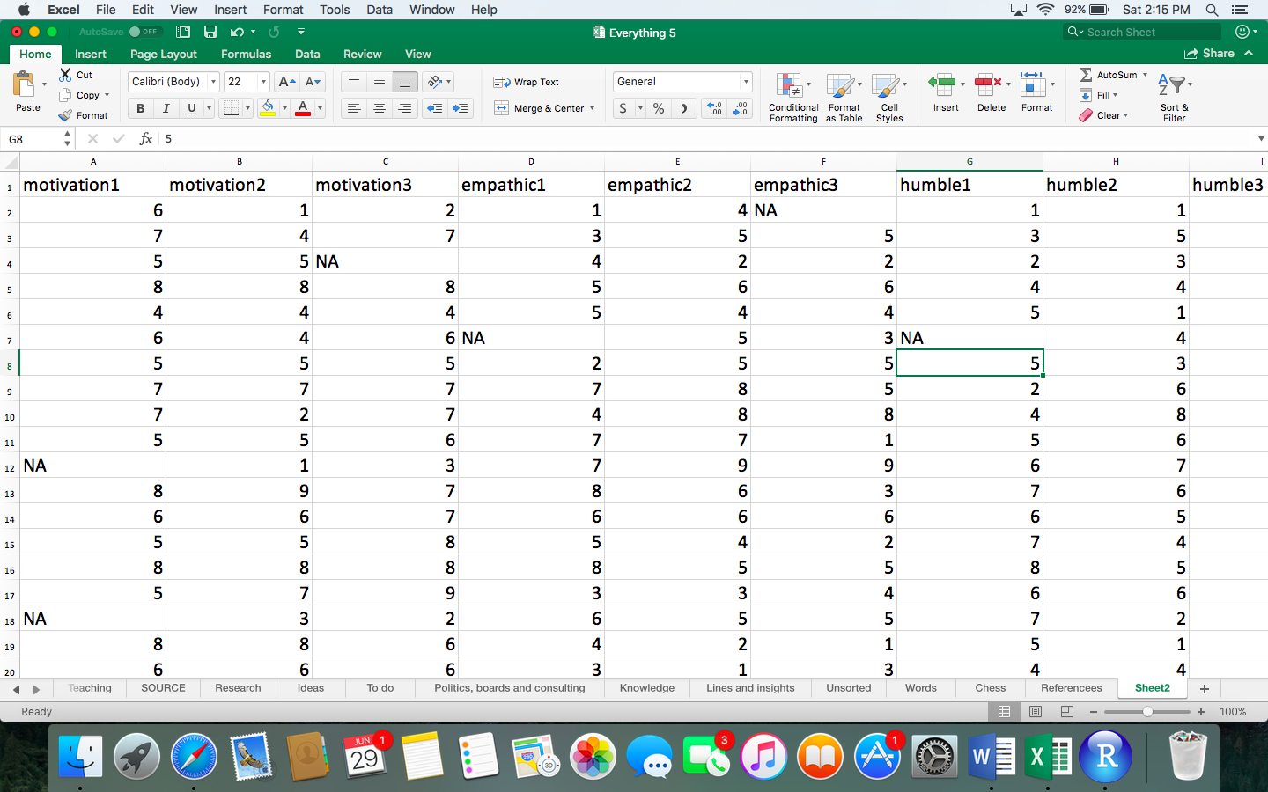

1 Recode your data if necessary

Sometimes you need to modify some of your data, called recoding. The following table outlines some instances in which data might need to be recoded. After you scan this table, decide whether you might need to recode some of your variables.

Reason to recode | Example
To blend specific categories into broader categories | The researcher might want to reduce married, de facto divorced, separated, widowed, or single to two categories: “living with a partner” versus “not living with a partner”
To create consistency across similar questions | To measure the humility of supervisors, participants indicate, on a scale of 1 to 10, the extent to which their supervisor  - admits faults  - admits mistakes  - conceals limitations  One participant might indicate 7, 8, and 3 on these three questions. In this instance,  - high scores on the first two questions, but low scores on the third question, indicates elevated humility.  - therefore, the researcher should not merely sum these three responses to estimate the overall humility of the supervisor—because a high score might indicate the supervisors often admits faults and mistakes or often conceals limitations  - to override this problem, the researcher could recode the responses to conceals limitations  - in particular, on this item, the researcher could substract the score of participants from 11—one higher than is the maximum  - a 9 would become a 2, a 2 would become a 9, and so forth  - this procedure is called reverse coding, because high scores become low scores and vice versa  In contrast, if the responses spanned from 1 to 5, you would subtract each number from 6 to reverse code.

How to recode data in R

To recode data in R, you can utilize several alternative commands. The first column in the following table illustrates some code you could modify to recode data. The second column explains this code.

Code | Explanation or clarification
install.packages("car") | - The package car is called “Companion to Applied Regression” and comprises several plots and tests that complement linear regression
library(car) | - Activates this package
humility3r = recode(humility3, '1=5; 2=4; 3=3; 4=2; 5=1') | - In this instance, the researcher has reverse coded an item or variable called humility to a revised items or variable called humility3r  - The researcher could have omitted “3=3”; that is, values that are not specified do not change
humility3r | - If you merely enter this revised variable, the scores should appear, enabling you to assess whether you successfully recoded the variables
marital.r=recode(marital, '3=2, 4=2 5=2') | - The categories originally labelled 3, 4, and 5 will be labelled 2 in the revised variable marital.r

2 Assess internal consistency

Consider the following subset of data. Each row corresponds to one participant. The first three columns present answers to the three questions that assess the humility of supervisors, after recoding the third item. The final column presents the average of the other columns. In subsequent analyses, researchers will often utilize this final column—the average of several items— instead of the previous columns because

- trivial events, such as misconstruing one word, can appreciably affect the response to a specific question or item
- but, these events are not as likely to affect the average of several responses to the same extent
- that is, these averages tend to be more reliable or consistent over time

Consequently, researchers often compute the average of a set of items or columns. This average or sum is sometimes called a composite scale or simply a scale.

Humility 1  Admits their faults | Humility 2  Admits their mistakes | Humility 3r  Conceals their limitations after recoding | Average
4 | 8 | 6 | 6
1 | 3 | 5 | 3
2 | 6 | 4 | 4

So, when should researchers construct these composite scales? That is, when should researchers integrate several distinct questions or items into one measure. Researchers tend to construct these composite scales when

- past research—such as factor analyses or similar techniques—indicates these individual questions or items correspond to the same measure or scale
- these questions or items are highly correlated with each other. That is, high scores on one item, such as “Admit their faults”, tend to coincide with high scores on the other items, such as “Admit their mistakes”

To determine whether these questions or items are highly correlated with each other—called internal consistency—many researchers compute an index called a Cronbach’s alpha. Values above 0.7 on this index tend to indicate the questions or items are adequately related to each other.

How to calculate Cronbach’s alpha in R

The first column in the following table illustrates the code you can modify to calculate Cronbach’s alpha. The second column explains this code.

Code | Explanation or clarification
install.packages("psy") | - The package psy includes some techniques that are useful in psychometrics, such as Cohen’s Kappa
library(psy)
humility.items<-subset(Datafile, select=c(humility1, humility2, humility3r)) | - Change “Datafile” to the name of your data file  - Change “humility1, humility2, humility3r” to the items in one of your scales  - This command constructs a subset of data that comprises only the items humility1, humility2, humility3r  - This subset is labelled humility.items
cronbach(humility.items) | - Computes the Cronbach’s alpha of the subset comprising humility1, humility2, and humility3r  You would then repeat this procedure for each of your composite scales or subscales.

An extract of the output appears in the following table. As this output shows

- Cronbach’s alpha for this humility scale is .724
- according to Nunnally (1978), values above .7 indicate that Cronbach’s alpha is adequate; in other words, the three items correlate with each other to an adequate extent
- the researcher could thus combine these items to generate a composite scale

$alpha
[1] 0.72421842

Nevertheless, this Cronbach’s alpha is not especially high. Some researchers might thus

- repeat this procedure, but exclude only the first item
- repeat this procedure, but exclude only the second item, and so forth
- they might discover, for example, Cronbach’s alpha is .8348 when only the third item is excluded.

Thus, when only the first two items are included in the scale, Cronbach’s alpha is higher. And, when Cronbach’s alpha is appreciably higher, the results are more likely to be significant: power increases. So, should the researcher exclude this item from the composite?

- If the scale has been utilized and validated extensively before, researchers are reluctant to exclude items; they prefer to include all the original items or questions
- If the scale has not been utilized and validated extensively before, the researcher may exclude this item from subsequent analyses
- However, scales that comprise fewer than 3 items are often not particularly reliable or easy to interpret.
- Therefore, in this instance, the researcher would probably retain all the items.

Unfortunately, Cronbach’s alpha is often inaccurate. To read about more accurate and sophisticated alternatives, read Appendix A in this document.

3 Construct the scales

If the Cronbach’s alpha is sufficiently high, you can then compute the average of these items to construct additional scales. The first column in the following table illustrates the code you can apply to construct these composite scales. The second column explains this code.

Code | Explanation or clarification
humility.scale<-rowMeans(Datafile[,c("humility1", "humility2", "humility3r")]) | - Change “Datafile” to the name of your data file  - Change “humility1, humility2, humility3r” to the items in one of your scales  - Change “humility.scale” to the label you would like to assign your composite  If you wanted to construct the sum, instead of the mean, of these items, replace “rowMeans” with “rowSums”
humility.scale | - If you merely enter this composite scale, the scores should appear, enabling you to assess whether you successfully constructed the scale

Mean versus sum or total

Rather than compute the mean of these items, some researchers compute the total or sum instead. If possible, however, researchers should utilize the mean instead of the total or sum for two reasons. First, the mean scores are easier to interpret:

- to illustrate, if the responses can range from 1 to 10, the mean of these items also ranges from 1 to 10.
- therefore, a researcher will immediately realize that a mean score of 1.5 is low, but cannot as readily interpret a total of 24

Second, the mean scores are accurate even if the participants had not answered all the questions. To demonstrate,

- if the participant had specified 3 and 5 on the first two items, but overlooked the third item, R will derive the mean from the answered questions
- in this example, the mean will be 4

How to construct composites when the response options differ across the items

In the previous examples, the responses to each item could range from 1 to 10. However, suppose you want to combine these two items

- what is your height in cm?
- what is your shoe size?

If you constructed the mean of these two items, the final composite would primarily depend on height rather than shoe size. Instead, whenever the range of responses differs between the items you want to combine, you should first convert these data to z scores and then average these z scores. So, what is a z score?

- To compute a z score, simply deduct the mean from the original score and divide by the standard deviation
- For example, suppose the mean height in your data set was 170 cm and the standard deviation was 5
- A person who is 180 would generate a z score of (180-170)/5 or 2
- These scores tend to range from -2 to 2.
- The mean of these z scores is always 0 and the standard deviation is always 1.

To compute these z scores, and then to average these z scores, utilize a variant of the following code.

Code | Explanation or clarification
zheight = scale(height)  zshoe = scale(shoe) | - zheight and zshow will comprise z scores—numbers that primarily range from -2 to 2
zheight  zshoe | - When you enter these new variable, these z scores will appear  - You will notice the scores tend to range from -2 to 2.  - These two added variables comprise the same standard deviation and, therefore, can be blended into a composite
size<-rowMeans(Datafile[,c("zheight", "zshow")]) | - This code then determines the means of these two added variables.

4 Manage missing data

In many data sets, some of the data are missing. Participants might overlook some questions, for example. However

- if participants have overlooked some, but not all, the items or questions on a composite scale, you do not need to be too concerned; R will derive the mean from the items or questions that have been answered
- if participants had overlooked all the items or questions on a composite scale—or overlooked a measure that is not a composite scale—you need to manage these missing data somehow

In particular, if more than 5% of your data are missing, you should probably seek advice on

- how to test the data are missing at random
- which methods you can apply to substitute missing data with estimates, called imputation, if the data are missing at random

Until you receive this advice, you could perhaps delete rows that include significant missing data—such as more than 5% of the items or questions. These analyses will tend to be more conservative, reducing the likelihood of misleading or false significant results.

5 Examine redundancies or multi-collinearity

When researchers conduct analyses, one or more variables may be somewhat redundant. For example, suppose a researcher wants to assess an interesting theory. According to this theory, if supervisors are tall, research candidates might feel more supported by an influential person, enhancing their motivation. To test this possibility, 100 research candidates complete questions in which they indicate

- their level of motivation, on a scale from 1 to 10
- the height of their supervisor
- the shoe size of their supervisor

The problem, however, is that height and shoe size are highly correlated with each other. If someone is tall, their feet tend to be long. If someone is short, their feet tend to be small. Two variables that are highly related to each other are called multi-colinear. In these circumstances

- including both height and shoe size will diminish the likelihood that either variable is significantly associated with candidate motivation
- in other words, multi-collinearity reduces statistical power
- instead, researchers should either discard one of these variables, such as shoe size, or somehow combine these variables into one composite, as shown previously.

How to use the menus and options to compute correlations

To identify multi-collinearity, one simple method is to calculate the correlation between all the variables you plan to include in your analyses. To achieve this goal, you could utilize a variant of the following code.

Code | Explanation or clarification
install.packages("Hmisc") | - This package entails a range of miscellaneous functions
library(Hmisc)
numerical.items<-subset(Datafile, select=c(motivation, empathy, humility)) | - Change “Datafile” to the name of your data file  - Change “motivation, empathy, humility” to all the numerical items, such as your composite scales  - You could also dichotomous items as well—items in which each individual is assigned one of two possible outcomes, such as whether they live in the Northern or Southern hemisphere  - The reason is that only numerical items and dichotomous items should be included in correlation matrices.
correlation.matrix=rcorr(as.matrix(numerical.items)) | - This command constructs a correlation matrix called “correlation.matrix”  - Only the numerical items, as defined in the previous step, are included in this analysis
correlation.matrix | - This command will generate several tables of output

The first table presents the correlations and might resemble the following output. The last table presents the p values that correspond to each correlation.

motivation empathy humility
motivation 1.00 .23 .14
empathy .23 1.00 .17
humility .14 .17 1.00

- In this instance, none of the correlations are especially high. For example, the correlation between motivation and humility is .14
- Correlations about 0.8 might indicate multi-collinearity and could reduce power, especially if these variables are all predictors or independent variables
- Correlations above 0.7 could also be high enough to reduce power, particularly if the sample size is quite small, such as less than 100.

Other measures of multi-collinearity: Variable inflation factor

Unfortunately, these correlations do not uncover all instances of multi-collinearity. To illustrate, suppose that

- the researcher wants to construct a new variable, called compassion, equal to empathy + humility—as the following table shows
- surprisingly, compassion might only be moderately correlated with empathy and humility
- thus, a variable might be only moderately correlated with other variables—but highly correlated with a combination of other variables
- yet, even this pattern represents multi-collinearity and diminishes power
- indeed, if one variable is derived from of other variables in the analysis, you will receive an error message. This pattern is called singularity and is tantamount to extreme multicollinearity

Empathy | Humility | Compassion
8 | 6 | 14
3 | 5 | 8
6 | 4 | 10

Because you might not be able to extract these patterns from the correlations, you might need to calculate other indices instead. Typically, researchers calculate these indices while, rather than before, they conduct the main analyses. To illustrate, if conducting a linear or multiple regression analysis, you would complete the analysis as usual, with a couple of minor amendments, as the following code shows.

Code | Explanation or clarification
install.packages("car ") | - As indicated earlier, the package car is a companion to applied regression and comprises several plots and tests that complement linear regression
library(car)
RegressionModel1 = lm(Motivation~Empathy + Humility) | - This code will conduct a technique called a linear or multiple regression  - In this instance, the dependent variable is motivation and the independent variables are empathy and humility
VIF(RegressionModel1) | - For each predictor or independent variable, this code generates an index called a variable inflation factor.

For example, this technique might generate a table that resembles the following output. To interpret these variable inflation factors, sometimes called VIF values

- a VIF that exceeds 5 indicates multicollinearity—and suggests one or more predictors need to be omitted or combined; a VIF that exceeds 10 is especially concerning
- strictly speaking, VIF is the variance of a regression coefficient divided by what the variance of this coefficient would have been had all other predictors been omitted
- if the other predictors are uncorrelated, VIF will equal 1
- if the other predictors are correlated, VIF exceeds 1

Empathy Humility

1.339727 1.339727

How to manage instances of multi-collinearity

If you do uncover multi-collinearity, you could exclude one of the variables from subsequent analyses or combine items or scales that are highly related to each other. To combine these items or scales, apply the procedures that were discussed in the previous section called “Construct the scales”.

6 Identify outliers

Classes of outliers

Finally, you need to identify and address the issue of outliers. An outlier is a score, or set of scores, that departs markedly from other scores. Researchers sometimes differentiate univariate outliers, multivariate outliers, and influential cases. The following table defines these three kinds of outliers.

Kind of outlier | Definition
Univariate outlier | - A univariate outlier is an extreme score on one variable—a score that is appreciably higher or lower than all the other scores on that variable
Multivariate outlier | - A multivariate outlier is a combination of scores in one row—such as one person—that differs appreciably from similar combinations in other rows
Influential cases | - An influential case is a person, animal, or other row in the data file that greatly affects the outcome of a statistical test

To differentiate these three kinds of outliers, consider the following graph. In this graph, each dot represents a different research candidate. The green dot for example, is probably a univariate outlier—humility is very high in this candidate relative to other candidates. However,

- the blue dot may be a multivariate outlier;
- this dot is not excessively high on humility and motivation; yet, the combination of humility and motivation seems quite high relative to everyone else
- nevertheless, the blue dot is consistent with the overall pattern and, therefore, might not change the results greatly.

The red dot, however, seems to diverge from the overall pattern and, therefore, might shift the results significantly. This red dot might thus be a multivariate outlier and an influential case.

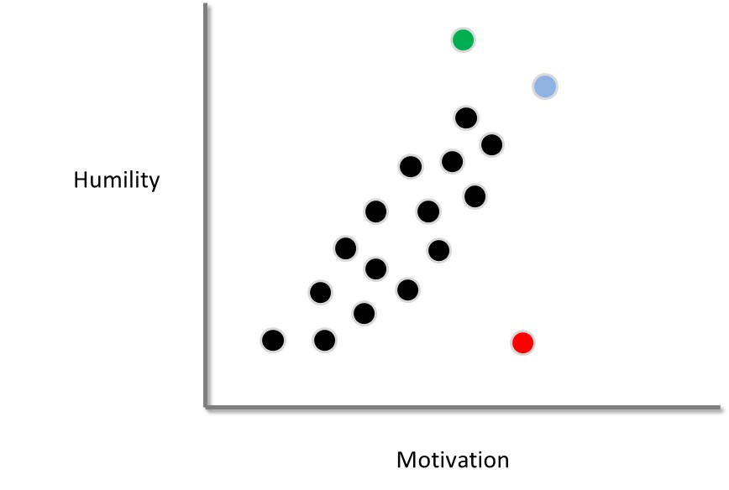

Causes or sources of outliers

Outliers can be ascribed to one of three causes:

- Outliers might represent errors—such as mistakes in data entry
- Outliers might indicate the person or unit does not belong to the population of interest. For example, the red dot might correspond to a school candidate, instead of a research candidate, who received this survey in error
- Outliers could be legitimate; in the population, some people are just quite distinct.

Effects of outliers

Outliers, even if legitimate rather than mistakes, can generate complications and should perhaps be omitted. In particular

- influential cases in particular reduce the reliability of findings; if this outlier had not been included, the results might have been very different
- when the data comprises outliers, the assumption of normality is typically violated; hence, the p values tend to be inaccurate
- outliers can increase the variability within group and, therefore, can sometimes diminish the likelihood of significant results

How to identify outliers

To identify errors in the data, you should first determine the frequency of each item or question. To illustrate

- the code “table(gender)” would generate the frequency—or number—of each category of gender
- this output can unearth errors
- for example, if the responses on some variable are supposed to range from 1 to 3, a 4 would indicate an error

To identify multivariate outliers, you could calculate a statistic called the Mahalanobis distance. To achieve this goal, you could modify the following code.

Code | Explanation or clarification
install.packages("dplyr") | - This package is often utilized to manipulate and transform data sets

library(dplyr)
MahDistance <- mahalanobis(Datafile[, c(2, 3, 5)], colMeans(Datafile [, c(2, 3, 5)]), cov(Datafile [, c(2, 3, 5)])) | - Change “Datafile” to the name of your data file  - (2, 3, 5) refers to the second, third, and fifth variable or column in your data file  - However, rather than merely include these variables or columns, choose all items that are numerical or dichotomous  - In addition, rather than utilize a number to specify the column, you could include actual names of variables or scales, such as humility, empathy, and motivation
MahDistance | - This code generates the Mahalanobis distance for each row or participant

To illustrate, the following table provides an extract of the output. In particular

- the first row of numbers specifies the Mahalanobis distances that correspond to participants 1 to 7 respectively
- the second row of numbers specifies the Mahalanobis distances that correspond to participants 8 to 14 respectively, as indicated by the number [8]
- to identify the highest five Mahalanobis distances, you could enter the code Mah[1:5]

[1] 2.393896 2.349020 3.028561 2.530915 2.960180 2.817262 1.973606
[8] 2.273630 2.500143 2.829827 1.905652 3.171735 2.190888 2.480056
[15] 2.583911 3.099079 2.100539 3.402522 5.334982 5.07359 3.243545

Very high numbers correspond to multivariate outliers. But, to decide whether a specific Mahalanobis distance is high enough to represent a multivariate outlier, what is the threshold you should apply? Which numbers are high? To answer this question

- open Microsoft Excel. Type "=CHIINV(0.01, 50)" in one of the cells--that is, type everything that appears within these quotation marks
- change 50 to the number of variables you included to calculate the Mahalanobis distance. This number corresponds to the degrees of freedom
- A value will then appear in the cell.
- Mahalanobis values that appreciably exceed this value are outliers at the p < .01 level.

These outliers should be excluded from subsequent analysis. For example, you could return to your original data file, delete the row, save the data file as another name, and then open the file again in R. Alternatively, you could modify this code

NewDataFile <- Datafile[-c(278),]

This code would generate another data file, called NewDataFile, after row or participant 278 had been excluded.

Influential cases

The Mahalanobis distances will signify multivariate outliers but not necessarily all influential cases. The method you should use to generate influential cases varies across techniques. That is

- for some techniques, influential cases are hard to identify
- for linear or multiple regression, influential cases are easy to identify
- to illustrate, you merely need to modify the following code.

Code | Explanation or clarification
RegressionModel1 = lm(Motivation~Empathy + Humility) | - Conducts a technique called a linear or multiple regression  - In this instance, the dependent variable is motivation and the independent variables are empathy and humility
cooks.distance(RegressionModel1) | - Generates the Cooks distance corresponding to each participant or row in the data file  - In particular, you will receive a list of numbers such as  1 2 3 4 5  0.011711 0.076 0.100 .06422 0.0005 1.197574

If a Cook’s distance exceeds 1, or is substantially higher than almost all the other Cook’s distances in the data file, the corresponding row or participant is an influential case. In this instance, the fifth participant or row is an influential case. You should repeat the analysis but after excluding this participant.

As the previous few paragraphs have shown, many researchers calculate an index called Cronbach’s alpha—an index that measures the degree to which the items are correlated, also called internal consistency. Nevertheless, many researchers have discussed the limitations of Cronbach’s alpha (e.g., McNeish, 2017; Wellman et al., 2020). Specifically, Cronbach’s alpha is perceived as a suitable measure of internal consistency only when the assumptions that appear in the following table are fulfilled.

Assumptions that underpin Cronbach’s alpha
All the items are related to the underlying characteristic—such as humility—to the same extent, sometimes called tau equivalence
The responses on each item are normally distributed; that is, if you constructed a graph that represents the frequency of each response, the graph would resemble a bell
The errors are uncorrelated across items; for example, if someone inadvertently underestimates themselves on one item, this person is not especially likely to commit the same error on the next item

If these assumptions are not fulfilled, Cronbach’s alpha tends to be inaccurate, especially if the number of items is fewer than ten. For example

- Cronbach’s alpha might be 0.58, indicating the items are not highly correlated with each other
- But actually, the items might be highly correlated with each other, suggesting the scale is suitable

Researchers have thus developed other indices that are not as sensitive to these assumptions. One of these indices, for example, is called Revelle’s omega total. To calculate this index in R, utilize something like the following code. You would merely need to

- replace “humility1, humility2, humility3r” with the name of your items
- replace humility.items with a more suitable name of your scale

install.packages("psych")
install.packages("GPArotation")
library(psych)
library(GPArotation)
humility.items<-subset(Datafile, select=c(humility1, humility2, humility3r))
omega(humility.items, poly=TRUE)

This simple code will generate a lot of output. A subset of this output appears in the following box. The key number will appear after “Omega Total”

…
Alpha: 0.9
G.6: 0.85
Omega Hierarchical: 0.04
Omega H asymptotic: 0.05
Omega Total 0.9
…

In this example, Revelle’s omega total is 0.9—the same as Cronbach’s alpha at the top. Often, however, Revelle’s omega total is higher than Cronbach’s alpha. To interpret this value

- utilize the same principles as you would apply to Cronbach’s alpha
- that is, if this value exceeds 0.7, the scale is regarded as internally consistent to an adequate degree.

References

Cortina, J. M. (1993). What is coefficient alpha? An examination of theory and applications. Journal of Applied Psychology, 78, 98-104.

McNeish, D. (2017). Thanks coefficient alpha, we’ll take it from here. Psychological Methods, 23, 412–433.

Nunnally, J. C. (1978). Psychometric theory (2nd edition). New York: McGraw-Hill.

Wellman, N., Applegate, J. M., Harlow, J., & Johnston, E. W. (2020). Beyond the pyramid: alternative formal hierarchical structures and team performance. Academy of Management Journal, 63(4), 997-1027.

