HOW TO USE R

by Simon Moss

Introduction

To conduct statistics, researchers utilize a variety of software packages, such as SPSS, STATA, and R. Unfortunately, many of these packages, such as SPSS and STATA are expensive and thus not used in all organizations. In contrast, R is free. Therefore, research candidates should become familiar with R—at least familiar enough to learn how to use this package if necessary in the future.
Initially, R might seem cumbersome to use. But, after a day or so of practice, these concerns will tend to evaporate.

Download R and R studio

You first need to

- Download R
- Download R studio—an interface that helps you use R

Download and install R

You can download and install R at no cost. To achieve this goal,

- proceed to https://cran.rstudio.com
- click the “Download R” option that is relevant to your computer—such as the Linus, Mac, or Windows version
- click the option that corresponds to the latest version, such as R 3.6.2.pkg.
- follow the instructions to install and execute R on your computer—as you would install and execute any other program.

Download and install R Studio

If you are unfamiliar with the software, R can be hard to navigate. To help you use R, many researchers utilize an interface called R studio as well. To download and install R studio

- proceed to https://www.rstudio.com
- click Download R studio
- under the heading “Installers for Supported Platforms”, click the RStudio option that corresponds to your computer, such as Windows or Mac
- follow the instructions to install and execute R on your computer—as you would install and execute any other program
- the app might appear in your start menu, applications folder, or other locations depending on your computer

Upload some data

To start, in Microsoft Excel, or some other spreadsheet, create a data file. The following screen illustrates an example. In this example, each column corresponds to a separate characteristic, such as the age, gender, and GPA of these individuals. The first row labels these characteristics. Every other row corresponds to a separate person. Include the symbol “NA” for missing data.

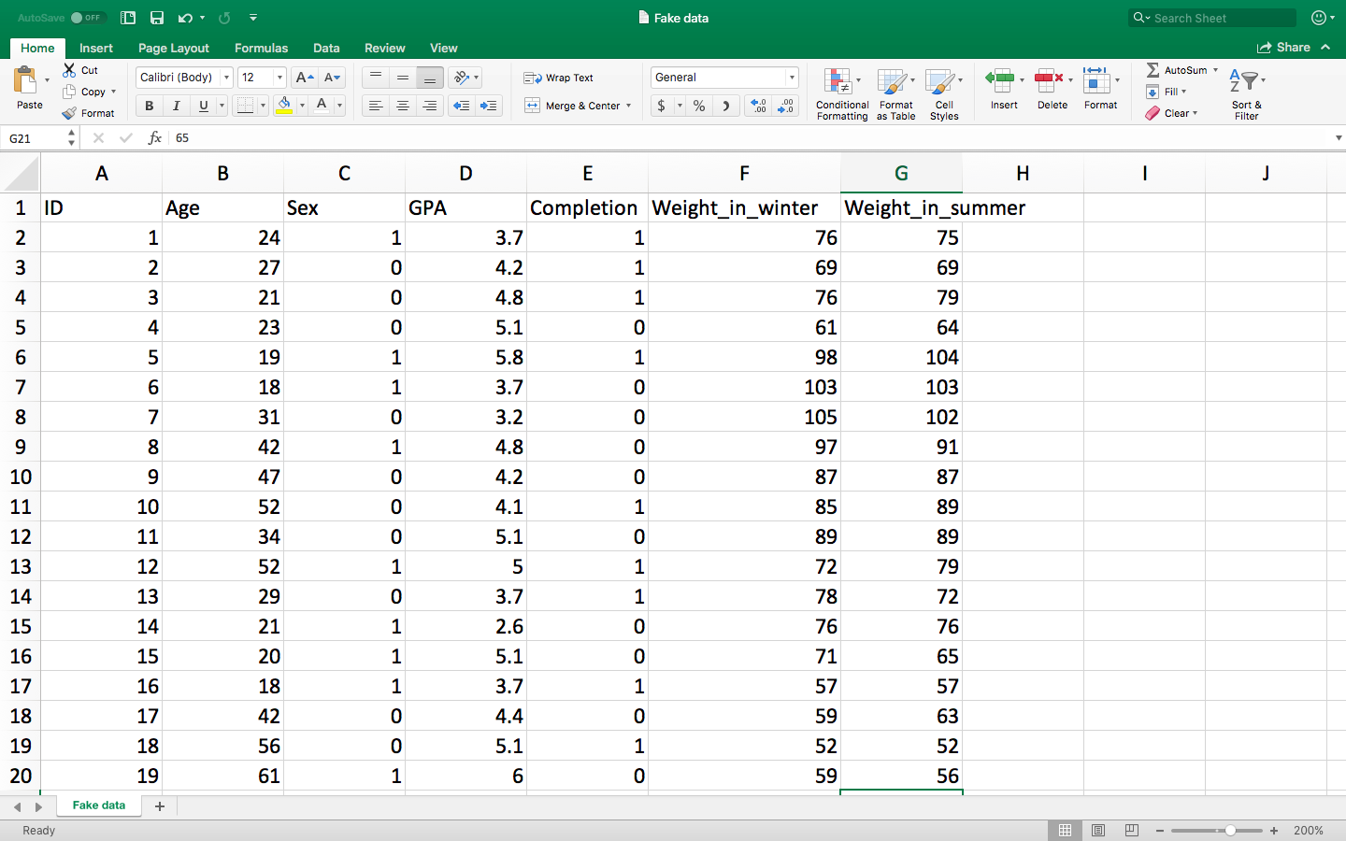

Unfortunately, you cannot directly open this file in R. Instead, you need to

- Save this data as a delimited txt file—or some other txt file.
- For example, in Excel, press “File” and “Save as”. Press the pair of arrows near the bottom right of the screen and choose tab delimited, before pressing “Save”
- Double click the R studio icon—an icon that should have appeared on your desktop after you downloaded this software, generating the following screen

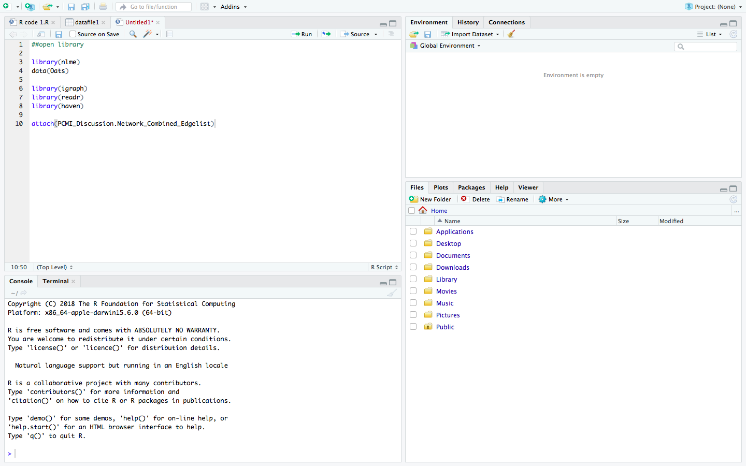

- In R studio, click “Import data set”—as highlighted by the arrow in the previous screen
- Then choose “From Text (base)”
- Next, locate and double click the text file you created earlier; alongside “Heading”, choose “Yes”. Press “Import” to generate the following screen

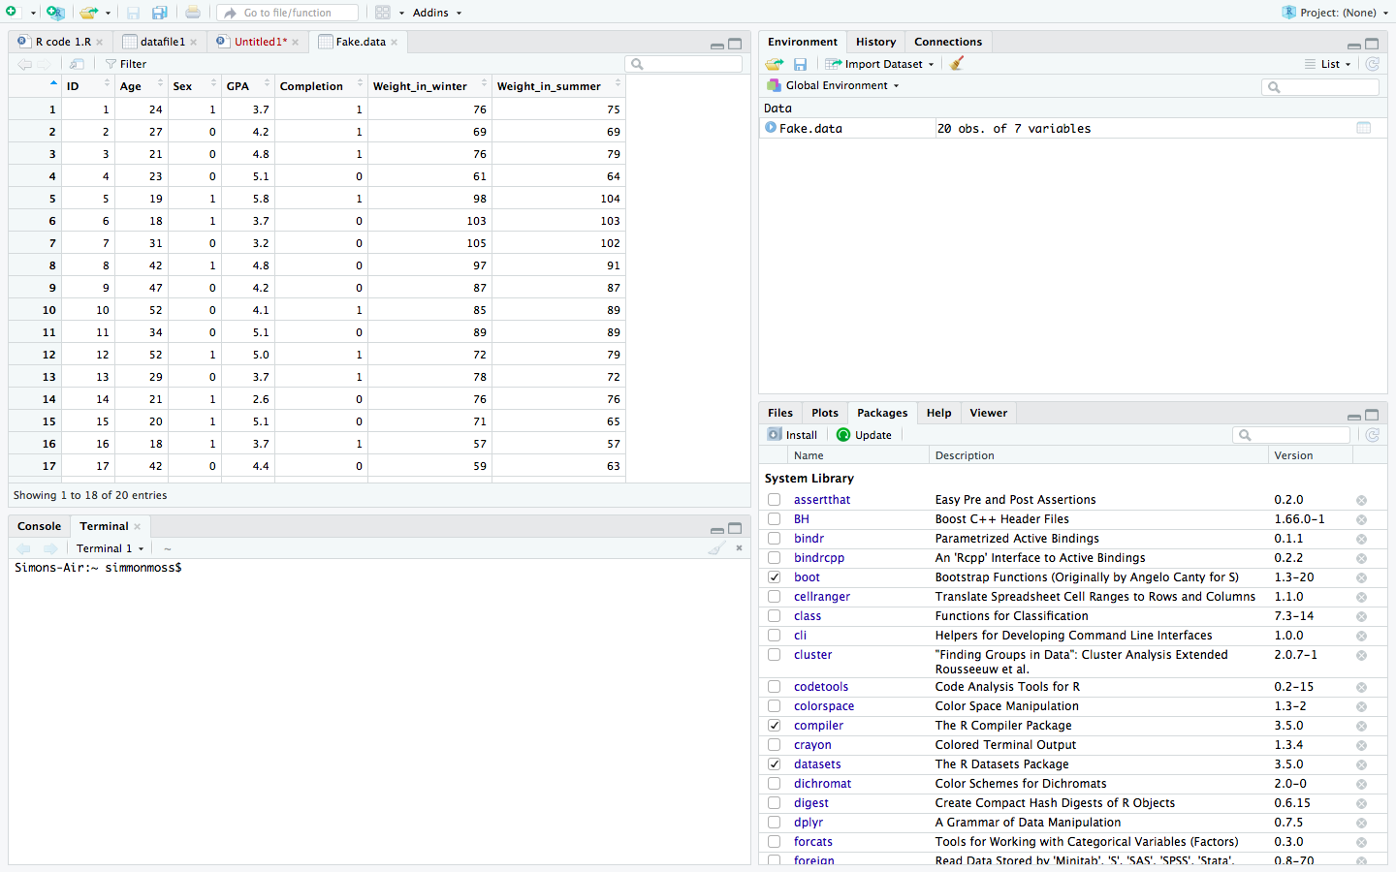

An extract of these data appear in one window. In this example, the tab is called “Fake.data”—the name of this file. You can also import Excel, SPSS, Stata, and SAS files as well. Nevertheless, in R, researchers often open several data files simultaneously. Therefore, you need to instruct R to utilize a specific data file. To achieve this goal,

- Insert the cursor towards the bottom left of this screen—in a window called Console.
- Console is the window in which you enter most of your commands or instructions
- In this instance, enter the phrase “attach(Fake.data)”. However, exclude the quotation marks and replace Fake with the name of your data

Practice some basic statistics

To familiarize yourself with R, you should enter a few commands or instructions in the Console window. The following table presents some examples. In particular

- the first column presents an example
- the second column indicates how you might need to modify this example to suit your data
- the third column explains the purpose of this command.

Example | Clarification | Purpose
summary(Fake.data) | Replace “Fake.data” with the name of your data file, such as “Data1” | - Generate summary statistics, such as the minimum, median, and mean of each variable or characteristic  - Remember the mean is merely the average
Sd(GPA) | Replace “GPA” with the name of another variable | - Computes the standard deviation of a variable  - A standard deviation is a measure of variability, roughly equal to the average extent that each number differs from the mean
Hist(Age) | Replace “Age” with the name of another variable | - Creates a histogram, as illustrated below  - This graph presents the frequency of various categories, such as people aged between 10 and 20
boxplot(GPA) | Replace “GPA” with the name of another variable | - Creates a boxplot, as illustrated below  - The lines represents the 0, 25, 50, 75, and 100 percentile  - A percentile is the percentage of individuals who generated a lower score
plot(Age, GPA) | Replace “Age” and “GPA” with the name of two other variables | - Create a scatterplot, as illustrated below  - Each circle corresponds to one person
t.test(data = Fake.data, GPA ~ Sex) | - The ~ sign is to the left of 1 on your keyboard  Replace  - “Fake.data” with the name of your data file  - “GPA” with your outcome measure  - “Sex” with your grouping variable—a variable that comprises two categories  Note that “data=Fake.data” is not needed if you have entered the “attach” function earlier and no other data is accessible | - Conducts an independent t-test  - In essence, if the p value is less than .05, you can be 95% certain the measure differs significantly between the two groups  - This command also generates the average for each group--in this instance, the average GPA for males and females.
t.test(Weight_in_winter, Weight_in_summer, paired = TRUE) | Replace  - “Weight_in_winter” and “Weight_in_summer” with two variables you want to compare | - Conducts a paired-samples t-tests  - In essence, if the p value is less than .05, you can be 95% certain the variables differ from each other  - This test is often used to compare scores before and after some intervention
cor.test(GPA, Age) | Replace  - “GPA” and “Age” with two of your variables | - Calculates a correlation coefficient—a number that appears under the label “cor”  - Correlations above 1 indicate that high values on one variable tend to coincide with higher values on the other variable  - Correlations below 1 indicate that high values on one variable tend to coincide with lower values on the other variable
summary(lm(GPA~ Age+Sex+Completion)) | Replace  - “GPA” with your criterion, outcome, or dependent variable  - “Age” with one of your predictors or independent variable  - This example includes three predictors: Age, Sex, and Completion  - But, your example might include fewer or more predictors. | - Conducts a linear regression analysis  - To interpret the output, scan the values that appear in a column called Pr(>|t|)  - If the one of these probability value is less than .05, the corresponding predictor is significantly related to the outcome measure after controlling the other predictors  - If the corresponding estimate is positive, this relationship is positive  - If the corresponding estimate is negative, this relationship is negative
anova(lm(GPA~Sex) | Replace  - “GPA” with your outcome measure  - “Sex” with your grouping variable—a variable that comprises two categories | - Conducts a one-way ANOVA  - If the Pr or probability value is less than .05, you can 95% certain the outcomes varies significantly across the groups.

In practice, you should probably learn more about how to conduct each technique. For example, you should learn how to test the assumptions as well.

Packages and libraries

Activating or loading packages

In practice, R is not one statistical tool but a collection of tools, called packages. Each package undertakes a subset of operations or techniques. To illustrate, in the bottom right window, click the “packages” tab. The following screen highlights this tab. This screen catalogues all the packages that you have downloaded. In particular

- the packages that are ticked have been activated—and can thus be utilized during this session
- the packages that are unticked have not been activated—and cannot be utilized during this session

For instance, in this example, readr has not been activated. To activate this package,

- Enter “library(readr)” in the console
- This command activates the package during this session. Alternatively, you can tick the package manually in the Packages tab
- The next time you use R you might need to activate or load this package again.

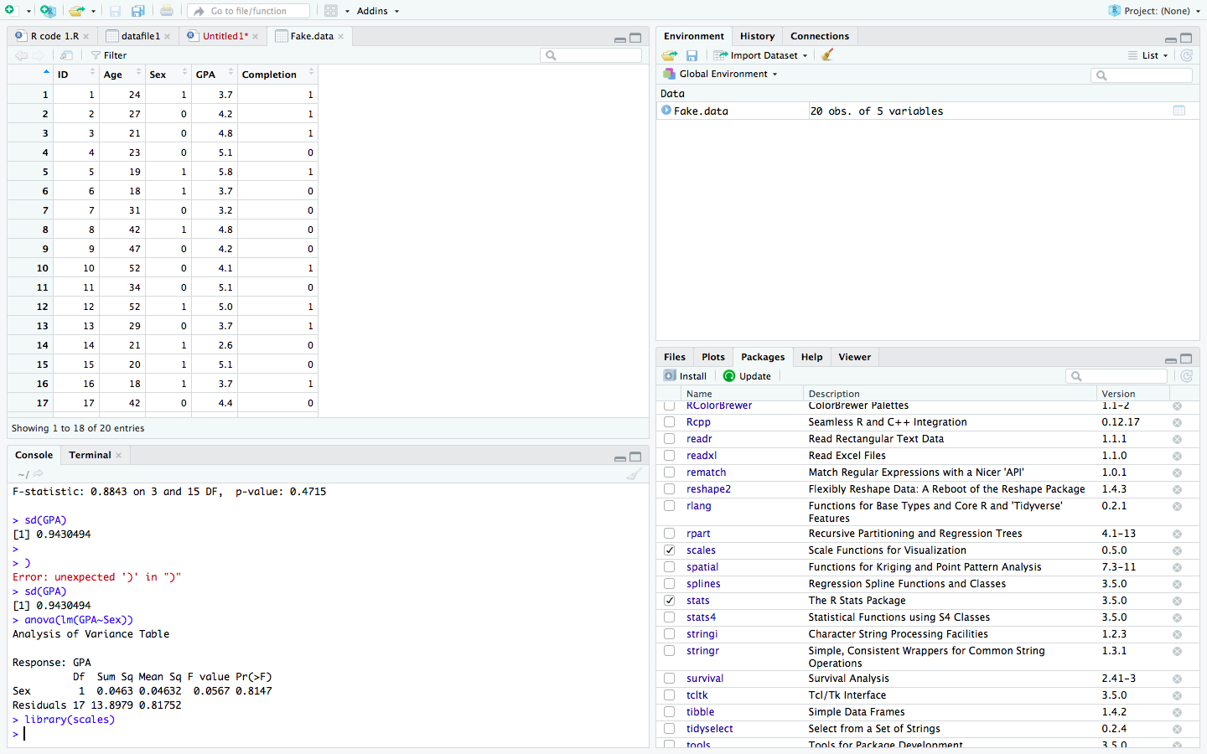

Installing packages

The library function activates only packages that you have downloaded. Sometimes, you might want to download other packages—such as packages that were created only days ago. To download most packages, such as a package called ggplot2,

- in the Console, enter “install.packages(gglplot2)”, but without the quotation marks
- then enter “library(gglplot2)” to activate or load this package.

This code is successful only if the package is stored in a specific repository called CRAN, the main repository of packages, and if you are connected to the internet. If the package is stored in another repository

- press “Install”—an option that appears under the “Packages” tab
- under “Install from” is usually the name of other repositories.

Learn how to manipulate data

Thus far, this document has demonstrated how you can

- upload data
- conduct some basic statistics
- install packages

The next phase is to learn how to modify and manipulate your data set. For example, sometimes you might want to

- delete some rows or participants
- correct a few errors
- transform variables, such as multiply a variable by 10
- extract a subset of columns or variables

Delete columns and rows

Sometimes, you need to delete rows and columns. For example

- if you discover that a participant did not complete a survey properly, you might delete the row in which the data of this person appears
- if you discover that one of the questions or measures was flawed, you might delete the column in which the data was stored.

To learn how to delete columns and rows

- first consider the following set of data again
- then read the following table

Example | Clarification
Fake.data.revised<-Fake.data[, -c(1, 3)] | - Generates a new data file called “Fake.data.revised”  - This data file is the same as Fake.data except Columns 1 and 3—in this instance, ID and Sex—has been removed  - If you then entered “Fake.data.revised”, R will produce the data set, but with ID and Sex missing
Fake.data.revised2<-Fake.data[-c(1, 3, 6), ] | - Generates a new data file called “Fake.data.revised2”  - This data file is the same as Fake.data except Rows 1, 3, and 6—in this instance, the first participant—has been removed  - If you then entered “Fake.data.revised2”, R will produce the data set, but with three participants omitted  Taken together, as these two examples imply  - c(1) before the comma represents Row 1 in the data file  - c(1) after the comma represents Column 1 in the data file
Fake.data.revised<-Fake.data[, -c(ID, Sex)] | - Rather than refer to a Column number, you can specify the Column label, such as ID.

Adding a column or row

Now suppose you want to add a column or row. For example, you might want to

- Add a column called ID, labelling each person or row 1, 2, 3, and so forth
- Add a row if you have collected data about another person, animal, and so forth

Each row or column of data, such as 1, 2, 3, 4, 5 or 3.2, 4.3, 5.8, is called a vector. To add a column or row to your data file, you need to learn how to create vectors and then append vectors to the existing data set. The following table will help you achieve this goal.

Example | Clarification
Create a vector
IDvector=c(1, 2, 3, 4, 5, 6, 7, 8, 9, 10) | - This code creates a vector comprising 10 numbers  - This vector if you want to create an ID column, and your data set comprises 10 rows or participants
IDvector=c(1:10) | - 1:10 implies 1 to 10  - Hence, this code also creates a vector comprising 10 numbers, but more efficiently
IDvector=seq(1, 10 by 1) | - This code also creates a vector comprising 10 numbers efficiently  - In particular, this code will generate a sequence from 1 to 10 in intervals of 1
table(IDvector) | - counts the number or frequency of each value in this vector  - for example, in the vector (1, 1, 3, 3, 3, 3), the table would indicate that 1 appears twice and 3 appears four times
Adding columns
Data.file$ID<-IDvector | - Replace “Data.file” with the name of your data file  - This code adds the column called “IDvector” to the data file called “Data.file”  - In addition, this code labels the column or variable “ID”
Check the data file
head(Data.file) | - This code enables you to observe the first few rows of your amended data file—primarily to assess whether you added the additional column correctly
ls(Data.file) | - This code lists all the variable names in your dataset
nrow(Data.file) | - Specifies the number of rows—often the number of participants, animals, or units—in your data file
ncol(Data.file) | - Specifies the number of columns—often the number of questions, items, or variables—in your data file
Adding rows
Newperson<-c(1, 4, 2, 5, 1) | - Creates a vector—a vector that will later be used as a row, corresponding to a new person or animal
UpdatedData2<-rbind(OriginalData.Newperson) | - Adds a new row—represented by the vector Newperson to a data file called “OriginalData”  - The updated data file is called “UpdatedData2”  One complication is you must ensure the type of data—such as numbers versus strings—is the same in both the original data and the added vectors

Correcting your data

Sometimes, you might want to change some of the data in your data file. For example, you might realize that you have entered some data incorrectly. The following table will help you achieve this goal.

Example | Clarification
ID[4]<-4 | - To illustrate, suppose the fourth value in the column ID was 3 but should be 4  - This code assigns the fourth value in this column a 4  - You can check the effect by simply entering “ID”
ID[3:100]<-3 | - This code assigns many values in ID, from the third to the one hundredth, a 3.  - So, the column or vector might now be something like 1, 2, 3, 3, 3, 3, 3, 3, 3, 3…
ID[c(2,4)]<-2.4 | - This code assigns the second and fourth values of ID a 2.4
ID[-c(2,4)]<-1.4 | - This code assigns every value, except the second and fourth values, of ID a 1.4
Age[Age>50]<-50 | - This code assigns all ages that are greater than 50 the value 50.
Age[Age>50]<- 'Old ' | - This code assigns all ages that are greater than 50 the label “Old”
Age[Age==50]<- 'On the cusp ' | - This code assigns all ages that are equal to 50 the label “On the cusp”

Creating data

In the previous examples, we uploaded data from Excel and then added columns, called vectors. Alternatively, we can also construct data files within R. That is, we can create a data file, called a data frame, by combining distinct vectors or columns.

Example | Clarification
Create a data frame
V1 <- c(“Ann”, “Jo”, Ken”, “Don”)  V2 <- c(25, 42, 19, 40)  V3 <-c(“F”, “F”, “M”, “M”)  DataSample <- data.frame(V1, V2, V3) | - The first three rows of code generate three vectors or columns.  - The first column is a list of names; the second column is a list of ages; the third column specifies the gender  - The final row of code integrates these three columns in one data file, called DataSample, using the command “data.frame”
names(DataSample)<-c(“Name”, “Age”, “Gender”) | - Assigns a label or name to each column  - Replace “DataSample” with the name of your data file  - Replace “Name”, “Age”, “Gender” with the names of your columns or variables
summary(DataSample) | - Generates some descriptive statistics about this data file
str(DataSample) | - Also generates information the data file; the “str” is an abbreviation of “structure”
Transpose the data
DataSampleTrans=setNames(data.frame(t(DataSample [,-1])), DataSample [,1]) | - This code transposes the data—so the rows become columns, and the columns become rows  - Replace “DataSampleTrans” with the name you want to called the transposed data file  - Replace “DataSample” with the data file you want to transpose

Merging data files

Sometimes, you might want to merge two data files. To illustrate, consider the following two data files.

Data file 1 |  |  |  | Data file 2
Name | Age | Height |  | Name2 | Gender | Weight
Adam  Betty  Carl  Donna  Enid | 25  62  42  37  51 | 165  168  173  167  153 |  | Adam  Betty  Donna  Carl | M  F  F  M | 85  72  67  92

We might want to merge these files to generate the following data set. As this example shows

- This procedure utilizes the “Name” and “Name2” columns to identify the rows in Data file 1 correspond to the rows in Data file 2
- This procedure deletes Enid—because Enid appears only in one of the data files
- To merge these files, you would use the command “CombinedDataFile<-merge(Datafile1, Datafile2, by.x=”Name”, by.y=”Name2”)
- But, you might change the name of the data files as well as which columns were used to identify which rows correspond to each other

Combined Data File
Name | Age | Height | Gender | Weight
Adam  Betty  Carl  Donna | 25  62  42  37 | 165  168  173  167 | M  F  M  F | 85  72  92  67

Imagine that two of the individuals in your data file were called “Adam”. In this instance,

- you might need to utilize another variable as well to ascertain the rows in one data file that correspond to the rows in another data file.
- you would adjust the command by.x=”Name” to by.x = “Name, Age” for example

