IN WHICH JOURNAL SHOULD I PUBLISH

by Simon Moss

Introduction

Either during or after your course, you are likely to submit one or more papers to a journal. To choose the right journal, you should

- Identify 4 to 10 journals in which your research is likely to be relevant
- Omit journals that are predatory or vanity publishers
- Omit journals in which your paper does not conform to the instructions
- Submit in order of quality

1 Identify 4 to 10 journals in which your research is likely to be relevant

Initially, you should identify a preliminary set of journals you might consider. To achieve this goal, you can obviously seek advice from supervisors or peers. In addition, you can skim your reference list to identify journals that you cited.
More interestingly, you can utilze programs, such as the Elsevier Journal Finder, to identify possible journals. In particular

- Proceed to https://journalfinder.elsevier.com.
- Simply copy your title and abstract in relevant spaces. You can also indicate the relevant field, such as social sciences or life and health sciences
- Print or copy the results of this search
- An exmaple of the output appears below

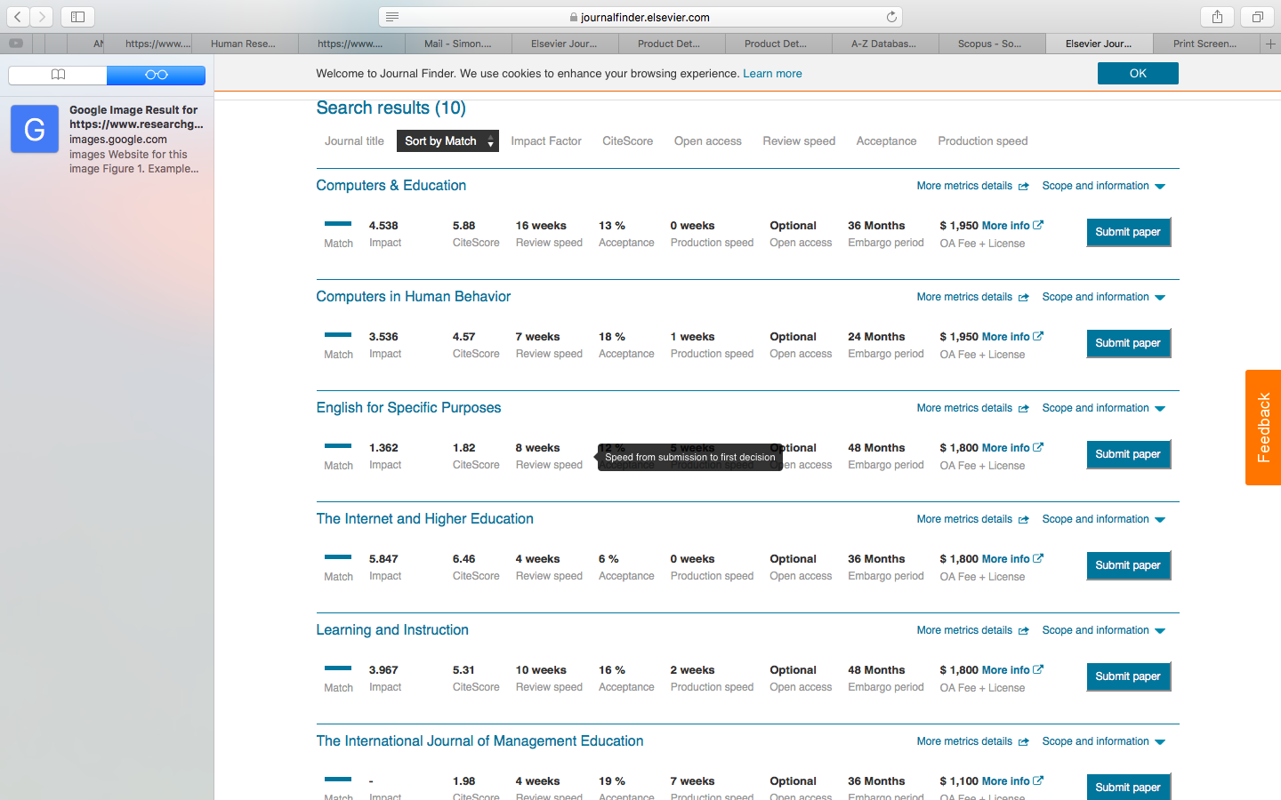

2 Omit journals that are predatory or vanity publications

The previous phase is likely to uncover reputable journals. Nevertheless, if you are not familiar with these journals, you should assess whether they are vanity and predatory publications. In particular

- Vanity publications charge authors to publish their paper or book—but without the provision of editorial or publishing services. In contrast, legitimate journals either do not charge authors or charge authors in accord with the services they offer, such as open access or colored figures.
- Predatory publications are similar, but often charge to enable authors to publish open access—that is, so anyone can read the publication at no cost.

The problem, however, is that vanity and predatory publications do not actually peer-review the paper—although they might assert and pretend otherwise. Consequently, these publications are not perceived as legitimate. Therefore, you should

- Visit https://beallslist.weebly.com/standalone-journals.html. Journals that appear in this list are predatory and should be discarded
- Avoid journals or books published by LAPLambert, VDM, or Nova Science. These publishers often publish work that is not peer-reviewed.

In addition, you can assess whether or not the journal is recognized by ERA or Excellence in Research for Australia. Journals that are recognized by ERA will not be vanity publications, predatory publications, or disreputed publications. To achieve this goal,

- Visit http://lamp.infosys.deakin.edu.au/era/?page=jnamesel15
- Enter the journal name in the leftmost box and press Search

3 Omit journals in which your paper does not fulfill the criterion for submission

After completing the previous phase, you might have identified three to ten journals to which you could submit. On the website of each journal are instructions that specify the criteria that submissions must fulfill. To assess whether your paper fulfills these criteria

- Google, and then visit the website, of each journal
- If possible, locate a link to “Instructions for authors”, “author guidelines”, “submission guidelines”, or something similar

If you are too busy to read all the instructions, focus your attention on

- Whether your paper matches the aims or scope of this journal.
- The minimum and maximum length of papers
- Whether the editors prefer empirical papers, systematic reviews, or other kinds of papers
- Whether the editors prefer quantitative papers, qualitative papers, or both
- Which disciplines the editors prefer
- The costs to authors if the paper is accepted

If you are not sure whether your paper fulfills these criteria, you could email the editor. A sample email appears below

Dear Professor Smith

I would like to submit a paper, entitled “Animals and academics”, to the Journal of Zoos. This paper outlines an observation study on the similarities between animals and academics. We applied a blend of thematic analysis and word count methods to analyze the data.

However, we are not certain whether this topic is germane to this journal. In addition, the paper is two pages longer than is the recommended maximum. Would you be able to advise us on you believe we should this manuscript to this journal

Yours sincerely

Matt Matts

4 Omit journals that do not permit you to include your article in your thesis

If you want to include this article in your thesis—often called thesis by publication—you should check the restrictions this journal imposes on authors. The vast majority of reputable journals will permit you to include this article in your thesis. Nevetheless, to check

- on the webpages of most journals is a link to a copyright, author, or contributor agreement.
- if you can locate this agreement, check whether the publisher has explicitly permitted authors to use their work in theses or dissertations
- if unsure, in the contacts list, identify the most suitable person to contact, and write the following

Subject: Clarifying whether I am permitted to include my work in a thesis by publication

Dear …

I am completing a PhD at Charles Darwin University. I am planning to submit a manuscript entitled “….” to your journal. I am enquiring as to whether I can include this paper, for an indefinite period, in an electronic version of my thesis—a thesis that would be stored in an open access digital archive at my university.

Kind Regards

…

If you later discover that you are not permitted to include work you have already published in your thesis, seek an exception. That is, in the contacts list, identify the most suitable person to contact, and write the following:

Subject: Seeking permission to include my work in a thesis by publication

Dear …

I am completing a PhD at Charles Darwin University. My research thesis includes the paper entitled “….” that was published in this journal. I am enquiring as to whether I can include this paper, for an indefinite period, in an electronic version of my thesis—a thesis that would be stored in an open access digital archive at my university.

Otherwise, I would like to seek from you a limited, non-exclusive license, to include this work in an electronic version of my thesis. If you agree to this license, could you notify me in writing

Kind Regards

…

5 Omit journals that you cannot afford

Some prestigious journals are open access. That is, people can access the papers without needing to subscribe or paper. The benefit is that more people will read, and ultimately cite, these papers. The drawback is that, to publish in the journal, authors must pay a fee—a fee that can exceed $2000. To pay this fee, you could

- use your own money; thus option is seldom necessary
- use your research allocation; although you might want to reserve this money to purchase services or products that are vital to your research
- ask your college to pay this fee; the college may pay in particular circumstances

University support

Fortunately, in specific circumstances, Charles Darwin University will pay up to $2500 US if you publish in a prestigious journal. Specifically, you need to publish what are called Q1 journals. To ascertain whether or not a journal if Q1

- proceed to https://www.scimagojr.com
- enter the name of this journal in the search box
- if several options appear, click the relevant journal
- in the output, scroll down to locate a display called “Quartiles”.
- the green colour indicates Q1
- if the journal if Q1, contact a research administrator or research academic in your college—such as a HDR convenor or Assistant Dean of Research—to request this payment.

6 Rank the possible journals from most appropriate to least appropriate

After completing the previous phase, you might have identified two to five journals to which you could submit. Your final task is to rank these journals from most appropriate to least appropriate. To complete this task, perhaps rate each journal on three attributes: impact factor, acceptance rate, and relevance. The following table presents an example. To gauge impact factor—the average number of times each paper is cited every year

- Google the website of this journal; or you may have uncovered this information from the Elsevier Journal Finder
- Alternatively, you can utilize other measures of quality or citation rate.
- For example, access Scopus—available from the CDU library databases or http://libguides.cdu.edu.au/az.php. Choose “Sources” at the top , click the orange box to choose “Title”, and then enter a journal in the adjacent box.
- This procedure will generate a series of indices—such as CiteScore.
- CiteScore, when divided by 3, is comparable to impact factors.

To gauge the acceptance rate
- Google the name of this journal and “acceptance rate”
- Or you may have already uncovered this information from the Elsevier Journal Finder
- You could also email the editor to seek this information
- Alternatively, assume the acceptance rate is around 15%, unless other people indicate the acceptance rate is higher or lower than average.

Next on a scale from 1 to 5, estimate the relevance of this journal. Finally, sum the columns to generate a total score for each journal.

Journal | Impact factor or similar | Acceptance rate | Relevance to topic | Total
 | 1: 0 to 1  2: 1 to 2  3: 2 to 3  4: 3 to 4  5: 4 + | 1: 0 to 5%  2: 5 to 10%  3: 10 to 20%  4: 20 to 30%  5: 30+ | 1 Very broad scope  5: Topic specific to paper
Computers and Education | 5 | 2 | 5 | 12
Learning and Instruction | 4 | 2 | 5 | 11
Computers in Human Behavior | 4 | 2 | 3 | 9
Journal of School Psychology | 3 | 2 | 1 | 6

Submit the paper

You should usually

- Submit the paper to the journal that receives the highest total
- If this journal rejects the paper, attempt the next journal, and so forth

