INSIGHTS ON HOW TO WRITE GRANT APPLICATIONS

by Simon Moss

Introduction

To thrive in academia—and indeed in many fields in which you need to attract funds—you need to learn how to write grant applications successfully. Admittedly, most of the skills you learn while completing a research degree are relevant to this pursuit. For example, you are more likely to attract funding if

- you write effectively
- you know how to write a compelling research proposal
- your knowledge of research methods is extensive

Information about these topics is available on the CDU website. Nevertheless, besides these fundamental skills, you also need to learn about the activities and qualities that are specifically germane to grant applications. This document outlines some of these activities and qualities.

How to apply this document

If you are planning to submit a grant application in the next year or two, you should begin this procedure as soon as possible. In particular

- gradually complete the activities recommended in this document
- until a specific opportunity transpires, dedicate about 2 to 3 hours a week to these activities
- if a specific opportunity transpires, divide 120 by the number of weeks before the due date. The answer is a very rough estimate of the number of hours a week you should dedicate to these activities.

How to seek funding opportunities

To secure funding, medical researchers often devote their attention to NHMRC grants and other researchers often devote their attention to ARC grants (see Appendix A1). Nevertheless, researchers tend to secure NHMRC grants and ARC grants only after they have secured other grants in the past. Therefore, to secure funding, you need to know how to identify which funding bodies are relevant to your research. Several avenues are available to uncover these alternatives.

Research Professional

All staff—as well as research candidates with staff accounts—can utilize a database called Research Professional to uncover funding opportunities. To utilize this program

- google “Research Professional Log in” and open the webpage
- if working on campus, you may be able to register using your @cdu.edu.au or @menzies.edu.au email account. Your username is your email
- if not, email RGBD@cdu.edu.au and indicate that you would like to access Research Professional but cannot register.
- you can also access “Research Professional” as a guest but then you cannot save your work
- after you log in, the following screen should appear

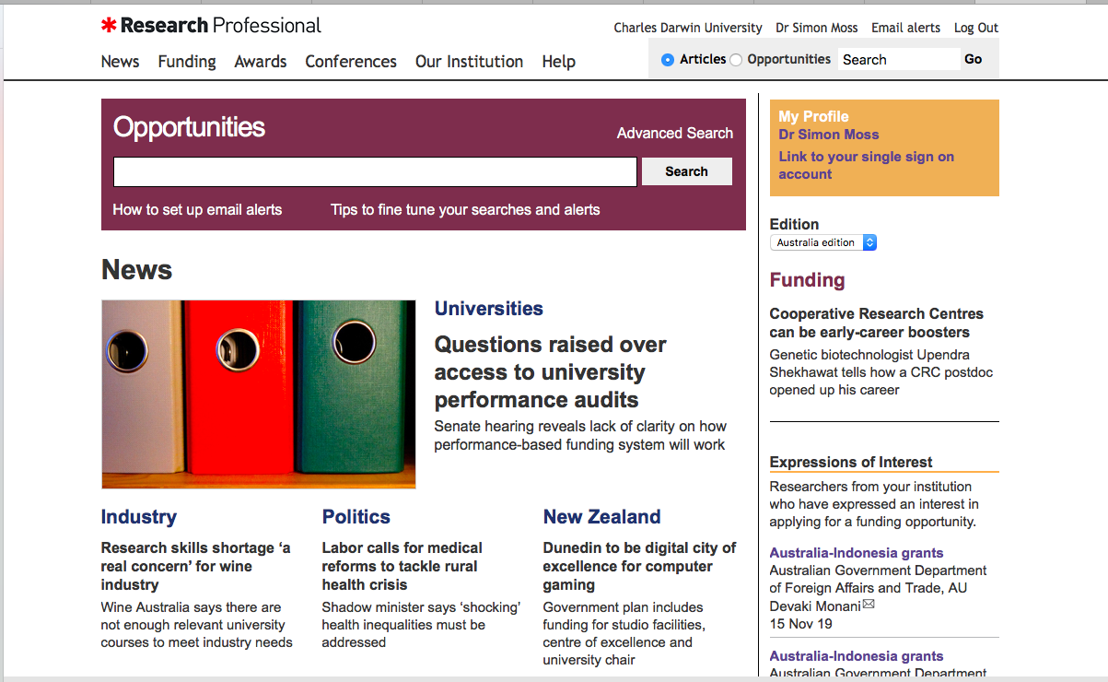

Once this screen appears

- choose the “Funding” tab on the top.
- in the Search box under “Opportunities”, enter the relevant field, such as “Psychology”, and click “Search”
- these actions will uncover a series of funding opportunities

If you press “Advanced Search” instead, you can limit the outcomes to

- specific types, such as “Early career fellowships” or “Financial aid to postgraduate students”
- specific disciplines
- specific nations—such as only Australian funding bodies.

This platform is simple to use. Nevertheless, if you need more information, Google “Research Professional User Guide”.

Assemble the team

Who are the investigators?

In most circumstances, the likelihood you will receive a grant depends on the profile and experience of the investigators in your team. Unless specified otherwise, to secure grants and to work effectively, teams should usually comprise three to six individuals—although this number might vary across disciplines and circumstances. The first column of the following table specifies the criteria that a suitable team would fulfil. To assemble a suitable team

- in the second column, indicate whether the criteria is relevant or not to your circumstances.
- some criteria might not be relevant to particular research ideologies or grants and could thus be modified or omitted
- in the third column, indicate which of these criteria you fulfill
- in the fourth column, identify one to three potential collaborators who fulfill some of the criteria that you do not satisfy

Criteria | Relevance to your grant | Do you fulfil this criterion? | Potential collaborators
Track record
During their research career, published at least 50 papers or books in this broad field
During the last five years, published at least 20 papers or books in this broad field
During the last five years, published at least 5 papers in this field in Q1 journals or equivalent
Published at least 3 papers or books that could be cited and regarded as precursors of this application
During the last five years, received a grant on a similar project
Expertise
Demonstrated expertise in the methods that will be applied to collect the data
Demonstrated expertise in the methods that will be applied to analyse the data
Has accrued significant experience in the setting in which the research will be conducted—such as a particular industry or community

Use this table to identify 3 to 6 collaborators—that is, 3 to 6 people, including yourself, who fulfil as many of these criteria as possible. Nevertheless, omit collaborators who are obviously too busy to dedicate time—such as half a day a week—to this project.

How to improve the credibility of these investigators?

This team of investigators need to be perceived as suitable—as sufficiently experienced, successful, and productive. Therefore, in the year or two before submitting a major grant application, the investigators need to optimize their profile and credibility. Specifically, besides merely extending the number and quality of publications or grants, these researchers may

- become a member of a relevant board, association, or peak body
- identify other international research teams they could join
- seek opportunities to evaluate other grants—such as ARC applications
- read and apply the document on how to attract more citations, available in the section on “Publications, communication, and networking” on the CDU website

Activities to complete before constructing a grant application

On most competitive grants, between 5% to 30% of applicants are successful. To outperform rivals, you should, in general, complete various activities before you start to write your grant application. After you complete these activities, your application will be more compelling. The following table outlines some of the activities you could initiate. Which activities you initiative, however, depends on your preferences, discipline, experience, and other considerations.

Activity | Details and justifications
Whenever possible, conduct one or more preliminary studies | - This preliminary study could be an inexpensive version of the actual project you would to conduct—such as the first wave of a longitudinal study  - This preliminary study could comprise a series of interviews or focus groups with relevant stakeholders, designed to clarify the magnitude or features of the problem you want to solve  - These studies could be used to justify various features of your research proposal—such as the sample size, measures, or significance of this project
If possible, conduct a systematic literature review or equivalent
Publish at least one of these preliminary studies or literature reviews with all the collaborators | - Funding bodies often like evidence to indicate the investigators can work together. That is, the team should seem both diverse, but cohesive, to reviewers  - If possible, publish a refereed journal article  - If you cannot publish a refereed journal article on time, post a report on a website or some other forum that accepts publications swiftly; you can then refer to this report in your grant application
Contact your media office to attract media interest in these preliminary studies or reviews | - You can refer to this media attention—such as radio interviews—in your application when justifying the significance of this work.
If possible, as a team, secure a small grant before you apply to receive a larger grant | - You might secure funds from your college or university
Develop a short video that outlines the proposed research project. These videos can be used to attract interest from stakeholders, such as members of a crowdfunding platform | - Read the document on “Visualize your thesis”, available in the section on “Confirmation of candidature, progress, and competitions” on the CDU website
Attempt to secure small amounts of money from crowdfunding—using Kickstarter, USEED, Consano, MedStartr, Experiment.com, or similar websites. Alternatively, garner insights from the public, sometimes called citizen science. | - Kickstarter is more suitable when the results could generate some benefit to the donor  - Interestingly, inexperienced researchers often attract more funding than experienced researchers from crowdfunding websites.  - You might also secure knowledge and insights from other crowd platforms, as discussed in “Crowd source user contribution patterns and their implications”
Sign memoranda of understandings or MOUs with relevant stakeholders | - MOUs can be utilized to demonstrate the interest of relevant partners  - You might sign MOUs with organizations that might want to offer participants, expertise, equipment, data, or other resources

Information to collect

To help you write your grant applications efficiently, you should first answer a series of questions as comprehensively as possible, such as “What are the unique features of your approach?” The first column in the following table outlines these questions Once you have answered these questions, the grant application should be straightforward to write. Specifically

- skim the first column
- in the second column, indicate whether this question is relevant to your circumstances.
- in the third column, answer the relevant questions as comprehensively as possible. This column presents some extracts of sample answers.

Question | Is this question relevant to you? | Sample answers
Significance and innovation
What is the problem in society you would like to solve? |  | This project is designed to diminish the elevated levels of anxiety and depression in PhD candidates.  In addition, this project assesses whether these elevated levels can be ascribed to pre-existing characteristics or uncertainty about the future.
What is the evidence this problem is very consequential? Besides exceptional circumstances, such as some arts projects, if the problem is not consequential, the project will not attract funding |  | According to recent studies, the incidence of anxiety and depression is twice as high in PhD students than other individuals of the same age.
What is the approach you will apply to solve this problem—such as the methodology, methods, or interventions you will apply. |  | Participants will complete an intervention in which they experience 10 possible jobs they could attempt in the future. For the 3 to 5 jobs they most enjoy, they receive a handbook that clarifies how they could pursue these jobs in the future. Their certainty about the future and mood is assessed at several times during and after this intervention.
What is unique about this approach? That is, why might this approach, but not previous approaches, solve this problem or controversy? |  | Past research has not explored the benefits of this intervention over time. This intervention is the only program that enhances the clarity and certainty of future goals simultaneously
Can this approach be extended to other settings or problems? That is, is this approach scalable? |  | In the future, this intervention could be adapted to assist students in their final year at school as well as dissatisfied employees at any age
How will the results of this study be translated to practice? How will the results be communicated—besides journal articles? Who will benefit from this study—either directly or indirectly? |  | If successful, we plan to develop a video and handbook that universities can utilize to apply this intervention as efficiently as possible
Review of the literature
What are the main theories or frameworks that have been applied to explore this problem or controversy in the past |  | Several theories have been applied to explain the elevated levels of anxiety and distress in PhD candidates  - Individuals who seek certainty are susceptible to anxiety but also like to study  - The relevant job opportunities after completing a PhD are uncertain  - PhD candidates do not feel they belong to the main communities, such as students or staff  - Authorities tend to shift the attention of candidates to their shortfalls instead of their strengths
What is the evidence that supports or refutes the various theories? |  | Table 1 outlines the main evidence that is consistent or inconsistent with the various arguments…
Have past researchers suggested this problem needs to be addressed |  | Many researchers, including Smith (2010), Brown (2015), and Jones (2018), have bemoaned the dearth of interventions that are specifically directed to the mental health of PhD candidates
In addition to the methods you have chosen, what are some other common methods you could, in principle, apply to fulfil the aim of this project? |  | Table 2 outlines various methods that could be applied to assess the anxiety and depression of individuals.
What is the evidence that supports or refutes the various methodologies or methods? |  | Table 3 summarizes the benefits and drawbacks of each approach
Given these considerations, which methodologies and methods are you likely to apply |  | The DASS will be administered to gauge anxiety and depression in the participants
Has a significant portion of the literature you collated been published recently—in the last five years and even in the last year? That is, does the research problem seem topical? If not, collect more recent literature |  | Over 40% of the cited articles have been published in the last 5 years
Feasibility
Why is your team in a better position than other researchers to conduct this study? You might, for example, refer to the insights and experience you accrued when conducting the pilot studies |  | One of the investigators was a co-founder of the intervention.
What is the evidence the methods are feasible within the timeframe? |  | This intervention was piloted last year with a sample of 20 PhD candidates; 90% of these individuals completed all phases of the intervention
How many participants, animals, specimens, and so forth will you need to recruit? How do you justify this number |  | Assuming that α = .05, β = .20, and d = 0.8, power analyses indicate that 200 participants will need to be recruited in Study 1.
What is the evidence the necessary participants, animals, specimens, and so forth can be recruited or accessed? |  | Three universities have signed MOUs, indicating they would like to apply this intervention to their PhD candidates and perhaps their Masters by Research candidates as well
What is the evidence that hypotheses, if specified, will be supported? |  | After the pilot study, the mood of participants improved by 20%
What procedures will you apply to manage the project effectively |  | To manage this project, a steering committee will be assembled every two months to monitor progress. In addition, a research administrator will be employed at 0.4 to manage the project.
Validity
If qualitative, which epistemology, paradigm, methodology and methods will you apply and why? |  | NA
If quantitative, which research design will you utilize? What are the limitations of this design?  To answer this question, perhaps read the document called “Which quantitative research design should I use”, available on the CDU website in the section called “Choosing your research methodology and methods? |  | A quasi-experimental design will be utilised. The limitation is that  - the direction of causality could be the opposite to what is theorized  - a third variable could generate a spurious relationship between the variables
Which measures will you introduce to counteract these limitations? |  | A longitudinal study will be conducted to ascertain the direction of causality.  To preclude spurious relationships, several control variables will be included such as age, gender, marital status, income, and personality
Ethics and safety
What are the physical, social, psychological, ethical or legal risks that need to be addressed? How will you address these risks? |  | In this study, individuals answer questions about their wellbeing—questions that could elicit stress. However, research indicates that such questions tend to normalise, and thus diminish, anxiety and depression.
Budget
What is the budget you might need to allocate to equipment, consumables, software, licences, travel, course, research assistants, PhD candidates, and other expenses?

Read the document on how “How to prepare a budget”, available in the section called “Scholarships and budgets” on the CDU website
Can you justify the importance of these expenses?
What resources will your university provide to facilitate you on this project? Reviewers prefer applications in which the university has offered some funding, equipment, or other resources

How to complete the application

To write the application efficiently, you can often utilise many of the answers to the previous questions. In addition, you need to learn how to write

- a compelling research proposal.
- a compelling abstract

To learn about these topics, read the documents on how to write research proposals and abstracts, available in the section on “Confirmation of candidature, progress, and competitions”, on the CDU website. However, because grant applications diverge from research proposals, you also need to learn some additional skills.

Read

First, you obviously need to read a few past applications as well as the instructions as carefully as possible. In particular

- the instructions may be updated occasionally; therefore, visit the website a few times to access the latest instructions
- if any of the instructions are ambiguous, email the relevant contact
- clarify which items the funding body is willing to support; for example, many bodies are not willing to dedicate funds to equipment
- check the eligibility criteria
- check the number of pages or words permitted for each question

Complications

Second, when constructing a grant application, the following table outlines some of the subtleties you should consider.

Subtlety to consider | Details and justifications
If you are posing hypotheses, you need to navigate the tension between confidence and redundancy | - To show the research is likely to be productive, you need to demonstrate the hypotheses are likely to be supported  - You might, for example, refer to pilot studies or past research  - But, if the hypotheses seem too convincing, the research may be perceived as unnecessary  - Therefore, you first need to show why the hypotheses are likely to be supported—but then offer some modest reasons why these results are not inevitable  - That is, you could demonstrate how previous results could be ascribed to an alternative explanation—and highlight how your research project will thus ascertain which explanation is correct  - Or you could demonstrate how previous results might not generalize to a broader range of circumstances or settings.
Although you want to show the broad range of benefits your project could generate, these benefits should primarily centre on the interests of this funder. | - To illustrate, suppose the funding body supports research on autism  - But suppose your research could benefit individuals with a range of disorders  - You could mention the range of disorders this project might benefit, but confine most of the attention to autism.
Do not complicate the proposal. The project should revolve around one key problem and one to three unique features. | - In the application, explicitly show how each method or study is related to the specific aims or hypotheses; often the study seems disjointed from the aims
Discuss the limitations of your design or methods honestly | - Do not pretend the research is flawless  - Instead, demonstrate how you plan to mitigate the effects of limitations  - If you do not concede your limitations, the reviewers tend to attach more weight to the limitations they uncovered themselves

How to collect information about your track record

When you apply to seek grants, one of the key criteria revolves around the track record of investigators, such as their research publications, research funding, and other research activities. This section clarifies how you can glean information about yourself and your co-investigators.

Scival

One helpful tool is called Scival—a tool that can be accessed from Scopus. In particular, to access this tool

- visit https://www.cdu.edu.au/library
- click "Databases". From the top row, choose S and then select "Scopus"
- press the option “Scival”, usually located towards the top of your webpage
- you may need to register a username and password first
- you should then observe the following webpage

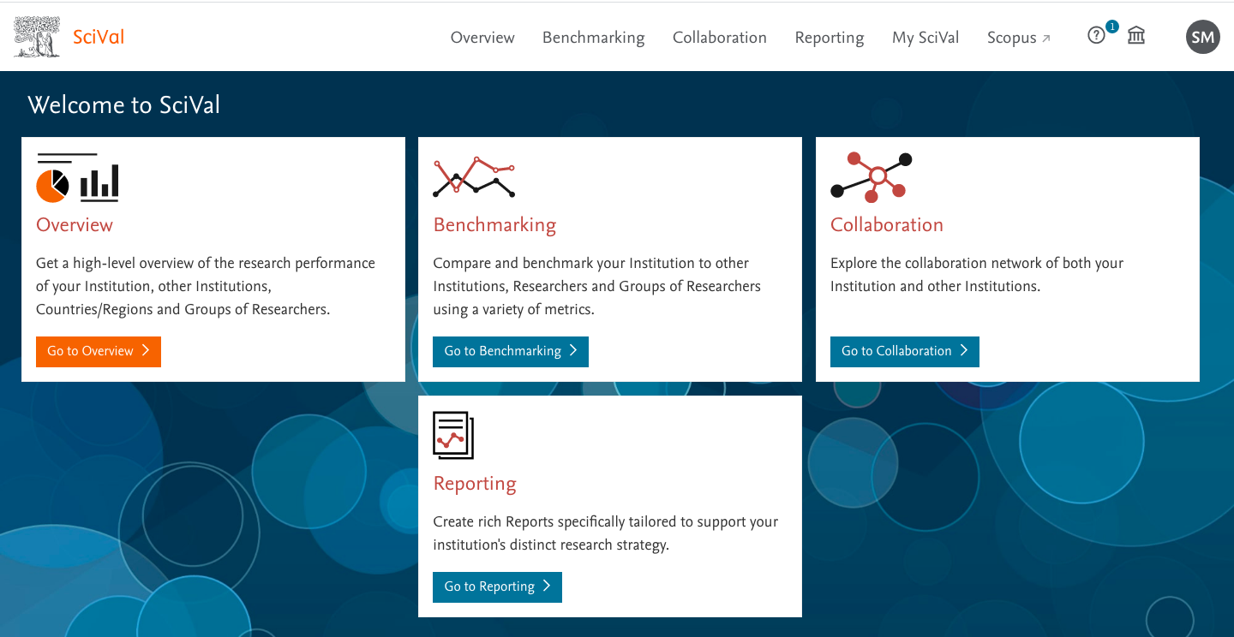

Now press “Got to overview”. You will then observe the next webpage

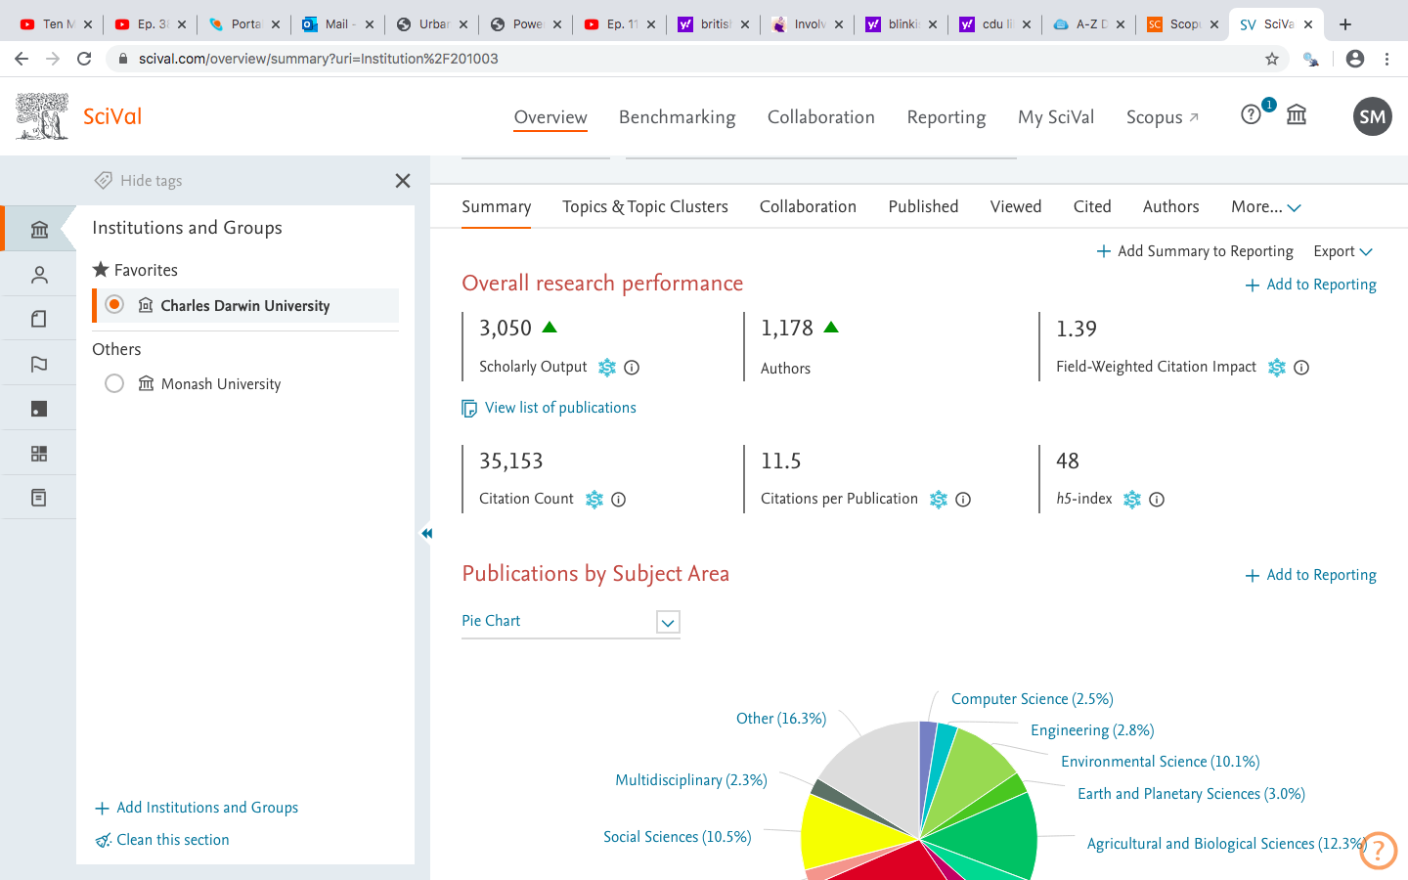

If you scroll down this webpage, you will receive information about your university, in this instance CDU. For example, the page indicates

- 1178 staff have published work that is recognized in Scopus
- on average, 11.5 individuals cite each of these works
- the field weighted citation impact is 1.39. This value represents the number of people who have cited the publications at CDU divided by the number of people you would have expected to cite these publications given the fields in which they were conducted. Numbers that exceed 1 indicate more people cited the publications that expected
- the pie chart represents the fields in which this research was conducted

To extract information about your own work,

- choose the “Authors” tab
- search the list until you can locate yourself, perhaps by selecting “Find” in the “Edit” menu
- if you cannot identify yourself, press the orange arrow towards the top to choose a field, such as medicine or psychology before attempting to locate yourself
- click your name to generate a screen that resembles the following display

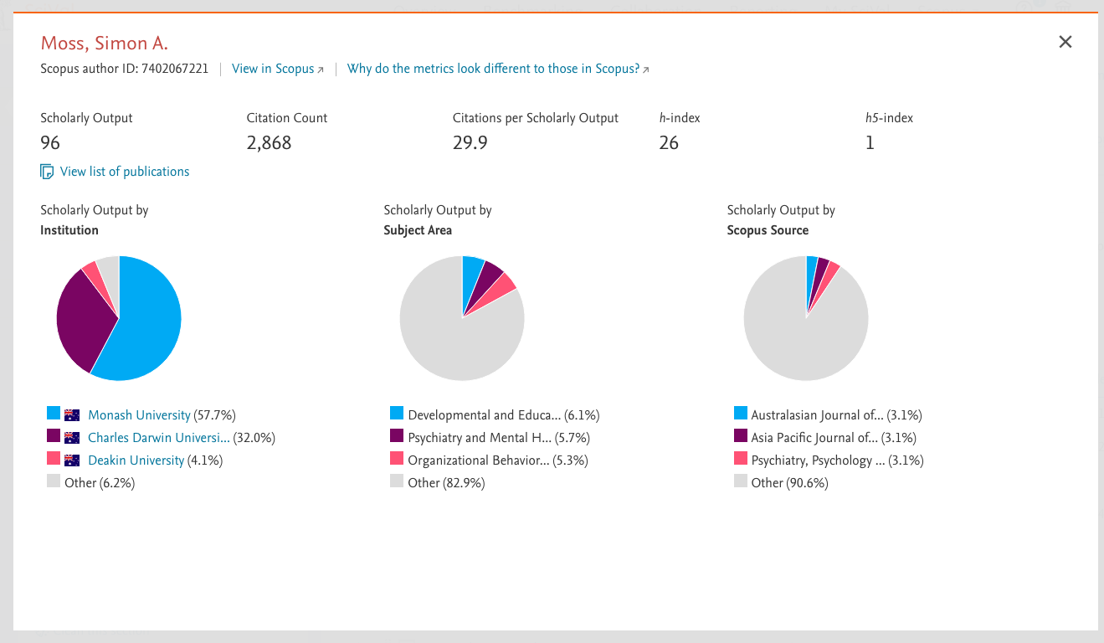

As this display shows, this person has been cited 2868 times and about 29.9 times on average. If you press “View list of publications”

- you can receive information about the number of times each publication was cited
- you will also receive information about the number of times you have published with each co-author
- if you want to locate information about staff at other universities, click the top icon on the left that resembles a building. Then click “Add institutions and groups” before entering the name of another university, such as “Deakin university”.

Other information can be derived from Google scholar, ORCID.org, and ResearchGate.

Appendix A1: ARC funding schemes

The following table outlines the range of funding schemes the ARC has developed at the time this document was written. To access the latest information, visit https://www.arc.gov.au/grants

Scheme | Aim and focus | Level of funding
Funding to support projects
Discovery Projects | - Funds research projects that are designed to expand knowledge and research capacity in Australia  - Projects must provide economic, commercial, environmental, social, or cultural benefits to Australia | - $30,000 and $500,000 a year for 5 or fewer years
Discovery Indigenous | - Supports research projects that an Aboriginal and Torres Strait Islander researcher leads  - Funding is directed to the organization instead of specific researchers
Linkage projects | - Supports projects that are partly funded by partners—such as other government agencies or corporations—ultimately to facilitate alliances between universities and end users | - $50,000 to $300,000 a year for two to five years
Fellowships: Funding to support good researchers
Discovery Early Career Researcher Award (DECRA) | - Designed to support excellent early-career researchers in supportive environments | - Commensurate salary + $50 000 project funding a year  - Up to 200 of these fellowships are offered a year
Future fellowships | - Designed to support excellent mid-career researchers in supportive environments | - Commensurate salary + $60 000 project funding a year  - Up to 100 of these fellowships are offered a year
Australian Laureate Fellowships | - Designed to attract and retain outstanding researchers and research leaders of international reputation | - Level E salary, $300 000 project funding a year, 2 PhD candidates, and up to 2 postdoctoral candidates  - Funded over 5 years  - Up to 17 fellowships are offered each year
Funding to support collaborations, centres, or programs
ARC centres of excellence | - Designed to fund a diverse network of collaborations between universities, research organizations, governments, and business  - Revolves around one topic of national interest
Industrial transformation research programs | - Funds research hubs that support at least one industry growth centre  - At this time, these growth centres revolve around advanced manufacturing, cybersecurity, agribusiness, medical technologies, mining, and energy resources.  - Also funds research training centres—innovations on how to help young researchers support industry better
Special Research Initiatives | - Support cooperative initiatives among researchers that align to specific emerging fields of research
Linkage Infrastructure, Equipment and Facilities or LIEF | - Funds research infrastructure, equipment, and facilities—to be shared between universities and industry

