INTRODUCTION TO BIBLIOMETRIC ANALYSES

by Simon Moss

Introduction

If you want to both learn about the literature on your topic, but also to construct, and even publish, a paper that outlines the key trends in this literature, you might want to consider a bibliometric analysis. Indeed, some research candidates will complete, and then include, both a systematic review and bibliometric analysis in separate chapters.

What is a bibliometric analysis?

A bibliometric analysis is, in essence, a statistical analysis of the publications on your topic. These measures assess a range of questions such as

- whether the number of articles on your topic is increasing or decreasing over time
- which are the most cited articles, nations, institutions, authors, and journals in this field
- which keywords are becoming the most prominent in this field
- in this field, what are the main subsets of topics, journals, authors, and articles. For example, which keywords or topics seldom appear in the same article?

What are the benefits of a bibliometric analysis?

If you conduct a bibliometric analysis, you will enjoy some key benefits. Specifically,

- you may learn about which issues within your topic are especially valued now rather than plateauing, increasing the potential impact of your work
- you may be able to identify pairs of keywords that have seldom been published in the same article—and thus might uncover a novel project
- you may identify journals that could publish your work
- you may learn about which authors could be potential collaborators or examiners
- you may be able to publish a paper relatively efficiently, even before you collect data
- you could impress some examiners with your knowledge about this topic and your skills in bibliometric analyses

Typical report

This section outlines and illustrates a typical bibliographic report. This illustration will help you both appreciate the main facets of bibliographic analyses and write your own report in the future.

Information to include | Illustrations
Introduction
Highlight the importance of this topic | - Over 25% of research candidates experience symptoms of depression or anxiety  - Therefore, more insights into the initiatives and circumstances that promote resilience in research candidates is vital…
Review the key themes that have emerged from the literature | - Many of the initiatives that have been implemented to foster resilience in research candidates can be divided into two clusters  - The first cluster attempts to expose research candidates to challenging situations—but situations in which these individuals might flourish  - The second cluster of attempts imparts coping skills  - Specifically…
Outline the benefits of a bibliometric analysis to this topic | - A bibliometric analysis—in which researchers characterize how the number of publications and citations varies across fields of research, nations, institutions, authors, and time as well as the uncover clusters of publications with similar citations—could facilitate progress on this topic  - For example, this analysis might clarify which topics are beginning to emerge in the research on how to foster resilience in this cohort  - In addition, this analysis could help researchers unearth potential collaborators  - Furthermore, this analysis might identify distinct strands in the literature that have not been explored simultaneously and thus may warrant further research  - Finally, this analysis can uncover the main bodies that have funded this research
Outline objectives or research questions in this paper | - The overall aim of this bibliometric analysis is to characterize trends and patterns in the research on resilience in research candidates  - Specifically, the objectives of this analysis is to characterize the authors, journals, institutions, and nations that have published more prolifically and effectively on this topic—as well as the funding bodies that have supported this research  - Second, this analysis clarifies which topics tend to have been explored separately, rather than together
Method
Specify the main sources of data—such as Web of Science or Scopus—and justify this choice | - Both Web of Science and Scopus were utilized to extract the publications on this topic as well as to characterize some of the trends in these publications  - These data sources were chosen because of their coverage, their capacity to save the data in a format that other software can analyse, and their inbuilt analytical tools  - Furthermore…
Clarify the keywords or journals you wanted to explore—as well as the restrictions you imposed on this search | - We uncovered all titles or abstracts that correspond to the following search term: “Resilience” AND (“PhD” OR “Doctora*” OR “Masters by Research” OR “research candidate” OR “research candidate”)  - We restricted this search to the years 1990 onwards, because the existing definitions of resilience emerged during this time  - In addition, we restricted the search to articles  - Furthermore…  - The searches were conducted on January 30, 2019 only, primarily to minimize fluctuations in the number of publications and citations.
Specify the inclusion and exclusion criteria | - We included all articles that examined some determinant of resilience—such as an intervention or pre-existing characteristics, conditions, or circumstances  - We included all articles in which the participants of this empirical study in which at least one condition comprised solely research candidates  - We excluded articles that were merely protocols—and, therefore, the results had not been reported  - Two researchers utilized these criteria to extract the relevant articles—and discrepancies were discussed and resolved
Indicate how you managed the data | - The identified articles were converted to a plain text file  - These data were converted to an MS Excel spreadsheet.
Defined the bibliometric indicators you used | - A variety of indicators were calculated to characterize these publications.  - First, we characterized the number and impact of publications in this field as a function of year, nation, language, field of research, journal, and funding source. Similarly, we identified the most productive institutions and authors  - To gauge impact, we utilized a variety of measures such as number of citations per article, the h index, Cite Score, SJR indicator, and SNIP  - The h index is defined as …  - Second…
Describe the visualization techniques you employed | - We utilized VOS viewer to generate bubble maps—displays that represent the most common keywords on this topic as well as the extent to which keywords are utilised in the same article  - Only terms that appeared in at least 5 publications were included in this map
Results
Outline each of the key results, often in separate subsections, such as  - the number of publications or citations over time—sometimes as a function of field of research  - the authors, journals, institutions, and nations that published the most papers or generated the highest impact  - the papers that had been cited most frequently  - the funding agencies that had supported the most publications  - visualization density map of the keywords | - Figure 1 presents the number of publications and average number of citations per paper on this topic over time. The X axis ranges from 1990 to the present…  - Figure 2 presents the same information but for the fields of Nursing, Medicine, Public Health, and Higher Education separately…  - Tables 1 to 4 list the 10 most prolific authors, journals, institutions, and nations on this topic as well as the average number of citations…  - Table 5 lists the 10 most cited papers on this topic…  - Table 6 presents the 5 funding bodies that had supported the most publications…  - Figure 2 presents a bubble map that indicates the most common keywords.  - The size of circles indicates the frequency of keywords or terms  - Circles that are closer together represent keywords that co-cited the most—that is, often utilized in the same paper  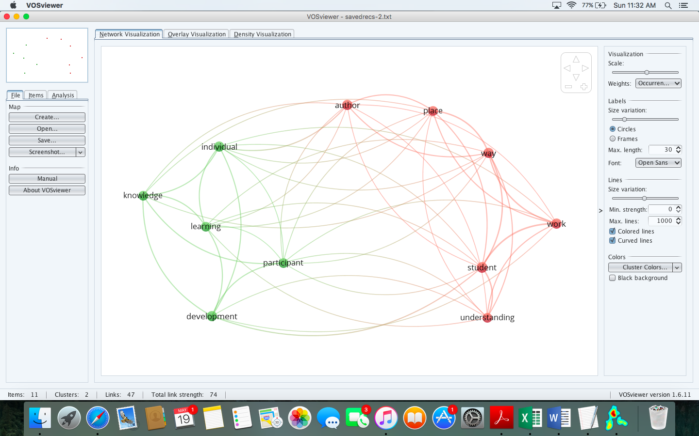
Discussion
Summarize the key findings
If applicable, compare the findings to previous bibliometric analyses
Outline some of key implications of these findings | - These findings indicate that researchers might want to explore both workplace and individual characteristics—issues that have seldom been examined concurrently before  - Furthermore, these findings imply the emphasis on resilience programs might have plateaued but the emphasis on workplace programs might be starting to burgeon
Discuss the limitations of this bibliometric analysis, such as

- excluded articles that were not included in Scopus or Web of Science—and may thus have overlooked non-significant effects
- publications that were not written in English were excluded—and should be included in future studies
Write a conclusive paragraph

Main considerations

Bibliometric analyses vary appreciably. Therefore, to conduct a bibliometric analysis, you will need to reach several choices about various questions. The following table summarises these questions.

Questions | Potential answers
What are the research questions you want to answer | - To clarify the main trends—the issues and keywords that are emerging—in your field  - To explore whether this topic is becoming more popular and cited over time  - To determine which nations, institutions, and authors are most dedicated to this topic  - To identify sets of topics that have seldom been explored together
Which techniques do you want to conduct to analyse the literature—sometimes called the design | - Citations—such as which papers or topics are most cited  - Visualization methods such as co-citation—which articles are cited by similar authors or articles—bibliographic coupling—which authors or articles cite the same articles—co-author—which authors publish together—and co-word—which papers share similar keywords  - Content analyses
Which data will you collect and how—as well as what are the inclusion and exclusion criteria | For example, you can search  - all the articles that include specific keywords  - all the articles in a journal  Furthermore, you can utilize a range of datasets, such as  - Web of science  - Scopus  - Proquest  And, you could restrict these articles to  - specific dates  - specific languages  - only articles that are cited more than 10 times  - and so forth
Which software will you utilize | - VosViewer  - Gelphi  - Sitkis  - Excel  - BibExcel, available for Windows only  Other visualization software includes CiteSpace, CiteNetExplorer, Pajek, UCINET, and an R package called iGraph
Which techniques will you utilize to analyse and interpret the data | - Some researchers use factor analysis, cluster analysis, or multi-dimensional scaling to explore the data in more detail

Derive information from databases: Web of Science

Search the Web of Science

After you plan your research, the analysis tends to begin with an attempt to extract all the relevant publications—usually with Web of Science, Scopus, Proquest, or other similar databases of publications. To utilize Web of Science

- Visit the CDU library online at https://www.cdu.edu.au/library/
- Choose “Databases”, “W”—in the list of letters near the top—and “Web of Science”. You might need to enter your username and password to access this database.
- The design of this data database appears below

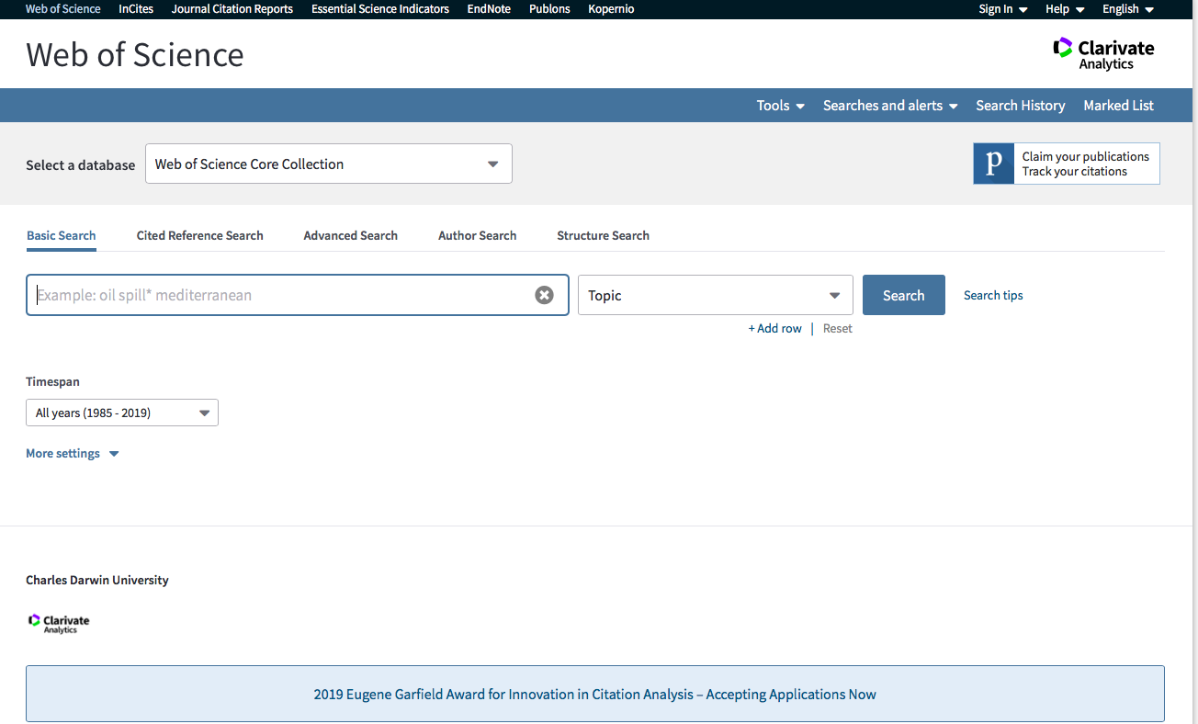

Now suppose you want to explore all articles that have explored how to enhance resilience in PhD and Masters by Research candidates. To achieve this goal

- In the search box—the location in which cursor is now—you might write terms like “Resilience” AND (“PhD” OR “Masters by Research” OR “Doctora*”)
- The * indicates that you are willing to include keyword that begins with “Doctora” such as “Doctoral” or “Doctorate”
- Retain the default “Topic”—although you can restrict the search to journals, authors, and other fields—options that would generate different insights
- Press Search. These search terms will generate about 90 articles
- On the left side, you can restrict these results to specific years, fields of research, and so forth.

Save your results in Web of Science

To analyse these publications, you first need to save these results and then to utilize other software. You can apply one of two approaches now

- You could simply save all these results
- To achieve this goal, press the “Export” button towards the top middle—and then choose “Other file formats” to generate the following set of options. Select “All records on page”.
- Instead of “Author, Title, Source, Abstract”, choose to save “Full Record and Cited References”—to save more information about each article
- Instead of “Other reference software”, choose “Plain Text” or a “Tab delimited” format.
- Press “Export”; rename that file that appears, perhaps with a title like “Articles on resilience”. This file will appear in your “Downloaded” files.

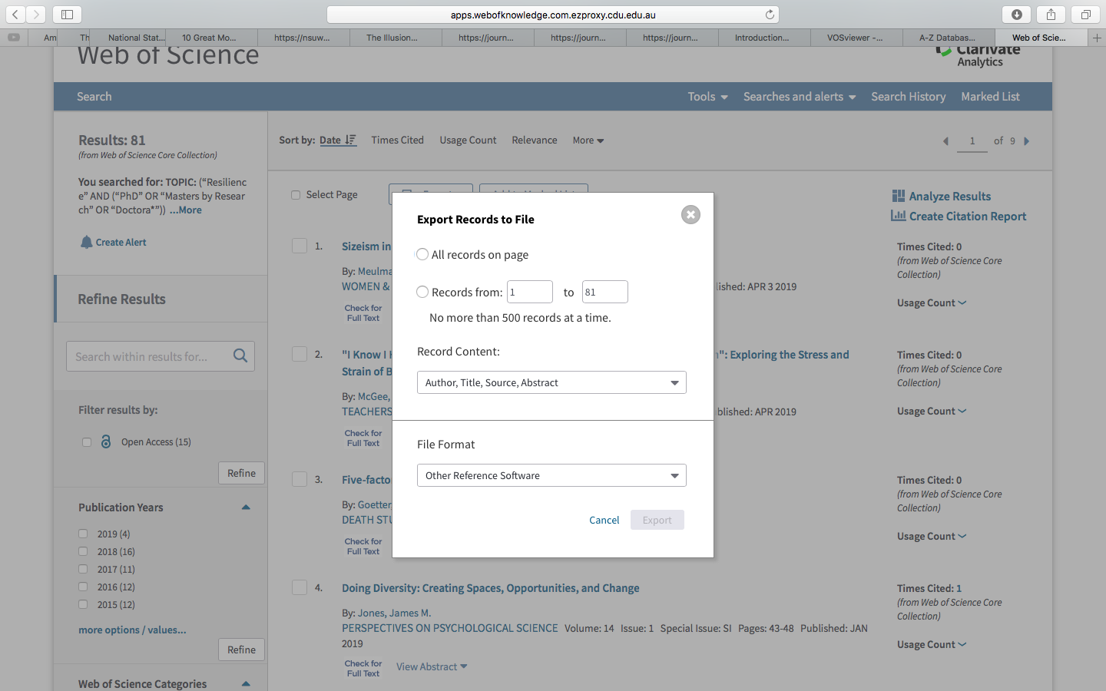

Alternatively, you can save only a subset of results—only the articles that you want to include. To illustrate, consider the following screen

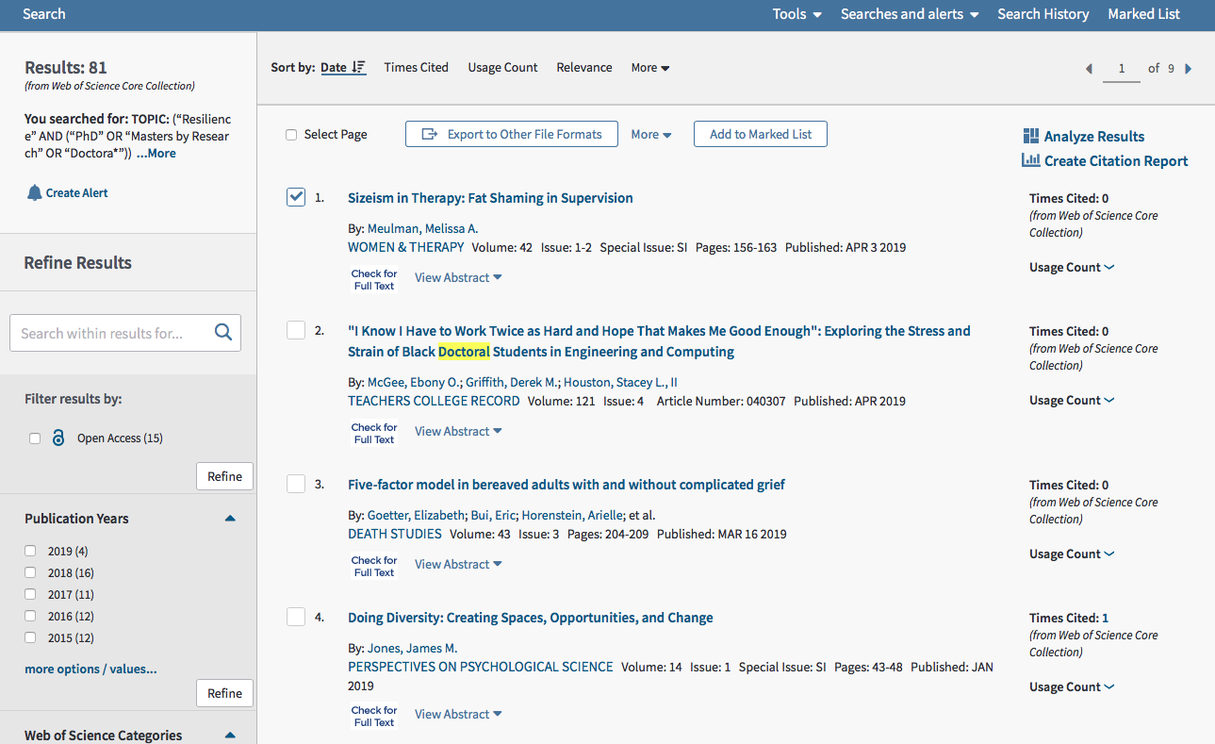

If you choose “Select page” towards the top left, the empty boxes alongside each article will be ticked or marked. In this example, only the first article is ticked. You can then untick articles that you do not want to save—perhaps because they are not relevant to your topic of interest. Once you have ticked or unticked the relevant articles

- Click “Add to Marked List” toward the topic
- Then click “Marked List” in the top right to generate the following screen

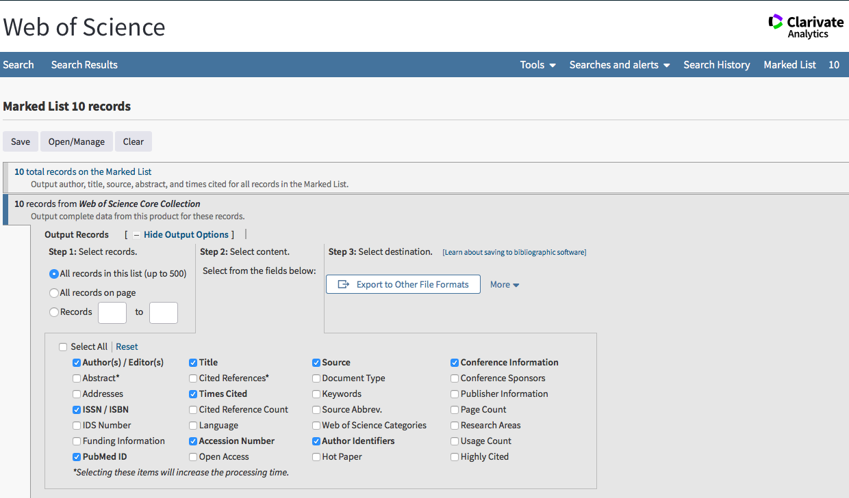

- You can then tick all the fields you want to include, such as Abstract—or indeed all the fields
- Then press “Export to Other File Formats” and again choose either “Plain Text” or “Tab delimited”

Analyse your results in Web of Science

Return to the page that lists all the results. On the top right of this screen, tick “Analyze Results” to generate the following screen. This screen shows that 32 of the publications on this topic are in the field of educational research. Now click “Create Citation Report” on the top right.

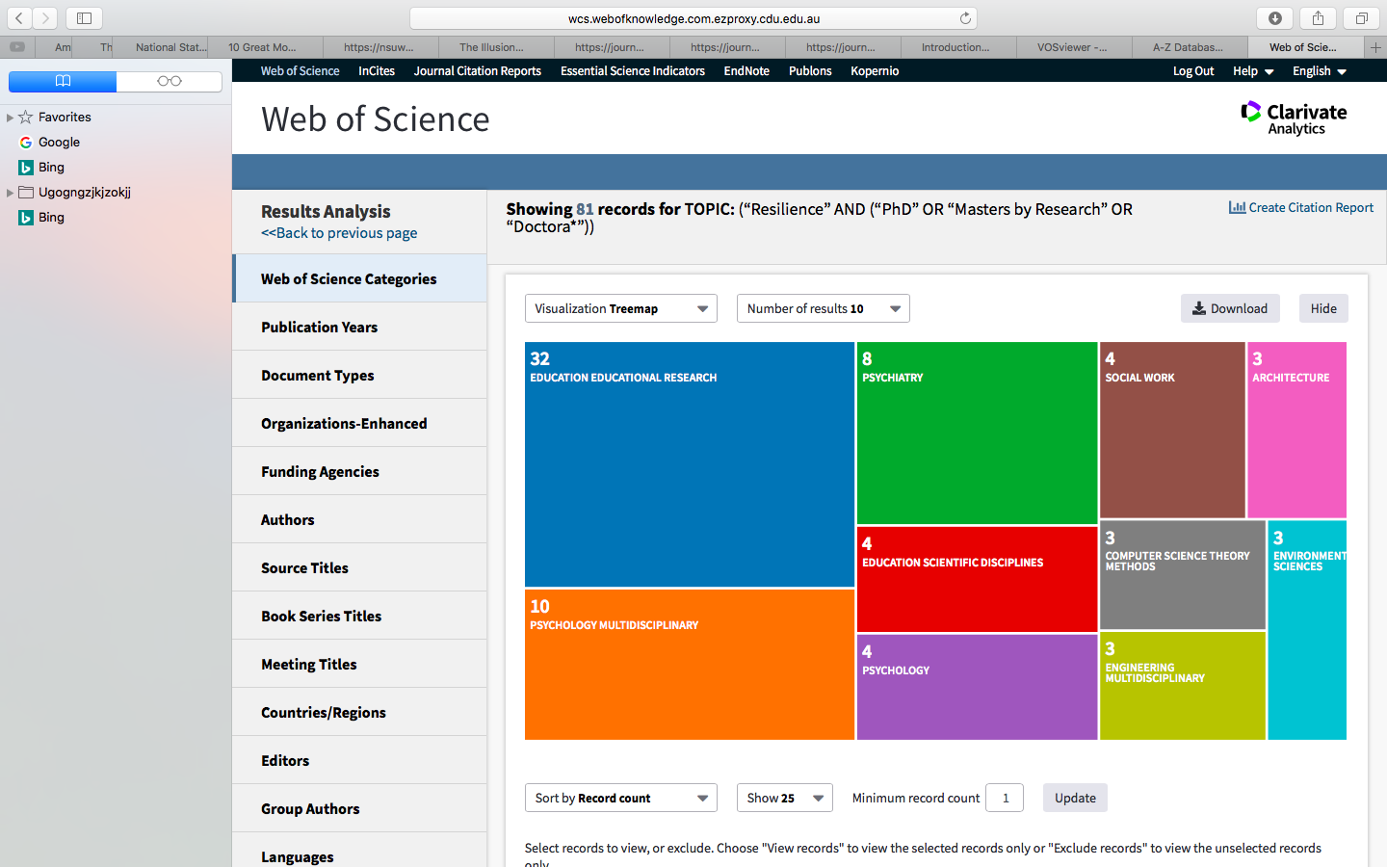

This procedure will generate the following screen. This screen, for example, shows that

- Of the 81 articles generated, the average number of times these articles were generated is 9.57.
- The h index of 9 indicated that 9 of these publications were cited at least 9 times. A h index of 20 would indicate that 20 of these publications were cited at least 20 times
- Overall, these 81 articles were cited 775 times. Indeed, even if instances in which authors cited themselves were removed, these 81 articles were still cited 775 times. Accordingly, none of the authors had cited themselves
- However, only 769 different publications had cited these 81 articles. The difference between 775 and 769 implies that some publications had cited more than one of these 81 articles

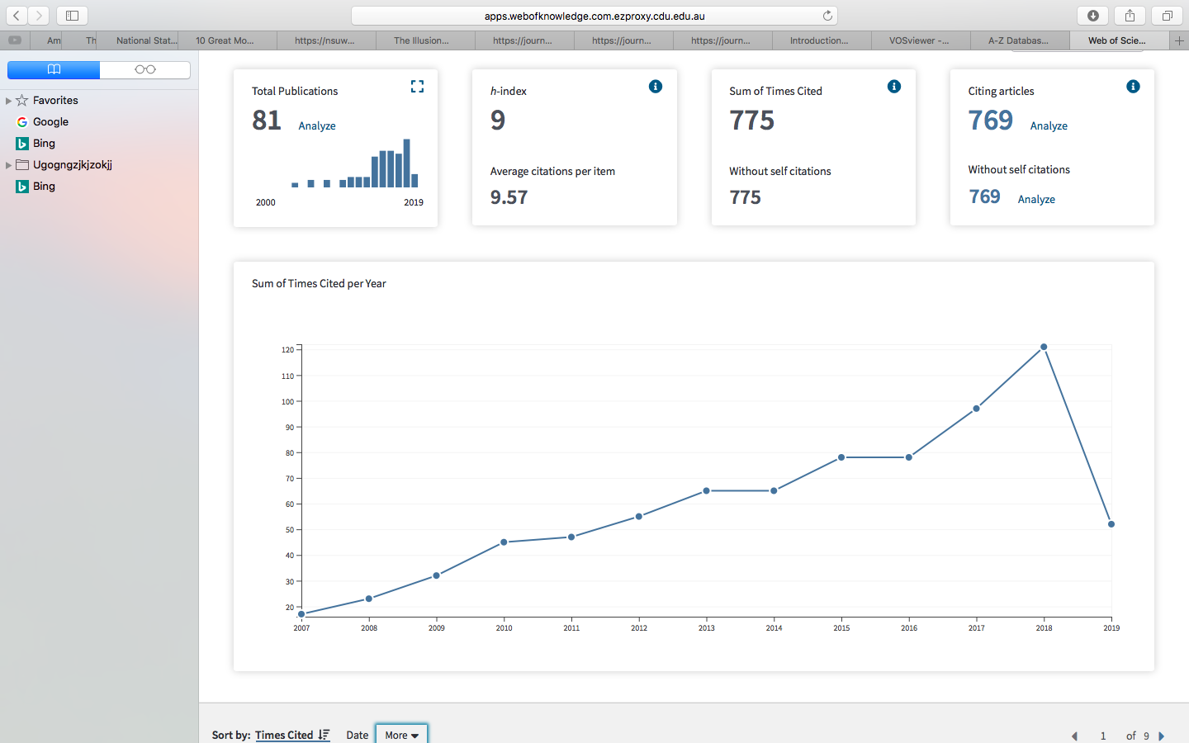

If you scroll down, you will receive more information. In particular, Web of Science lists the 81 articles, ordered from most cited to least cited.

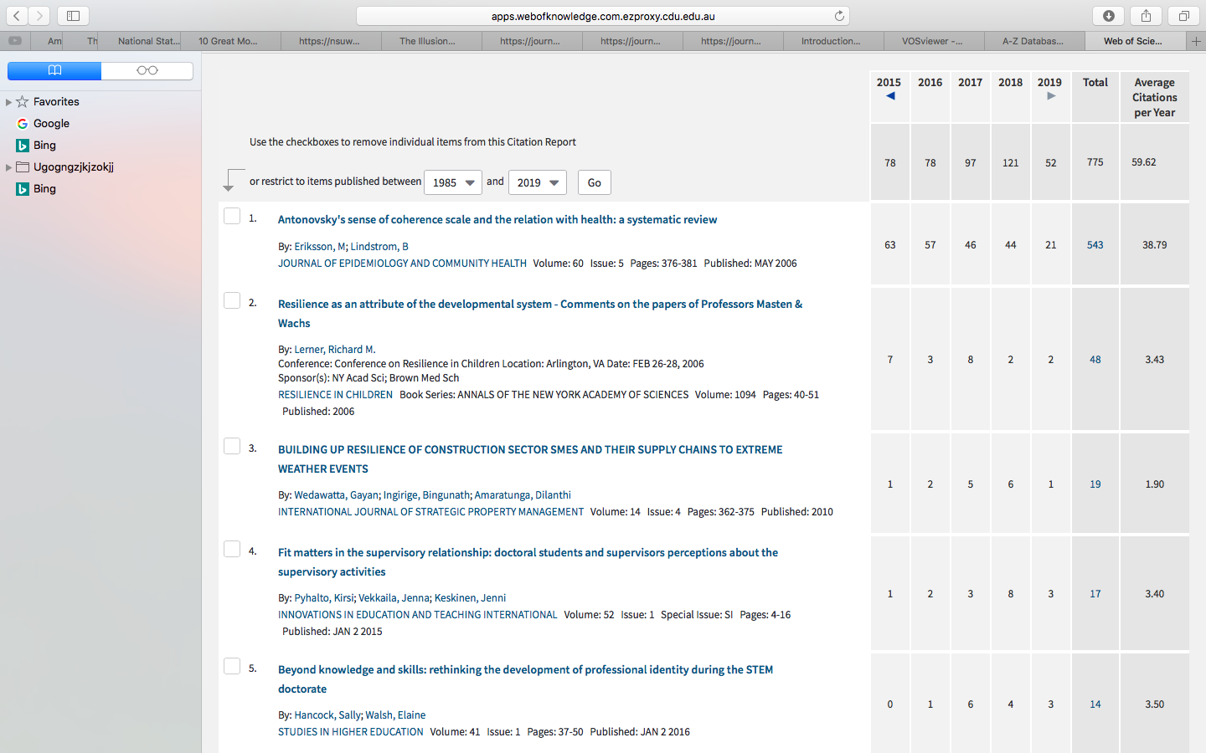

Derive information from databases: Scopus

Rather than Web of Science, you could utilize another database of publications, such as Scopus. The procedures are similar except

- in the CDU library online, after you select “databases, choose “S” rather than “W” to locate and then access Scopus.
- after you enter your search terms, you will receive a screen that resembles the following

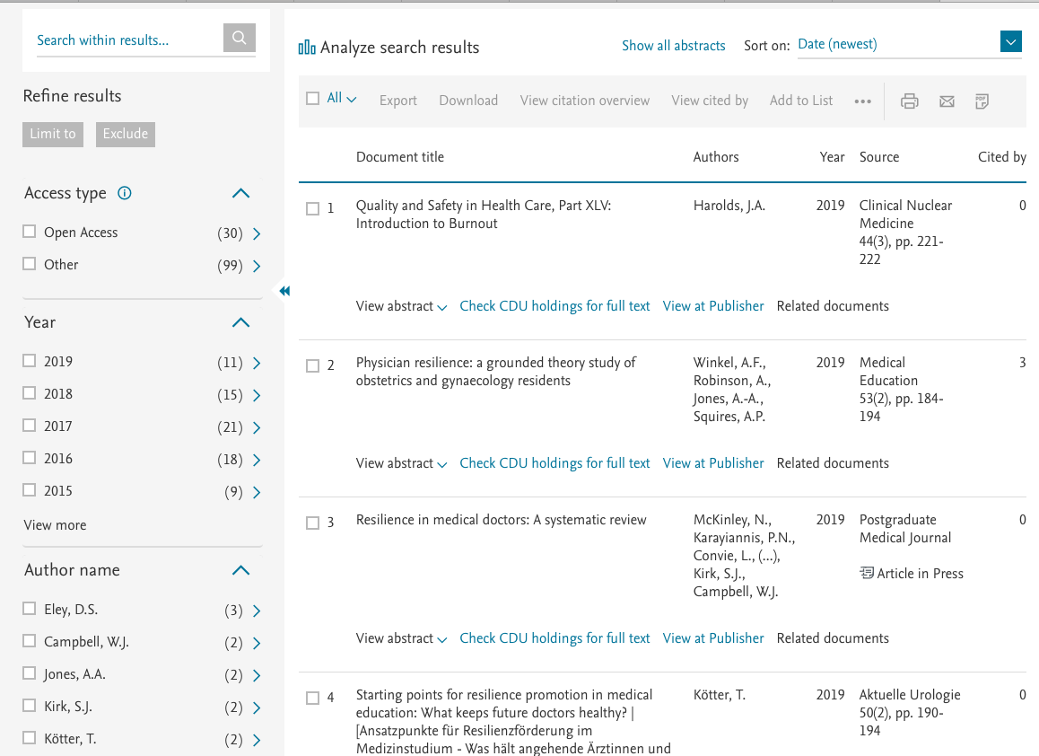

- Click “All” to tick or mark all the articles
- Untick articles that you want to exclude—perhaps because they are not relevant to your topic
- To analyze these results, click “Analyze search results” on the top.
- This procedure will generates a long array of tables and graphs. The following figure presents an extract of this output
- These figures, for example, present the authors, institutions, and nations that generated the most papers. Other graphs also specify the most common funding sources, fields of research, and so forth

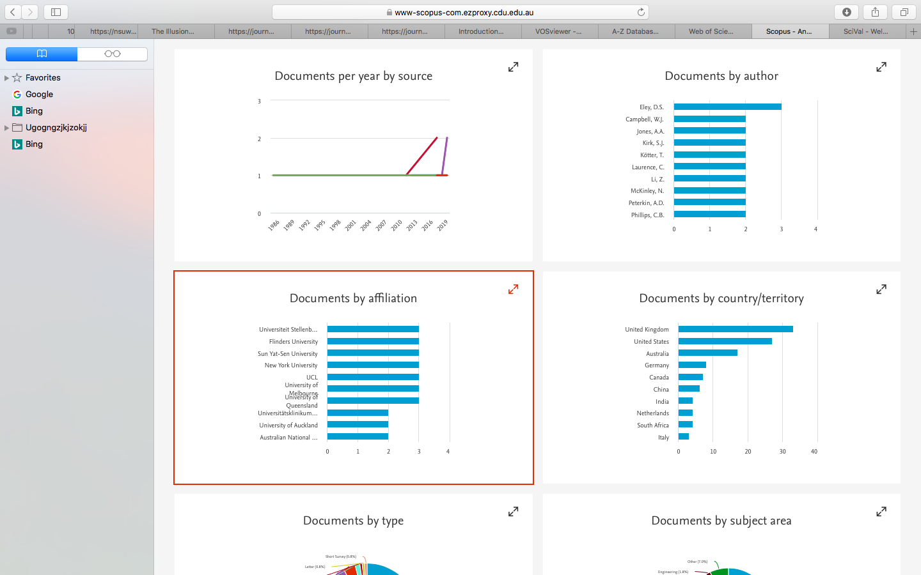

Visualisation displays: VOS Viewer

Web of Science, Scopus, and other databases of publications offer insights into the number of publications and citations. These databases, however, do not offer more detailed analysis—such as which keywords, authors, or papers tend to be cited by the same papers, sometimes called the structure of publications. Instead, researchers tend to use other software, such as VOS Viewer.

Download and open VosViewer

To download and open VosViewer—a free software package

- proceed to www.vosviewer.com
- click “Download” and then download the Windows, Mac, or another version.
- open as you would open any other software—usually by double clicking the file “VOS Viewer”
- When you open this software, the following screen appears

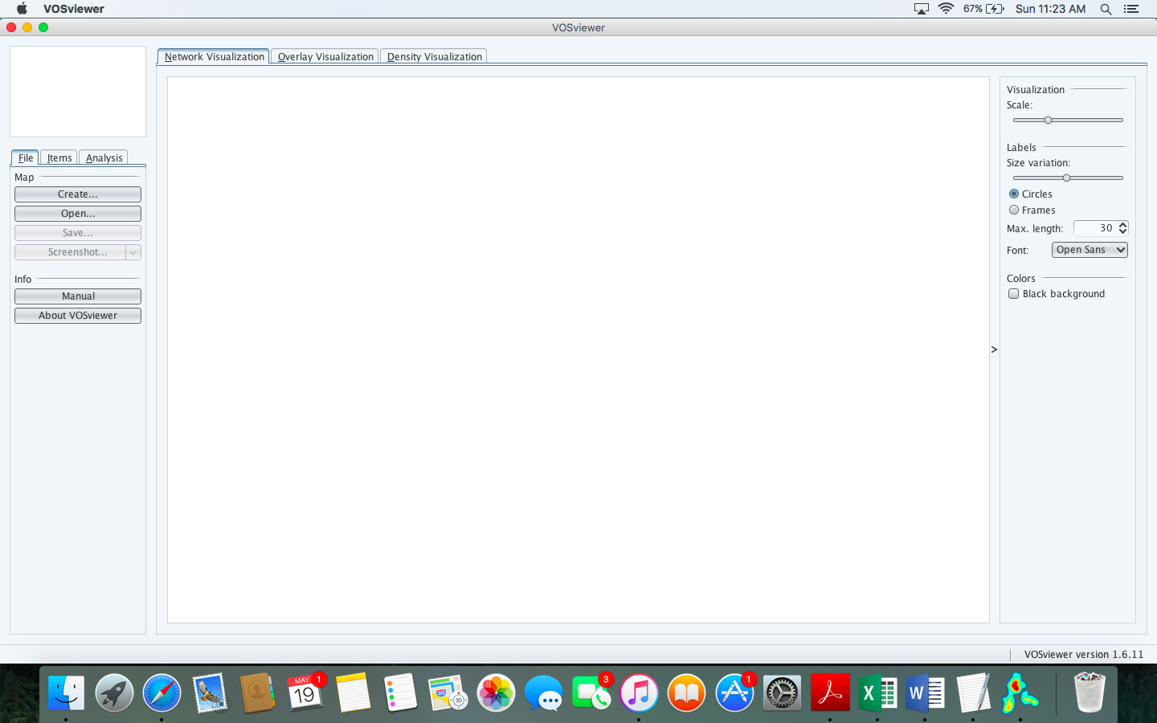

Create a visual display

To create a visual display of the results or articles you saved in your file previously, first click “Create” on the left side of this screen to generate the following screen

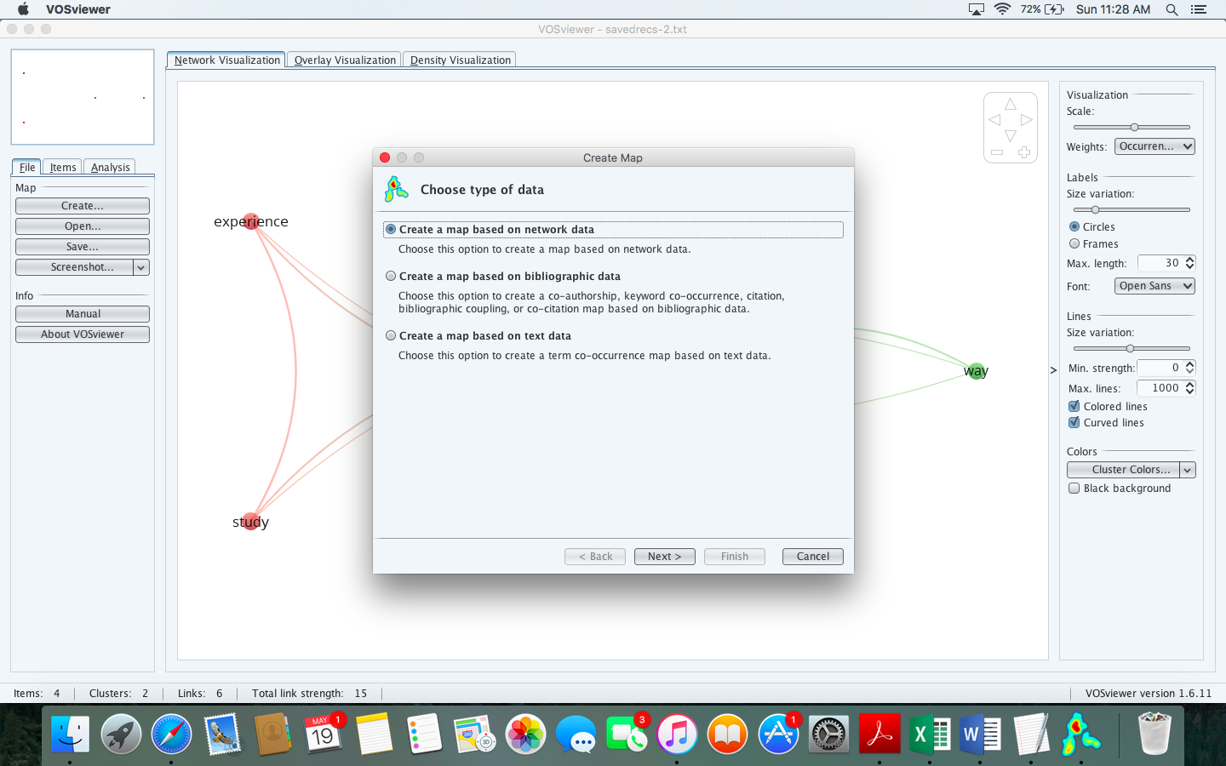

You then need to

- Choose create a map based on text data, and press Next
- Choose “Read data from bibliographic database files and Next.
- Select the fine in which you stored your results. Click …, locate your file, and press Next
- Continue to press Next and accept the defaults.
- One exception might be to reduce “Minimum number of occurrences of a term”. If this number is too high, your display will not include enough keywords
- After you press “Finish”, you should generate something like the following figure.

You now need to interpret this graph. Specifically

- the size of circles indicates the frequency of keywords or terms; for example, although most of these circles are similar in time, the keyword “student” is probably the most frequent
- circles that are closer together represent keywords that co-cited the most—that is, often utilized in the same paper. Thus, many papers refer to both “student” and “understanding” but not “student” and “knowledge”
- the different colours tend to correspond to distinct clusters; the green cluster seems to coincide with words that relate to learning and development, for example.
- on the left hand side, you can choose various options to modify the display; you can, for example, amplify the difference in size between the circles to facilitate analysis
- on the right side, you can choose the “Analysis” tab to conduct a range of analyses as well

Create other displays

VOS Viewer can also be utilized to construct many other displays. These displays include

- co-authorship displays: shows which authors tend to publish together
- key co-occurrence: shows which keywords tend to appear in the same publications
- bibliographic coupling and co-citation maps—show which publications tend to cite the same publications

To illustrate

- Click “Create” but, this time, choose “Create a map based on bibliographic data” and then Next
- Choose “Read data from Bibliographic database files” and then Next
- Open the file you saved before—the file you derived from Web of Science or Scopus and then Next to generate the following screen.

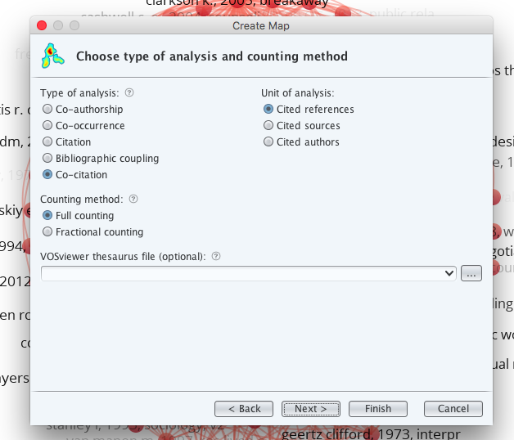

You should then choose all possible combinations of types of analysis and units of analysis. Then, decide which of these maps seem to be meaningful to you. You can use the manual to clarify the meaning of these maps.

Measures of impact

Scopus and other databases can also generate a variety of other indices to the impact of publications and journals. The following table defines these indices and specifies how these indices can be calculated.

Index | Objective | Descriptions | How to calculate
Cite Score | - Measures the extent to which the articles in one journal are cited frequently | - The average number of citations each paper has attracted in the last year divided by the number of papers published in the previous three years | - In Scopus, clicking on the names of journals will often generate the cite score
h index or Hirsch index | - Measures the extent to which a set of publications—such as all the publications on one topic or all the publications of one author—have been cited | - h equals the number of publications that have been cited more than h or more times; a h index of 12 indicates that 12 publications on a topic have been cited 12 or more times | - In Scopus, clicking on the names of authors will often generate the h index of an author
RRI or relative research interest | - Measures the extent to which one field of research produces more publications than other fields of research in a topic | - RRI equals the number of publications in one field on a topic divided by all the publications on this topic. | - Available in Web of Science
SJR indicator or SCImago Journal Rank indicator | - Measures the extent to which the articles in one journal are influential | - Calculates the average number of citations for each paper  - However, citations from prestigious journals are weighted more than citations from other journals | - Go to www.scimagojr.com
SNIP or Source Normalized Impact per Paper | - Measures the extent to which the articles in one journal are influential | - Calculates the average number of citations for each paper  - However, citations from disciplines in which citations tend to be lower are weighted more than citations from disciplines in which citations tend to be higher | - In Scopus, clicking on the names of journals will often generate the SNIP

Further information

Many other bibliometric techniques have been developed. For further information

- skim some typical bibliometric reports, some of which appear in the reference section
- at http://www.vosviewer.com/getting-started, download the “VOS viewer paper”—a comprehensive discussion of VOS viewer and other visualization software

References and examples

Gao, Y., Wang, Y., Zhai, X., He, Y., Chen, R., Zhou, J., Li, M., & Wang, Q. (2017). Publication trends of research on diabetes mellitus and T cells (1997–2016): A 20-year bibliometric study. PLOS ONE, 12(9), e0184869.

Holman, D., Lynch, R., & Reeves, A. (2018). How do health behaviour interventions take account of social context? A literature trend and co-citation analysis. Health, 22(4), 389–410.

Jun, S.P., Yoo, H.S., & Choi, S. (2018). Ten years of research change using Google Trends: From the perspective of big data utilizations and applications. Technological Forecasting and Social Change, 130, 69-87.

Krauskopf, E. (2018). A bibliometric analysis of the Journal of Infection and Public Health: 2008–2016. Journal of Infection and Public Health, 11(2), 224-229.

Leung, X. Y., Sun, J., & Bai, B. (2017). Bibliometrics of social media research: A co-citation and co-word analysis. International Journal of Hospitality Management, 66, 35-45.

Martínez-López, F.J., Merigó, J.M., Valenzuela-Fernández, L., & Nicolás, C. (2018). Fifty years of the European Journal of Marketing: A bibliometric analysis. European Journal of Marketing, 52(1/2), 439-468.

Popescu, C. (2017). Is environmental protection a central issue to the business strategy of high profile companies? Content analysis of website corporate communication. Journal of Urban and Regional Analysis, 9(1), 87-99

Shapira, P., Kwon, S., & Youtie, J. (2017). Tracking the emergence of synthetic biology. Scientometrics, 112(3), 1439-1469.

Van Nunen, K., Li, J., Reniers, G., & Ponnet, K. (2018). Bibliometric analysis of safety culture research. Safety Science, 108, 248-258.

Wang, Q. (2018). Distribution features and intellectual structures of digital humanities: A bibliometric analysis. Journal of Documentation, 74(1), 223-246.

Yu, D., Wang, W., Zhang, W., & Zhang, S. (2018). A bibliometric analysis of research on multiple criteria decision making. Current Science, 114(4), 747-758.

