INTRODUCTION TO RELATIVE WEIGHT ANALYSIS

by Simon Moss

Introduction

Many researchers conduct regression analyses—such as linear regression or logistic regression. Relative weight analysis is a technique that you can apply to extend and to clarify the results of these analyses. In particular, you can apply this technique to

- ascertain the relative importance of each predictor—overriding the drawbacks of B coefficients and semi-partial correlations
- demonstrate your expertise in research methods, increasing the likelihood that reviewers and examiners trust your work

Limitations of regression analysis

Background

To introduce you to relative weight analysis, consider this example. Suppose you want to predict which research candidates are likely to be especially motivated. To investigate this topic, a researcher administers a survey to 500 research candidates. This survey includes questions that assess

- motivation, such as “On a scale from 1 to 10, how motivated do you feel”
- their IQ, and
- their emotional intelligence, or EQ, on a scale from 1 to 10, as measured by a battery of tests

These data could be subjected to a linear or multiple regression. The following display presents a subset of the output. This output indicates that IQ, EQ, and age are positively associated with motivation after controlling the other predictors.

Predictor | Unstandardised B | SE | Standardised B or beta | t
IQ | .42 | .04 | .31 | 4.43**
EQ | .14 | .02 | .14 | 2.82*
Age | .22 | .04 | .13 | 2.41*
Gender | -.02 | .02 | .04 | 0.43
* p < .05, ** p < .01

Importance of each predictor

As these results indicate, to predict which candidates are likely to be motivated, universities could assess the IQ, EQ, and age of individuals. However, tests of IQ and EQ are expensive. The university might consider whether they should utilise only one of these tests to predict motivation. Specifically, researchers might

- interpret the standardized B coefficients—sometimes called beta coefficients
- realise the beta coefficient that corresponds to IQ is a lot higher than is the beta coefficient that corresponds to EQ
- conclude that IQ is a lot more important than EQ in predicting motivation
- thus decide, in the future, to measure only IQ rather than emotional intelligence

Limitations with this conclusion

This conclusion, at first glance, seems reasonably sound. However, a few subtle problems compromise the legitimacy of this conclusion. The following table outlines these problems.

Problem | Examples or details
Trivial differences in correlations often generate huge differences in beta coefficients. | To illustrate, consider this correlation matrix  - the correlation between IQ and motivation is 0.45  - but the correlation between EQ and motivation is 0.4—only slightly lower  - although these correlations are similar, the beta coefficient differ considerably between IQ and EQ  - this pattern is common, because the beta coefficients are sensitive to trivial differences in correlations
   | Motivation | IQ | EQ | Age
  IQ | .45
  EQ | .40 | .12
  Age | .30 | .03 | .04
  Gender | .01 | .01 | .02 | .01
If the analysis was repeated with a comparable sample, the results could be different | For example, suppose another sample generated the following correlation matrix  - Although this correlation matrix is similar to the previous correlation matrix, the beta coefficients could be very different  - The beta coefficients that correspond to IQ and EQ could now be .24 and .27  - That is, after minor changes to the correlations, the beta coefficient associated with EQ is higher: EQ suddenly appears to be more important than IQ
   | Motivation | IQ | EQ | Age
  IQ | .410
  EQ | .415 | .12
  Age | .30 | .03 | .04
  Gender | .01 | .01 | .02 | .01
Regression analyses do not present information about whether this order of beta coefficients is reliable | - That is, what is the likelihood this order of beta coefficients in your sample represents this order of beta coefficients in the population?  - In other words, how accurate is this order of beta coefficients?
The magnitude of beta coefficients is hard to interpret | - Suppose the beta coefficient that corresponds to IQ is .31.  - Accordingly, if you increase IQ by one standard deviation, motivation will tend to increase by .31 standard deviations  - But, this description does not really impart an intuitive insight into the degree to which IQ is related to motivation  - A percentage would be more intuitive—something like “35% of the effect of these predictors can be ascribed to IQ”

As this table shows, regression analyses—such as linear regression and logistic regression—do not present unambiguous information about the importance of predictors. Relative weight analysis is a simple technique that overcomes this problem.

Step 1: Install and use R

Download and install R

You can use a variety of statistical packages to complete relative weight analysis. The researchers who popularised this technique, however, developed code that can be used in the statistical program called R. Therefore, this document will show you how to conduct relative weight analysis in R. If you have not used R before, you can download and install this software at no cost. To achieve this goal,

- proceed to https://cran.rstudio.com
- click the “Download R” option that is relevant to your computer—such as the Linus, Mac, or Windows version
- click the option that corresponds to the latest version, such as R 3.6.2.pkg.
- follow the instructions to install and execute R on your computer—as you would install and execute any other program.

Download and install R Studio

If you are unfamiliar with the software, R can be hard to navigate. To help you use R, most researchers utilize an interface called R studio as well. To download and install R studio

- proceed to https://www.rstudio.com
- click Download R studio
- under the heading “Installers for Supported Platforms”, click the RStudio option that corresponds to your computer, such as Windows or Mac
- follow the instructions to install and to execute R on your computer—as you would install and execute any other program
- the app might appear in your start menu, applications folder, or other locations depending on your computer

Familiarise yourself with R

You do not need to have become a specialist in R to conduct relative weight analysis. Nevertheless, you might choose to become familiar with the basics—partly because expertise in R is becoming an increasingly valued skill in modern society. To achieve this goal, you could read the document called “How to use R”, available on the CDU webpage about “choosing your research methodology and methods”. Regardless, the remainder of this document will help you learn the basics of R as well.

Step 2: Upload the data file

Your next step is to upload the data into R. To achieve this goal

- open Microsoft Excel
- enter your data into Excel; you might need to copy your data from another format. Or your data might already have been entered into Excel

In particular, as the following example shows

- each column should correspond to one variable
- each row should correspond to one unit—such as one person, one animal, one specimen, and so forth
- the first row labels the variables
- to prevent complications, use labels that comprise only lowercase letters—although you could end the label with a number, such as age3



Save as a csv file called rawdata.csv

Now, to simplify the subsequent procedures, convert this file to a csv file, called rawdata. That is

- choose the “File” menu and then “Save as”
- in the list of options under “File format”, choose csv
- name the file “rawdata” and press Save

Upload the data in R studio

You can now upload this data into R studio. In particular

- click the arrow next to “Import dataset”—usually located towards the top right, under “Environment History Connections”
- choose “From Text(base)”
- locate the file “rawdata.csv” and press Open

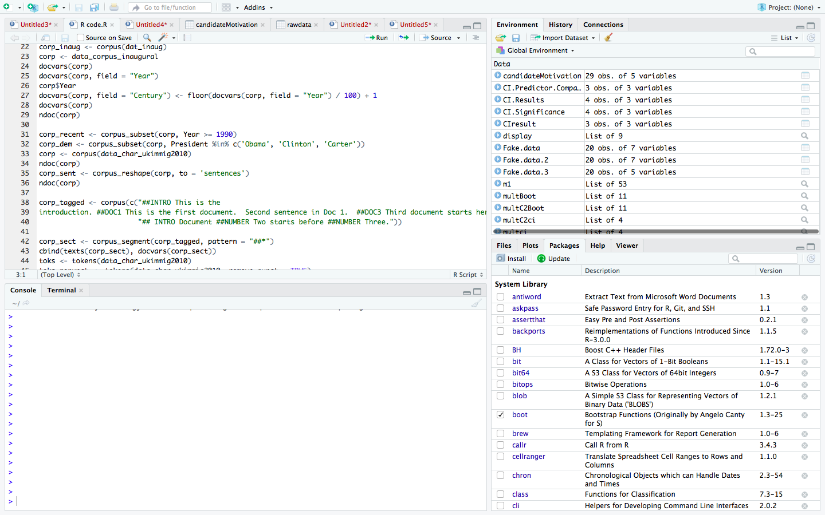

Step 3: Generate the code

To complete the relative weight analysis, you need to construct some code. Unfortunately, this code might look overwhelming. Fortunately, you do not have to develop this code yourself: Another website has been specifically designed to achieve this goal. Specifically

- visit https://relativeimportance.davidson.edu/
- in the blue box at the bottom, choose “multiple regression” or “logistic regression”—depending on whether the outcome is numerical or binary respectively
- scroll down the screen until you see the following options
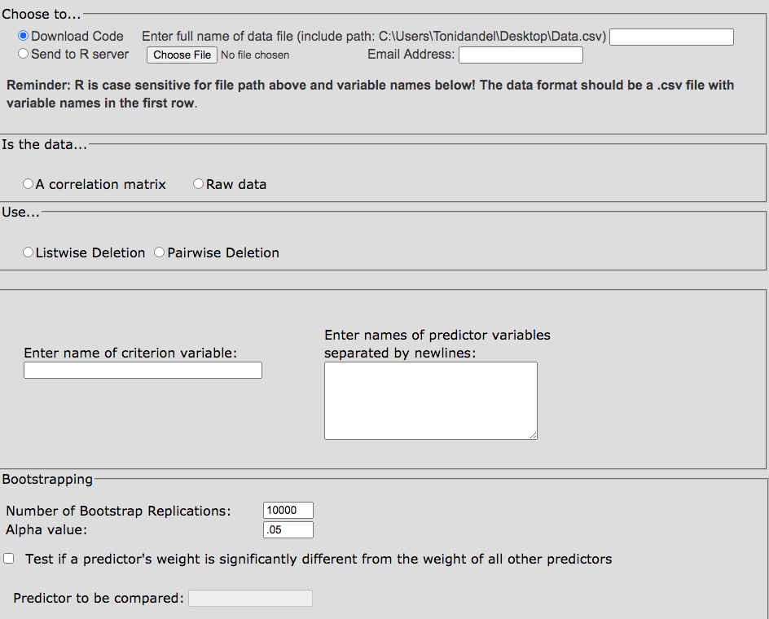

You now need to choose various options. In general, I would recommend you

- in the top white space, next to Data.csv), simply enter “dummy.csv” but without the quotation marks of course
- choose “Raw data” instead of “A correlation matrix”
- select “Pairwise Deletion” rather than “Listwise deletion”
- enter the name of your criterion variable, such as “motivation”
- enter the names of your predictors, such as “iq”, “eq”, “age”, and “gender”, each located on a separate line
- choose “Test if predictor’s weight is significantly different from the weight of all other predictors”
- in the box called “Predictor to be compared”, specify one of the predictors—the predictor you might like to compare to all the other predictors
- press “Submit”—an option that usually appears on the bottom of this page.

Some code should then appear. Copy this code—using Control C or Command C, for example. If this procedure does not work, you could use the code in the appendix—and then change the variable names that appear in bold. However

- the first variable name in bold should be the outcome variable
- the third variable name in bold should be the reference predictor—the predictor to which you want to compare the other predictors.

Step 4: Execute this code

To execute this code, you need to open a new file, paste this code, and then executive this code. To achieve these goals

- in R studio, choose the File menu, then “New File”, and finally “R script”

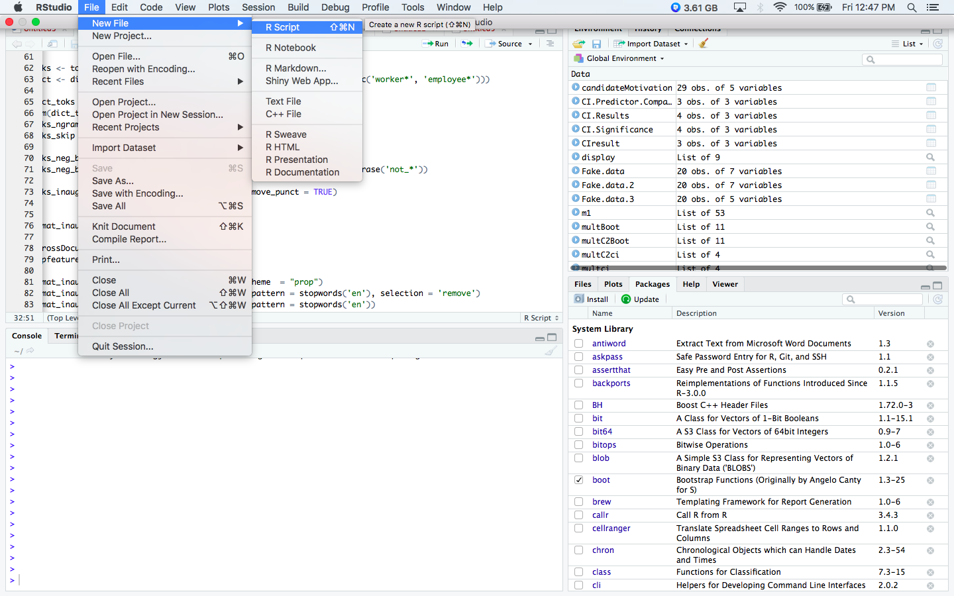

- An empty space should then appear in the top left quadrant
- Paste your code into this quadrant
- Delete the first row of code
- Highlight the rest of this code with your mouse or cursor
- Press “Run”—a button that appears above this quadrant.

Step 5: Interpret this code

In the bottom left quadrant of R studio, called the “Console”, rows of output should eventually appear. Some of this output merely replicates the code. But, some of this output also presents information about the relative importance of each predictor.

Raw and rescaled relative weights

The following display presents a subset of data. As these data showed

- the first column of numbers—the raw relative weights—indicates that IQ is appreciably more important than are the other predictors
- indeed, the second column of numbers—the rescaled relative weights—indicate that 67% of the effect of these predictors can be ascribed to IQ; 22% of the effect of these predictors can be ascribed to gender.

#The Raw and Rescaled Weights
RW.Results

Variables Raw.RelWeight Rescaled.RelWeight
1 iq 0.30694986 67.301211
2 eq 0.02580514 5.657983
3 age 0.01941775 4.257496
4 gender 0.10391097 22.783310

Confidence intervals

The next display presents the confidence intervals of these raw relative weights. For example, the researcher can be 95% certain the raw relative weight associated with IQ is between .101 and .516

#BCa Confidence Intervals around the raw weights
CI.Results

Variables CI.Lower.Bound CI.Upper.Bound
1 iq 0.1010562999 0.51599134
2 eq 0.0012700935 0.10778546
3 age 0.0009609704 0.07055428
4 gender 0.0045354808 0.32073377

Tests of significance

The following display presents information about whether these raw weights differ from 0. In particular

- if these confidence intervals do not include 0—that is, if both the lower bound and upper bound are positive or if both the lower bound and upper bound are negative—the corresponding raw weight differs from 0
- in this instance, the relative weight of only IQ differs significantly from zero.

#BCa Confidence Interval Tests of significance
#If Zero is not included, Weight is Significant

CI.Significance
Labels CI.Lower.Bound CI.Upper.Bound
1 iq 0.10510477 0.5567064
2 eq -0.05650843 0.2006932
3 age -0.04565169 0.1514920
4 gender -0.02874370 0.3764078

Comparison to one predictor

The final display presents information on whether the relative weights of a specific predictor, such as eq, differs from the relative weights of other predictors. To interpret this table

- identify the confidence intervals that do not include zero—in which both the lower bound and upper bound are positive or both the lower bound and upper bound are negative
- if a confidence interval does not include zero, the corresponding relative weight differs from the reference weight—the weight associated with the specific predictor
- in this example, the relative weight that corresponds to EQ differs from the relative weight that corresponds to IQ but not age or gender

#BCa Confidence Interval Tests of significance
#Comparing one predictor with all others
#If Zero is not included, Weights are Significantly different from one another

CI.Predictor.Comparison

Labels2 CI.Lower.Bound CI.Upper.Bound
1 iq 0.09113247 0.50693757
2 age -0.13530207 0.08737388
3 gender -0.10477909 0.36117596

Rationale

So, what is the rationale that underpins relative weight analysis? In essence

- the computer somehow transforms the predictors
- specifically, the transformed predictors are as similar to the original predictors as possible but with the condition they are uncorrelated with each other
- these transformed predictors are then subjected to a typical regression analysis

Limitations

Tonidandel and LeBreton (2011) recommend that researchers should always complement multiple regression or logistic regression with relative weight analysis. Despite the benefits of relative weight analysis, decisions should not be purely derived from this technique. To illustrate

- suppose you might want to decide which initiatives to implement to motivate research candidates
- also suppose that IQ generated a higher weight than EQ

You might thus conclude that, to improve the motivation of candidates, you should invest in initiatives that promote IQ instead of EQ. However, perhaps this conclusion is flawed; for example

- perhaps IQ is harder to change than EQ—and thus initiatives that are designed to enhance IQ are futile
- furthermore, perhaps EQ did not vary appreciably in the sample for some reason; hence, perhaps, the effects of EQ were underestimated.

As this simple example shows, researchers need to consider other information about the predictors, besides relative weights, to decide on which variables they should devote their attention.

References

Johnson, J. W. (2000). A heuristic method for estimating the relative weight of predictor variables in multiple regression. Multivariate Behavioral Research, 35, 1-19.

LeBreton, J. M., Baysinger, M., Abbey, A., & Jacques-Tiura, A. J. (2013). The relative importance of psychopathy-related traits in predicting impersonal sex and hostile masculinity. Personality and Individual Differences, 55, 817-822.

LeBreton, J. M., Binning, J. F., Adorno, A. J., & Melcher, K. M. (2004). Importance of personality and job-specific affect for predicting job attitudes and withdrawal behavior. Organizational Research Methods, 7, 300-325.

LeBreton, J. M. & Tonidandel, S. (2008). Multivariate relative importance: Extending relative weight analysis to multivariate criterion spaces. Journal of Applied Psychology, 93, 329-345.

Tonidandel, S. & LeBreton, J. M. (2011). Relative importance analyses: A useful supplement to multiple regression analyses. Journal of Business and Psychology, 26, 1-9.

Tonidandel, S. & LeBreton, J. M. (2010). Determining the Relative Importance of Predictors in Logistic Regression: An Extension of Relative Weights Analysis. Organizational Research Methods, 13, 767-781.

Tonidandel, S., LeBreton, J. M., & Johnson, J. W. (2009). Determining the statistical significance of relative weights. Psychological Methods, 14, 387-399.

Appendix: Code to utilise if the original analysis was a multiple regression

attach(rawdata)
thedata<-data.frame(motivation, iq, eq, age, gender)
>Labels<-names(thedata)[2:length(thedata)]
multRegress<-function(mydata) {
numVar<<-NCOL(mydata)
Variables<<- names(mydata)[2:numVar]

mydata<-cor(mydata, use="pairwise.complete.obs")
RXX<-mydata[2:numVar,2:numVar]
RXY<-mydata[2:numVar,1]

RXX.eigen<-eigen(RXX)
D<-diag(RXX.eigen$val)
delta<-sqrt(D)

lambda<-RXX.eigen$vec%*%delta%*%t(RXX.eigen$vec)
lambdasq<-lambda^2
beta<-solve(lambda)%*%RXY
rsquare<<-sum(beta^2)

RawWgt<-lambdasq%*%beta^2
import<-(RawWgt/rsquare)*100

result<<-data.frame(Variables, Raw.RelWeight=RawWgt, Rescaled.RelWeight=import)
}

multBootstrap<-function(mydata, indices){
mydata<-mydata[indices,]
multWeights<-multRegress(mydata)
return(multWeights$Raw.RelWeight)
}

multBootrand<-function(mydata, indices){
mydata<-mydata[indices,]
multRWeights<-multRegress(mydata)
multReps<-multRWeights$Raw.RelWeight
randWeight<-multReps[length(multReps)]
randStat<-multReps[-(length(multReps))]-randWeight
return(randStat)
}

multBootcomp<-function(mydata, indices){
mydata<-mydata[indices,]
multCWeights<-multRegress(mydata)
multCeps<-multCWeights$Raw.RelWeight
comp2Stat<-multCeps-multCeps[2]
comp2Stat<-comp2Stat[-2]
Labels2<<-Labels[-2]
return(comp2Stat)
}

#bootstrapping
install.packages("boot")
library(boot)

mybootci<-function(x){
boot.ci(multBoot,conf=0.95, type="bca", index=x)
}

runBoot<-function(num){
INDEX<-1:num
test<-lapply(INDEX, FUN=mybootci)
test2<-t(sapply(test,'[[',i=4)) #extracts confidence interval
CIresult<<-data.frame(Variables, CI.Lower.Bound=test2[,4],CI.Upper.Bound=test2[,5])
}
myRbootci<-function(x){
boot.ci(multRBoot,conf=0.95,type="bca",index=x)
}

runRBoot<-function(num){
INDEX<-1:num
test<-lapply(INDEX,FUN=myRbootci)
test2<-t(sapply(test,'[[',i=4))
CIresult<<-data.frame(Labels,CI.Lower.Bound=test2[,4],CI.Upper.Bound=test2[,5])
}

myCbootci<-function(x){
boot.ci(multC2Boot,conf=0.95,type="bca",index=x)
}

runCBoot<-function(num){
INDEX<-1:num
test<-lapply(INDEX,FUN=myCbootci)
test2<-t(sapply(test,'[[',i=4))
CIresult<<-data.frame(Labels2,CI.Lower.Bound=test2[,4],CI.Upper.Bound=test2[,5])
}
myGbootci<-function(x){
boot.ci(groupBoot,conf=0.95,type="bca",index=x)
}

runGBoot<-function(num){
INDEX<-1:num
test<-lapply(INDEX,FUN=myGbootci)
test2<-t(sapply(test,'[[',i=4))
CIresult<<-data.frame(Labels,CI.Lower.Bound=test2[,4],CI.Upper.Bound=test2[,5])
}

multRegress(thedata)
RW.Results<-result

RSQ.Results<-rsquare

multBoot<-boot(thedata, multBootstrap, 10000)
multci<-boot.ci(multBoot,conf=0.95, type="bca")
runBoot(length(thedata[,2:numVar]))
CI.Results<-CIresult

randVar<-rnorm(length(thedata[,1]),0,1)
randData<-cbind(thedata,randVar)
multRBoot<-boot(randData,multBootrand, 10000)
multRci<-boot.ci(multRBoot,conf=0.95, type="bca")
runRBoot(length(randData[,2:(numVar-1)]))
CI.Significance<-CIresult

multC2Boot<-boot(thedata, multBootcomp, 10000)
multC2ci<-boot.ci(multC2Boot,conf=0.95, type="bca")
runCBoot(numVar-2)
CI.Predictor.Comparison<-CIresult

RSQ.Results

RW.Results
CI.Results
CI.Significance
CI.Predictor.Comparison

