RECRUITING PARTICIPANTS - INTRODUCTION TO MTURK

by Simon Moss

Introduction

For many research methods, such as surveys, researchers need to recruit human participants. Sometimes, researchers struggle to recruit enough participants. To expedite recruitment, many researchers now utilize online resources. This document introduces perhaps the most popular website for this purpose: Amazon Mechanical Turk, sometimes called MTurk. This website might be especially helpful to you if

- participants can complete your study online
- the sample does not have to be restricted to a specific organization or community—but includes a broad population, such as any adult who lives in the United States, for example.

In essence, MTurk is a website in which some individuals, called requesters, post jobs they want other individuals, called workers, to complete. These jobs are called human intelligence tasks or HITs. Typical tasks include completing surveys, writing code, or creating art.

How to utilize MTurk: An illustration

Suppose you have constructed a survey in Qualtrics, Survey Monkey, or another website. Typically, to administer the survey, you need to send participants a link to this survey, such as www.researchsurveys.com/id1048274. So, how can you distribute this survey to a large sample of participants.

Sign in

To achieve this goal, you first need to establish an account. In particular

- Proceed to https://www.mturk.com
- Press the button “sign in as a requester” to generate the following page.
- Enter your email address
- If you already use Amazon, you could enter your Amazon password alongside “Yes I have a password”
- Otherwise, choose “No, I am a new customer”, press “Sign in using our secure server”, and follow the instructions to create a password.
- You should then be able to sign in using this password

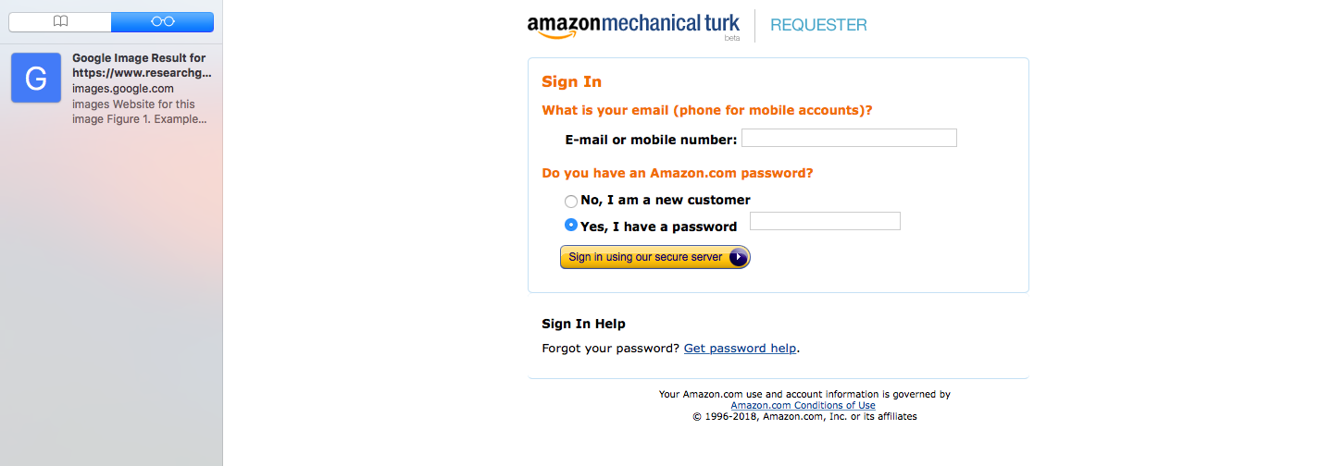

Create the survey link

- After you sign in, press the “Create” tab
- “Press “Survey Link”, because you want to create a job in which you instruct participants to click a survey link and complete the survey.
- Press “Create project”. The following options will now appear.

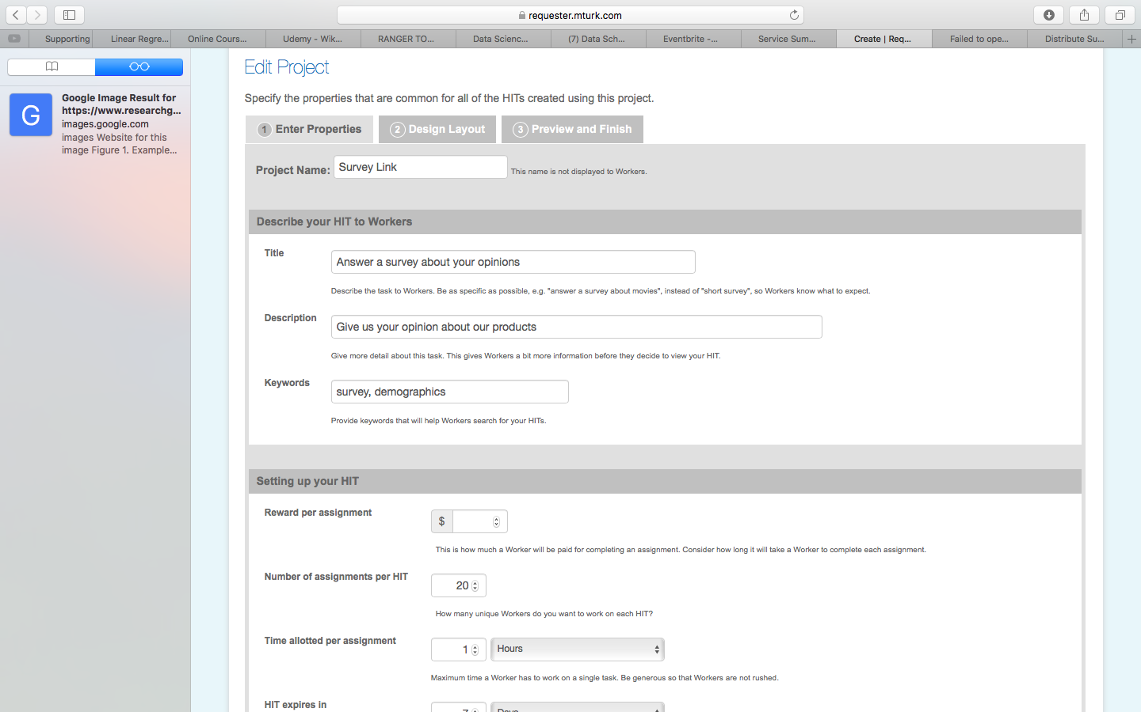

After pressing the tab “Enter Properties”, you need to answer various questions. The following table offers some insights about these questions

Box | Suggestions
Project name | Enter a name for this project, such as “Survey about colds”. Chose a name that helps you differentiate this project from other projects you might develop
Title | Enter a title that is designed to attract participants and is thus appealing, such as “Can you prevent colds: A survey”.
Descriptions | Enter details that could clarify the task for participants, such as “This survey explores which practices might prevent colds and can be completed within 15 or so minutes”
Keywords | Workers can search jobs that align to specific keywords. So, enter some relevant keywords, such as “survey” and “health”.
Reward per assignment | Offer about $4 US to $5 US per hour. For example, workers will tend to receive about $1 US if they complete a 15-minute survey
Number of assignments per HIT | Specify the sample size, such as 200
Time allotted per assignment | This number is the maximum time available for workers. Perhaps enter a number that is about 2.5 to 3 times the typical duration. If a survey can usually be completed within 10 minutes, the maximum should be between 25 and 30 minutes.
HIT expires in | Usually, surveys should be available for about 2 weeks
Auto-approve and pay workers in | The default is 3 days—indicating the worker will be paid automatically in 3 days. Therefore, if the worker has not completed the task properly, you can intervene within 3 days to stop the payment. But, after 3 days, the payment will be dispensed to the worker
Require that workers be masters to do your HITs | If you like, you can restrict the workers to Masters—individuals who have performed very well on tasks in the past. Perhaps you could choose this option initially. If you do not receive enough responses within a reasonable time, you can open the survey to everyone
Specify any additional qualifications Workers must meet to work on your HITS | Click the downward arrow. You can then restrict the sample to  - People of specific age groups, such as 18 to 25, 25 to 30, or 55 an older  - People in specific industries, such as Education, Banking, or Retail  - People who work full time, part time, or not at all  - People who exercise often or not at all  - Males or females  - Right handers  - Parents  - Smokers, and so forth  Likewise, if you choose “Location”, you can restrict the sample to individuals who live in specific nations or regions.

After you press the Design Layout tab, another set of boxes or questions will appear. The following table offers some insights on how to answer these questions.

Box | Suggestions
Survey link instructions | Typically, MTurk will present some default instructions. You could use these instructions. An alternative is…  “This survey is designed to examine…To complete the survey, copy and paste the link below into your web browser or click the link.  At the end of this survey, you will receive a code. Copy this code. Then, you will return to this page. Paste this code in the box below to receive your payment”
Survey link | Enter the survey link here

As these instructions imply, when you construct your survey, you should include something like the following sentence at the end: “To receive payment, please paste the code SAJFSH1624 into the relevant box”.
Finally, after you press the Preview and Finish tab, you merely check the information you entered and then press the button “Finish”. This procedure merely saves the survey but does not send the survey to potential workers.

Send the survey

After you press “Finish”, a screen should appear that lists your project or projects. Alongside the relevant project, press “Publish Batch”. Then

- Preview how the page will appear to potential workers. To edit the information, press Cancel to return to the previous screen and then Edit to modify the instructions
- Press Next
- The next page summarizes the costs.
- If you have not used MTurk before, you will receive a warning that indicates that your account does not include sufficient funds to publish these items. Thus, click “here” and follow the instructions to transfer money into this account, using a credit card.
- Finally, press “Publish” to launch the survey

Other procedures

When using MTurk, here are some other options to consider

- Use the Manage tab to check progress on your projects.
- Rather than SurveyLinks, you can choose Survey to construct your own survey within MTurk.

Evidence

MTurk is one of the most prevalent, if not the most prevalent, source of research participants. Nevertheless, in your papers or thesis, you should probably include some evidence to justify the validity of this approach. Indeed, one of the benefits of MTurk, relative to other alternatives such as Microworkers and Crowdtap, is the magnitude of evidence that has accrued to justify this website. The following table presents some of this evidence. In addition, to read about how to accommodate the limitations of MTurk, perhaps proceed to https://link.springer.com/article/10.1007/s10869-016-9458-5

Reference | Insight
Buhrmester, M., Kwang, T., & Gosling, S. D. (2011). Amazon’s Mechanical Turk: A new source of inexpensive, yet high-quality, data? Perspectives on Psychological Science, 6, 3–5. | In contrast to American college samples and, to a lesser extent standard internet samples, MTurk samples comprise a more diverse demographic profile  When the sample is recruited from MTurk rather than traditional sources, the reliability of measures does not seem to diminish significantly
Clifford, A., Jewell, R. M., & Waggoner, P. D. (2015). Are samples drawn from Mechanical Turk valid for research on political ideology?  Research and Politics, 2. doi: 10.1177/2053168015622072 | The proportion of MTurk workers with liberal rather than conservative ideologies aligns closely to the general population.
Gardner, R., M., Brown, D. L., & Boice, R. (2012). Using Amazon's Mechanical Turk website to measure accuracy of body size estimation and body dissatisfaction. Body Image, 9(4), 532-534. doi: 10.1016/j.bodyim.2012.06.006 | Some health measures—such as the degree to which people tend to overestimate their body size—seem comparable in MTurk workers relative to the traditional samples.
Goodman, J. K., Cryder, C. E., & Cheema, A. (2013). Data collection in a flat world: The strengths and weaknesses of Mechanical Turk samples. Journal of Behavioral Decision Making, 26(3), 213-224. doi: 10.1002/bdm.1753 | Compared to traditional student samples or community samples, MTurk workers tend to generate comparable distributions on many measures. However, relative to these traditional samples, MTurk participants are not as likely to orient attention to experimental materials, are not as extraverted, and may use the internet to locate answers to factual questions, if we correct responses are not rewarded.
Horton, J. J., Rand, D. G., & Zeckhauser, R. J. (2011). The online laboratory: Conducting experiments in a real labor market. Experimental Economics, 14, 399–425. | Whether experimental designs are conducted in laboratories or using MTurk does not seem to diminish validity

Alternative platforms

In lieu of MTurk, some researchers utilize other websites, such as Microworkers or prolific. According to the profilic website https://prolific.co/, profilic offers several advantages over MTurk:

- profilic is specifically designed to administer surveys—and hence, for example, the customer support team can impart relevant scientific expertise
- you can send messages to participants anonymously
- you can more readily conduct studies again on the same participants
- the sample is more likely to be representative of the nation—and you can identify the participants you want more effectively

Also, prolific deduct a smaller fee—only 33% rather than 40%. However, for ethical reasons, prolific ensure that every participant receives at least $6.50 an hour.

