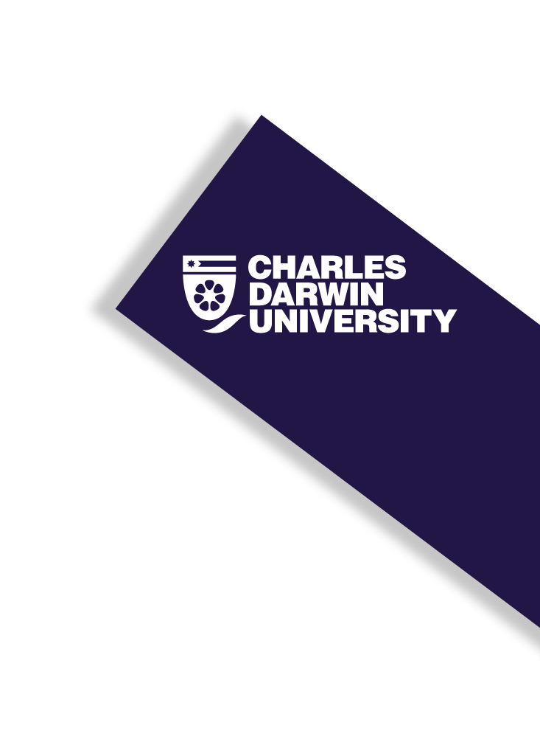
Student Q&A

2019 Higher Degrees by Research Marketing Campaign

Overview
As part of CDU’s marketing campaign to attract students to study their Higher Degrees by Research, the marketing department is seeking students who are willing to share their stories about studying with CDU.
These stories will appear across a range of platforms, including social media and CDU’s website and blog. All material will be provided back to you for approval prior to publishing.

Q&A
To participate, please complete the Q&A below and the marketing department will be in touch. Please be as descriptive as possible!
- Full name: Click or tap here to enter text.

- Student number: Click or tap here to enter text.

- Who is your supervisor? Click or tap here to enter text.

- Email address: Click or tap here to enter text.

- Mobile number: Click or tap here to enter text.

- Do you have any photographs of yourself at work/in the field that you are willing to share? If so, please attach them or if you would prefer, share your social media handles with us. We will never use your images without your express permission.
- Instagram: Click or tap here to enter text.
- Facebook: Click or tap here to enter text.
- Twitter: Click or tap here to enter text.

- What is your research project about? We’d appreciate if you could simplify or provide an explanation for any highly technical information
Click or tap here to enter text.

- How will your research findings make an impact on our world? What are you hoping to improve, change or uncover? We’d appreciate if you could simplify or provide an explanation for any highly technical information. How would you describe it to a 16-year-old?
Click or tap here to enter text.

- Why are you doing your HDR now? What motivated you to apply?
Click or tap here to enter text.

- Why did you choose CDU for your HDR?
Click or tap here to enter text.

- How would you describe your experience of being an HDR student at CDU? Please be as descriptive as possible. Think about the staff, facilities, fellow students and community around you.
Click or tap here to enter text.

- What have been the highlights of being an HDR student at CDU?
Click or tap here to enter text.

- What have been the biggest challenges about being an HDR student at CDU?
Click or tap here to enter text.

- Professionally, what do you plan do to when you complete your HDR?
Click or tap here to enter text.

- What advice would you to someone considering completing their HDR?
Click or tap here to enter text.

- What advice would you to someone considering an HDR at CDU?
Click or tap here to enter text.

Thank you! The marketing team will be in touch!

