USING LINKEDIN TO RECRUIT PARTICIPANTS

by Simon Moss

Introduction

In many studies, researchers need to recruit participants with specific attributes—such as CEOs of mining companies. LinkedIn, a social media platform, can be especially useful in this circumstance, especially if you need to recruit people who belong to a specific occupational category. This document offers some insights on how you can utilize LinkedIn most effectively.

Develop a profile

First, you need to develop a specific profile on LinkedIn. Even if you have developed a LinkedIn profile before, you might need to develop another profile that is specific to your project. In particular, you could

- Visit www.linkedin.com
- If you already have developed a profile, but want to develop another profile, sign out. That is, press Me towards the top and choose Sign out.
- You will then be invited to develop another account or profile: simply follow the instructions; for example, you will need to enter your name, email address, and a password

Enter information that is relevant to your research. The website is quite intuitive to use. The following table outlines some information you should include in your profile as well as some examples or clarifications.

Information to include in your profile | Examples or clarifications
Include a photograph | Insert a photograph that is relevant to your research interests and would be appreciated by your target participants. For CEOs of mining industries, a photograph of a mine or boardroom might be applicable
Summarize your research interests | “I am interested in research on how managers can enhance safety in mines while increasing profitability. The reason I am interested in this topic is that I… “
Indicate your intention to recruit participants | “I have joined this LinkedIn group to listen to the perspectives of mining executives and to seek participants to my research”.
Specify the university for which you are conducting research | Participants often prefer researchers who reside at universities and are thus likely to be independent

Join relevant LinkedIn groups

Next, you should locate, and then join, relevant LinkedIn groups. To achieve this goal

- In the Search box, enter a word that is related to your target population, such as CEOs or mining companies
- You should receive something that resembles the following screen

- Click the option More near the top right. Then select Groups.
- Hopefully, a list of potential groups will appear
- Click a relevant group and then select Request to join.
- For all relevant groups, repeat this procedure.

Promote your research to the group

If these groups approve your request to join, you can then access these groups. Specifically, press “My network”. On this page, you should be able to choose “Groups” as well. After you click a group, a page will appear, resembling the following example.

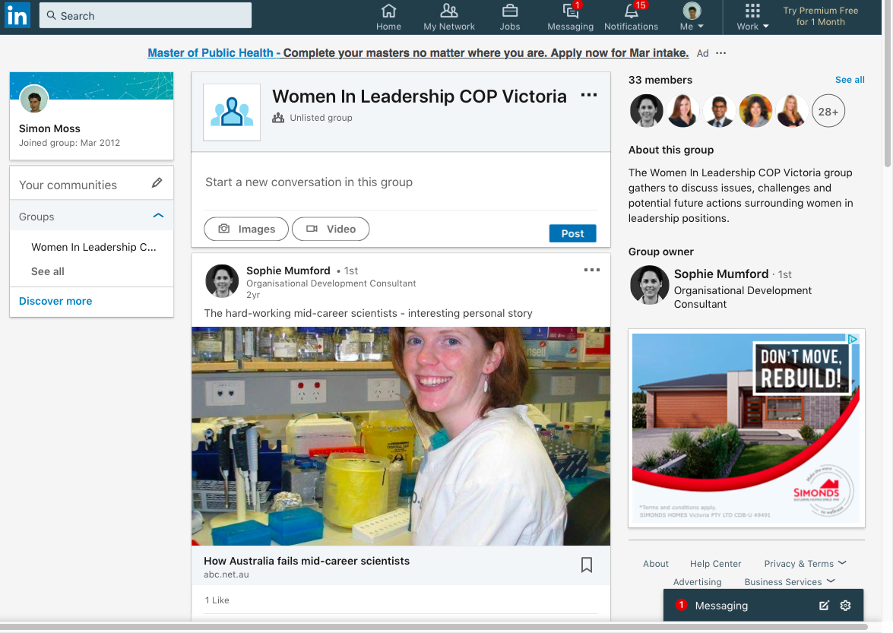

You should now promote your research to this group. The following table outlines how you could achieve this goal

Activities to undertake | Examples or clarifications
In the space above the button “Post”, seek opinions about your research. | “I am interested in studying how managers can enhance safety in mines while increasing profitability. Do you feel this issue is important? What other issues are vital to mining executives at this time?  Frank Smith”
After you have developed some rapport, you could now invite individuals to participate in your research—or to promote this research to their employees | “Thank you for all your feedback about my research into safety and profit in mines. If you are interested in this issue, could you either  - complete this 10 minute survey by clicking www.qualtrics.com/dip_sd932s_sde or  - invite other employees to complete this survey.  For example, you could write to employees “If you would like to support research into safety and profit in mines, please click this link--www.qualtrics.com/dip_sd932s_sde – to complete a 10 minute survey”

Connect to relevant individuals

Furthermore, if you like, you could also invite relevant individuals to connect to your profile. You could then advertise your survey to these individuals. The following table outlines how you could achieve this goal.

Information to include in your profile | Examples or clarifications
In the Search box, enter a word that is related to your target population | You might enter CEO mines”
Click the option People

Press Connect to invite relevant people to connect to your profile
Choose “Add a note” to write a personal message | “Dear Stacey  I am conducting research on how to assist CEOs of mines. If at all interested in joining this research network, feel free to approve my request  Frank Smith”
Once someone approves your request, send an invitation to prompt individuals to participate | “Thank you for connecting to this research. If you would like to support research into safety and profit in mines, please click this link--www.qualtrics.com/dip_sd932s_sde – to complete a 10 minute survey  Frank Smith”

Caveats

You should be aware of several caveats. For example

- you might inadvertently recruit participants who are not relevant to your study. Therefore, in the invitation, you could specify the population of interest. Or, in the survey, you could include questions that assess the suitable of participants

References

Dusek, G. A., Yurova, Y. V., & Ruppel, C. P. (2015). Using social media and targeted snowball sampling to survey a hard-to-reach population: A case study. International Journal of Doctoral Studies, 10, 279-299.

Watters, J., & Biernacki, P. (1989). Targeted sampling: Options for the study of hidden populations. Social Problems, 36(4), 416-430.

