HOW AND WHY TO INCREASE THE ENGAGEMENT AND IMPACT OF YOUR RESEARCH

by Simon Moss

Introduction

If you want to thrive in research, especially at universities, you need to appreciate the goals these institutions strive to achieve. To illustrate, in Australia

- the financial position of many universities is often fragile
- consequently, these universities need to increase their revenue
- one of the best sources of revenue are international students
- but many international students gravitate to universities that are perceived as prestigious and ranked as a top institution

Several measures have been applied to rank universities, such as the Academic Ranking of World Universities, the QS World University Rankings, the Times Higher Education World University Rankings, and CWTS Leiden Ranking. The appendix of this document outlines the algorithms these bodies apply to calculate these rankings. Interestingly, all these rankings depend more on the research productivity, instead of the teaching capacity, of universities. Therefore, to attract international students, and to improve their financial position, universities need to enhance their research.

ERA versus EI

So, how is the research of universities evaluated? Each ranking scheme utilises distinct formulas. Australian universities tend to prioritize the schemes that were developed by the Australian Research Council. In particular, the Australian Research Council applies two schemes to evaluate the quality of research at universities.

- The first scheme is called Excellence in Research for Australia or ERA.
- The second scheme is called the Engagement and Impact Assessment or EI.

Roughly speaking, ERA is designed to evaluate the quality of research that a university produces. EI is designed to evaluate the degree to which researchers engage with end users as well as the impact of this research on individuals, families, organizations, communities, and nations

- specifically, engagement refers to the degree to which researchers interact with end users—that is, individuals, organizations, or communities outside academia that could benefit from this research
- in contrast, impact refers to the extent to which the research benefits the economy, society, environment, or culture outside academia

If you understand these schemes, you may be more likely to initiate activities that could increase the likelihood you will be sought and employed by other universities. This document thus outlines these schemes. Furthermore, this document offers some insights into how you develop the attributes that universities are seeking.

ERA

ERA evaluate the quality of research that a university produces. In particular, this scheme assigns a number, from 1 to 5, to every discipline within a university. The following table clarifies how to interpret these numbers.

ERA | Interpretation
1 | - average performance well below world standard
2 | - average performance below world standard
3 | - average performance at world standard
4 | - average performance above world standard
5 | - outstanding performance—well above world standard

To illustrate

- if the Mathematics discipline scored a 3, their research, on average, is deemed to be equivalent to world standard
- if the Mathematics discipline did not receive any score, this workgroup did not reach the threshold of enough published research
- for most disciplines, if the workgroup published fewer than 50 papers, they do not reach this threshold and, therefore, do not receive any score.

Evaluation

So, how does ERA evaluate the quality of research that is published by universities? What measures or information do they utilise to evaluate this quality. To some extent, the measures or information they utilise varies across disciplines. Nevertheless, the following table outlines the measures that are applied in many disciplines.

Measure | Discipline | Publications are assumed to be higher in quality if…
Citation analysis | - Most sciences | - the publications are cited frequently
Peer review | - Mathematics  - Most humanities and social sciences | - peers evaluate these publications as high in quality  That is  - other academics may read 30% of outputs  - they evaluate the quality of these publications
Research income | - All disciplines | - Category 1 grants: competitive government grants such as ARC and NHMRC  - Category 2 grants: other public-sector research income  - Category 3 grants: industry and other research funding  - Category 4 grants: cooperative research centers
Patents | - Most disciplines, especially the sciences | - the university has arranged many patents
Commercialisation | - Most disciplines | - the research has been commercialized—such as converted to products, services, or programs that attracted a revenue

EI: Engagement and Impact

Besides the ERA ratings, each discipline in the university also receives three EI ratings, provided the number of publications exceed some threshold. The following table outlines these ratings. As this table implies, each discipline can receive a rating—that is, high, medium, or low—on engagement, approach to impact, and impact.

Measure | Interpretation
Engagement | - High: researchers and end users exchange knowledge, technologies, methods, and resources very effectively to the benefit of all parties  - Medium: researchers and end users exchange knowledge, technologies, methods, and resources quite effectively to the benefit of all parties  - Low: limited evidence of beneficial exchange in knowledge, technologies, methods, and resources between researchers and end users
Approach to impact | - High: the workgroup have introduced very effective mechanisms to translate research into benefits outside academia  - Medium: the workgroup have introduced quite effective mechanisms to translate research into benefits outside academia  - Low: the mechanisms designed to translate research into benefits outside academia are not effective or embedded
Impact | - High: The impact of this research outside academia was highly significant  - Medium: The impact of this research outside academia was quite significant  - Low: The impact of this research outside academia was limited or negligible

To receive a rating on engagement, the discipline must submit a narrative that illustrates engagement between the research and end user as well as quantitative data, such as cash support from partners. To receive a rating on impact, the discipline submit case studies on how the research benefited society or communities as well as how the institution facilitated the translation of research into impact.

Measures of engagement

To measure engagement, universities need to supply narratives about how they engaged various end users as well as more objective information about performance. The following table outlines some of the activities or features of universities that generate high scores on the engagement measure.

Activities or features | Details
Engagement with stakeholders | - Co-location of industry partner on campus  - Staff exchanges between university and industry partner  - Conferences and workshops in collaboration with an industry partner  - Development of university business units, such as a consulting arm or unit that helps academics engage with industry  - Citizen science in which volunteers assist with research
Offers to stakeholders | - Opportunities to enable stakeholders to access to specialised equipment, infrastructure, and resources at the university  - Specialist advice to industry  - Development of training workshops, webinars, and videos
Cash support from end users | - Amount of cash that end users, such as industry partners, distributed to the university to conduct research—especially Category 1, 2, 3, and 4 research. This amount is represented as both an absolute figure and as a portion of all research income  - This amount is assumed to signify the degree to which industry is engaged with the research of this university
Research commercialisation income | This income is defined as the aggregate of  - income derived from subsidiaries owned by the institution  - income from spinoff companies  - income from license and options
Other information | - Awards  - Book sales  - Patents  - Alternative metrics, such as website visits and social media posts

Examples of engagement

The previous table outlined the key activities that affect engagement measures. The following table clarifies these practices in more details.

Strategy or method | Details
Collaboration with stakeholders
Co-location on campus | - Industry partners are often invited to locate some or all their operations on the university campus—although university staff might relocate to industry settings instead  - Co-location enables more regular exchange of solutions, capabilities, and materials to solve relevant problems  - Universities developed criteria to decide which partners to invite—usually partners that overlap with their research strategy
Staff exchange or embedding | - When staff were embedded within an industry—or staff were exchanged between universities and industries—several benefits unfolded.  - First, the academics could appreciate the industry setting more intimately  - Second, industry staff, embedded within research settings, imparted advice on how the research could accommodate industry needs and perspectives better  - Senior academics should also assume positions on industry boards
Conferences and workshops that relate to industry | - Some conferences and workshops were collaborations between universities and industry partners in which knowledge, research, and feedback was shared
Development of university business units | - Some universities have established specialized business units to impart the skills that are needed to foster collaborations between universities and end users  - These units were sometimes dedicated consulting arms of the university to impart advice to industry, sometimes providing a single point of contact to support partners
Public participation
Citizen science | - Collaborations with public volunteers in which individuals participate in the collection of data, the analysis of data, and crowdsourcing of ideas, art, and coding  - These arrangements harness the interests and hobbies of individuals or associations  - Audiences includes school children, teachers, hobby clubs, and environmental agencies  - These arrangements demand careful planning to divide broader programs into specific tasks  - Social media, TV, and radio are used to attract audiences
Provide specialist resources and services
Access to specialised equipment, infrastructure, and resources | - Universities might offer access to laboratories, field testing, and other facilities  - For example, defense forces, emergency services, environmental agencies, and a range of private organizations were granted this access.  - Both the university and industry partners invested in the maintenance of these services
Specialist advice | - Academics also offered specialist advice to industry
Specialist training or trainee programs
Training workshops, webinars, and videos | - Universities offered training on technology, updated standards, and recent methodologies  - Examples included the provision of updated teaching standards to schools, often using virtual reality or augmented reality

Examples of impact

When delineating the impact of key studies, universities refer to a range of considerations. The following table illustrates some examples of how research can affect the society.

Impact | Details or examples
Delivering the latest technologies | - Universities often commercialized their technology across STEM fields  - They often developed these technologies in partnership with government, business, or community beneficiaries
Community support and safety | Examples include  - improvements in safety and health standards  - advanced defense technologies  - changes to legal and sentencing practices  - advances in medical treatments
Improving everyday life | Examples include  - education campaigns to promote health behavior  - improved management of the environment  - better urban and transport planning
Fostering communities | Universities implemented strategies to improve community resilience and cohesion such as  - parenting programs  - support for ex-service members
Addressing challenges affecting society | Universities introduced programs that address social problems and issues such as  - climate change and environmental management  - food security  - economic efficiency  - cultural preservation in Aboriginal and Torres Strait Islander communities

Approach to impact

Universities must also delineate the approaches they apply to enhance the impact of their research on society. The following table outlines some of the approaches that universities have adopted.

Approach to enhance impact | Details or examples
Events that enable researchers to engage with stakeholders | For example, universities  - convened business forums that displayed research achievements to industry leaders  - organized workshops around specific research projects and findings to include the contributions of communities  - used media and public seminars to engage the general public on relevant topics
Government engagement | - Engagements with local, state, and federal levels clarified the strategic direction of projects as well as uncovered joint funding opportunities  - Lead researchers contributed to government committees and reference groups—to discuss issues around policy and shortfalls in knowledge.  - Similar events were convened in concert with local councils
Staff placements within industry or vice versa | - External partners, such as government agencies worked within universities and research groups.
Research agreements | - Universities organized MOUs, joint ventures, and other agreements to help the institution collaborate with industry partners to achieve a shared goal

How to demonstrate the impact of your publications

In several circumstances, researchers may want to demonstrate the impact of their work. In particular, researchers may utilise indices that measure the impact of their publications. For example

- when universities submit cases studies on how the research benefited society or communities, they might like to buttress these submissions with objective measures of impact
- when researchers seek other roles or promotions, they might want to demonstrate the impact of their research
- when researchers apply to secure grants, they are sometimes granted opportunities to present these indices to defend their track record

Researchers can cite a variety of metrics to demonstrate the impact of their research publications. The two most common sets of metrics are called PlumX and Altmetrics. These metrics are simple to produce. For example, PlumX are available from the database of publications called Scopus. In particular, to access these metrics

- visit https://www.cdu.edu.au/library
- click “Databases”. From the top row, choose S and then select “Scopus”
- you may need to use your email address and password to sign in
- in the search box, enter part, or all, the title of your publication, such as “future clarity”. After you press “Search”, a list of publications should appear

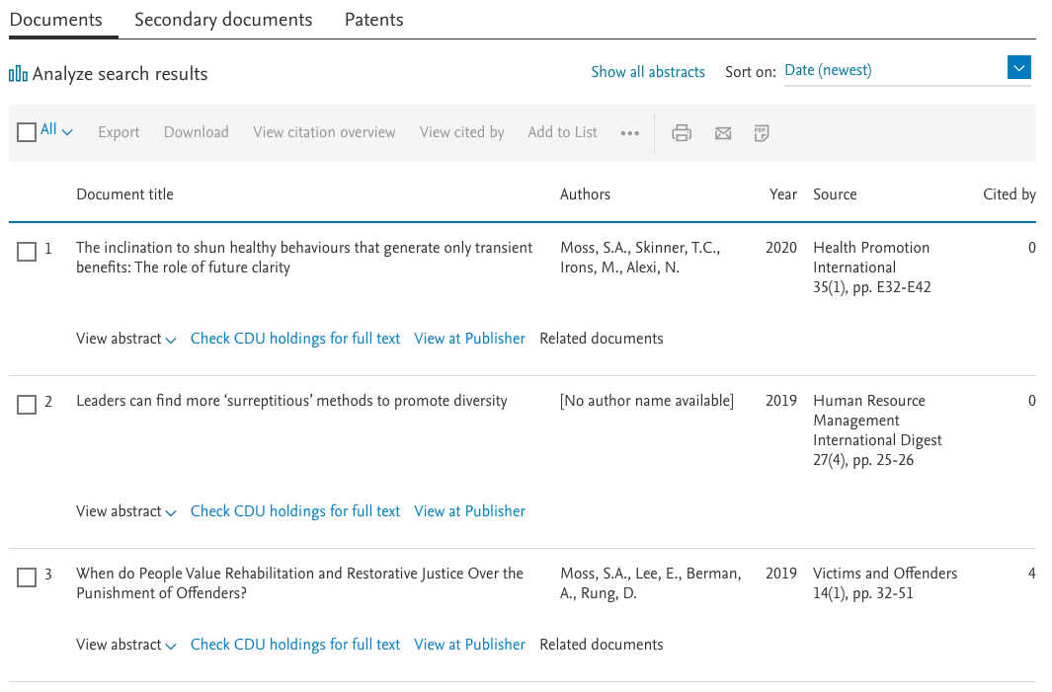

- Next, click the title that corresponds to the publication you want to analyse, such as “The inclination to shun healthy behaviours…”
- Finally, click the small, orange downward arrow that appears to the right of this screen, close to “PlumX Metrics”.

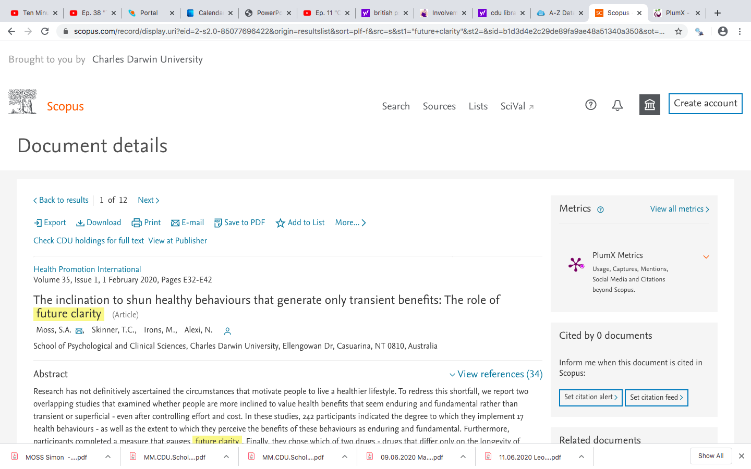

Often, after you press this arrow, a series of metrics appear. The following table outlines some of the metrics that can appear. However, metrics that equal 0—such as zero mentions in Twitter—will not appear.

Categories of measures in PlumX | Specific examples
Citations | - Number of citations from policies  - Number of citations from the National Institute for Health and Care Excellence  - Number of citations from PubMed Clinical Guidelines  - Number of citations from the United States Patent and Trademark Office  - Number of citations from journals in Scopus and other databases
Usage | - The number of times the abstract has been viewed  - The number of times the url of this publication has been clicked  - The number of times the publication has been downloaded  - The number of times the full text of this publication has been viewed
Captures | - The number of times this publication has been bookmarked  - The number of times this publication has been marked as a favourite—in websites like Youtube, Slideshare, and SoundCloud  - The number of times this publication has been followed in Github  - This number of times this publication has been exported to bibliographic management tools
Mentions | - The number of blog posts wrote about this publication  - The number of comments about this publication in Reddit, SlideShare, Vimeo, and Youtube  - The number of reviews written about this publication in Amazon, Goodreads, and SourceForge  - The number of references to this publication in Wikipedia  - The number of mentions about this publication in Stack Exchange
Social media | - The number of times a link about this publication was shared, liked, or broached in Facebook  - The number of upvotes, relative to downvotes, on Reddit about this publication  - The number of tweets and retweets that mention this publication  - The number of recommendations this publication has received on Figshare or SourceForge

Besides PlumX, some researchers derive similar metrics from Altmetrics instead. To access Altmetrics

- visit https://app.dimensions.ai/discover/publication
- enter part, or all, the title in the search box, usually located towards the top of this webpage
- click the relevant publication, generating something like the following screen

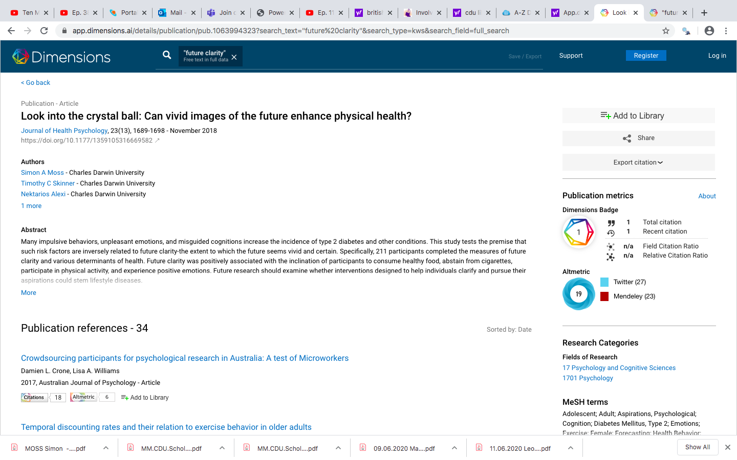

- press the Altmetric symbol to generate the following screen
- like PlumX, these metrics indicate the degree to which the publication was mentioned in social media, accessed from websites, stored in reference management systems, and so forth
- Altmetrics also displays other information, such as the nations in which the publication was mentioned

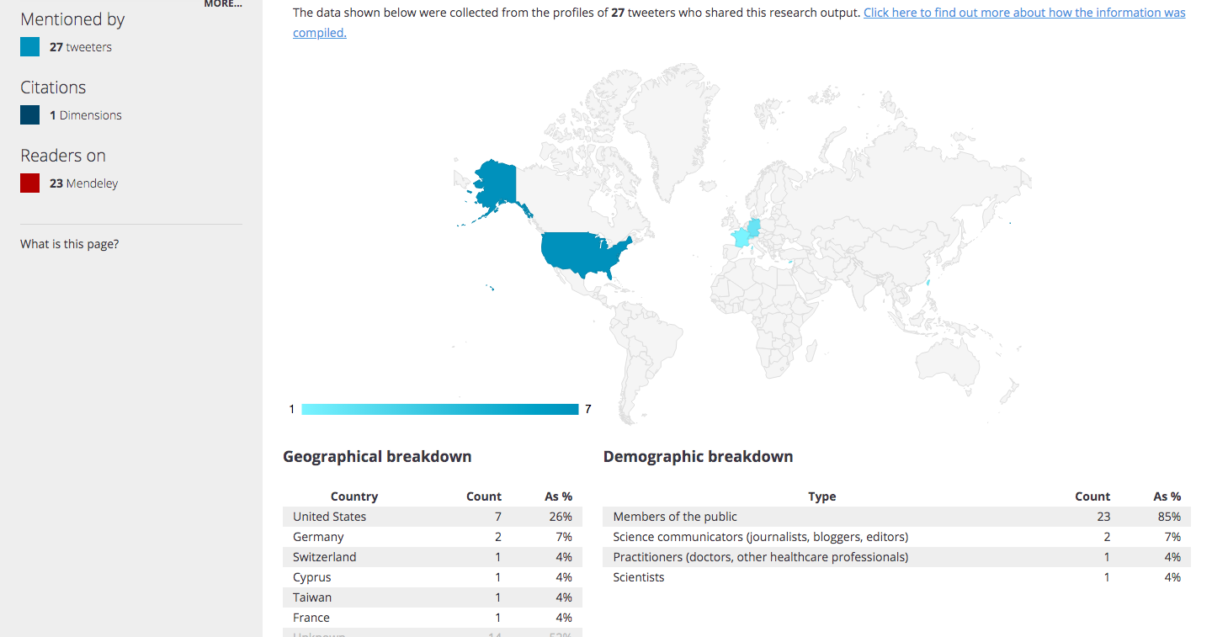

You should also seek advice on how to improve your ratings on these publications. For example

- tweet during the most active time of day, usually in the afternoon in Australia
- insert two hashtags into each tweet

Translational research

In short, this discussion on ERA and EI offers some insight into how researchers can become attractive to universities. Specifically, as this discussion implies, researchers should

- increase the degree to which their work is cited; another document in this series offers insights into how researchers can attract more citations
- increase their capacity to attract funding; another document in this series offers insights into how researchers can attract funding
- commercialise their research—in which the insights that emanate from a research project are converted to commercial products or services; another document in this series offers insights into how researchers can attract funding
- learn how to translate their research into practice—in which the insights that emanate from a research project or program inform the policies and practices of governments and other organizations.

The rest of this document primarily revolves around how researchers can translate their research into practice, sometimes called translation. In previous decades, research programs tended to be subdivided into two realms: basic and applied. Specifically

- basic research was primarily conducted to satisfy curiosity about science and to pursue fundamental questions about the world—such as the structure of genes
- applied research utilized the insights derived from basic research to solve problems in society.

Yet, over the last couple of decades, scholars have challenged this division between basic research and applied research. The reason is that

- many, if not most, great practical inventions were fortuitous offshoots from explorations into one phenomenon that generated implications to solve a seemingly unrelated problem
- hence, scholars who conduct basic research need to be sensitive to applied implications as well—a sensitivity that could diminish if basic research and applied research is separated
- likewise, applied researchers need to be involved in basic research, otherwise their attempts to solve a problem could be premature. That is, they might attempt to solve a problem, such as treat schizophrenia, before the basic knowledge about this disease is adequate
- if researchers abandon their research, hoping other individuals will apply their insights, these ideas are seldom implemented.

As these considerations imply, if scholars conceptualise basic research and applied research is separate, problems can unfold. Instead

- researchers should not define themselves as only basic researchers or as only applied researchers
- researchers should be interested in basic research and applied research; that is, they should be interested in exploring, and then applying, fundamental questions to solve practical matters
- this mindset is sometimes called translational research.

The notion of translational research emanated from the health and medical field. In this field, translational research entails five phases: basic research, pre-clinical research, clinical research, clinical implementation, and public health. This model diverged from previous conceptualisations of health research in that

- these phases are not necessarily implemented in sequence but overlap and affect one another
- research includes efforts to facilitate implementation, such as policy change, and efforts to improve public health, such as communication strategies
- thus, exemplary research projects should include activities that are designed to update polices and communicate effective health practices
- each of these five phases entail three main activities: the development of novel approaches, the evaluation of these approaches, and the dissemination of findings

Therefore, to thrive in research nowadays, individuals need to be translational researchers. That is, they should be able to shift between basic research and applied research. The following table outlines some of the characteristics that enable researchers to be translational researchers.

Quality of translational researchers | Details or examples
Lifelong learning about many topics from many perspectives | - Unlike researchers of the past, who tended to restrict their attention to a confined topic, translational researchers need to be curious about many topics  - They need to be competent in understanding, evaluating, and discussing many varieties of research  - They need to be able to communicate to many segments of the population; health researchers, for example, need to be able to adapt their language to communicate their perspectives to epidemiologists, geneticists, patients, and so forth
A multi-disciplinary mindset | - Insights are seldom applied effectively unless the researchers who uncovered these insights also implement these insights  - Yet, researchers cannot complete all the phases alone and must collaborate with individuals from other fields and disciplines  - They need to conduct multi-disciplinary research, inter-disciplinary research, and trans-disciplinary research  - That is, when conducting multi-disciplinary research, researchers from each field convey their perspective but do not interact closely  - When conducting inter-disciplinary research, the researchers from each field affect one another; that is, researchers adapt or improve their own approaches as they work in collaboration with other disciplines  - When conducting trans-disciplinary research, the researchers transcend their own fields; in essence, they develop an approach that is novel  - To cultivate this mindset, researchers should attend more events, or listen to more podcasts or speeches that seem unusual but interesting and diverge from their discipline
A personal connection to the problem | - Translational researchers should become very familiar with the problems they are striving to solve  - They might, for example, relate their work to the experiences of loved ones or themselves—such as a disease of a sibling  - This connection to the problem tends to inspire the effort and persistence that translational research demands

Limitations to translational research

Although funding bodies often award translational research, many institutions inadvertently deter this approach. For example, if academics confine their work to a niche, they are often more likely to publish effectively and thus more likely to attract promotions.

Policy cycles

To translate research into policy, especially government policy, you need to understand how policies evolve. That is, you need to understand what is sometimes called the policy cycle. To illustrate, a book called the Australian Policy Handbook, written by Peter Bridgman, Glyn Davis, and Catherine Althaus, distinguish eight phases. The following table outlines these phases. In practice, these phases are not always implemented in sequence. For example, the final phase, evaluation, often informs the first phrase, identification.

Phase of the policy cycle | Details or examples
Identification | - At some moment, some problem or concern suddenly appears important to government and thus becomes a policy issue  - For example, governments might suddenly become more concerned about the welfare of international students  - A public institution, such as a particular government department or agency, is then assigned the responsibility to address this issue  - The aim of researchers, at this time, is to demonstrate the importance, prevalence, implications, or cost of some problem
Analysis | - Specialists in government policy—or sometimes consultants and other individuals—attempt to uncover data and information that can be used to guide the scope of this problem.  - In particular, they tend to delineate the problem, clarify the goals and objectives to be fulfilled, identify the constraints or parameters—such as costs and timelines, seek alternatives to solve or circumvent this problem, and propose initial solutions or possibilities to explore.  - This phase might resemble a review of the literature around this policy  - Researchers may be able to contribute to this analysis and review
Instruments | - Government specialists must then consider the methods and avenues that are available to achieve some policy objective and address some problem.  - For example, they may consider how they harness advocacy, money, resources, or legal authority to shape behavior and actions  - They might also consider which agencies or organizations could deliver the necessary changes.
Consultation | - The government will then consult individuals who are the targets of this policy as well as interest groups, think tanks, research associations, specialists in public service, parliamentary committees, and so forth  - This consultation is not usually confined to a single period but persists during most of the policy cycle
Coordination | - Relevant individuals in the public service will then attempt to collate, as well as integrate, all the data and information to support decision makers
Decision | - Governments and ministers then need to reach decisions about which actions to implement and policies to change
Implementation | - Changes to policies need to be planned carefully to be implemented
Evaluation | - Governments and public service must evaluate whether these changes are appropriate and efficient.  - In addition, they must evaluate the degree to which the various policies are coherent and useful as a set

As this policy cycle implies, researchers need to offer different advice, depending on which phase is most prominent. To illustrate

- during the identification phase, members of parliament and advisors are most sensitive to information about the importance and prevalence of some issue
- during the analysis phase, policy makers are attuned to information about the range of solutions or perspectives
- during the consultation phase, policy makers are attuned to information on which solutions are the most effective and the most accepted

But, how can researchers contribute to this policy cycle? What opportunities can they harness to interact with the relevant individuals? Unfortunately, no one approach has been shown to be effective. Yet, researchers should

- gradually develop a portfolio of insights or ideas they could offer various organisations or governments
- attend committee meetings or functions of relevant associations, NGOs, and so forth
- during these opportunities, when meeting people, they should describe the key problem they are striving to solve in their research; but their main goal is to develop relationships and learn about the needs of these organizations
- start to promulgate their insights and solutions on social media

Appendix A: Rankings

The following tables present information on how the universities are ranked. Specifically, each table corresponds to a distinct ranking scheme

Academic Ranking of World Universities or ARWU
Criteria | Details or examples
Quality of education | - Number of alumni as Nobel laureates & Fields Medalists
Quality of academics | - Number of staff as Nobel laureates & Fields Medalists  - Number of very highly cited researchers
Research output | - Number of publications in Science or Nature  - Number of papers
Per capita performance

QS World University Rankings
Criteria | Details or examples
Academic peer review (40%) | - Academics around the world complete a survey about their perceptions of this university  - These academics answer questions only about their discipline.  - For example, environmental scientists will evaluate the environmental department of each university
Ratio of staff to students (20%) | - Refers to the number of staff at the university relative to the number of students
Citations (20%) | - The number of times publications from the university are cited relative to the number of research-active staff
Employer review (10%) | - Employers rate their perceptions of graduates from this university
International student ratio (5%) | - The percentage of students who are international
International staff ratio (5%) | - The percentage of staff who are international

Times Higher Education World University Rankings
Criteria | Details or examples
Income from industry | - Research income from industry for each academic staff member
International diversity | - Ratio of international to domestic students  - Ratio of international to domestic staff
Teaching reputation | - Derived from a survey
PhD completion | - Number of PhD completions per academic
Undergraduates | - Number undergraduates per academic
Teaching income | - Amount of teaching income per academic
Research reputation | - Derived from a survey
Research income
Publications | - Publications per academic staff and per research staff
Citations | - Average number of citations per publication
For these rankings, teaching reputation, research reputation, and citations are ranked most heavily.

