TRANSCRIBING

by Simon Moss

Introduction

When recording interviews, focus groups, or other spoken words, one of the most laborious, but important, activities is to transcribe this material into text. The vast majority of qualitative researchers will convert their audio files into written text—primarily so they can later code and analyse these data systematically. This document offers some insights about how to transcribe audio files effectively.

Benefits of transcription

Not all researchers transcribe the data. That is, not all researchers convert their audio files into written text, such as a Microsoft Word documents. Nevertheless, transcription does benefit researchers. The following table outlines these benefits.

Benefit | Details
Reduces bias | - If researchers derive their conclusions from their memory of interviews—or from merely listening to the audio recordings—their attention tends to be directed to answers they already perceived as significant.  - The conclusions of researchers, therefore, may be biased towards their preconceptions or preferences.
Systematic analysis | - The transcribed data could be subjected to more systematic analyses  - For example, the words can be subjected to software packages that utilize techniques, such as latent semantic analysis, to uncover themes
Sharing | - After interviews or other audio recordings are transcribed, the researcher can more readily share these data with co-researchers, reviewers, and other stakeholders

Drawbacks of transcription.

The main drawback of transcription revolves around the duration of this task. Typically, to transcribe each hour of audio, you need to devote 6 to 7 hours to this task. If you want to record only the words, and no other features, sometimes 3 hours is sufficient. If you want to include as many details as possible, such as interjections and changes in tone, 10 hours might be necessary (Bailey, 2008).

Overview of transcription

Researchers often assume that everyone applies the same practices, or observes the same principles, to transcribe data. Yet, researchers can apply a range of practices and principles, depending on

- the research question
- the research methodology
- the preference of researchers and
- many other considerations (for a seminal discussion of this topic, see Ochs, 1979)

Unfortunately, researchers seldom report these practices or principles with precision and, therefore, this variability is often overlooked (Azevedo et al., 2017). The following table outlines some of the key variations across researchers. In this table, each row presents two conflicting perspectives that researchers can espouse

One perspective | An alternative perspective
Transcription is objective. Some researchers conceptualise the transcriber as like a machine that converts spoken words to written text, devoid of emotion or intuition. This perspective assumes the values and experiences of transcribers should not affect their transcription. | Transcription is subjective. Other researchers recognize that transcribers are not unemotional machines but instead utilize their experience and intuition to interpret and transcribe the data. Consequently, if two researchers transcribe the same data, discrepancies between these researchers do not necessarily imply an error but could emanate from distinct interpretations
Naturalized transcription. Some researchers do not only transcribe the spoken words but also attempt to characterize the context or circumstances—such as pauses, stutters, coughs, the surroundings, the mannerisms of each person, and so forth. Conversation analysis, discussed in this document, epitomises this approach. | Denaturalized transcription. Other researchers direct their attention only to the spoken words, called denaturalized transcription (see Bucholtz, 2000)
Comprehensive transcription. Some researchers, especially if they adopt a naturalized approach, tend to transcribe all speech, including repeated words | Selective transcription. Some researchers, especially if they adopt a denaturalized approach, will exclude repeated words, repeated sentences, false starts, interruptions, encouragements, and other speech they perceive as extraneous to their purposes (e.g., Sandelowski, 1994)

Some approaches are more compatible with specific methodologies. For example, if you adopt a constructivist approach to research

- you presuppose that researchers cannot uncover or represent one true, objective reality
- consequently, you should assume that a transcribed file should not be regarded as the one true, objective representation of an interview (Lapadat, 2000)

Similarly, to decide whether to apply naturalised transcription or denaturalized transcription, consider these principles:

- if you plan to conduct discourse analysis, naturalised transcription is suitable, because the context will shape the conclusions that researchers unearth
- if you plan to conduct a variant of content analysis, denaturalized transcription is sufficient, because the context seldom shapes the themes that researchers uncover (see Nascimento & Steinbruch, 2019)
- if you plan to apply member checking, in which participants are granted opportunities to review the transcripts, naturalized transcription is inappropriate. Participants may feel uncomfortable if they read descriptions about themselves (Oliver et al., 2005).
- You may construct and store both a naturalised transcription and a denaturalised transcription—and then utilise the version that is needed at a particular time (Oliver et al., 2005).

Despite this variation, most researchers who transcribe spoken words to written text apply a particular sequence of phases (see Azevedo et al., 2017). The following table outlines these phases.

Phase | Outline
1 Preparation | - Organize back-up copies of your audio recordings—and record these copies on a separate device to diminish the risk of loss  - Consider other equipment; some researchers, for example, utilise a foot pedal to pause and play the audio recording as they transcribe  - Prepare the document in which you will record the text—such as a Microsoft Word file  - On this file, you might record other details, such as the name or pseudonyms of the interviewer, the interviewee, and the transcriber as well as the setting or location
2 Familiarisation | - Many transcribers listen to the audio in full before they transcribe; this experience facilitates their capacity to interpret the material as they transcribe  - Some transcribers also read all field notes—observations and insights recorded during the interview or other events—to also facilitate interpretation
3 Transcription | - Convert the spoken words into written text  - During this phase, do not be too concerned about other information, such as punctuation, formatting, or records of events, such as interruptions, initially  - Nevertheless, develop and utilize a set of codes to help you record common events, such as interruptions  Usually, researchers transcribe the audio themselves, partly because transcription helps these individuals understand and immerse themselves in the data. However, researchers may instead  - organize someone else to transcribe the data—such as a professional service  - utilize software to transcribe the data
4 Edit | - Correct the initial draft of written text  - For example, include punctuation, uppercase letters, and descriptions of events  - Record errors you observed as well.
5 Review | - Compare the transcribed file—that is, the written text—with the original recording  - Correct errors you identify  - If possible, ask someone else, preferably the interviewer or collaborator, to assist this review

Resources to facilitate transcription: A codebook

To represent pauses, mistakes, interruptions, mannerisms, events, and other features, you should develop a set of codes, called a codebook. Codebooks are especially vital if you adopt a naturalised approach. Each researcher will develop a unique codebook. Nevertheless, many researchers use the symbols that appear in the following table.

Example | Interpretation
I agree (laughs gently) | - Describe emotions and behaviours in brackets
I agree but (…) I think | - Utilise (…) to represent pauses
Hmm. I agree. Mm. But I am not sure. Ah, I know why- | Strings, such as Hmm, Mm, and Ah, represent interjections that resemble the sounds that speakers emit
I know why- | - Hyphens represent interruptions
I tend to argue (agree) | - The word in brackets can indicate the term that researchers assume the participant intended
I tend to (agree) | - In brackets and italics, researchers tend to insert the word they believe, but are not sure, the participant articulated

You might also develop codes to fulfill other purposes. For example, researchers may utilise codes to label the interviewer, setting, or other information

Resources to facilitate transcription: The Transcription capabilities of Word online

Microsoft has developed a function in Word that can transcribe interviews, focus groups, and other speech data. At this time, this capability is available only in Office 365—but is accessible to all researchers and research candidates at this university. This section clarifies how you can utilise this service. Other software can also fulfill this purpose.

Access Microsoft Word from Office 365

To access Word from Office 365, you need to be connected to the internet. Then, you should

- first visit portal.cdu.edu.au to generate a screen that may resemble the following example; your screen may present fewer tiles, however
- click the tile labelled “Office 365”—the tile surrounded by a yellow square in this example
- a page should appear that comprises a column of icons

You should then click the 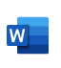 icon to access Word online.

Locate and utilise the transcription function

After you access Word, a screen that resembles the following example should appear. To activate the transcription function

- press the downward arrow next to the microphone icon
- two options should appear; choose “Transcribe”

Upload the speech data

After you choose this option, the following screen should appear. You should now

- select “Upload audio” to upload an audio file—such as an .mp4 or .wav file that you recorded earlier and saved
- or you can select “Start recording” to record an interview or speech now

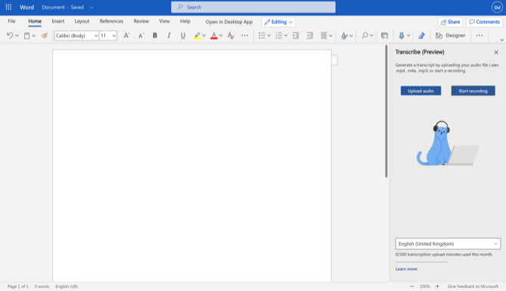

Once the speech is uploaded or recorded, Word will convert these data to text. You might need to wait a while. But eventually, the text should appear on the left side of your screen. You can then press an option “Add to document” to shift this text into a Word document.

Benefits and limitations to this service

This service is free to anyone who can access Office 365. The transcription is surprisingly accurate. You should, however, listen to your recording again, primarily to correct possible errors. Furthermore, you should be aware of other limitations

- at this time, you can transcribe up to five hours a month—although this limitation might be lifted in the future
- if the quality of audio is deficient, the transcription might not be as accurate

OTTER and other tools

Many other tools have been developed to facilitate transcription, such as OTTER. OTTER is free, although paid versions include more features. To use OTTER

- visit https://otter.ai/
- you can then press “Get started” to access this tool; you will gain access after entering your email address and a couple of other details
- after you enter these details and open the app, a display that resembles the following screen will eventually appear
- if you press “Record” and then speak, the audio will be converted to text almost instantly
- you can later access this text, select “My Conversation” on the left side

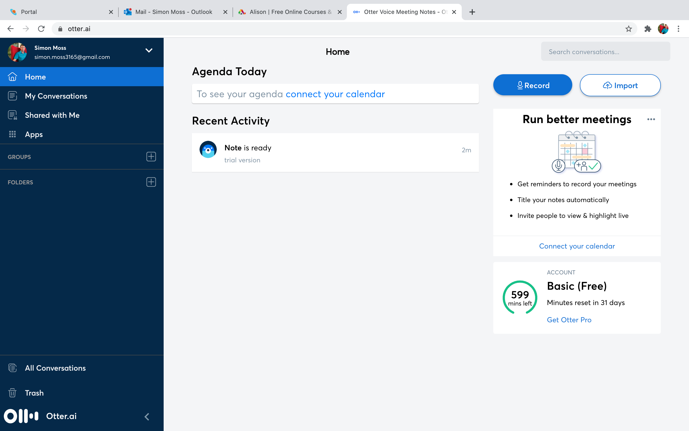

Other considerations

Because no one approach to transcription has prevailed, researchers must contemplate how they will transcribe the data more effectively. They should then outline these considerations in their report. The following table outlines some key considerations.

Consideration | Details
Consistency in corrections | - When constructing a transcript, some researchers choose to correct, rather than retain, the grammatical errors  - If they choose this option, they need to apply this approach to both the participant and interviewer  - That is, some researchers are tempted to correct the errors they commit but not the errors that participants committed—a practice that is regarded as unfair
Which verbalisations and actions to include | - Transcripts that refer to an excessive number of vocalisations, gestures, mannerisms, and so forth—such as audible inhalations—are cumbersome to read  - Transcripts that are devoid of these features may overlook information that facilitates interpretation  - So, researchers need to think carefully about which features to code  - For example, the researcher might decide to exclude vocalisations or actions that are not perceived as means of communication, such as sneezes.

Alternatives to transcription

Not every researcher transcribes the audio to text. These researchers might argue that

- transcription squanders excessive periods of time—time that could be devoted to other productive tasks
- transcriptions are often not as accurate as assumed

To address these concerns, Halcomb and Davidson (2006) proposed another method that could obviate the need to transcribe data. The following table outlines the activities that researchers could apply to analyse spoken words—a set of activities that circumvents transcription.

Phase | Outline
Record notes during interviews or other sources of data | - Although you should still record the interview or event, you should also transcribe more notes about your impressions, observations, and insights during the conversation—called field notes
Expand these field notes | - Clarify and elucidate these field notes  - Identify the key insights or perspectives the participant raised  - Consider other features of the setting that could have shaped the answers
Amend these field notes again while listening to the audio | - Listen to the audio again, perhaps several times  - As you listen, clarify and expand your field notes
Apply the field notes to content analysis | - That is, subject these field notes, instead of written transcripts, to the analyses you planned to conduct  - You might then conduct other analyses; for example, you could organize another researcher to conduct this content analysis; you could then extract broader themes and so forth

References

Azevedo, V., Carvalho, M., Fernandes-Costa, F., Mesquita, S., Soares, J., Teixeira, F., & Maia, Â. (2017). Interview transcription: conceptual issues, practical guidelines, and challenges. Revista de Enfermagem Referência, 4(14), 159-167.

Bailey, J. (2008). First steps in qualitative data analysis: Transcribing. Family Practice, 25(2), 127–131.

Bucholtz, M. (2000). The politics of transcription. Journal of Pragmatics, 32(10), 1439–1465.

Davidson, C. (2009). Transcription: Imperatives for qualitative research. International Journal of Qualitative Methods, 8(2), 36–52.

Halcomb, E. J., & Davidson, P. M. (2006). Is verbatim transcription of interview data always necessary? Applied Nursing Research, 19(1), 38–42.

Jaffe, A. (2007). Variability in transcription and the complexities of representation, authority and voice. Discourse Studies, 9(6), 831-836.

Lapadat, J. C. (2000). Problematizing transcription: Purpose, paradigm and quality. International Journal of Social Research Methodology, 3(3), 203–219.

McLellan, E., MacQueen, K. M., & Neidig, J. L. (2003). Beyond the qualitative interview: Data
preparation and transcription. Field Methods, 15(1), 63–84.

Nascimento, L. D. S., & Steinbruch, F. K. (2019). “The interviews were transcribed”, but how? Reflections on management research. RAUSP Management Journal, 54(4), 413-429.

Ochs, E. (1979). Transcription as theory. In Ochs, E., Schiefflin, B. B (Eds.), Developmental pragmatics (pp. 43–72). New York: Academic.

Oliver, D. G., Serovich, J. M., & Mason, T. L. (2005). Constraints and opportunities with interview transcription: Towards reflection in qualitative research. Social Forces, 84(2), 1273–1289.

Sandelowski, M. (1994). Focus on qualitative methods: Notes on transcription. Research in Nursing & Health, 17(4), 311–314.

Widodo, H. P. (2014). Methodological considerations in interview data transcription. International Journal of Innovation in English Language Teaching and Research, 3(1), 101-107.

