INTRODUCTION TO SCOPING REVIEWS AS WELL AS OTHER REVIEWS

by Simon Moss

Introduction

Rather than conduct a traditional review, many researchers now begin with an approach called a scoping review. In particular, these researchers

- apply a systematic approach to derive all the publications about a specific topic
- use strict criteria to decide which of these studies to retain
- extracts key data or information from these studies
- conducts some numerical analyses, thematic analyses, and other methods to derive conclusions from these data.

Scoping reviews often precede a systematic review. However, unlike a systematic review, the main purpose of scoping reviews is to

- determine the scope and range of research that has been conducted on some topic
- outline the key findings or insights that have emanated from this research
- clarify the shortcomings in this literature—to ascertain which studies should be conducted in the future
- to determine whether a systematic review may be viable.

Systematic approaches

In previous decades, the traditional review was not especially systematic. Researchers would merely read the literature that seemed relevant. They would then construct a narrative or summary that outlines this work and stipulate the issues that have not been resolved. However, over time, scholars began to develop more systematic approaches—such as systematic reviews, meta-analyses, bibliometric analyses, and structured reviews. The question, then, becomes how does scoping reviews differ from these other alternatives.

Differences between scoping reviews and systematic reviews

Despite a few key similarities, scoping reviews and systematic reviews differ on several features. The following table outlines these differences. Munn et al (2018) presents some guidelines to help researchers decide whether to apply systematic reviews or scoping reviews.

 | Systematic review | Scoping review
Research question | Systematic reviews explore a specific research question such as  - is a particular intervention or treatment effective?  - what characteristics affect the impact of this intervention?  - what characteristics predict some outcome or problem?  - what are the consequences or incidence of some problem? | Scoping reviews explore a broader research question around the topic; in particular, the question often includes  - what research has been conducted on some topic?  - what are the key findings on this topic?  - what are the specific questions on this topic that have not been answered?  - what systematic reviews on this topic may be viable?
Range of studies | Systematic reviews will tend to derive the results from only studies that are sufficiently high in quality | Scoping reviews do not restrict the analysis to studies that are high in quality

To conduct a scoping review, researchers tend to apply five main phases and, occasionally, a sixth phase. Like systematic reviews, scoping reviews can demand six months or more to complete. To learn about these phases, you should

- read this document
- skim the paper that many researchers cite: Arksey and O'Malley (2005)
- skim other papers that also present additional considerations, such as Khalil et al (2018) and Peters et al (2020)

1 Identify the research question

During the first phase of a scoping review, you need to clarify the research question you want to explore. Researchers tend to distinguish the overarching research question from one to four more specific research questions. The following table stipulates the kinds of specific questions that researchers tend to pose and then illustrates these specific questions.

 | Kinds of research questions | Examples
Overall research question | What is the literature on this topic? | What has the literature revealed about the attempts of universities to improve the supervision of research candidates
Range of topics explored | Which practices or initiatives have past researchers examined? | What initiatives and practices that are designed to enhance the supervision of research candidates have researchers investigated?
Key findings | What findings has this literature uncovered? | What are the key insights about these initiatives and practices that past researchers have unearthed?
Shortfalls in the literature | Which issues have not been resolved sufficiently? | Which initiatives and practices need to be investigated more thoroughly?  Which features of these initiatives and practices need to be investigated more thoroughly?
Potential to conduct systematic reviews | What systematic reviews on this topic may be viable? | Which features of these initiatives and practices could be subjected to systematic review?

Differences between scoping reviews and bibliometric analyses

Some researchers also utilise another technique, called bibliometric analyses, to clarify the scope and range of studies that have explored some topic. However, scoping reviews diverge considerably from bibliometric analysis—and indeed some researchers apply both approaches (e.g., Pirri et al., 2020). To illustrate the differences

- bibliometric analyses mainly derive numerical information from the databases—and not from the publications directly
- consequently, scoping reviews present more nuanced information about the findings and insights that can be derived from the literature
- bibliometric analyses present more insight into the extent to which various studies have been conducted in various geographic regions and so forth.

2 Identify relevant studies

During the second phase, you attempt to uncover all published and unpublished studies that have explored the topic of interest and could resolve the research question. To achieve this goal, researchers tend to apply the same range of strategies that are conducted during systematic reviews. Yet, researchers might consider sources that proponents of systematic reviews might neglect. The following table outlines some of the strategies that researchers might apply to identify the relevant studies.

Strategies | Examples
Limits. Limit the time span and language; otherwise, the search might be impractical | - Only studies published in English were chosen to reduce the costs and complications of translation  - The review included only the studies published from 1990 to 2020  - This year was chosen because, since 1990, most candidates have been assigned more than one supervisor, fundamentally transforming supervision practices
Electronic databases. Usually with the assistance of a suitable academic librarian or information officer, determine which electronic databases of studies to utilise and how to search these electronic databases. In particular  - determine which possible keywords might be relevant to the research topic  - ascertain which databases might be relevant to the research topic  - pilot different combinations of keywords to determine which strategy is most inclusive—that is, most likely to identify the studies the researchers have already read  - indicate when the final search was conducted | - After consultation with an information officer, we decided to utilize the electronic databases Ovid, PsychINFO, Google Scholar, and PubMed – MEDLINE  - We then piloted four combinations of possible keywords that are relevant to this topic to ascertain an effective search strategy  - In particular, we determined which strategy would uncover the 20 studies we had already identified on this topic  - The most effective search terms included a blend of (PhD OR Masters) AND (supervis*) AND (intervention OR initiative * practice*)  - We utilised the same keywords to search each of these databases  - The search was conducted on 30 August 2020
Reference lists. Check the reference list or bibliography of the identified studies to uncover other publications that could have been overlooked | - We first scanned the reference lists or bibliographies of all the systematic reviews we had uncovered to unearth publications we might have overlooked  - We then applied the same approach to the other sources we had located—but terminated this search once no more additional publications were observed after 20 reference lists were scrutinized
Specific contacts. You can then contact relevant individuals, networks, and organizations—such as

- authors of relevant papers
- relevant professional associations

3 Select the studies

After you identify publications that could be relevant, you need to decide which studies to include in the final review. That is, the original search will, inadvertently, uncover many studies that are not germane to the research question. You thus need to apply eligibility criteria to extract the studies that are relevant.

Inclusion criteria

You first need to specify the inclusion criteria—criteria that stipulate which studies to include. Typically, the inclusion criteria are derived from the intervention or independent variable, the comparison or control groups, the outcomes, and sometimes the study design. In the following table, the first column classifies these criteria, although you would not include these classifications in a paper. The second column illustrates these inclusion criteria.

Technique | Examples
Interventions, independent variables, and comparisons | - Studies that examine the effects of particular supervisory initiatives or practices
Outcomes | - Studies that examine the effect of these initiatives or practices on the perceptions, attitudes, and performance of candidates
Study design | - Quantitative studies or mixed methods studies

Exclusion criteria

You also need to stipulate the exclusion criteria—criteria that stipulate which studies to exclude. In contrast to the inclusion criteria, the exclusion criteria are often derived from the population and sometimes the study design. In the following table, the first column classifies these criteria. The second column presents these exclusion criteria.

Technique | Examples to practice
Problem or participants
Demographic or other characteristics of participants or organizations | - Private universities or colleges
Location or setting
Study characteristics
Publication status | - Papers that report only interim results instead of the final results

Apply the eligibility criteria

To ascertain which studies to select, researchers must then apply these inclusion criteria and exclusion criteria. Researchers utilise a variety of principles to apply these criteria proficiently. For example

- two researchers might initially apply these criteria to a random subset, such as 20%, of the publications
- specifically, they would first read the abstract; if they could not reach a decision from the abstract, they would read other sections of the publication
- they might then discuss each disagreement until 90% agreement is reached
- once they reach this level of agreement—implying they have refined and mastered this procedure sufficiently—they might divide the remaining publications between the two individuals
- if uncertain about how to classify a publication, they might seek advice from the other researcher—or even a third researcher if needed.

Systematic reviews and scoping reviews

In general, to derive and to apply these eligibility criteria, researchers utilise the same principles they would apply to a systematic review. However, in contrast to a systematic review, proponents of scoping reviews tend to

- develop the criteria after they scrutinize a subset of publications
- apply broader criteria—such as “all quantitative studies” instead of “randomized control trials only”

4 Extract the data from these studies

Fourth, researchers then apply a technique that is often called charting—comparable to the notion of data extraction in systematic literature reviews. In essence, the researcher will first develop a data extraction form in a spreadsheet or similar format. Each column then corresponds to one facet of the publications the researcher may want to extract. For example

- the researchers might initially want to retain information about the initiative that was examined, the key findings of this study, the complications that were observed, the limitations of each study, the practical implications of each study, and so forth
- then, after they pilot this form, the researchers might then refine these columns or fields—such as the population, purpose of this study, and methodology.
- furthermore, one column should specify the reference
- finally, other columns could specify information about the setting, such as the location or nation

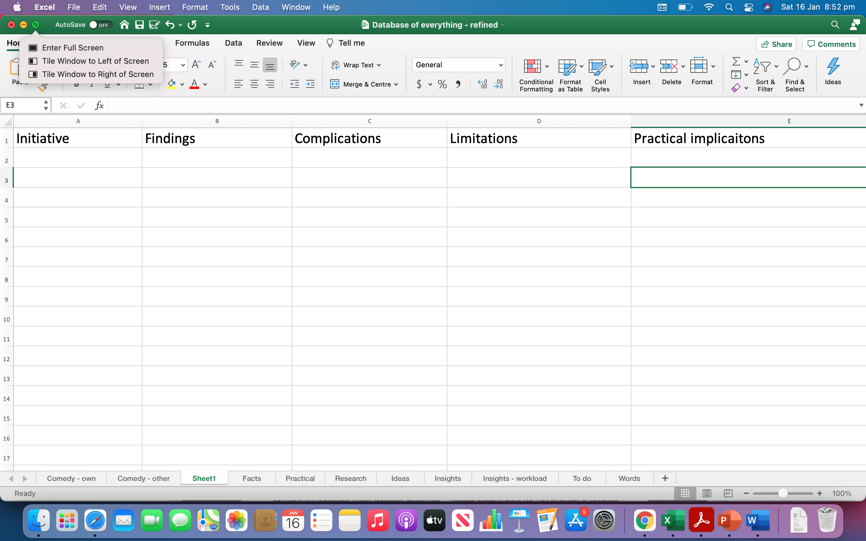

Then, to extract the data, researchers might apply a range of procedures. For example

- two researchers might extract the data of a random subset of publications, perhaps 25% of the total
- they might discuss instances in which they did not extract the same data or sentences from the publications
- once they reach sufficient agreement, they might divide the remaining studies between the two individuals.

In contrast to systematic reviews, when conducting a scoping review, researchers will often extract more information. They might, for example, extract more information about the setting, circumstances, and context, for instance.

5 Collating, summarizing and reporting the results

To summarize and report the results from this extraction, researchers can apply a range of methods. In general, they will tend to apply both numerical methods, such as reporting the percentage of studies that utilised particular methods, and qualitative methods, such as thematic analysis.

Numerical methods

Researchers can often derive vital numerical information from the extracted data—and then convert this numerical information to tables or graphs. For instance

- they might produce tables or graphs to show the percentage of studies that applied specific initiatives, such as workshops, rewards, and discussion groups
- they might produce tables or graphs to reveal the percentage of studies that explored a particular aim and so forth
- they might show how these frequencies differ across some other characteristic, such as location

The following table represents a typical example. The research question, availability of data, and intuition of researchers will tend to determine which facets of the study appear in these tables or graphs.
 | US and Europe: n and % | Asia, Africa, South America: n and %
Workshops | 13 (6%) | 41 (40 %)
Rewards | 18 (9%) | 23 (20%)
Discussion groups | 21 (11%) | 7 (6%)
Coaching | 18 (9%) | 1 (1%)

Thematic analysis

Next, researchers can apply a thematic analysis, or other qualitative approaches, to analyse the data that appear in the data extraction form. They could, for example, apply the techniques that appear in this document. To illustrate, researchers might

- convert the data to codes; they might assign a few words, for example, to each key sentence or argument in the data file
- they might then identify themes—sets of codes that correspond to a shared notion and so forth

Conclusions

Finally, researchers might derive conclusions from the numerical data and thematic analysis. For instance, they might show that

- specific issues have been explored in one but not another setting—revealing shortfalls that could be explored in future studies
- a specific issue has been examined many times and, therefore, could be analysed by formally in a systematic review.

6 Consult

One optional phase is to seek the contributions of practitioners and consumers. For example, researchers might consult these individuals to

- seek additional studies
- to comment on the results and so forth

Write the report

To write the report, researchers sometimes adapt the PRISMA guidelines, commonly used to present systematic reviews (see also Tricco et al., 2018). However, they tend to adapt these guidelines to suit their purposes. For more information on how to report these reviews

- read a brief paper by Peters et al (2015)—who discuss how to construct the title and write the background, objectives, eligibility criteria, participants, concept, context, search criteria, data extraction, charting, and discussion

Other variants of reviews: Rapid reviews

Sometimes, researchers need to complete a review within a few weeks. For example, one of their collaborators, such as a government agency, may need to decide which of several approaches or policies to adopt in the next month. In these circumstances

- you will not be able to conduct a systematic review or scoping review—methods that often demand six months or longer
- but you still want to conduct this review as rigorously and methodically as possible

To achieve this goal, you might embrace another method, called a rapid review. A rapid review is similar to a systematic review except that you truncate some of the activities. For example

- the search to uncover potential publications is streamlined rather than comprehensive
- sometimes, the researcher does not evaluate the quality of studies as rigorously as proponents of a systematic review because of time constraints
- typically, only one researcher selects the studies and extracts the data, obviating the need to examine agreement across researchers.

How to truncate the various activities

One important consideration revolves around how researchers can limit the time they dedicate to searching possible articles and books. To achieve this goal, researchers may

- confine the search to scholarly journals rather than grey literature
- confine the search to past reviews instead of original articles
- center the research question around a more specific topic, diminishing the number of search terms that are applicable (for more variations, see Tricco et al., 2015)

Each researcher will apply a distinct combination of activities to limit the review and then delineate these practices as explicitly and precisely as possible in the report. Nobody has yet developed a standard or universal set of practices that all researchers follow (see Khangura et al., 2012).

Limitations of rapid reviews

Although sometimes a suitable compromise, rapid reviews can generate biased or inaccurate conclusions. The following table outlines some limitations of rapid reviews.

Limitation | Details
Confined research questions overlook vital insights | - Because the research question is often artificially constrained, important considerations are frequently overlooked.  - For instance, the researcher might overlook studies that examined relevant issues but utilized different keywords
Flawed studies might be biased | - In contrast to systematic literature reviews, rapid reviews are not as likely to exclude flawed studies.  - And flawed studies, such as studies in which participants are not randomly assigned to conditions, might tend to generate the same error.  - Consequently, this error might disproportionately shape the conclusions

References

Arksey, H., & O'Malley, L. (2005). Scoping studies: towards a methodological framework. International journal of social research methodology, 8(1), 19-32.

Ganann, R., Ciliska, D., & Thomas, H. (2010). Expediting systematic reviews: methods and implications of rapid reviews. Implementation Science, 5(1), 1-10.

Grant, M. J., & Booth, A. (2009). A typology of reviews: an analysis of 14 review types and associated methodologies. Health Information & Libraries Journal, 26(2), 91-108.

Khalil, H., Peters, M., Godfrey, C. M., McInerney, P., Soares, C. B., & Parker, D. (2016). An evidence‐based approach to scoping reviews. Worldviews on Evidence‐Based Nursing, 13(2), 118-123.

Khangura, S., Konnyu, K., Cushman, R., Grimshaw, J., & Moher, D. (2012). Evidence summaries: the evolution of a rapid review approach. Systematic reviews, 1(1), 1-9.

Munn, Z., Peters, M. D., Stern, C., Tufanaru, C., McArthur, A., & Aromataris, E. (2018). Systematic review or scoping review? Guidance for authors when choosing between a systematic or scoping review approach. BMC medical research methodology, 18(1), 143

Opara, C. C., Aghassibake, N., & Watkins, D. A. (2020). Economic consequences of rheumatic heart disease: A scoping review. International Journal of Cardiology, 323, 235-241.

Peters, M. D., Godfrey, C. M., Khalil, H., McInerney, P., Parker, D., & Soares, C. B. (2015). Guidance for conducting systematic scoping reviews. International journal of evidence-based healthcare, 13(3), 141-146.

Peters, M. D., Marnie, C., Tricco, A. C., Pollock, D., Munn, Z., Alexander, L., ... & Khalil, H. (2020). Updated methodological guidance for the conduct of scoping reviews. JBI Evidence Synthesis, 18(10), 2119-2126.

Pirri, S., Lorenzoni, V., & Turchetti, G. (2020). Scoping review and bibliometric analysis of Big Data applications for Medication adherence: an explorative methodological study to enhance consistency in literature. BMC Health Services Research, 20(1), 1-23.

Royle, P., & Milne, R. (2003). Literature searching for randomized controlled trials used in Cochrane reviews: rapid versus exhaustive searches. International journal of technology assessment in health care, 19(4), 591.

Tricco, A. C., Antony, J., Zarin, W., Strifler, L., Ghassemi, M., Ivory, J., ... & Straus, S. E. (2015). A scoping review of rapid review methods. BMC medicine, 13(1), 1-15.

Tricco, A. C., Lillie, E., Zarin, W., O’Brien, K., Colquhoun, H., Kastner, M., ... & Straus, S. E. (2016). A scoping review on the conduct and reporting of scoping reviews. BMC medical research methodology, 16(1), 15.

Tricco, A. C., Lillie, E., Zarin, W., O'Brien, K. K., Colquhoun, H., Levac, D., ... & Straus, S. E. (2018). PRISMA extension for scoping reviews (PRISMA-ScR): checklist and explanation. Annals of internal medicine, 169(7), 467-473.

Wolfe, D., Corace, K., Rice, D., Smith, A., Kanji, S., Conn, D., ... & Hutton, B. (2020). Effects of medical and non-medical cannabis use in older adults: protocol for a scoping review. BMJ open, 10(2), e034301.

