HOW TO ATTRACT PHD OR MASTERS BY RESEARCH CANDIDATES

by Simon Moss

Introduction

Supervision of PhD or Masters by Research candidates is often a fulfilling experience. This supervision enables academics at CDU to

- extend their research profile and thus attract grants
- extend their knowledge and skills in the topic these candidates explore
- help another person to forge a career

Consequently, many staff at CDU would like to supervise more PhD or Masters by Research candidates. Yet, in practice, this goal can be hard to achieve because

- at CDU, scholarships to support international candidates are scarce
- domestic candidates may prefer to study elsewhere

This document offers some guidelines on how staff can overcome these obstacles and supervise more candidates. In particular, if staff apply these guidelines, they may be able to

- supervise more candidates who are already enrolled at CDU but may need another supervisor
- attract international candidates who are granted a scholarship from their home nation
- attract domestic candidates

Summary of activities

This section outlines the activities you could undertake to fulfil these goals. The following table summarises these activities and then clarifies the benefits of these activities.

Activity to attract research candidates | Benefit of this activity
1 Optimise your profile on CDU’s Research Webportal as well as on LinkedIn | - Enrolled CDU candidates might contact you to seek a person with your expertise—such as experience with a specific methodology  - Other CDU staff might contact you to fulfill the same purpose  - Your profile is more likely to appear in response to Google searches on your topic of expertise  - If potential candidates want more information, you can refer these individuals to this website
2 Inform the research office of your research expertise and goal to attract more candidates | - CDU will collate this information to construct a database  - CDU will publicize this information during inductions  - CDU will publicize this information in college meetings
3 Contact our international representatives | - These representatives might be able to identify candidates who have or could attract a scholarship from their home nation
4 Post advertisements on relevant websites or society email lists | Possible websites include  - www.findaphd.com  - Times higher education jobs  - naturejobs.com  - academicpositions.eu  These advertisements are unlikely to be effective unless you optimize your social media profile, such as your LinkedIn profile.
5 Develop and publicize a research group with colleagues | - Research groups can be publicized more effectively than individuals
6 Present tutorials to potential research candidates | For example, you could present online tutorials to third year candidates on  - some exciting future trends or innovations in your field—trends or innovations that are relevant to their assessments  - your research projects about these future trends or innovations  You might offer these tutorials to candidates at other universities.
7 Attend or even organize events with potential research candidates | For instance, you might attend or arrange an event in which  - third year and Honors candidates receive insights on their careers  - during this event, these candidates are granted opportunities to speak to academics in a speed networking format

1 Develop an elevator pitch

To attract PhD and Masters by Research candidates, as well as to promote your research and capabilities in general, you need to first develop a suitable elevator pitch—a description that characterize your strengths and importance in a few sentences. Variants of this pitch can be useful in many circumstances, such as social media sites and conferences. The following table outlines how you can develop an appealing elevator pitch.

Activity | Illustration
Outline your role as briefly as possible. This outline enables other individuals to classify you—so they know which attributes to consider | - I am an Associate Professor in the field of workplace psychology
Clarify the problems you strive to solve. If possible, include a vivid example or statistic that demonstrates the scale of this problem | - My research explores the problem that mental health interventions are often too expensive and inaccessible, costing Australia over $6 billion a year
Indicate the unique feature of your work that could solve this problem | - In particular, my research explores how changes to the policies and practices of organisations can enhance the wellbeing and productivity of individuals
If the audience is sophisticated, include an example that clarifies and demonstrates this capability | - For example, I have shown that practices that help people feel their activities now are vital to their future tend to feel more resilient and motivated
If speaking to a person or audience, clarify what you may be seeking | - I am seeking PhD candidates, researchers, and agencies that might want to collaborate

Although you do not need to follow these guidelines precisely, your pitch should be as efficient as possible. And your tone should be gentle rather than forceful.

2 How to optimize your profile on CDU’s Research Web-portal

Introduction to the web portal

CDU has developed a website that publicizes the research activity, interests, and achievements of all researchers and academics at CDU. Prospective candidates, as well as staff and candidates at CDU, can utilize this website to locate relevant supervisors and collaborators. This website comprises two distinct facets

- CDU’s Research Webportal displays the research profile of every CDU researcher
- The Research Information System enables staff to update these profiles

Check your existing profile

You should first check your existing profile. In particular

- Google “CDU’s Research Webportal” or visit researchers.cdu.edu.au
- Type your name in the Search box
- If your profile appears, click your name, generating a page that might resemble the following screen, but hopefully with a more appealing photograph
- This page automatically includes many of your publications or other research activities.

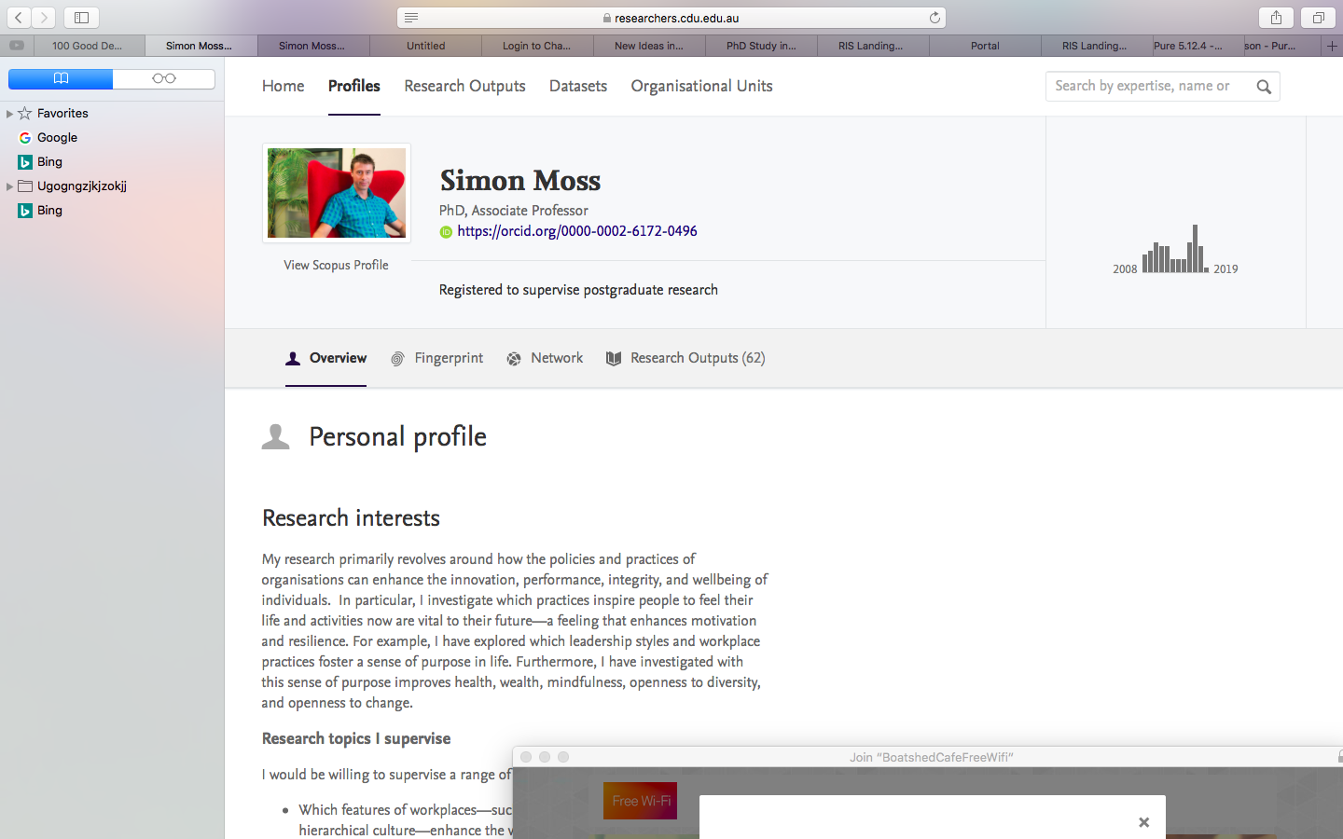

If your name does not appear, email research.systems@cdu.edu.au. The research office will then create your profile or correct some error.

Update your profile

To attract PhD or Masters by Research candidates, you should

- visit the CDU portal page—portal.cdu.edu.au—and enter your username and password
- select “RIS Landing Page”
- choose “Login to RIS”— the Research Information System. The following screen should appear

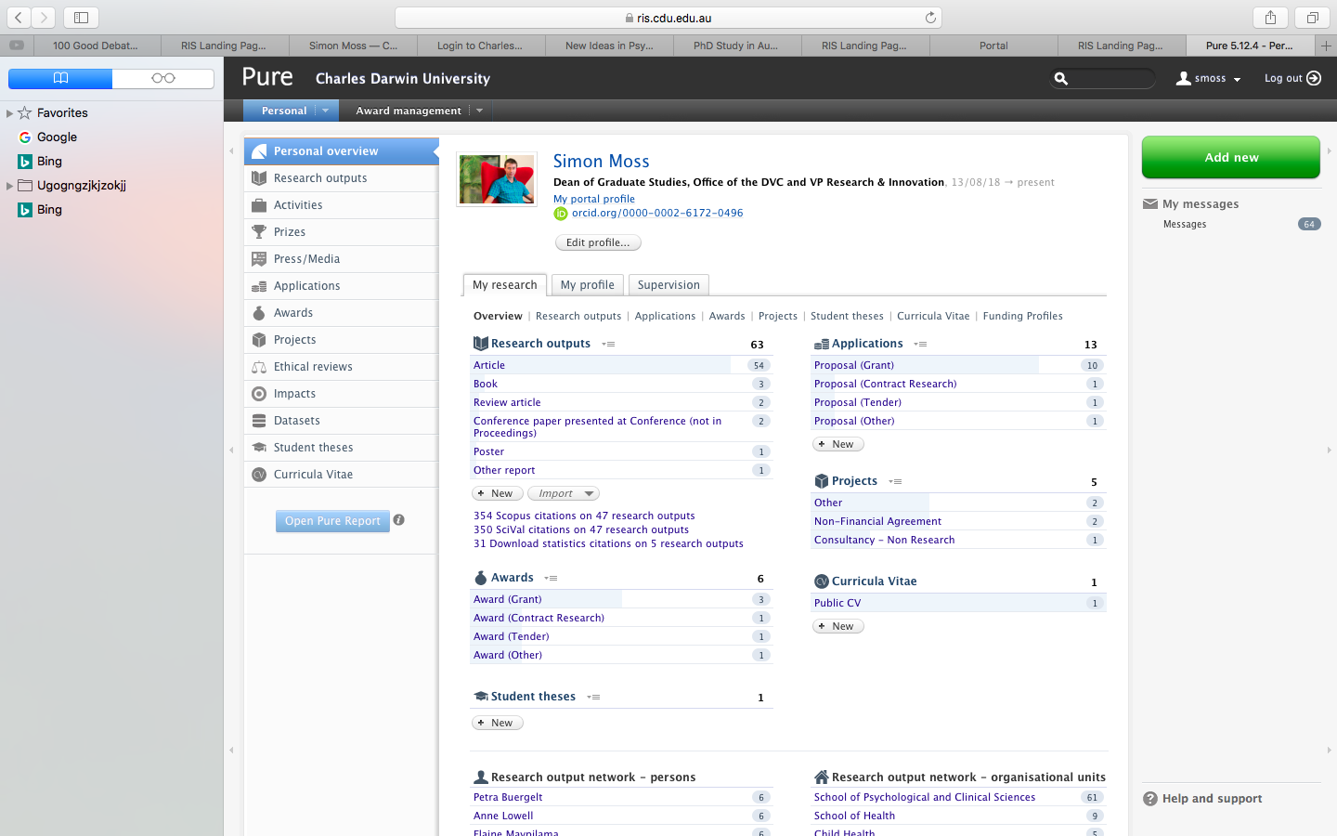

- Press “Edit profile” towards the top of this screen to generate the next screen

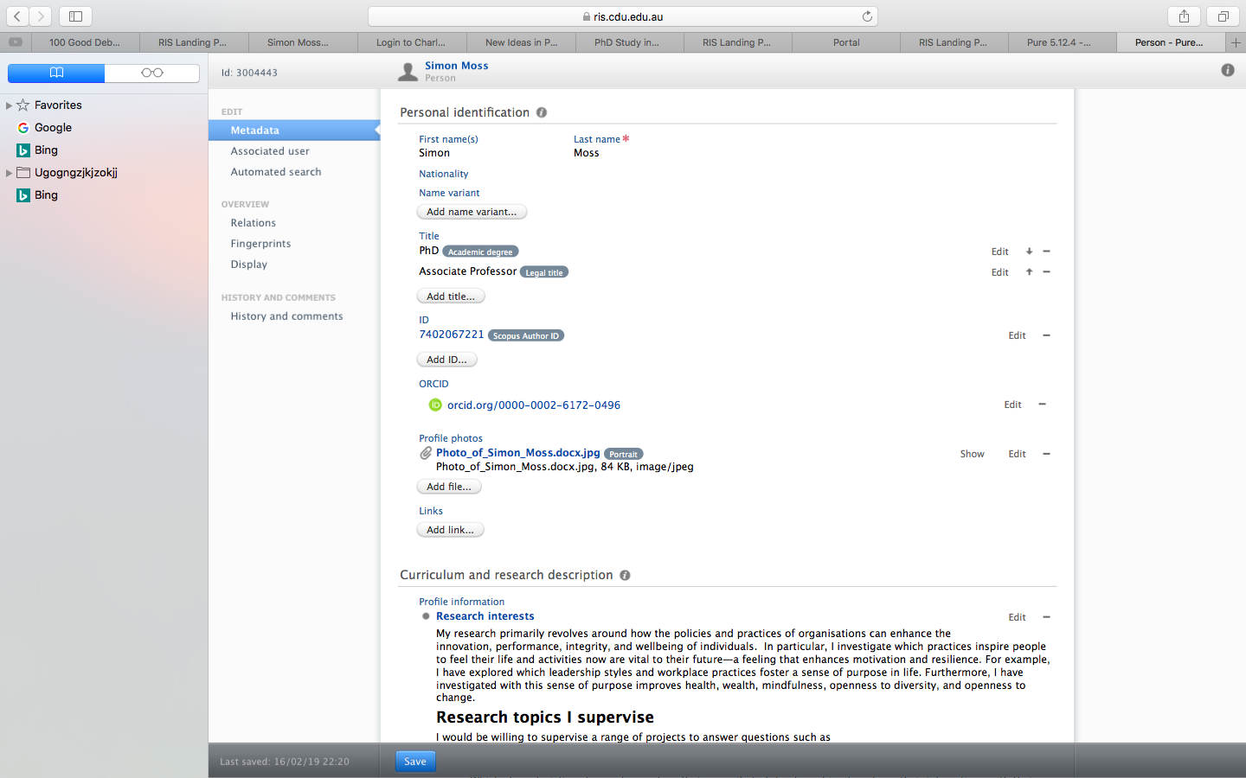

- This screen enables you to edit your profile—such as adding a photo
- Midway down, you should locate a section called “Curriculum and research description”
- Press “Add public information” or “Edit” to generate the following screen

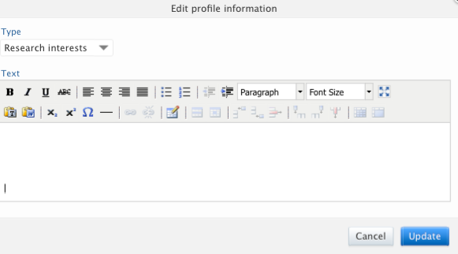

You can now outline your research—such as your research interests, topics you would supervise, and key research skills. As this example shows, you can utilise or amend your elevator pitch and then specify the projects you might like to supervise.

I am an Associate Professor in the field of workplace psychology. My research explores the problem that mental health interventions are often too expensive and inaccessible, costing Australia over $6 billion a year. In particular, my research explores how changes to the policies and practices of organisations can enhance the wellbeing and productivity of individuals. For example, I have shown that practices that help people feel their activities now are vital to their future tend to feel more resilient and motivated

Research topics I supervise

I would be willing to supervise a range of projects to answer questions such as

- Which features of workplaces—such as an egalitarian rather than hierarchical culture—enhance the wellbeing of people who experience various mental health problems?
- Which characteristics of parents—such as their capacity to tolerate ambiguity—shape their interactions with their children?
- Which words or phrases in speeches and articles are most likely to inspire and convince other people?
- Which initiatives at university enable candidates to feel their activities now are vital to their future—ultimately enhancing their motivation, creativity, integrity, and wellbeing?
- Initiatives that I want to explore include an opportunity to observe futuristic roles, a workshop that promotes compassion, a program that fosters critical thinking, an app that helps candidates manage skill development, and a community wall to collate ideas

Key skills

- Social, personality, emotion, and work psychology
- Multivariate statistics, such as mixed linear models and generalised estimating equations
- Writing skills, such as the psychology of persuasion

When finished, you must

- press update and then
- press save—a blue button that appears at the bottom of your page
- then, check your profile in CDU’s Research Webportal again.

You should utilise the same elevator pitch to develop a profile in LinkedIn. Visit au.linkedin.com.

2 Inform the research office

The university has also constructed a spreadsheet that specifies which staff members are seeking more PhD or Masters by Research candidates as well as the key skills of these staff members. To disseminate this information to research candidates and staff

- the spreadsheet will be distributed to candidates during their induction
- the research office will publicize this information in various forums

To include your details in this spreadsheet, please

- email the Dean of Graduate Studies or simon.moss@cdu.edu.au
- outline your key capabilities, such as grounded theory, machine learning, and organic chemistry

3 Contact our international representatives

CDU have employed individuals to seek opportunities to collaborate with other nations, such as Indonesia and China. If you feel your skills and interests are particularly relevant to individuals in these nations, you should inform the relevant person. In particular

- if your skills and interests are relevant to other nations, visit this webpage to identify a suitable representative
- you might write something like the following

Dear Emily

I am interested in supervising PhD candidates from China. My research interests specifically revolve around programs that facilitate the adjustment of Chinese candidates to Australian conditions. If you hear of any candidates who might be interested in this topic, please let me know

Kind regards

Frank Smith

4 Post advertisements on relevant websites

You may also post advertisements on websites that are designed to attract PhD candidates. The following table offers some insights into the key features of exemplary advertisements.

Feature of exemplary advertisements | Illustrations
You might want to begin with a short, catchy sentence | - If people ate degrees, our PhDs would be the dessert
Describe the unique opportunity if applicable | - Would you like to earn over $37 500 a year to complete a PhD in economics, or a related field, while you broaden your work experience?  - Charles Darwin University is offering five individuals a scholarship to complete a PhD in collaboration with Treasury and Finance in the Northern Territory
Describe the possible projects—with reference to both topic issues and broad fields | - Projects might revolve around topical issues such as fracking, water allocation, alcohol reform, and house prices—ultimately to explore the impact of government initiatives, incentives, regulations, and investment strategies on economic stability, development, and innovation in the region.
Characterize the candidates you are seeking and the criteria that will you apply to choose  Specify how candidates should proceed | - We are seeking candidates with a passion to help people who are not always granted opportunities to help themselves  - If you are eligible to complete a PhD--perhaps because you have completed and thrived during a semester worth of an Honors or postgraduate research project--and would like further information, contact…

You can then post these advertisements. In particular

- post these advertisements on a range of relevant websites, such as, www.findaphd.com or society newsletters, bulletins, and research email lists
- perhaps do not advertise in newspapers or journals, because the return on investment is often limited

Other activities

You might also consider a range of other activities too. For example

- you could develop a website, with a team of other researchers, to promote your research more effectively
- include testimonials, either on this website or on LinkedIn, about your supervision
- if you feel your projects could be especially interesting to Indigenous research candidates, perhaps contact the Indigenous Leadership office at CDU. Visit www.cdu.edu.au/indigenous-leadership/key-people and contact the Executive Assistant to seek advice on who could help.

