HOW TO PRESENT YOUR THESIS EFFECTIVELY AND CONFIDENTLY

by Simon Moss

Introduction

Thousands of videos and articles have been developed on the topic of oral presentations. Typically, these videos and articles encourage speakers to start with engaging anecdotes, to practice extensively, to speak clearly, to embody passion, to maintain eye contact, to smile occasionally, to cater to the audience, and to summarize the core message. Unfortunately, however, most of these recommendations are obvious and hard to achieve. And few of these recommendations address the key problem that research candidates experience. In particular, research candidates must portray themselves as experts while they are judged like novices.

Which information should you include?

So, when presenting your thesis—at a confirmation of candidature, seminar, or conference, for example—what information should you include? The short answer is to include the information you want to include. Every presentation is unique. Every presentation comprises a distinct sequence of topics.

But the long answer appears in the following table. In particular, the first column in this table presents a possible sequence of topics you could include. The second column justifies the uncommon topics, often with reference to recent studies. You obviously do not need to include all these topics. Nevertheless, some of the information could be helpful to all candidates.

Topics to include | Justifications
Introduction
Convey an anecdote about some event that inspired you to pursue this topic  - Include enough details to help audience imagine this event as vividly as possible  - Describe the emotions you experienced—perhaps excitement, disappointment, sympathy, or confusion for example | After the audience listen to your emotions or experiences—especially emotions that are specific to humans, like disappointment or relief—they become more empathic and supportive (e.g., Vaes, Paladino, & Leyens, 2002).
Specify the goals or choices this anecdote or event inspired

- For example, this event might have inspired you to assist a specific community
Describe why you feel you could achieve this goal  - That is, specify which of your skills, resources, or passions you feel could benefit this pursuit. | After candidates articulate their distinct qualities, capabilities, or motivations, they do not feel the need to please other individuals as keenly. They feel more independent and confident as a consequence (Zhang, Feick, & Price, 2006)
Briefly outline your research, such as the key aims and methods  - Attempt to describe your research in a few sentences  - Allude to some of the main theories, techniques, or concepts, with sentences like “To achieve these goals, I will use a theory called self-construal and a methodology called social network analysis”. | If you allude to the main concepts now, these concepts will seem more compelling later. People are more likely to trust a concept that have heard days, hours, or even minutes before, called the fluency bias (Reber et al., 1998).
Literature review
Demonstrate the importance of this topic  - Refer to some key problem that needs to be resolved, such as the prevalence of some disease  - Perhaps refer to some important statistics or events that underscore the significance of this problem  - If possible, either now or later, include some misconception about your topic | When people refer to specific numbers, such as “1304 people”, their arguments tend to be perceived as more compelling (Janakiramana, Syrdal, Freling, 2016).
Summarize the pioneering attempts to resolve this problem

- You might refer to pioneering theories, studies, or techniques for example
- Describe one of these attempts in depth—especially the methods that resemble the techniques you will use
Present the key limitations of these pioneering attempts
Outline more recent advances that were designed to resolve these limitations
Present three or so limitations of these recent advances—limitations your research was designed to address
Demonstrate how your research is designed to overcome these three or so limitations. | Individuals tend to perceive three related events as a pattern. Hence, if you show a theory, method, or approach that solves three limitations, the audience will feel your work addresses problems in general. Your endeavours will seem more compelling (Carlson & Shu, 2007).
Articulate the main purpose of your research—together with the hypotheses, if appropriate
Methodology
Outline your methodology or methods

- If qualitative, delineate your theoretical perspective and methodology
- If quantitative, describe the design
Describe the methods in detail

- Usually describe the methods you plan to implement in order
Describe the techniques you will use—or have used—to analyse the data
The other sections depend on the purpose of your presentation
For research proposals

- Illustrate what the results might be
- Clarify two or three key ethical matters
- Present a timeline
For the presentation of results

- Summarize one to four key results
- Outline one to three main conclusions
- Present one to three key limitations

Slides

If you are familiar with Microsoft Powerpoint or other presentation software like Prezi or Google Slides, the slides are not hard to construct. The main principles to remember are

- Most slides should include a relevant picture, such as a photograph or diagram
- Most slides should include few words—usually keywords such as concepts that might be unfamiliar to the audience, such as “Bayesian analysis”
- Each slide should begin with a relevant heading. The headings could relate to general topics, such as Aims, Hypotheses, Participants, Equipment, Procedures, Data analysis, Results, Limitations, Ethical Implications, Timeline, Significance. Or the headings could specify particular theories, techniques, or concepts
- The most important words should be as conspicuous as possible—often printed in a color that diverges from the background.

Some typical slides appear below.

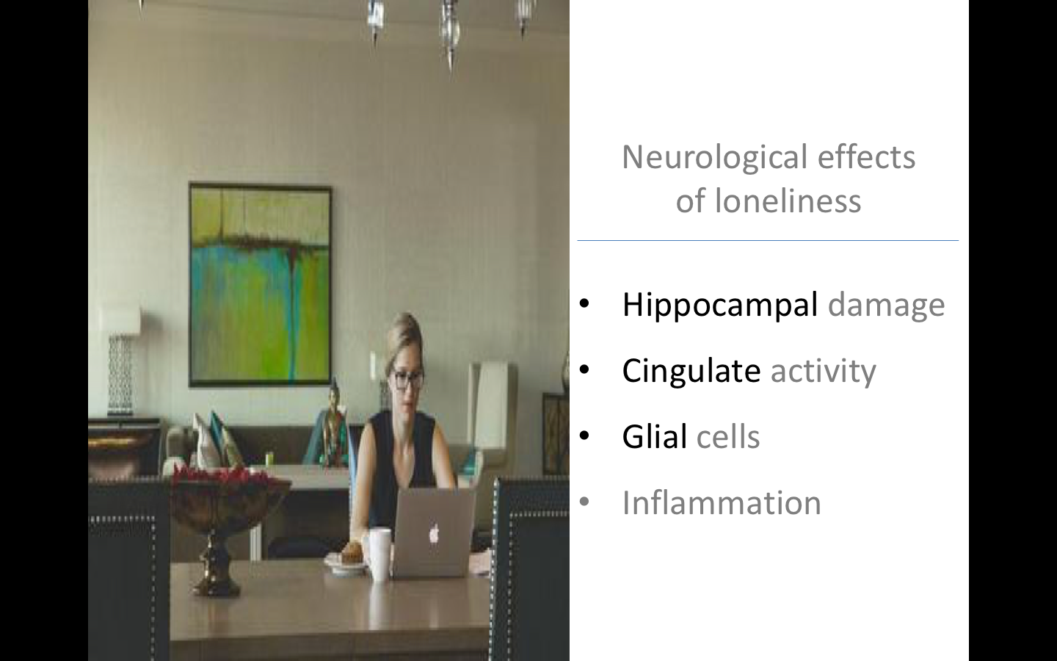

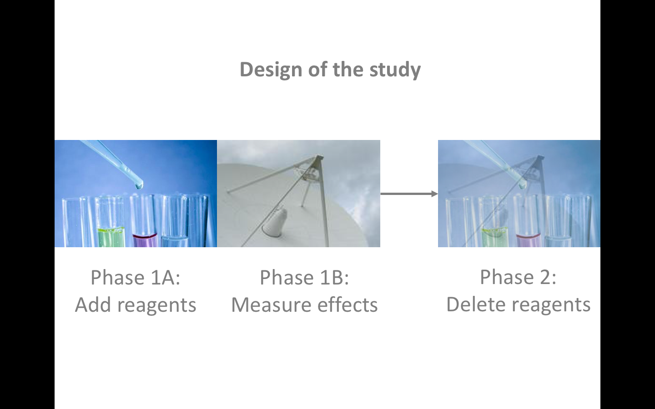

Software

Until recently, most people used Microsoft Powerpoint to construct slides. Then, Prezi became increasingly popular. Recently, many people have adopted Google slides. The following table compares the features of Microsoft Powerpoint and Google slides.

Feature | Powerpoint | Google slides
Price | - Free with Microsoft Office—and thus free for CDU candidates | - Free with Google Docs
Accessibility | - To use Powerpoint in a presentation, this software needs to have been downloaded.  - Fortunately, Powerpoint is downloaded on most computerse | - To use Google slides, this software does not need to be downloaded but is available on the cloud. So, you need to be able to access the internet
Collaboration |  | - Google slides facilitates collaboration between you and your colleagues more effectively than Powerpoint
Special effects | - Powerpoint—especially the desktop version—offers more animations and transitions that Google slides
Fonts | - Because Google slides supports all Google fonts, you should be able to utilize the vast majority of fonts on any computer | - Because Powerpoint uses fonts that are installed on the computer, your presentations might look different when you use another computer

Mental preparation

Some people, before they present a speech, attempt to relax. This attempt, however, generates several problems. Specifically, when people attempt to relax, they inadvertently reinforce the belief that anxiety is undesirable. Consequently, they worry about moments of anxiety—merely aggravating this anxiety. Yet, moments of anxiety are not detrimental. These moments can actually help concentration.

Instead, before you present a speech, you want to feel like your life is important and special. You want to feel like your aspirations are achievable and significant. In this state, you are more likely to conceptualize this presentation as a challenge to embrace and not as a threat to avoid. To achieve this state, you should, an hour or so before the presentation, consider these exercises.

Technique | Justification
If possible, sit in a comfortable location, with your eyes close for a few minutes
Describe, as precisely as possible, some of the sensations you feel in your body, such as shaky legs or tightness around the chest. Begin with your feet or legs and gradually proceed to other body parts | This exercise tends to decrease the intensity of emotions (Lieberman et al., 2007). Indeed, attempts to amplify these sensations actually diminishes these sensations (Ascher & Schotte, 2006).
Imagine yourself in five to ten, in a position that you cherish—in a position of power | When people experience a sense of power, they do not feel as vigilant and concerned; their performance tends to improve (Lammers, Dubois, Rucker, & Galinsky, 2013)
Imagine some key skills or qualities you have developed over this time.
Perhaps either actually speak with someone, or imagine conversing someone, who you really trust—someone who is always supportive rather than judgmental. | Even images of supportive people tend to enhance resilience (Jakubiak & Feeney, 2016).
Reminisce about an amusing event—especially an event you experienced with this supportive person | Smiling and nostalgia tend to enhance resilience (Kraft & Pressman, 2012)

Finally, candidates are often concerned they might seem anxious or nervous. Yet, as research indicates, candidates tend to overestimate the extent to which the audience is aware of this anxiety. That is, the audience tend to overlook these nerves.

Style

During the presentation, to enhance your confidence and credibility, you should

- Speak slightly louder than usual, partly to boost confidence
- Speak in a slightly lower pitch than usual (Stel, van Dijk, Smith, van Dijk, & Djalal, 2013).
- Stand with your hands and feet as far away from your midline as possible—and not in a crouched or wary position. If their legs are apart and their arms are away from their body, people feel more dominant and powerful. This sense of dominance and power diminishes their sensitivity to worries (Bohns & Wiltermuth, 2012)

Answering questions

Before the presentation, many candidates are most concerned about the questions they might receive. After the presentation and before candidates receive questions, they tend to feel quite relieved. Because of this relief, their concerns about questions subside. Nevertheless, to answer challenging questions, you might consider these principles.

Technique | Examples to practice
Rephrase the question. You might rephrase the question to emphasize an issue that seems more relevant or familiar to you. | - Listen carefully, then withdraw eye contact as you prepare your response  - Then, you might rephrase the question, such as “So, in essence, how can I attract more participants to this study”
Express your main thoughts regardless of relevance. Sometimes a question will elicit a thought that, although insightful, is not directly relevant to the question. In these circumstances, simply express this thought. You do not have to answer the question precisely | - “One possibility, although only peripherally related to your question, is…”  - “That question reminds me of the issue around…”
Express commitment to explore the concern. If someone raises a concern, concede you had considered a similar issue and will explore this problem more in the future | - “Yes, we had discussed a related concern before, and I agree we need to overcome this problem”

Other presentations

This document has presented some guidelines on how to present your thesis, especially at the university. However, you may also need to present a speech in other forums, such as business meetings. This section outlines some principles you could apply to most settings.

Preparation before presentations

Principle | Details
Before you prepare your presentation, consider the audience carefully—primarily so you naturally adapt the speech to accommodate their needs | Consider  - why they have attended?  - what do they want?
Consider the main goal of your presentation—again so you naturally adapt the speech to achieve this goal | Possible goals include  - to attract interest  - to demonstrate expertise  - to change attitudes  - to initiate an action
Begin your speech with a hook and then outline of the key argument | A hook might include  - a startling example, such as a disturbing statistic or story  - a question to the audience about their beliefs on this topic  Then outline your key argument in 30 seconds—such as the aim of your research and how you will fulfill this aim
Each slide should revolve around one idea, with limited text | - Bullet points should usually comprise 5 or so words—rather than whole sentences
To help the audience remember you, you can prepare something these individuals can retain, such as a handout | - To ensure you do not distract the audience, distribute any handouts after the presentation

Body language

The following table outlines how to adapt your voice, posture, and facial expressions during presentations. Nevertheless, each time you rehearse or present a speech, orient your attention to only one or two of these recommendations at a time—to avoid distractions. To decide which recommendations to consider, video yourself during each rehearsal and identify which habits you feel you could modify. Rehearse at least twice.

Principle | Details
Maintain appropriate eye contact to entice the audience and to seek positive feedback, such as nods | - Every 30 seconds or so, switch your eye contact from one segment of the audience to another segment  - Do not restrict your attention to managers or specific individuals
Your voice should be sufficiently loud but not monotonic | - Speak marginally louder than usual, especially on the key arguments  - Yet vary your volume and pitch—as though pretending to read an exciting story to a child  - Pause momentarily after key arguments  - If you must read a script, underline which words to emphasize; a list of prompts is preferable to a script
Use your hands appropriately | - Manoeuvre your hands to emphasize or illustrate an argument, such as shift your hands apart to simulate increases, often in an exaggerated manner  - Otherwise, your hands rest naturally towards your side  - These hand movements will prevent distracting or nervous habits, such as using your hands to play with an object, touch your face, point, or access your pockets
Your posture | - Your feet should be apart, your shoulders should be dropped, and your hands outstretched  - Lean forwards slightly, especially when presenting a key argument
Smile at least occasionally

References

Ascher, L. M., & Schotte, D. E. (2006). Paradoxical intention and recursive anxiety. Journal of Behavior Therapy and Experimental Psychiatry, 30, 71-79.

Bohns, V. K., & Wiltermuth, S. S. (2012). It hurts when I do this (or you do that): Posture and pain tolerance. Journal of Experimental Social Psychology, 48, 341-345.

Carlson, K. A., & Shu, S. B. (2007). The rule of three: How the third event signals the emergence of a streak. Organizational Behavior and Human Decision Processes, 104, 113-121.

Cuddy, A. J. C., Wilmuth, C. A., Yap, A. J., & Carney, D. R. (2015). Preparatory power posing affects nonverbal presence and job interview performance. Journal of Applied Psychology, 100, 1286-1295. doi: 10.1037/a0038543

Jakubiak, B. K., & Feeney, B. C. (2016). Keep in touch: The effects of imagined touch support on stress and exploration. Journal of Experimental Social Psychology, 65, 59-67. doi: 10.1016/j.jesp.2016.04.001

Janakiramana, N., Syrdal, H. A., Freling, R. (2016). The effect of return policy leniency on consumer purchase and return decisions: A meta-analytic review. Journal of Retailing, 92(2), 226-235. doi: 10.1016/j.jretai.2015.11.002

Kraft, T. L., & Pressman, S. D. (2012). Grin and bear it: The influence of manipulated facial expression on the stress response. Psychological Science, 23, 1372-1378. doi:10.1177/0956797612445312

Lammers, J., Dubois, D., Rucker, D. D., & Galinsky, A. D. (2013). Power gets the job: Priming power improves interview outcomes. Journal of Experimental Social Psychology, 49, 776-779. doi: 10.1016/j.jesp.2013.02.008

Lieberman, M. D., Eisenberger, N. I., Crockett, M. J., Tom, S. M., Pfeifer, J. H., & Way, B. M. (2007). Putting feelings into words: Affect labeling disrupts amygdala activity in response to affective stimuli. Psychological Science, 18, 421-428.

Reber, R., Winkielman, P., & Schwartz, N. (1998). Effects of perceptual fluency on affective judgments. Psychological Science, 9, 45-48.

Stel, M. van Dijk, E., Smith, P. K., van Dijk, W. W., & Djalal, F. M. (2013). Lowering the pitch of your voice makes you feel more powerful and think more abstractly. Social Psychological and Personality Science, 3, 497-502. doi: 10.1177/1948550611427610

Vaes, J., Paladino, M., & Leyens, J. (2002). The lost e-mail: Prosocial reactions induced by uniquely human emotions. British Journal of Social Psychology, 41, 521-534.

Zhang, Y., Feick, L., & Price, L. J. (2006). The impact of self construal on aesthetic preference for angular versus rounded shapes. Personality and Social Psychology Bulletin, 32, 794-805

