INTRODUCTION TO MICROSOFT TEAMS AND INTEREST GROUPS

by Simon Moss

Introduction

To thrive in your research degree, you need to interact frequently with your supervisors, your peers, and other individuals. These interactions are not only a font of information and insight but also a source of hope and enthusiasm. As research shows

- even introverted candidates tend to feel more energised after social interactions with peers—especially online interactions
- social interactions also facilitate learning and memory

While completing your degree, for a range of reasons, you might not be able to interact in person as frequently as you would like. To illustrate,

- you might be living interstate or overseas
- you might be conducting fieldwork
- you might need to work from home because of illness, pandemics, and similar events

So, you will need to interact online regularly. Although a variety of platforms are available—such as Skype, Zoom, Slack, and Discord—this document will demonstrate the benefits of Microsoft Teams. We recommend Microsoft Teams because

- we have established, and will continue to establish, many initiatives and provisions in this platform, such as interest groups
- Microsoft Teams can be integrated more effectively with other Microsoft tools and, therefore, offers many helpful functions.

 | If possible, even if you are familiar with Microsoft teams, please complete all the activities that are accompanied by the icon on the left. These activities are designed to facilitate collaboration and camaraderie across research candidates

Access Microsoft Teams

Microsoft Tools can be used to converse with individuals or groups on video or to share information with individuals or groups. All research candidates should be able to access Microsoft Teams from their portal. Specifically, Microsoft Teams is part of Office 365.

 | - Visit the CDU portal—portal.cdu.edu.au  - You may need to enter your username and password  - Click the “Office 365” icon  - A set of small icons should slowly appear; choose the “Teams” icons | 

You can use either your student account or staff account. As a minor complication, you may need to use both accounts. To clarify

- a colleague might have assigned you to a team
- but you cannot be sure whether this person assigned your student account or staff account to this team

A free version of Microsoft Teams is available as well. But, some helpful features are not available in this version.

Online versus desktop

If you use Windows, you may be asked whether you want to use the Web app or Windows app. If you use Macs, you may be asked whether you want to use the Web app or Mac app. Specifically

- if you choose the Windows app, you need to access the portal each time to use Teams
- if you choose the Windows or Mac app, you can open an app on your desktop to use Teams
- furthermore, some features are available only if you use the Windows or Mac app; hence, this option is usually preferable

Join or create teams

Join a team

After you access Microsoft Teams, one of your first tasks should be to join or create a relevant team or interest group. On this platform, teams are individuals with whom you share information and resources. We have established quite a few possible teams that might interest you.

- On the left sidebar is a series of options, such as Activity, Chat, and Teams.
- Click Teams
- Click “Join or create team”. This button often appears towards the top right
- In the search box, enter “Researchers”
- This search term should generate a series of options, quite like the boxes that appear on the next screen
- When you shift the cursor to one of these options, a button, labelled “Join team”, should appear. Simply click this button to join the team. You can leave this team whenever you would like.

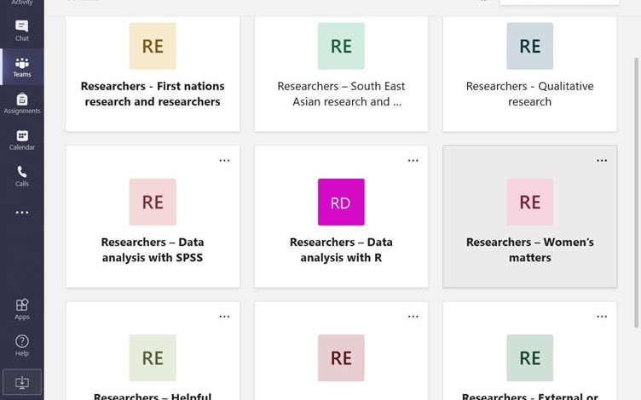

We have already established a range of teams that are relevant to research candidates—and indeed researchers in general. For example, some of the teams revolve around

- external or remote candidates and researchers
- First Nations peoples and researchers
- South East Asian peoples and researchers
- qualitative or mixed-method researchers
- quantitative researchers, such as users of SPSS or R
- software, apps, and other advances in IT that facilitate research
- external or remote candidates and researchers

Create teams

You might feel that none of these teams or interest groups are relevant to you. Or, you might feel that a vital team, such as a team that is specifically related to your research institute or college, has been overlooked. If so, you are welcome to create your own groups. That is, after pressing the button “Join and create team”

Optional | - a few boxes or options should appear. Choose “create a team”  - you might then be asked to select a team type; if you choose any one of these options, the following box should appear

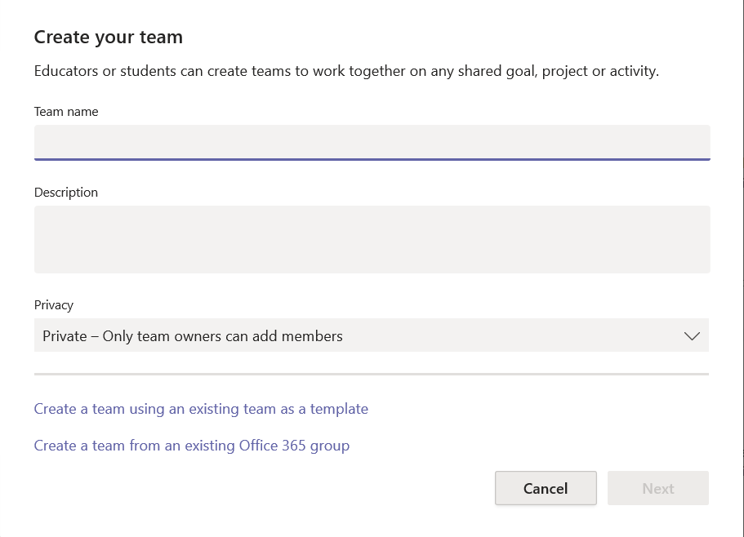

- enter a team name. The name should relate to a specific group of individuals, such as “Menzies HDR candidates” rather than a specific project, such as “Christmas event”.
- you should describe the project in simple words
- finally, you should click the downward arrow on the right to indicate whether the group should be private or public. If the team is private, only the team owner can approve requests to join.

After you press “Next”, the following box appears. At this time, you can press Skip. Or, if you prefer, you can add members to your team. In particular

- insert the cursor into the box called “Start typing a name or group”
- as you start typing the name of a friend, such as Andr…, the program will gradually show you every account that begins with these letters
- you simply choose the relevant names and press Add.

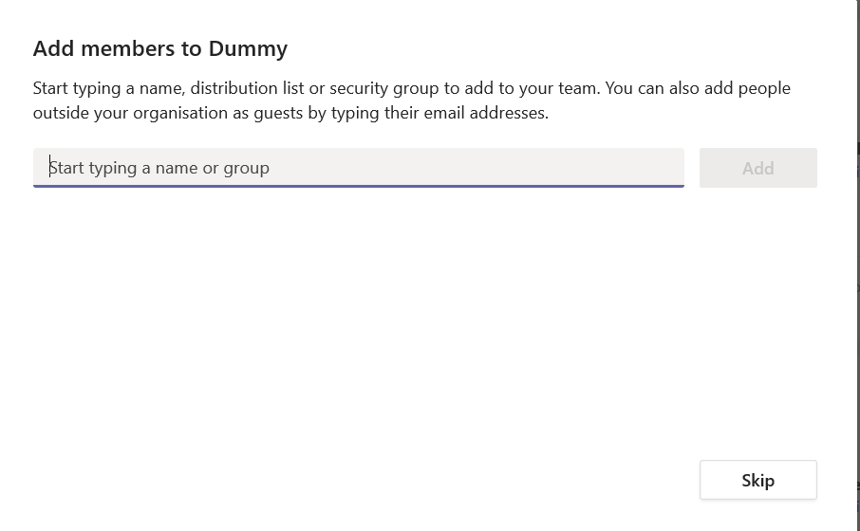

Delete or edit teams you created

If you would like to delete or edit the team you created

- press “Teams” in the left sidebar of your screen to locate the teams in which you are a member
- you might notice three dots … alongside each team. Click these dots
- various options should appear, such as delete team or edit team. Choose the option that is relevant to you.

Creating channels

The previous section demonstrated how you can join or create teams—individuals who share an interest in common. Soon, you will learn how to post and read information that is relevant to these teams. Often, however, you might want to post or read information that is relevant only to a subset of members. To illustrate

- suppose one team revolves around qualitative research
- sometimes, you might want to post or read information about one specific methodology only, such as grounded theory, narrative inquiry, or phenomenology.
- or, you might want to post or read information about qualitative software only

To achieve this goal, you can use or create channels. Channels are basically subtopics within each team. The following activity will introduce you to channels

- Locate your teams. To achieve this goal, press “Teams” in the left sidebar of your screen
- Click one of your teams to generate a screen that might roughly mirror the following example

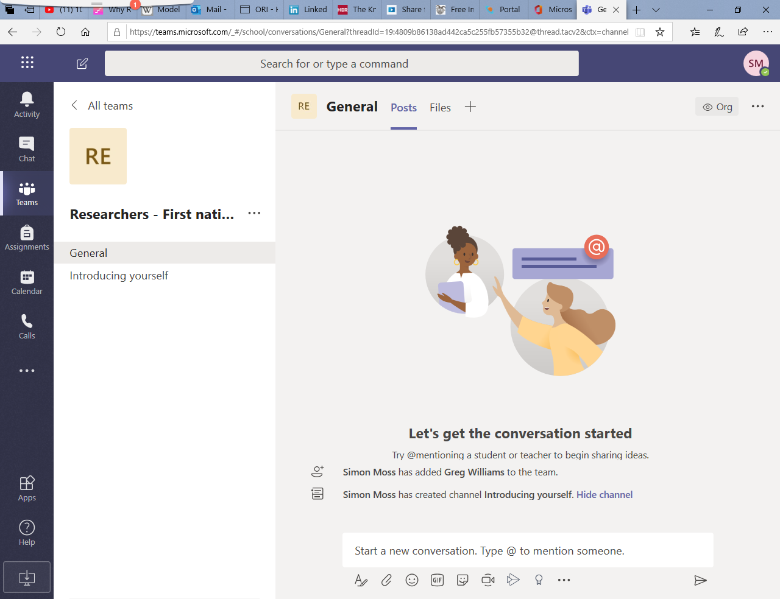

- Towards the left of this screen, under the title of this team, you will notice several options, such as General and Introducing yourself. These options are the existing subtopics within your team
- All teams will include a “General” channel or subtopic, in which members tend to post or read information about the overall team

If your team does not include a channel called “Introducing yourself”, create this channel yourself. That is,

- click the three dots alongside the title of your team, such as “Researchers – First Nations”
- choose “Add channels”
- In the box called “Channel name”, enter “Introducing yourself”
- Tick “Automatically show this channel in everyone’s list” before pressing Add.

If your team does include a channel called “Introducing yourself, perhaps consider another channel that you could add.

Introduce yourself

To help you learn how to post and read information that is relevant to your teams or interest groups, you should introduce yourself to the team. The following instructions will help you complete this task.

- Locate your teams. To achieve this goal, press “Teams” in the left sidebar of your screen
- Click one of your teams to generate the screen that resembles the previous example
- Click the option “Introducing yourself”
- In the box at the bottom, containing the words “Start a new conversation”, type a short introduction.

For example, you could

- outline your research topic, your interests, your occupation, your hobbies, or other information that could be relevant or interesting to peers
- press the leftmost icon under this space—an icon that resembles an A with a pencil. Once clicked, you can now change the format of your message
- if you like, to add attachments, and emoticons, you can use the other icons
- press the rightmost icon—an icon that resembles a paper airplane—to post your message
You can also reply to the introductions of other candidates. You merely need to press the “Reply” button immediately below their post. Furthermore, you can edit a message you posted

- point the cursor or mouse onto the message to generate a set of icons, such as

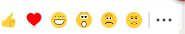

- click the three dots
- once you click these dots, a series of options will appear, such as edit, delete, or save.
- merely choose the option that is relevant to your needs, such as edit

Alerting individuals

In general, only some of the individuals who visit a particular team and channel will read the messages you post. Sometimes, however, you would really like specific people to read your posts. To achieve this goal, attempt the following activity:

- identify someone in the team to whom you would like to communicate
- if you cannot identify anyone else, choose Simon Moss, the Dean of Graduate Studies
- in one of the channels, such as General, write a message that is relevant to this person
- for example, if writing to Simon Moss, you could specify a topic on which you would like more information, such as “Could you write more advice on …”
- within the message, enter @ and the name of this person, such as @Simon. You can then choose one of several names that will gradually appear
- the person will then be notified about this message. How this person is notified will depend on their settings.
- for example, this person might receive an email. Or a symbol might appear next to the Activity or Teams icon in the left sidebar

Communicating with specific individuals

If you want to post or read messages that are relevant to multiple individuals, you should use the “Teams” option in the left sidebar. However, if you want to communicate with only one person—or a limited set of people—you should use the “Chat” or “Calendar” options instead. This section demonstrates how to utilise these options most effectively.

First, you should organize a meeting with someone at CDU—perhaps another research candidate. To organize meetings, use the “Calendar” option. So

- press the “Calendar” option on the left side to organize a meeting
- on the Calendar, click on a time in which you might be available to meet someone else online. Something like the following screen should appear

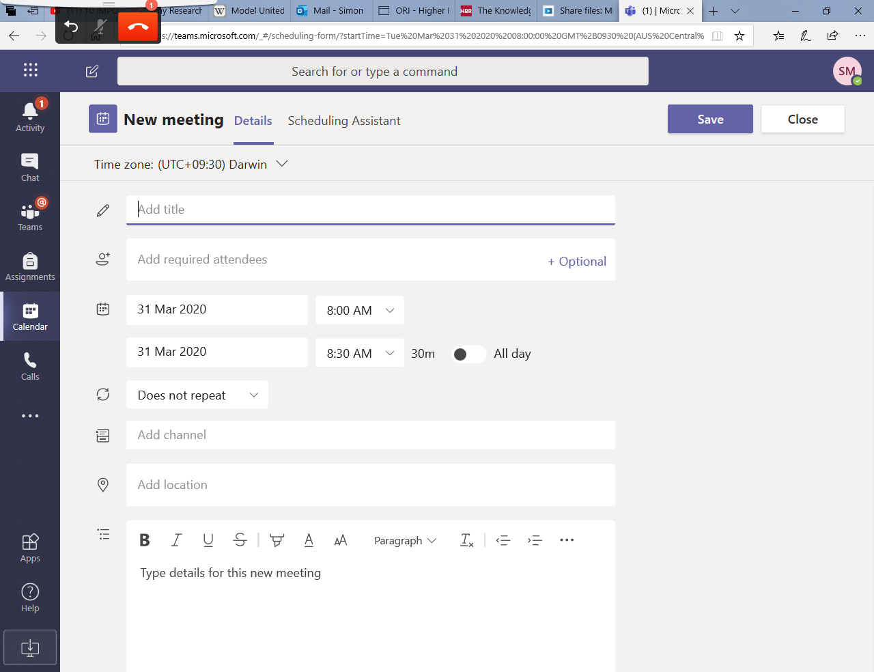

- Then, in the box called title, enter the purpose of this meeting, such as “Initial conversation”
- Click the cursor onto “Add required attendees”. Start to write the name of the person to whom you would like to meet.
- A series of names should appear. Choose the relevant person.
- You may also be able to invite entire teams
- Adjust the dates and times to suit your needs
- In the box called “Add location”, write “Microsoft Teams”
- Finally, in the bottom space, write a message like “I’ve been instructed to organize a meeting with a colleague on Microsoft Teams—and to discuss some of the challenges I am experiencing. Are you available at this time?
- Press Send.

Hopefully, this person, or someone else, will agree to this meeting. When the time arrives, return to your calendar. To start the meeting, consider these activities.

- Click the relevant item in your calendar
- Press “Join”—a button that typically appears towards the right of your screen
- If your computer is connected to a microphone and video, a video of you should appear in the middle of your screen; if your computer does not include a inbuilt microphone or video, you could attach a USB webcam instead
- Click Join now to start the meeting. The meeting should resemble the following screen

If you point the cursor or mouse to this screen, a series of icons, as shown in the yellow box. The following table outlines the role of each icon

Icon | Role
Video camera | - Switches the video camera on or off.  - If bandwidth is limited, you might choose to turn the camera off
Microphone | - Switches the microphone on or off.  - While listening, you can switch the microphone off so that no background noise disrupts the meeting
Upward arrow | - Enables you to share other open windows, such as a Powerpoint presentation, to the other participants  - You can also share your entire screen. This option, however, is not recommended, because you might inadvertently share private information, such as emails  - Sometimes, after you share a window, the video camera switches off. You might thus need to switch the camera on again.
… | - Displays other options. For example, you could record the session—one of the most important functions
Chat box | - Enables you to send written messages to the participants  - That is, sometimes, you want to send a note without disrupting the meeting
Two people | - Enables you to invite other participants to the meeting  - You can continue to invite people after the meeting has started  - If their Teams is open, they will receive an alert on their screen
Phone | - The last red icon is to hang up—or stop the meeting

If you have recorded the meeting, Microsoft Teams will create a file that you can access after several minutes. To access this recording

- choose “Chat” in the left sidebar
- you might observe a reference to this meeting, labelled “Meeting: Recorded by…”, like the following screen
- click the three dots…
- choose “Open in Microsoft Stream”—another Microsoft app
- to play the recording from this app, simply press the arrow on the screen
- to download the file, click the … below the screen. You can then choose several option, such as download or delete

Spontaneous chats and calls

Sometimes, you might want to contact someone on Teams spontaneously, without scheduling a meeting. To achieve this goal, several options are available. For example, you could

- select the “Chat” option from the left sidebar
- choose the “Contacts” tab near the top and press the … next to “Contacts” to add other contacts
- select this person
- press the video or phone icon that usually appear on the top right to begin a video or audio call
- alternatively, you can select the “Call” option from the left sidebar

Status

Of course, these individuals will not answer your call, unless they are available. You can usually check their status by pointing the mouse towards their name. You will then discover whether they are available, online, offline, away, and so forth. You can also change your own status, as the following table outlines.

- To facilitate camaraderie, whenever you use the portal, click Microsoft Teams;
- That is, Teams should be open as often as possible

Activity | Details and examples
Microsoft Teams automatically sets your status | - If you are not connected to the internet, your status will be offline.  - If Microsoft Teams is open, your status will be available
You can also modify your status as well | - Click the mouse or cursor on your account—usually your initials or picture of you near the top.  - You can change your current status from “Available” to “Appear away” for example.

Other insights about Teams

The previous activities were designed to expose you to a subset of the features that Microsoft Teams offers—as well as to encourage collaboration among researchers. Yet, Microsoft Teams also offers many other features. This section outlines some of the key features.

Privacy and ownership

If you create a team or a channel, you become the owner of this team or channel. As the owner, you are granted special privileges. The following table outlines these privileges as well as how to apply these privileges.

Privilege | How to apply these privileges
You can delete teams or channels | - Press the “Teams” option from the left sidebar  - Click the … alongside your team or channel  - Choose “Delete team” or “Delete channel”
You can grant ownership to other people | - Press the “Teams” option from the left sidebar  - Click the … alongside your team or channel  - Choose “Manage team”  - You should notice a heading “Members and guests”  - Click the arrow next to this heading to unveil all the members and guests  - In the last column, press the downward arrow next to the word “Member” corresponding to one person  - Choose “Owner” instead
You can change the picture or icons that symbolizes the team | - Press the “Teams” option from the left sidebar  - Click the … alongside your team or channel  - Choose “Manage team”  - Choose the “Settings” tab towards the top  - You can change the picture here—as well as other settings too, such as which features members are permitted to use
You can shift the team from public to private or vice versa | - Press the “Teams” option from the left sidebar  - Click the … alongside your team or channel  - Choose “Edit team”  - You can then change the option in the box labelled “Privacy”  If a team or channel is private, individuals can request to join. The team or channel owner can then accept or reject this request.

Individuals from outside CDU

When adding individuals to your teams, channels, or meetings, you can include people from outside this organization. These individuals are called guests. To illustrate

- after you press the … next to a team or channel, the option to “Add member” appears.
- choosing this option will generate the following screen
- you can then enter the email address of this person in the box and press Add

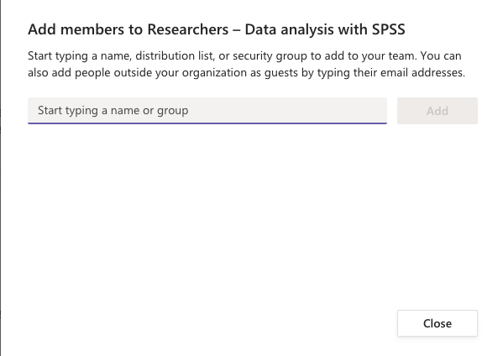

Nevertheless, you should be aware of several limitations or complications with guests. Specifically

- they may need to enter their Microsoft username and password—usually their work username and password. Otherwise, they might need to open a Microsoft account. They can open this account at no charge
- some features are not available to guests; for example, the calendar in Teams will not integrate with their personal calendar

