MICROSOFT PLANNER AND PROJECT MANAGEMENT OF YOUR THESIS

by Simon Moss

Introduction

This document integrates three interrelated but distinct topics. Specifically, after you read this document, you will have developed some expertise on

- how to utilize Microsoft Planner
- how to conduct project management in general
- how to manage your research and thesis

Microsoft Planner is a tool that can help you divide your research into specific tasks and subtasks, choose the order in which you should complete these tasks and subtasks, assign due dates to these tasks, monitor your progress, and collaborate with your supervisors and other relevant individuals. You might have already developed expertise on Microsoft Planner or project management. Regardless, this document could still be useful by helping you apply these approaches to manage your research in particular.

Initiate your first plan

To learn about these topics, you should apply the instructions as you read this document. To start, you need to access Microsoft Planner. To achieve this goal

- in Google Chrome, visit the portal—that is, portal.cdu.edu.au—and login
- choose the tile called “Office 365”, because Microsoft Planner is an application in Office 365; a series of icons should appear
- if “Planner” is not one of these icons, click “All apps” to display all the applications in Office 365
- choose “Planner” to generate something like the following screen

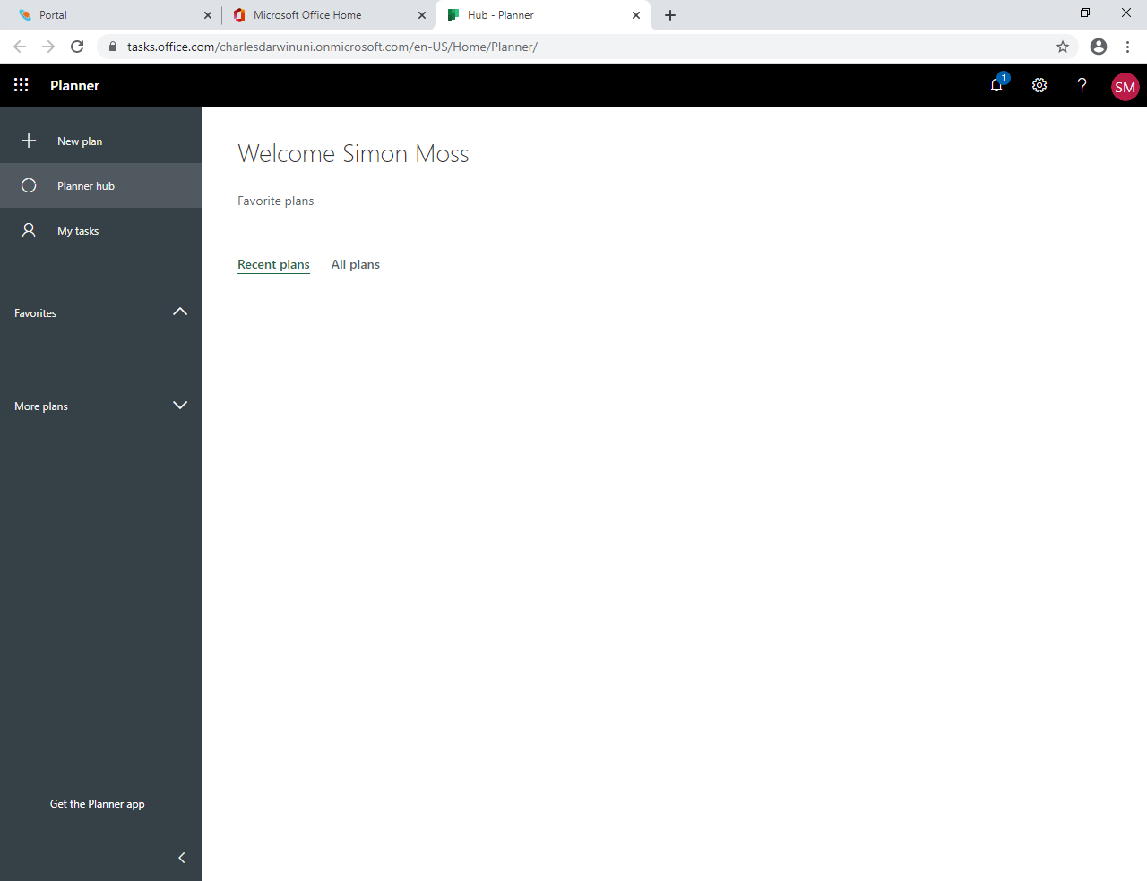

If you use another internet browser, such as Edge, the page might not quite look the same and some of the words might be concealed. At first glance, this screen looks quite empty and uninformative. You are now ready to generate a plan to manage your research. To achieve this goal

- click “New plan” to generate the following screen

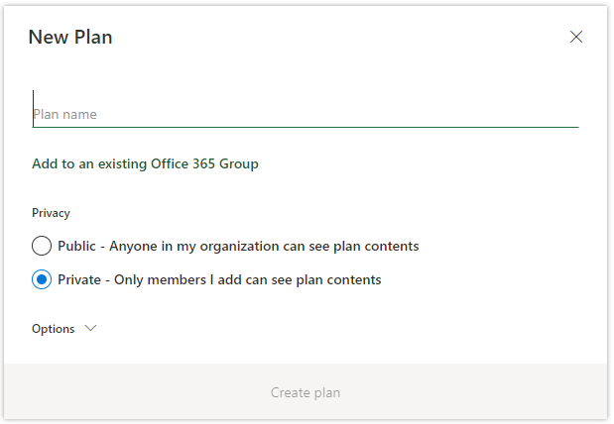

- in the space “Plan name”, you could enter “Research project” or something similar
- do not choose “public”; you do not want everyone to be able to access your plan
- if you like, you could also click the arrow next to “Options” and then enter more information in the box called “Group description”.
- for example, you could write “This project revolves around the research of Betty Smith. This project, however, does not include internships or other extra-curricular activities”
- click “create plan” at the bottom of this box to generate something like the following screen
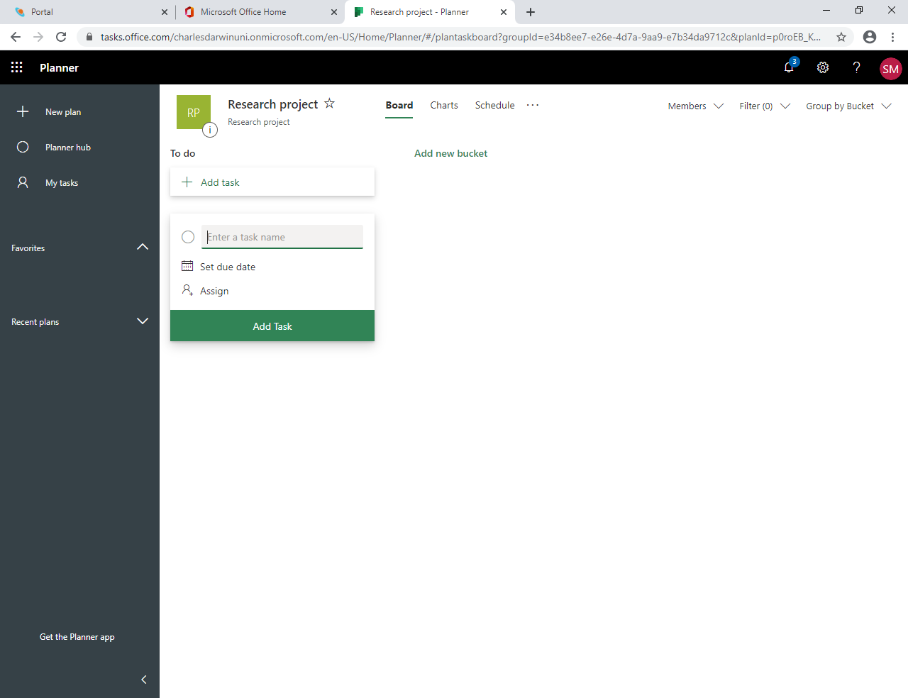

This page will be used to plan your research project. However, plans can be used to manage more specific activities, such as a single research study. Alternatively, plans can used to manage broader activities, such as a research program—that is, a set of related projects—or even a portfolio—that is, a set of research programs in a university, such as “health research”.

Specify your tasks

Create a few tasks

Microsoft Plans is simple to use. In general, you will need to

- specify the various tasks you want to complete
- allocate these tasks to various clusters, called buckets
- assign dates and individuals to these tasks
- divide these tasks into subtasks
- monitor your progress.

To create a task, you can type in the box labelled “Add Task” and the bottom. If this box does not appear, simply click “Add task”. In particular

- enter a name of this task, such as “Read some previous theses”. You can then press enter
- another box, called a card, will appear. If you click this box, the following options materialise

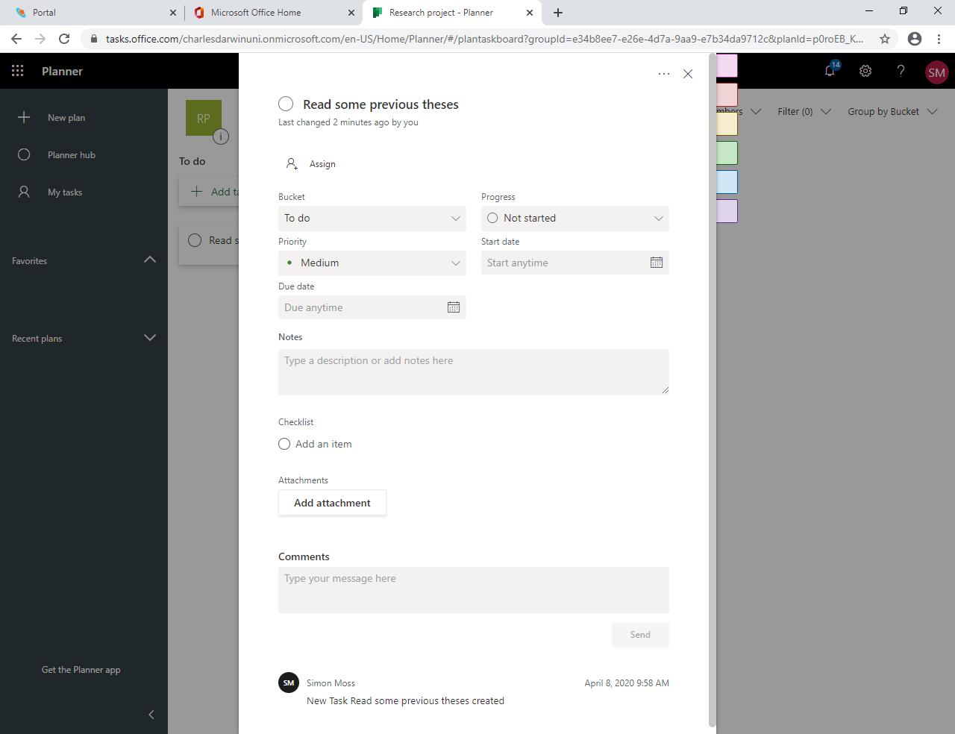

Some of these options are not relevant yet. But, even at this time, you could

- indicate the progress—that is, whether the task is completed, in progress, or not started
- specify the priority you want to assign this task—such as low, medium, important, or urgent
- choose a start date and due date
- describe the task in more detail, within the box called Notes
- click the X at the top to close this box

We recommend you now construct about 5 to 10 tasks now. Examples of tasks might include

- construct the supervision agreement
- construct a data management plan
- finalize my supervision panel
- submit the ethics application
- join an interest group

Create some buckets

After you have created a set of tasks, a long series of cards appears, often towards the left of your screen. This series of cards might feel cumbersome. The following screen illustrates this problem. To organize this plan better, you need to arrange these tasks into clusters, called buckets. To achieve this goal

- click the “To do” label near the top right and enter a meaningful label, such as “Induction”
- click “Add new bucket” label near the top and enter the name of another cluster, such as “Literature review”
- continue to create several other buckets or clusters, such as “Confirmation of candidature”, “Preliminary study”, “Publish”, and “Submit”
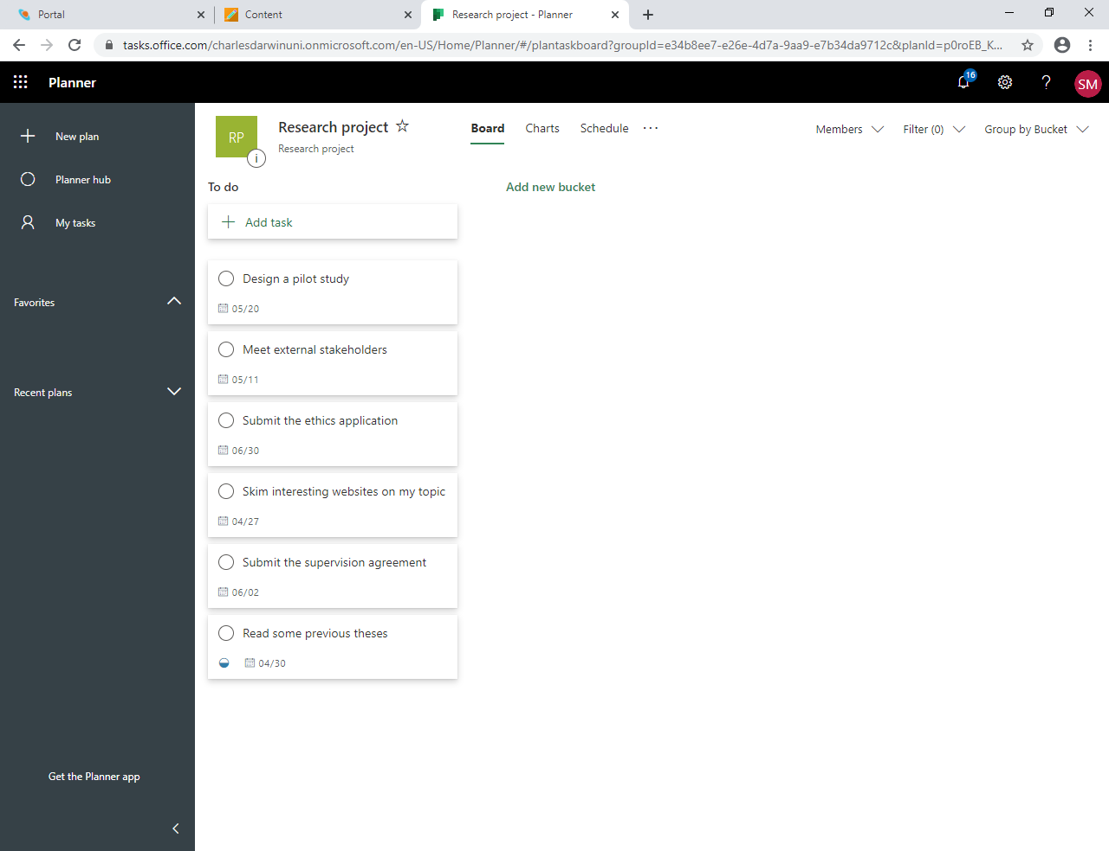

These activities will generate a series of labels at the top of your project. To shift your tasks to the appropriate label or bucket, you could

- drag the card to the appropriate location with your mouse, or
- click the card. In the box that opens is an option to change the bucket
- after you complete this task, your screen is more likely to resemble the following example

No more than a few buckets can appear on the screen at the same time. So, you meet need to shift the grey bar at the bottom to switch between the buckets.

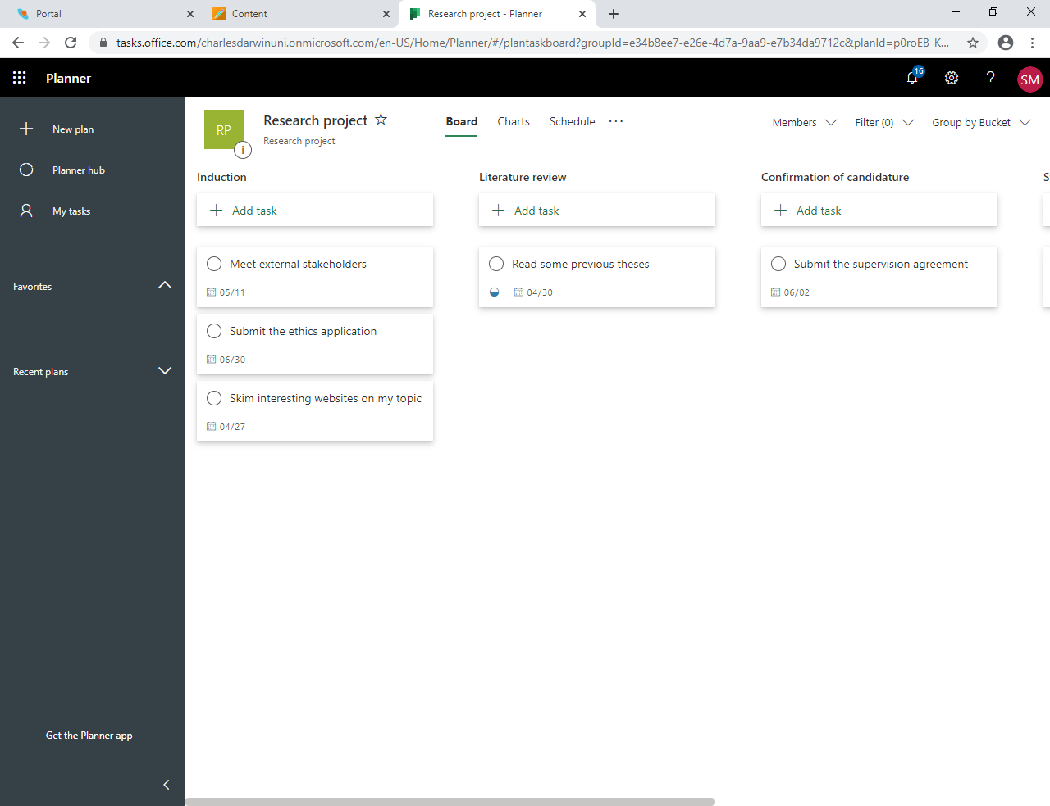

Create subtasks

Most tasks comprise many subtasks. For example, to read previous theses, you might need to

- determine how to access previous theses at CDU or other institutions
- search these repositories to identify suitable theses to read
- read or skim one to three theses
- record lessons or insights you glean from this thesis

In Microsoft Planner, you can record these subtasks. This list of subtasks is called a checklist. To specify a sequence of subtasks

- click the card that corresponds to your task, such as “Read some previous theses”
- locate an option called “Checklist”
- above “Add an item”, enter your first subtask, such as “determine how to access previous theses”, and then press enter
- repeat this procedure to enter other subtasks
- if you click the cursor on the square next to “Show on card”, these subtasks will appear on the card in your project

Create more tasks, buckets, and subtasks

You are now ready to create more buckets, tasks, and subtasks as well as specify possible timelines. You can then modify this information later—usually by simply clicking the card or bucket. To help you create this information, consider the following table. In particular

- the information in the black rows, especially before the colons, are possible buckets
- the leftmost column lists some possible tasks you could include
- the middle column specifies roughly when you should complete this task; double this time if you study part time; halve this time if you are completing a Masters
- the rightmost column lists some possible subtasks—that is, a checklist—for each task
- you could also use mind-mapping to help you uncover these tasks; Google the word “mindmeister”—software that can be used to construct mind-maps

Possible tasks | Timeline | Possible subtasks
Induction: Familiarise yourself with the university and course
Introduce yourself to the relevant individuals | Month 1 | Meet  - your supervisors  - the administrative staff in your college or school  - the research coordinator in your college or school  - other research candidates  - other staff in your discipline  - staff from the Office of Research and Innovation
Organize basic resources and computer access | Month 1 | The HDR administrator of the college or school should help you organize  - an office with a chair, computer, shelf, and filing cabinet s  - access to the building at night for internal candidates  - an email account and internet  - a printer and photocopier  - necessary software; learn how to utilize software central
Read some previous theses | Month 1 | - Determine how to access previous theses at CDU or other institutions  - Search these repositories to identify suitable theses to read  - Read or skim one to three theses  - Record lessons or insights you glean from this thesis
Submit the supervision agreement | Month 2 | - Access the agreement on the web  - Discuss with your principal supervisor which clauses you want to retain
Preliminary review: Conduct a preliminary literature review to modify or confirm your research question
Imagine the problems you would like to solve | Month 1 | - Transcribe the problems in your life or in society you would like to solve with your research  - Imagine the world, decades in the future, after these problems have been solved
Skim websites that refer to the key developments in this field | Month 1-2 | - Locate these websites, such as www.reddit.com or sciencedaily.com  - In these websites, locate articles that relate to the problems you want to solve in your research  - Skim these articles  - Record insights from these articles  - Read several relevant Wikipedia pages
Skim scholarly papers that refer to the key developments in this field | Month 1-3 | - Locate relevant databases of scholarly journals in your field  - Search the database to locate 50 to 100 relevant articles or books  - Skim the abstracts  - Read a few relevant articles in depth  - Record and categorize some of the key insights
Read or skim some relevant books | Month 1-3
Blend or integrate distinct insights | Month 3
Thorough review: Conduct a thorough literature review or even a systematic review
Read about how to conduct literature reviews | Month 2 | - Locate the information on the CDU website  - Read the information  - Decide on whether you want to conduct a traditional literature review, systematic review, qualitative synthesis, or a combination
Develop a plan on how to search and access the relevant literature | Month 2-3
Develop a plan on how to record the information you uncover | Month 2-3
Apply these plans on how to search and record the relevant literature | Month 3-5
Construct a rough plan of your literature review | Month 4-7 | - Construct a plan that specifies the main arguments you want to include  - Construct a plan that specifies the main paragraphs  - Convert this plan to a rough draft  - Utilise the resources on how to write to improve this draft
Construct a preliminary design of your research
Learn about possible methodologies and methods | Month 4-5
Select your methodologies | Month 5
Choose methods to collect data | Month 6
Choose methods to analyse data | Month 7
Consider the resources you need | Month 7 | - Develop a budget  - Consider from whom you will seek assistance  - Identify existing resources you could use
Engage stakeholders
Identify key stakeholders | Month 3
Develop a communication plan | Month 6 | - Learn about communication plans  - Consider how you will inform stakeholders of updates, for example
Implement the communication plan | Month 7 onwards
Confirmation of candidature and ethics
Write a research proposal | Month 3-7 | - Describe the problem you want to solve  - Review the literature  - Outline limitations of past research-  - Specify the aims of your research and, if applicable, the hypotheses  - Summarize the methodology and methods  - Specify the participants, materials, procedure, and data analysis—at least for one study  - Outline the schedule of research activities; You could include a GANTT chart or merely specify the likely dates  - Discuss the main ethical or safety concerns as well as how you might manage these concerns.  - Outline the resources that you need to complete this project
Prepare the presentation | Month 8 | - Plan the main sections you want to include  - Write a rough script  - Plan the slides  - Construct the slides
Respond to feedback | Month 9
Consider the risks of your project | Month 8
Submit the ethics application | Month 10
Conduct a preliminary or main study
Design methods to collect data | Month 11
Design methods to analyse data | Month 11
Prepare materials | Month 12 -13
Collect data | Month 14-18
Analyse data | Month 19
Write report | Month 20-21
Publish or disseminate the results
Identify suitable publication outlets |  | - Access journalfinder.elsevier.com.  - Omit predatory or vanity publications  - Assess the submission criteria  - Establish whether you can include these publications in your thesis  - Determine the costs of these journals  - Rank the possible journals
Submit publications |  | - Write the cover letter  - Choose the keywords  - Follow the instructions
Identify suitable conferences |  | - Seek advice from your supervisors or colleagues  - Access conference directories, such as www.allconferences.com/Search
Submit abstracts to conferences |  | - Clarify the guidelines  - Write a sentence or two that outlines the background, aim, methods, results, and conclusion
Prepare conference presentations
Write and complete the thesis
Write the introductory chapter |  | - Plan a section about the importance of this problem you want to solve  - Plan a section about your main approach  - Plan a section that outlines the chapters of your thesis  - Convert these plans to full sentences and paragraphs
Write the literature review chapters
Write paragraphs that link chapters
Write the general discussion
Organise appendices |  | - Decide which appendices you want to include. Examples include interview transcripts, coding schemes, computer code, statistical output, research materials, and communications with stakeholders  - Collate these materials
Organise front pages |  | - The title page  - The statement of original authorship  - Acknowledgements  - The abstract  - Table of contents and figures  - Your publications included in this thesis
Optimise writing
Optimise formatting
Proofread
Organise paperwork
Prepare submission paperwork |  | - Identify the forms to complete  - Choose the examiners together with your supervisor

Optimise the layout

Finally, you can optimise the layout. To illustrate, you might want to delete a task or bucket as well. Specifically

- when the cursor or mouse hovers over a task or bucket, three dots, called an ellipsis, will appear
- click these three dots…
- the option to delete will appear

You can also click this ellipsis to shift tasks or buckets to the left or right.

Collaborate with other individuals

So far, this document has delineated how you can set tasks and deadlines alone. However, to manage a project effectively, you will need to collaborate with other individuals at the university. Research candidates, for example, obviously need to collaborate with their supervisors. They may also need to collaborate with peers who are completing overlapping or similar research, technicians, as well as other staff. This section will help you achieve this goal.

Assign people to your project or tasks

You can assign people, such as your supervisors or colleagues, to your project or tasks. The following table outlines how you can achieve these goals.

How to assign | Details
Use the Members option at the top to assign people to your project | Procedure  - Press the downward arrow next to “Member”, a label that usually appears towards the top right  - In the box, start to enter the name of a student or staff member at CDU, such as “Jonat  - The computer will then specify various alternatives, such as “Jonathon Smith” or “Jonathon Jones”  - Choose the relevant alternative  Consequences  - This person will then be able to access the project—such as update the various tasks and subtasks
Click the ellipses alongside each task to assign people to tasks | Procedure  - Hover the cursor or mouse over a specific task  - Three dots, such as .…, should appear towards the right of this card  - Click these dots, called an ellipsis  - Choose the “Assign” option  - In the box, start to enter the name of a student or staff member at CDU, such as “Jonat  - The computer will then specify various alternatives, such as “Jonathon Smith” or “Jonathon Jones”  - Choose the relevant alternative  Consequences  - When this person chooses “My tasks” in the left panel, this task will appear  - Therefore, these individuals will be more likely to contribute to this task  - This person will also be assigned to the overall project—and thus be able to access every task

One limitation, however, is that only staff and students at CDU can be assigned to your plan or tasks. Supervisors or other collaborators who are not affiliated with CDU will not be granted this access.

Communicate with members of your project

You can also utilise Microsoft Planner to communicate to members of your project team. The following table illustrates some examples of how you might communicate to these individuals.

Examples of communication | Details
Submit comments to justify changes | Procedure  - Click a specific task card  - Change some feature of the task, such as the due date  - In the box called “Comments”, justify this change  Consequence  - The comments are emailed to the owners of this task—usually the people who created the task  - The comments enable you to communicate the changes you introduced
Email members of this project only | Procedure  - Click the ellipsis, the three dots, towards the center and top of your page  - Choose “Conversation” to open the group email in Outlook  - The emails you send now will be sent to all members of your project
Attach files to specific tasks | Procedure  - Click a specific task  - Click “Add attachment” and then “file”  - Then browse your hard drive, such as your One Drive, to identify files that might be relevant to this task—such as a pdf file, a Word file, or an Excel file  - You can select or de-select the tick next to “Show on card”  Consequence  - This method is an effective means to share information about a task  - When members click this file, the file opens in Sharepoint but can be downloaded, edited, and attached again  - They might then submit a comment after you change these files  Clarifications  - You can also access every file that has been attached to this overall project  - In particular, click the ellipsis, the three dots, towards the center and top of your page. Then choose “Files”
Utilise labels to earmark tasks | You can assign labels to the various task cards. For example  - When you click a card, you will notice a set of colored labels on the right side, towards the top  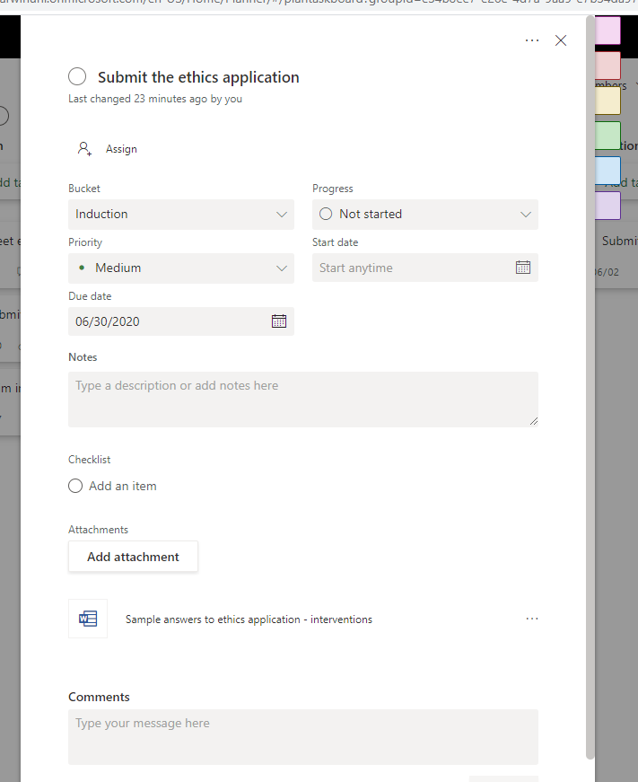  - Click a label  - Type a phrase, such as “Needs supervisor approval”, “Unsure how to proceed”, “Daily task”, and “Weekly task”  - Now, you can assign these labels to the various cards  - Specifically, hover the mouse or cursor above a card to uncover the ellipsis or three dots  - Click the three dots and then choose “Labels”  - Click the various labels to tick or untick the relevant options  - The task will then be assigned these labels, as shown below  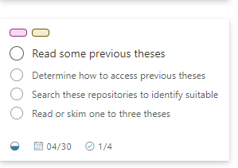  - Other team members can utilize these labels  - Supervisors, for example, might be instructed to approve the tasks with a pink label—the label designated as “Needs supervisor approval”  - To help individuals locate the relevant tasks, they might click the arrow next to “Group by Bucket” on the top right and then choose “Group by Labels”  - Consequently, all the tasks assigned a pink label will appear together, as the following example shows  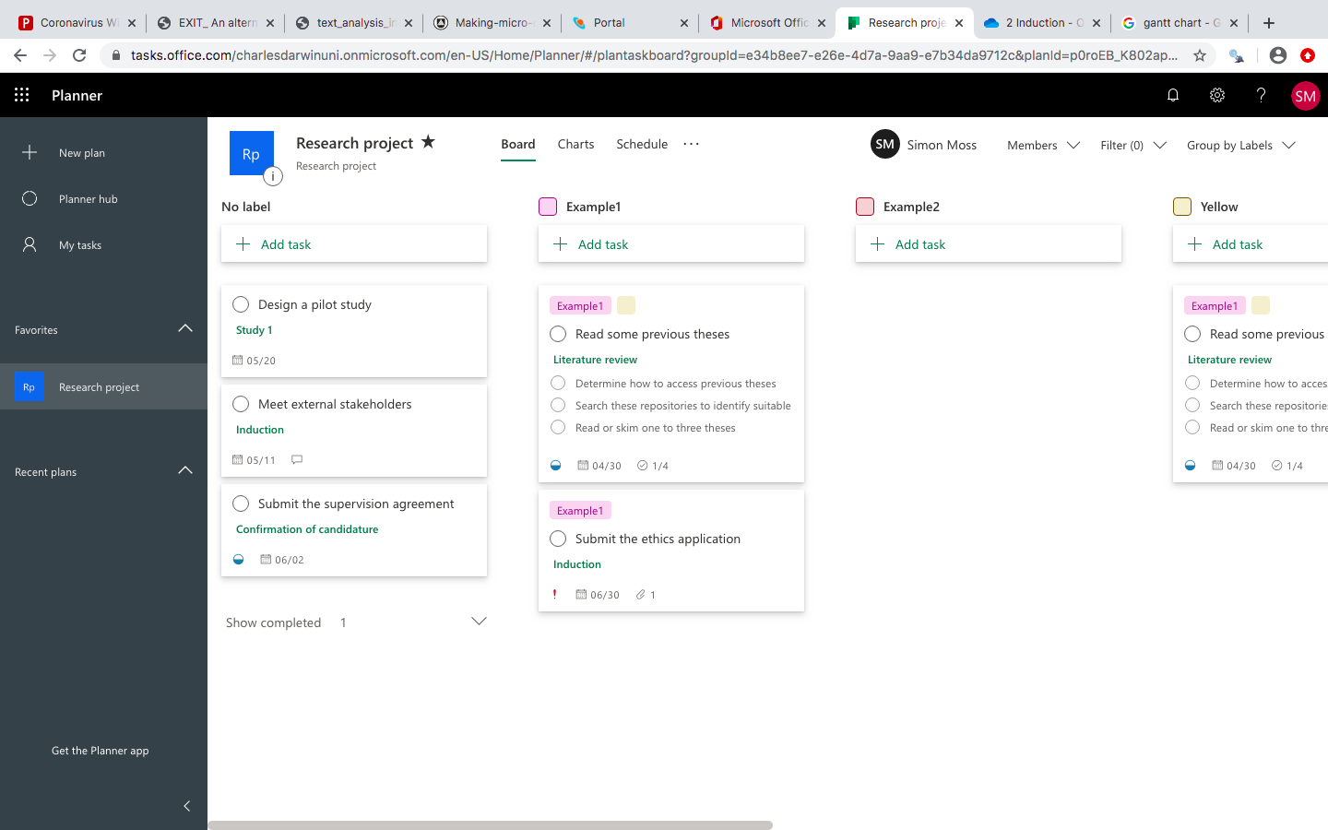
Integrate with Microsoft Teams | - If you have developed expertise in Microsoft Teams, you can integrate this application with Microsoft Planner  - To illustrate, in Microsoft Teams, when creating a team, you can choose the option “Existing Office 365 group” and then choose the members of this plan.  - Consequently, you can communicate to members of this plan using Teams.

Monitor your progress

Clarify which tasks to prioritize

Thus far, this document has merely demonstrated how you can utilize Microsoft Planner to set and to organize tasks as well as to communicate this information to other people, such as your supervisors. But, more importantly, Microsoft Planner can present feedback about your progress and inform decisions around which tasks you should prioritize. To illustrate, if you choose the “Charts” option towards the top of your project, you will receive a screen that resembles the following example.

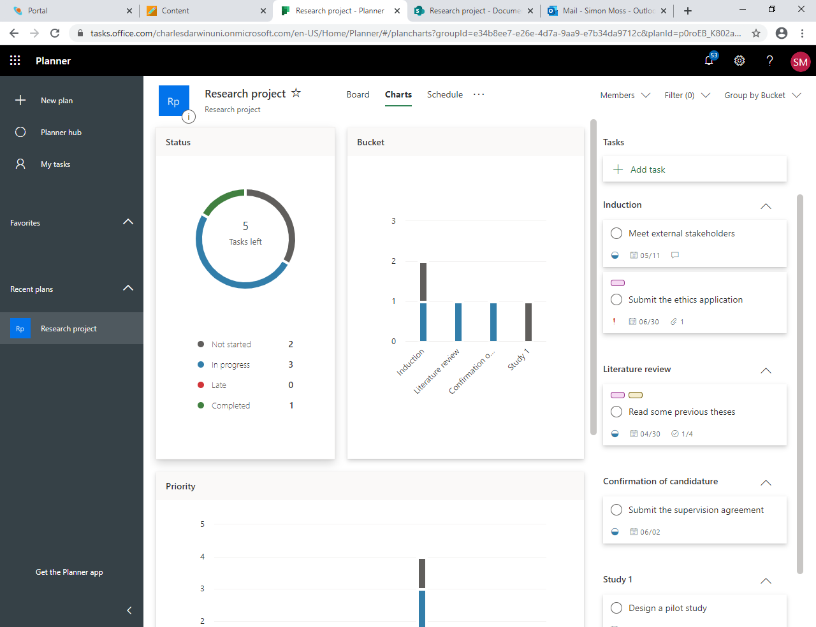

This information can be quite useful. For example

- the graph labelled “status” offers insight into the number of tasks in which you have not started, started, and completed as well as the number of tasks that are overdue and, therefore, need to be addressed immediately
- the next graph, labelled “Bucket”, presents similar information, but for each bucket or cluster of tasks separately
- although slightly obscured in the previous screen, the graph called “Priority” presents information on the number of urgent or important tasks you have yet to complete
- to determine which urgent tasks you need to complete, click the arrow next to “Group by Bucket” on the top right and then choose “Group by Priority”

Receive alerts

If you do not use Microsoft Planner habitually, you might overlook the observation that some of your tasks are overdue or need to be completed very soon. To overcome this problem, you could arrange Microsoft Planner to send you or your team members alerts or notifications. To illustrate

- click the three dots or ellipsis towards the top and center of this screen
- choose “Plan settings”
- you might choose “send email to the group when a task is assigned or completed”.
- if so, all members will receive alerts about these changes in Outlook—but in their groups folder rather than in their Inbox

Or instead

- select “notification settings”—a link that appears just below “Group email settings”
- tick or untick the options to decide whether you want to receive emails when a task is assigned to you, due today, or due in 7 days

Analyse your tasks and deadlines in Excel

You can export your plan to Excel. Specifically,

- click the three dots or ellipsis towards the top and center of this screen
- choose “Export plan to Excel”
- an Excel file will then appear in your Downloads folder on your computer
- open this file to generate a spreadsheet that resembles the following screen

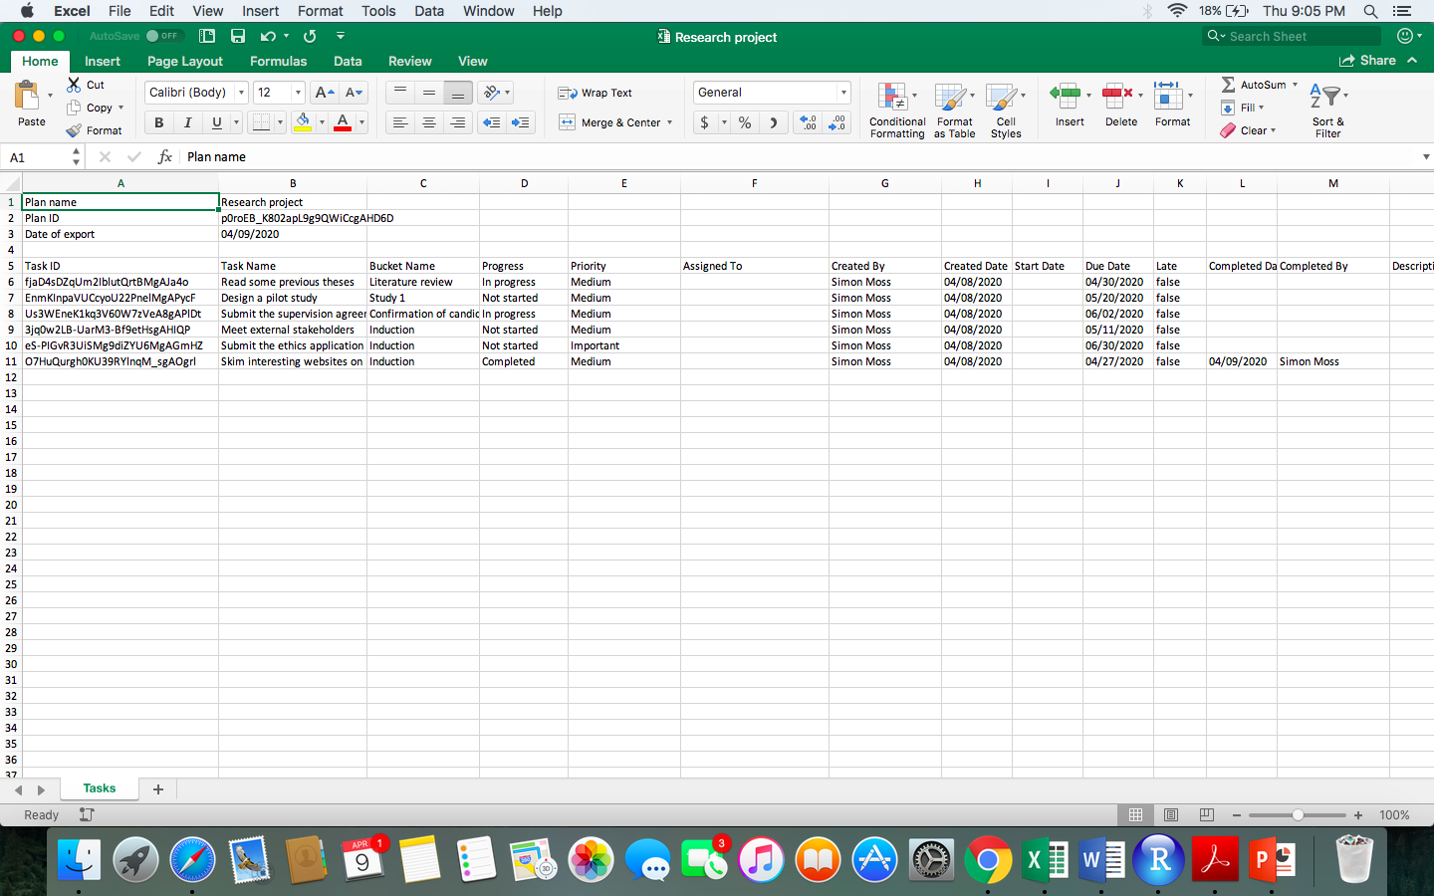

Although this example is blurry, each row corresponds to information about each task, such as

- the name of this task
- to whom the task was assigned
- the start and end date
- the labels, and so forth

You can, in principle, subject these data to a range of analyses. For example, you could assess the relationship between who was assigned the task and the number of late tasks. These analyses may guide future decisions on how to allocate tasks effectively and how to set appropriate deadlines. To illustrate, you might not assign important tasks to the person who often completes task over time.

Other insights about project management

This document has, thus far, introduced you to Microsoft Planner—a tool that helps you manage projects effectively. Nevertheless, project management encompasses more than merely using Microsoft Planner. For example, to manage projects effectively, you need to

- locate a suitable mentor—someone who can offer you insights about how you should manage this project more effectively. This person could be a colleague who is more experienced than you or someone who has completed a thesis before
- become involved in your industry, such as volunteer to assist a relevant association or attend public events that are relevant to your industry
- identify the people who are close to key authorities or decision makers—and, if appropriate, develop a relationship with these people
- some tasks should be completed daily, such as writing
- some tasks should be completed weekly, such as updating your plan
- some tasks should be completed monthly, such as updating your literature review; in Microsoft Planner, you can use labels to distinguish these daily, weekly, and monthly tasks
- evaluate your progress every one or two weeks
- enter comments on which tasks or subtasks were not completed as readily as planned; that is, maintain a journal about lessons you have learned or insights you have gained

Gannt charts

Microsoft Planner does not generate Gannt charts. A Gannt chart, as the following example illustrates, displays the months you plan to devote to each task. Fortunately, you can download a variety of free applications to generate Gannt Charts—such as https://www.teamgantt.com/ or https://www.teamgantt.com/free-gantt-chart-excel-template

