Placement Concern Procedures

Overview
It is in the best interests of the preservice teacher (PST), the mentor teacher and the students that any concerns regarding the PST’s conduct or competence be addressed as soon as possible.

Should the mentor have concerns about a PST’s progress at any stage in the placement, the principal/director, the PST and, in the cases of Levels 2 and 3, the CDU unit coordinator should be notified. Contact information is provided in the interim and final reports and placement requirements and guidelines documents. The CDU Associate Dean – Work Integrated Learning (claire.bartlett3@cdu.edu.au) should also be notified in cases of Level 3 and any early cessation of placement.

Level of Concern |  | Examples | Documentation | Outcome
1 | Concern | - Punctuality/absences  - Standard of dress  - Lack of initiative  - Limited understanding of placement requirements | Notification of Concern Agreement | Documentation retained by mentor and PST
2 | Targeted Support | Targeted Support needed to:  - Plan lessons  - Teach effectively  - Demonstrate content knowledge  - Accept and use feedback  - Communicate professionally  - Manage classroom behaviour  - Differentiate for student learning  - Engage in inclusive and anti-discriminatory practice  - Complete full days and weeks where required/rectify continued absences or lateness  - Meet graduate standards as identified in assessment forms | Targeted Support Plan | Documentation sent to CDU lecturer
3 | Misconduct | - Breach of educational setting’s duty of care  - Breach of CDU’s code of conduct  - Breach of confidentiality  - Unethical or unsafe behaviour  - Inappropriate language  - Defiance  - Inappropriate behaviour towards students, parent, staff and/or community  - Racist, sexist or other discriminatory behaviours  - Maligning the reputation of CDU/educational setting | Misconduct Report | Documentation sent to CDU lecturer and to Associate Dean – Work Integrated Learning
Level 1: Concern
Concerns are not limited to the examples in table above. These issues can be resolved after they have been formally identified by the mentor with the PST.

The mentor and PST complete a Notification of Concern Agreement, available on the inschool website copies of which are kept by PST and the mentor.

No formal notification to the CDU unit coordinator is required at this level, but the mentor may choose to contact the lecturer to share information or receive support.
Level 2: Targeted Support
Concerns are not limited to the examples in the table above. Where the mentor teacher has concerns that the PST may fail to achieve the requirements of the placement, the Targeted Support Plan, available on the inschool website must be completed as soon as the concerns are identified, or by the Interim Report stage, whichever is sooner.
The Targeted Support Plan should be completed following a discussion between the mentor teacher, setting-based Professional Experience coordinator, and the PST, and in consultation with the CDU unit coordinator. It must then be signed by all present and emailed to the CDU unit coordinator, with all parties copied into the email.
The Targeted Support Plan runs for a period of 5 days. Its purpose is to identify the key areas of concern in the form of developmental goals and to establish a program of strategies to support the PST in meeting these goals. PST performance against these goals is assessed daily over the 5-day period.
- If the Targeted Support Plan results in the PST successfully getting back on track to meet the requirements by the end of the placement, the PST submits this form with the final report to the CDU unit coordinator.
- If the PST is unable to meet the identified developmental goals within the 5 days, a second and final opportunity may be provided.
- If the PST does not successfully complete the Targeted Support Plan over two targeted support periods (10 days total) they will be deemed to be unsuccessful in the placement.
An Early Cessation of Placement by Educational Setting form, available on the inschool website is to be completed and emailed to inschool@cdu.edu.au, with the mentor teacher, PST, CDU unit coordinator, and Associate Dean – Work Integrated Learning copied in.
A Fail grade will be recorded.

Targeted Support - Guidelines for Mentor Teachers
Mentors should follow these guidelines to support a PST who is identified as potentially failing to meet the professional experience requirements.
1. Advise the CDU unit coordinator
Mentor indicates concerns in Interim Report. Ensures the PST copies mentor when Interim Report is sent to the CDU unit coordinator, or mentor emails it and copies the PST.
If concerns occur before the midpoint, mentor emails the CDU unit coordinator directly. PST will provide lecturer contact details.
2. Initiate Targeted Support Plan
PST, mentor, and the setting-based Professional Experience Coordinator will meet to initiate the Targeted Support Plan. Mentor maintains clear notes of this and subsequent meetings, dated and signed by all participants.
Mentor emails page 1 of the plan to the CDU unit coordinator.
3. Daily Progress Report
Mentor and PST discuss PST’s performance together at the end of each day and rating is determined against evidence of PST’s practice. PST and mentor to sign each day’s form.
4. Conclude Targeted Support Plan:
At the end of the Targeted Support period, PST, mentor, and setting-based Professional Experience Coordinator meet to determine recommendation:
1. PST has made sufficient improvement during the Targeted Support period to indicate they are on track to successfully fulfil the Professional Experience placement requirements
2. PST has not yet made sufficient improvement during the first Targeted Support period and will undertake a further and final 5-day Targeted Support period.
3. PST has not made sufficient improvement during the Targeted Support period (1 or 2) and has failed the Professional Experience placement.

Extreme difficulty
If the PST is experiencing extreme difficulties, that warrant further action, but do not go as far as misconduct, the parties involved may agree to:
- Relocate the PST to another class or setting
- Terminate the professional experience placement by completing the Early Cessation of Placement by Educational Setting and email to the CDU unit coordinator and the Associate Dean – Work Integrated Learning
Note: in the situations above, the placement days undertaken are not automatically credited and, in most instances will have to be repeated in the new class setting.

Level 3: Misconduct
Relevant CDU Policy
Charles Darwin University Student Code of Conduct
Charles Darwin University (Student General Conduct) By-Laws
Concerns are not limited to the examples in the table above. As part of the duty of care of teaching professionals, PSTs, practising teachers and CDU staff are bound to report any unprofessional behaviour.
Where a PST has been identified as breaching the CDU Code of Conduct the regional TRB’s Code of Ethics, or otherwise demonstrating significantly non-professional behaviour, the setting-based coordinator or principal/director should advise the PST, the CDU unit coordinator and the Associate Dean – Work Integrated Learning (Claire.bartlett3@cdu.edu.au) within 24 hours if possible.
If the instance/s of behaviour is deemed to be of significant seriousness by the educational setting the principal/director may terminate the placement. An Early Cessation of Placement form is completed and emailed to the CDU unit coordinator and the Associate Dean – Work Integrated Learning (Claire.bartlett3@cdu.edu.au).

Termination of Professional Experience Placement
Termination of placement may occur if a PST is experiencing extreme difficulty in meeting the placement requirements (Level 2), or in cases of misconduct (Level 3).
Termination of placement is a last-resort process and will usually only occur after consultation with the PST, mentor teacher and the setting-based coordinator. Termination usually does not occur without warning or before remedial actions have been implemented.
Termination can occur immediately if the situation is viewed as urgent or of significant seriousness. This includes if a PST presents to a placement under the influence of drugs or alcohol, or if the safety and well-being of students in the host school is compromised.
If a placement is terminated at short notice the principal/director should complete the Early Cessation of Placement form and email the CDU unit coordinator and the Associate Dean – Work Integrated Learning (Claire.bartlett3@cdu.edu.au) within 24 hours if possible.
Voluntary withdrawal by the PST
A PST who voluntarily withdraws from a placement at any stage before its completion, without the knowledge and/or agreement of both the university and the educational setting, will be deemed to have failed the placement. The principal/director completes the Early Cessation of Placement form and emails to the CDU unit coordinator and the Associate Dean – Work Integrated Learning (Claire.bartlett3@cdu.edu.au).
Consequences Of Failure in Professional Experience Placement
A PST may be offered a second opportunity to successfully complete the placement component of the Professional Experience unit, without re-enrolling. If the PST fails the placement component on their second opportunity, they have failed the unit.
If the second opportunity is unsuccessful, the PST needs to re-enrol in the Professional Experience placement unit to complete it.

Flow chart of the Concern Process
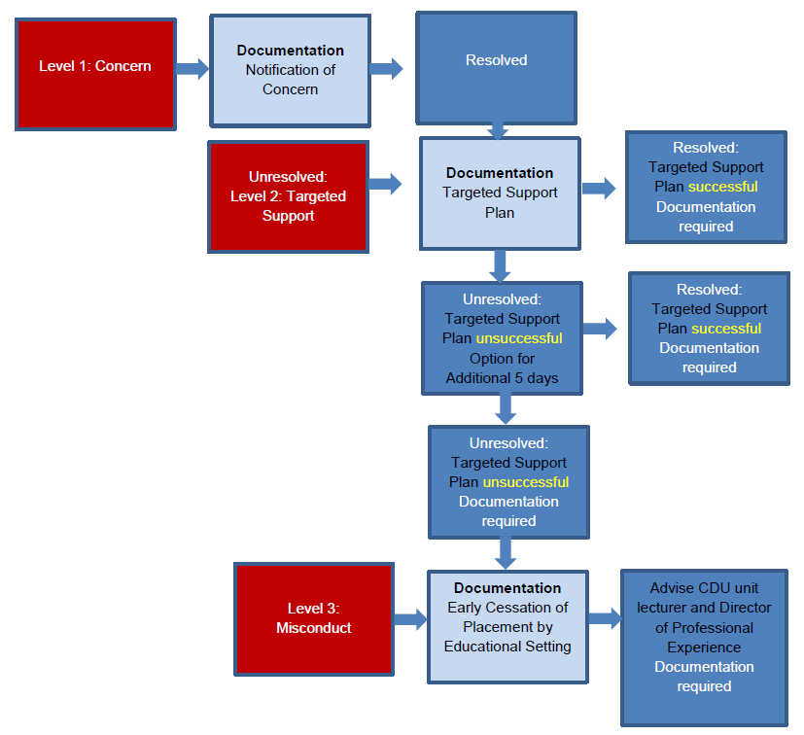

Notes:

