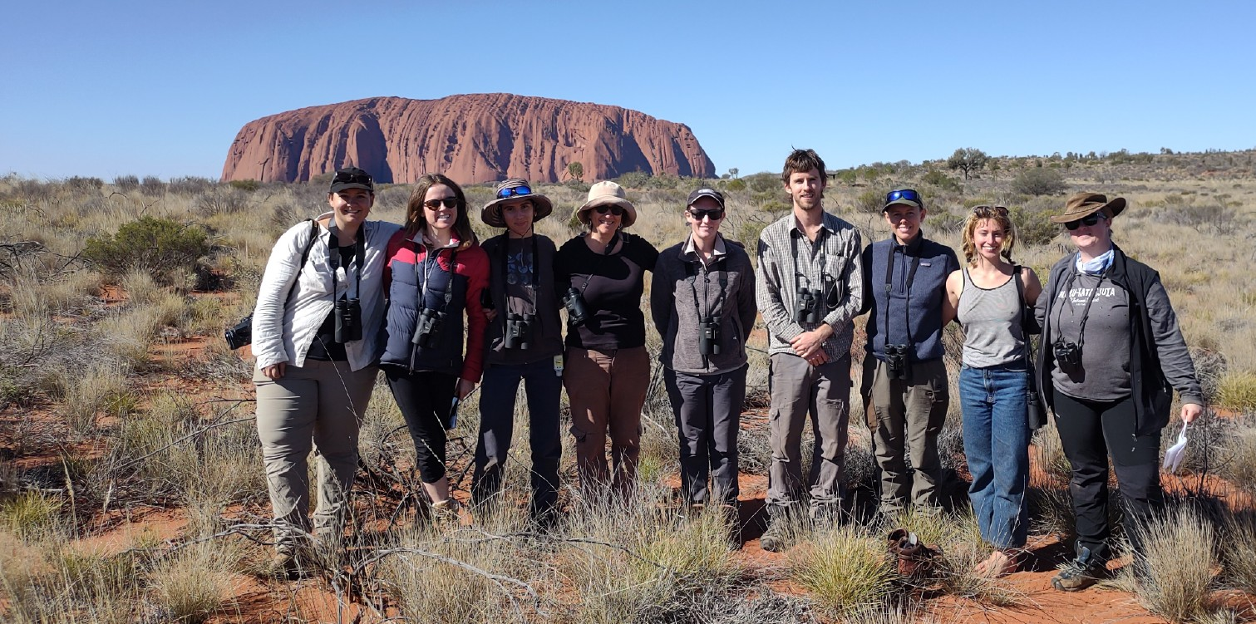ENV315 (undergraduate)
DESERT FIELD ECOLOGY: ENVIRONMENTAL FIELD INTENSIVE UNIT
UNIT CODES
Desert Field Ecology
UNIT TITLE
Desert Field Ecology

UNIT COORDINATOR
Christine Schlesinger Christine.Schlesinger@cdu.edu.au 08 8959 5218

TIMING
SEM‐1
8-14 April 2025
7 day intensive, plus on‐line study before and after field intensive

LOCATION
Starts at the CDU Alice Springs campus and ends at Yulara (Uluru). Students may choose to fly out of Yulara or can travel back to Alice Springs in CDU vehicles on 15 April.
NUMBERS
12 places available
ENV515 (postgraduate)

April 2025
This advanced ecology unit introduces the fundamentals of desert ecology with a focus on the ecology and conservation of birds and mammals. You will learn about the key principles driving central Australian semi-arid and arid ecosystems and the most pressing conservation issues faced within the region. Field‐ based research during the 7‐day intensive will involve surveying birds in four key desert habitats across two regions, in the spectacular World Heritage listed Tjoritja / West MacDonnell and Uluru‐Kata Tjuta National Parks.

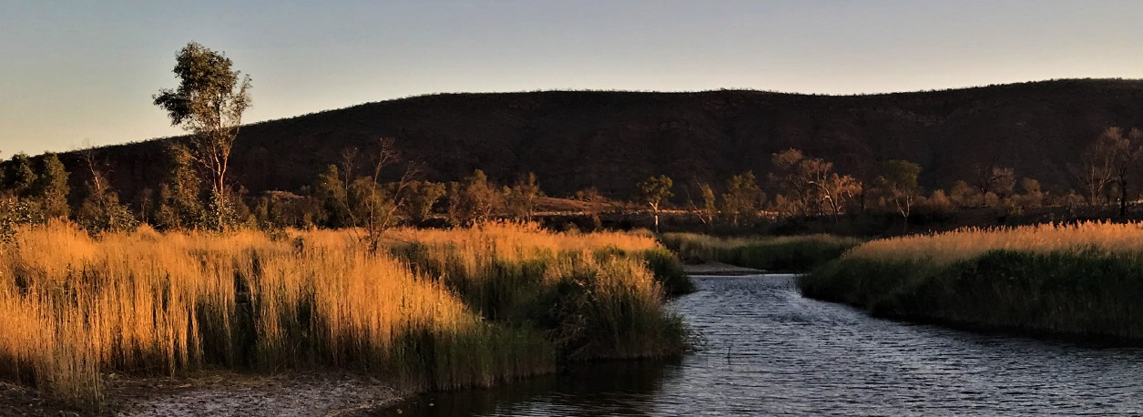
Investigate the dynamic ways arid‐zone fauna respond to spatial and temporal patterning of resources first-hand through collecting, analysing, and interpreting survey data. Learn to identify arid‐ zone birds, also considering experimental design and methods. Explore a range of topics including the management and conservation of endangered mammals and joint management of protected areas.
This subject is available to students studying at undergraduate and Masters level. Students from
other universities are welcome to apply through cross‐institutional arrangements.

Contact us

Unit Coordinator: Christine Schlesinger T: 08 8959 5218
E: christine.schlesinger@cdu.edu.au
W: www.cdu.edu.au/science-technology/environment

HOW TO ENROL
    - 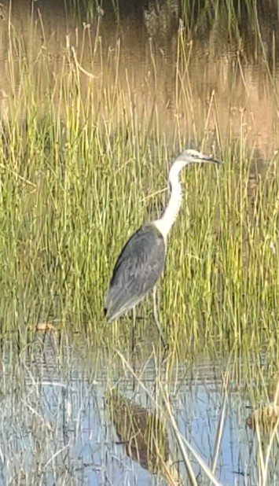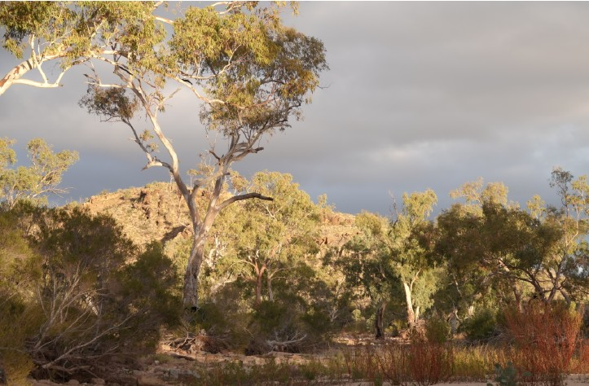Ensure any prerequisite or assumed knowledge requirements are met: See CDU Unit Catalogue on cdu.edu.au
    - Submit Special Enrolment through CDU Portal (CDU students) or Cross Institutional Enrolment form for HE Semester 1 to Student Central.
Enrolment will be approved by the Unit Coordinator based on meeting entry requirements and remaining availability of places.
March 2025 Final date to enrol
(Note places are limited and enrolment forms should be submitted as early as possible to allow for approval before this date).

pril 2025 Field intensive commences
    - If the course is full, students may choose to go on a wait-list in case places become available.

COST
The unit costs are HECS plus an additional $350 which goes toward eight nights pre‐arranged accommodation at:

      - the CDU Alice Springs campus (twin share rooms with share kitchen and laundry facilities) on 7, 8, 9, 10, 11 April.
      - Yulara (swags and safari tents) on 12, 13, 14 April.

The Ka the A
fee also covers entry fees to Alice Springs Desert Park and Uluru-
ta Tjuta National Parks and limited meals plus all transport during intensive and optional transportation back to Alice Springs on 15
pril.

TTING THERE
udents are required to make their own way to Alice Springs before intensive and home from Yulara (or Alice Springs) after and are sponsible for the costs of this travel. The program begins early on
esday 8 April and ends in the evening on Monday 14 with a rewell dinner.
ease do not arrange travel on the start and end dates of the teaching
ogram.

GE
St the re Tu fa Pl pr

IMPORTANT DATES

3 March 2025 | Teaching commences (online)  Students will have access to the unit Learnline site with full details of the course and preliminary learning activities to be completed prior to the field intensive.
14
8 A

DESERT FIELD ECOLOGY: ENVIRONMENTAL FIELD INTENSIVE UNIT

Contact us
Unit Coordinator: Christine Schlesinger
T: 08 8959 5218

E: christine.schlesinger@cdu.edu.au
W: www.cdu.edu.au/science-technology/environment
CRICOS Provider No. 00300K (NT/VIC) | 03286A (NSW) | RTO Provider No. 0373 | TEQSA Provider ID PRV12069 Produced May 2022 | UniPrint 72094

