UNIT CODES
ENV316 (undergraduate)
ENV516 (postgraduate)
UNIT TITLE
Exploring Ecosystem Dynamics: Field Studies in North Australia

UNIT COORDINATOR
Lindsay Hutley lindsay.hutley@cdu.edu.au 08 8946 7103

TIMING
HE Intensive 4
20 June ‐ 30 June 2025
11 day intensive, plus online study before and after field intensive.

LOCATION
Starts at the CDU Casuarina Campus, Darwin
Travels to study sites to the south

NUMBERS
18 places available
Field Studies in North Australia

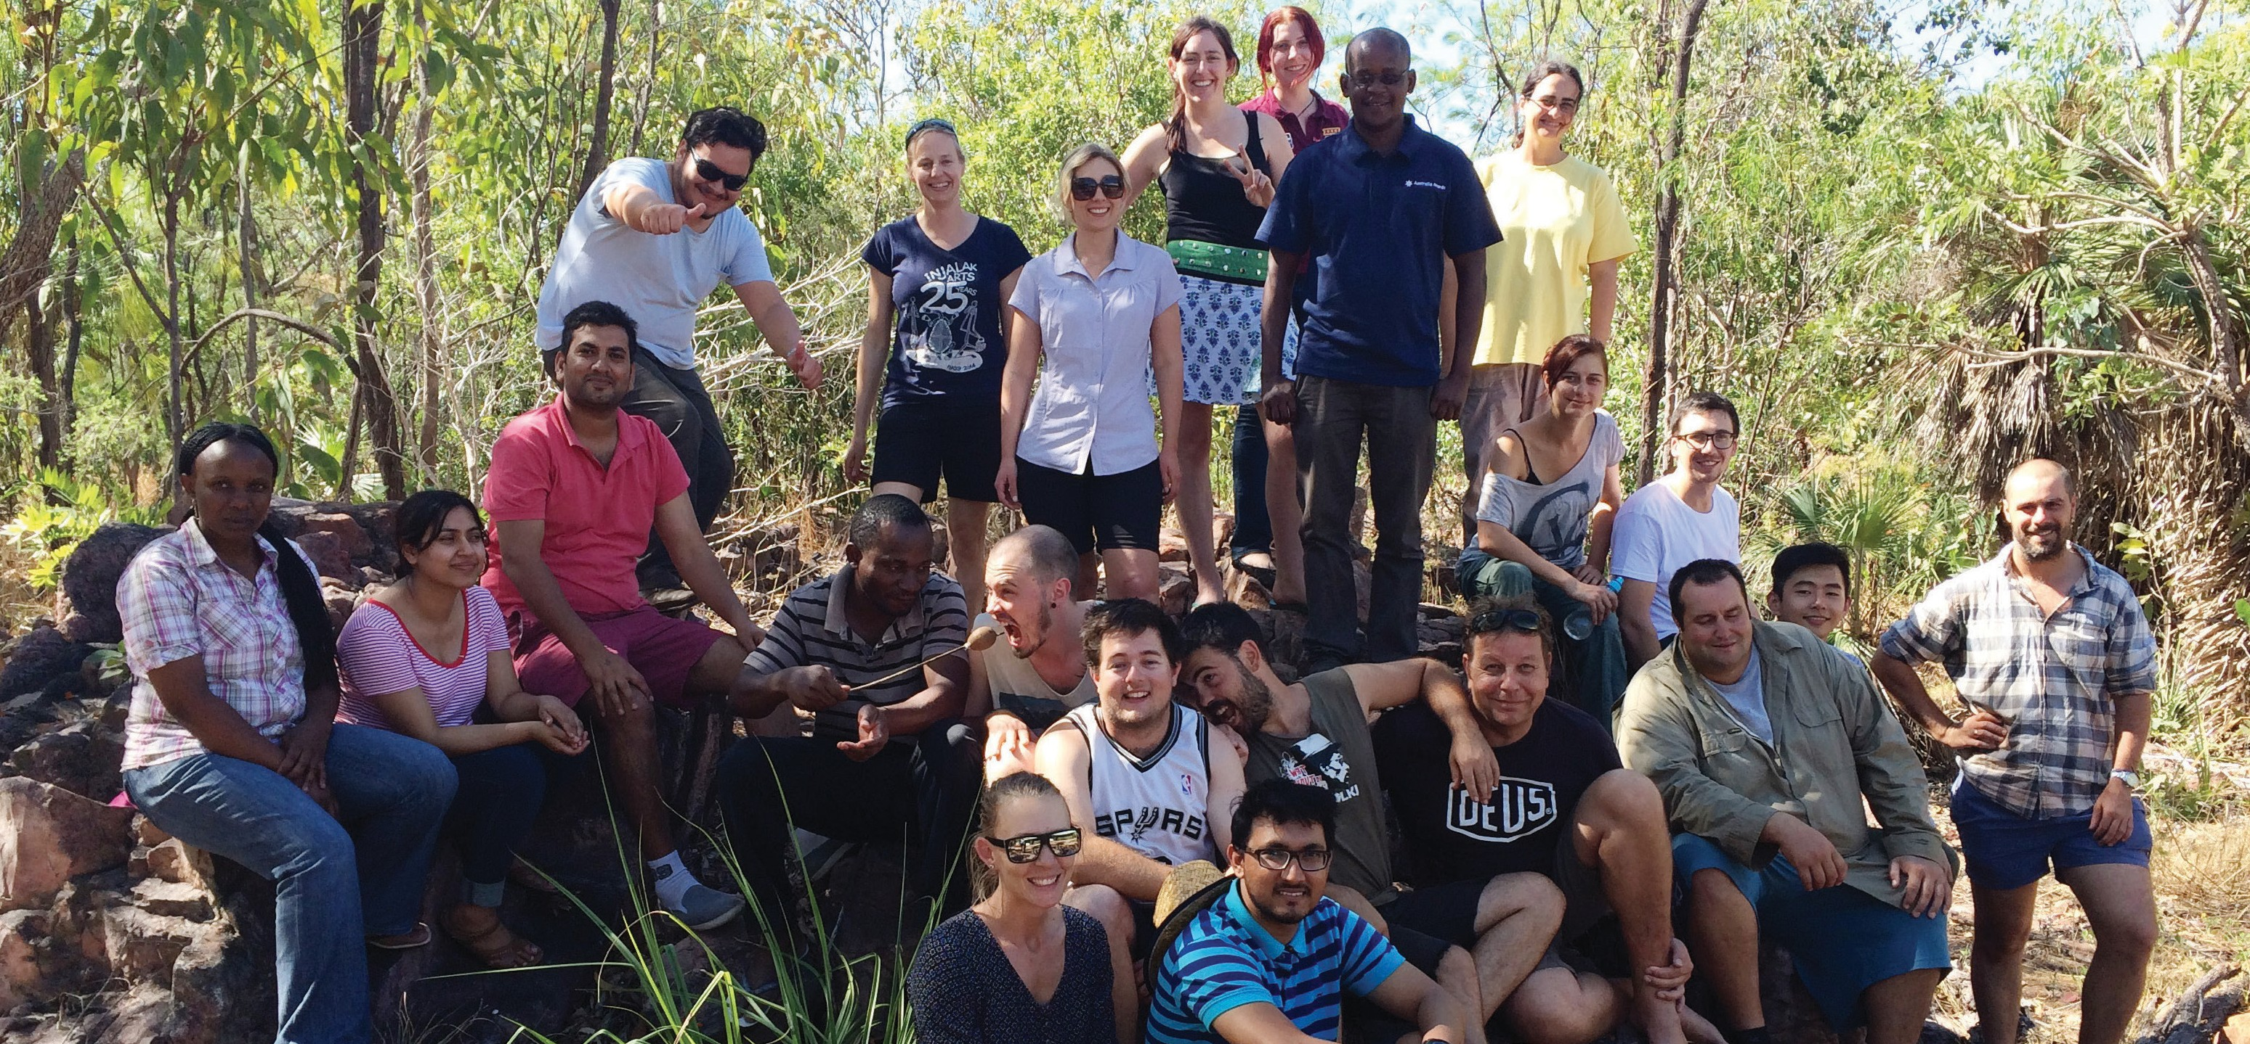20 June - 30 June, 2025
EXPLORING ECOSYSTEM DYNAMICS: FIELD STUDIES IN NORTH AUSTRALIA
Exploring Ecosystem Dynamics:

COURSE OVERVIEW
This unit introduces the tropical savanna biome and landscapes of northern Australia, while developing a range of skills in field survey and data collection methods, data management, analysis and presentation.
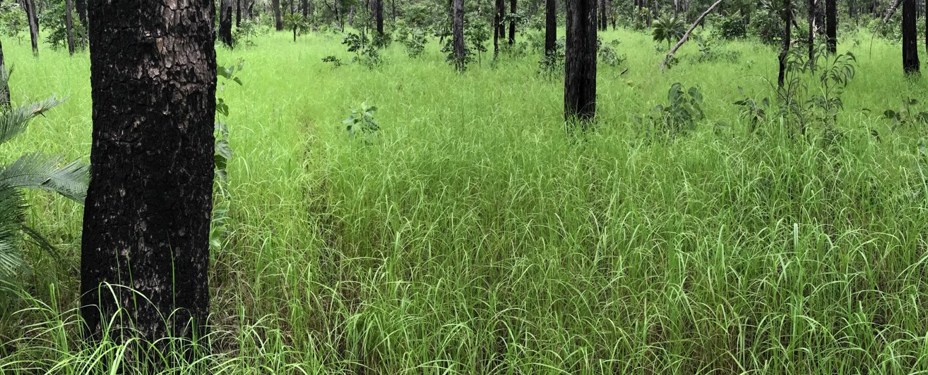
Central to the unit is a 11-day field program, during which students will investigate environmental gradients and ecosystem function by assessing landforms, soils, vegetation and fire regimes. Land management practices are also considered from a range of perspectives - natural resource management, production and Indigenous. The field intensive involves a 1000 km return journey between Darwin visiting study sites to the south (Mataranka, Daly River, Adelaide River and Litchfield National Park). In Litchfield NP the group will spend time at a research site managed by
CDU Litchfield Savanna SuperSite: www.tern.org.au/tern-observatory/tern-ecosystem-processes/
Ecosystem Function: Field Studies in North Australia is available as both an undergraduate and master level unit. Students from other universities can attend through cross-institutional enrolment into the unit.


Contact us
Unit Coordinator: Lindsay Hutley
T: 08 8946 7103 E: lindsay.hutley@cdu.edu.au
www.cdu.edu.au/science-technology/environment/intensive-units

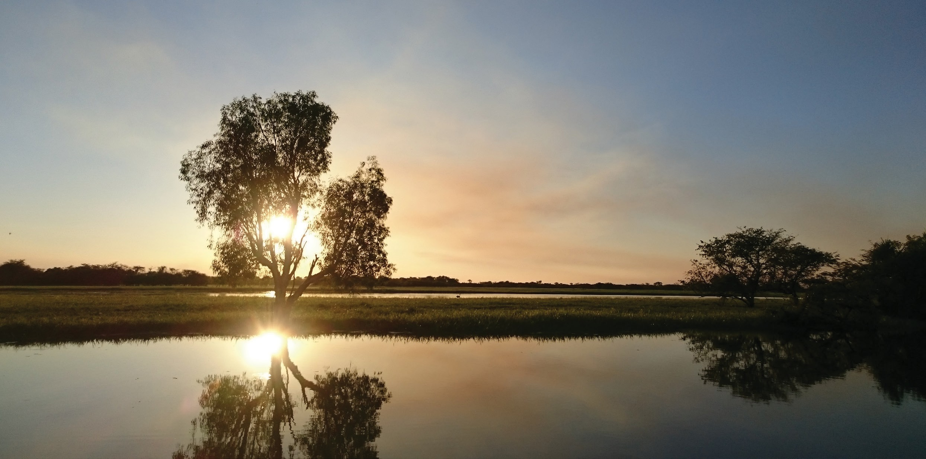

HOW TO ENROL
- Ensure any prerequisite or assumed knowledge requirements are met: See CDU Unit Catalogue on cdu.edu.au
- Submit Change of Enrolment form or Cross Institutional Enrolment form for the Intensive 4 period to Student Central. Change of Enrolment forms will be approved by the Unit Coordinator based on meeting entry requirements and date of form submission. Other factors such as academic merit and
course progress may be considered if there are large numbers of applicants.
- If places are full, students may choose to go on to a waitlist in case places become available.

COST
Students cover the costs of their accommodation and meals during the field trip. CDU arranges very cost-effective accommodation with inexpensive camping options available. Meals are shared and arranged by CDU. All final arrangements TBA after enrolment.

GETTING THERE
Students are required to make their own way to Darwin before 20 June 2025 and home after 30 June 2025. The field intensive begins at the Casuarina campus at 8:30 am on 20 June for a briefing session and end on the afternoon of 30 June.

IMPORTANT DATES
13 June 2025 | Final date to enrol  (note places are limited and enrolment forms should be submitted as early as possible to allow for approval before this date).
23 May 2025 | Teaching commences  Students can access the unit's Learnline site with details of the course and preliminary learning activities (on‐line quiz) to be completed prior to the intensive.
20 June 2025 | Field intensive commences

Contact us
Unit Coordinator: Lindsay Hutley
T. 08 8946 7103 E: lindsay.hutley@cdu.edu.au
www.cdu.edu.au/science-technology/environment/intensive-units
CRICOS Provider No. 00300K (NT/VIC) | 03286A (NSW) | RTO Provider No. 0373 | TEQSA Provider ID PRV1206 9
Produced January 2024

