Power Up Your Planner
How to get your studies sorted and rock this year

📖 Your step-by-step guide to organising your semester like a pro!
How to Use This Workbook:
✅ Work through each section at your own pace.
✅ Follow the activities to create your personalised study plan.
✅ Use the planner templates to stay on track throughout the semester.
📖 Section 1: Weekly Planning – Structuring Your Time
A weekly plan helps you stay consistent and prevents you from falling behind.
📌 Activity: Create Your Ideal Study Week
- Decide how many hours per week you need to dedicate to study.
(General rule: 10 hours per unit per week, including lectures & readings)
- When are you most productive? Morning, afternoon, or night?
- Fill in the weekly sections with your study, work, and personal commitments.
EXAMPLE | MORNING | AFTERNOON | EVENING | NIGHT
MONDAY | Lecture | Work | Work | Study session
TUESDAY |  | Lecture | Study Group | Study session
WEDNESDAY | Lecture | Tutorial | Work | Work
THURSDAY |  | Zumba |  | Study session
FRIDAY | Tutorial | Work | Work
SATURDAY | Work | Work |  | Study session
SUNDAY | Yoga class | Study session | Study session
Consider:
- Do you have a balance between study, work, and life?
- Are there time slots you could use more efficiently?
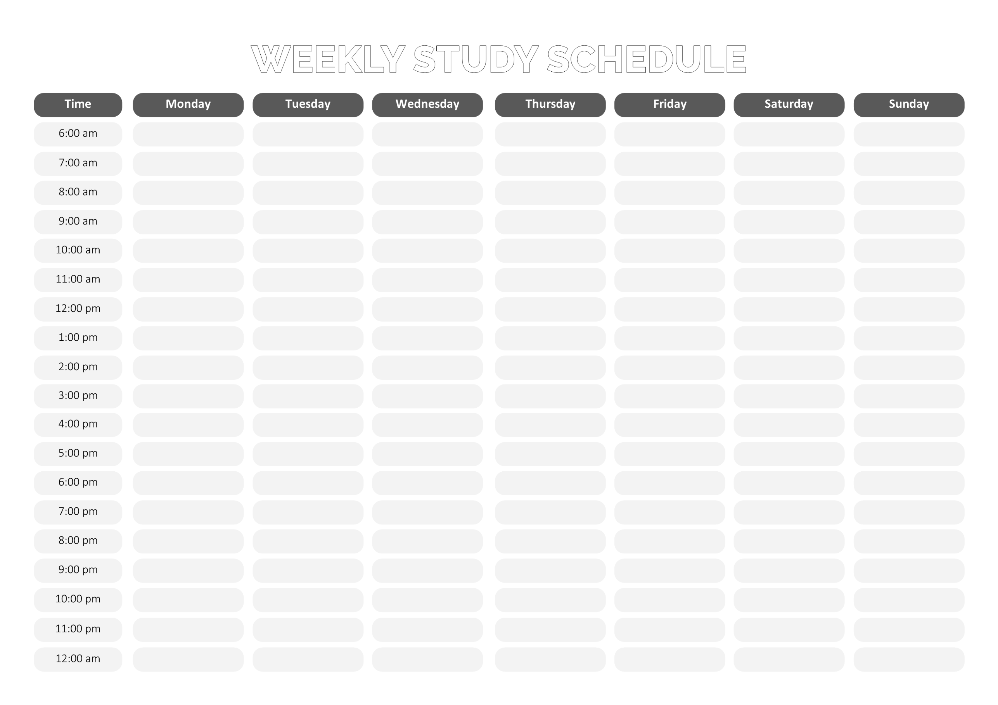

📖 Section 2: The Big Picture – Mapping Out Your Semester
Understanding your semester at a glance prevents last-minute surprises.
📌 Activity: Semester Overview
In your planner or student diary write down the following:
- Semester dates and breaks
- Assignment due dates (check your unit outline)
- Birthdays, anniversaries, or other important events
When you are writing these dates in your planner, consider:
- Are there any busy weeks where multiple deadlines fall together?
- How can you plan ahead to reduce stress during these times?
MON | TUES | WED | THURS | FRI | SAT | SUN
Week 1!  Buy textbooks, explore | First lecture, set up planner | Work shift (5-9 PM), | Gym, lecture and tutorial | Social event (BBQ) | Gym, light reading  study session | Meal prep,  Study (2 hrs), rest
Start assignment Work shift (5-9 PM) | Lecture, gym  Matteos B-day party! | Study group (2 hrs)  Work shift (5-9 PM), | Lecture and tutorial, club meeting | Library study (3 hrs)  Movie night | Study (2 hrs), laundry | Relax, grocery run
Lecture, work shift (5-9 PM) | Lecture  Study session (2 hrs), | Work shift (5-9 PM), gym | Lecture and tutorial Assignment research | Work shift (5-9 PM), unwind | Library study (3 hrs)  social lunch | Study (2 hrs),  Self-care, game night
Lecture, group project meeting | Work shift (5-9 PM), study session | Club meeting, tutorial | Lecture and tutorial, finalise the assignment | Assignment Due! Social night out | Work shift (5-9 PM) | Meal prep, light review  study session
Semester Dates
 | Sem 1 2025 | Sem 2 2025 | Sem 3 2025
Teaching starts | 3 Mar 2025 | 21 Jul 2025 | 17 Nov 2025
Census date | 24 Mar 2025 | 11 Aug 2025 | 4 Dec 2025
Semester break | 7-13 Apr 2025 | 25-31 Aug 2025 | 22 Dec-2 Jan 2026
Teaching ends | 30 May 2025 | 17 Oct 2025 | 6 Feb 2026
Revision | 2 to 3 Jun 2025 | 20 to 22 Oct 2025 | N/A
Exam period | 4 to 13 Jun 2025 | 23 to 31 Oct 2025 | 9 to 13 Feb 2026
Grade release | 27 Jun 2025 | 14 Nov 2025 | 27 Feb 2026
NT Public Holidays 2025
Wednesday 1 January - New Year's  Monday 27 January - Australia Day  Friday 18 April- Good Friday  Saturday 19 April - Easter Saturday  Sunday 20 April - Easter Sunday  Monday 21 April - Easter Monday  Friday 25 April - Anzac Day | Monday 5 May - May Day  Monday 9 June - King’s Birthday  Friday 25 July - Darwin Show Day  Monday 4 August - Picnic Day  Thursday 25 December - Christmas  Friday 26 December - Boxing Day

📖 Section 3: Managing Assignments & Deadlines
Breaking down your assignments into smaller tasks makes them less overwhelming and easier to complete.
📌 Activity: Create Your Ideal Study Week
Choose one of your upcoming assignments and break it into manageable steps.
✅ Step | 📅 Due | 📝 Notes
Read assignment instructions | March 1 | Check the rubric & start planning
Research and collect sources | March 3 | Use Google Scholar/CDU library
Create an outline | March 5 | Organise key points
Write the first draft | March 10 | Aim for 80% completion
Edit and proofread | March 13 | Check grammar & citations
Submit | March 15 | Final review before submission
As you are planning your deadlines consider:
- How far in advance do you usually start assignments?
- Have you set manageable goals that will help you succeed?
- What strategies can help you stay on track?

📖 Section 4: Setting SMART Goals
Vague goals like “I want to study more” won’t help you stay accountable. SMART goals make success measurable. SMART goals are:
Specific: Clear and focused.; Measurable: You can track progress; Achievable: Realistic and doable; Relevant: Important to your overall success and Time-bound: With a clear deadline.
📌 Activity: Set Your SMART Goals
Write one academic and one personal SMART goal for this semester.
🎯 Example of a SMART goal:
🚫 “I want to get better at writing essays.”
✅ I will complete one full draft essay for each assignment and get feedback from an online tutor.
Specific:
Measurable:
Achievable:
Relevant:
Time-bound:

Specific:
Measurable:
Achievable:
Relevant:
Time-bound:

