Education Placement Concern Procedures
Introduction
Purpose of Concern Procedures
These concern procedures are designed to ensure quality outcomes for pre-service teachers (PST) on placements, as well as mentor teachers (MT) and site coordinators (SC) in schools and early learning centres.
The procedures include:
1. An overview of the process for initiating and managing a concern
2. Clear communication and documentation procedures
3. Guidelines to support effective decision-making.
These procedures provide clarity and consistency for all stakeholders involved in the placement process.
Overview
Guidelines for Managing Placement Concerns
These guidelines outline the process for managing concerns during placement, ensuring clear pathways for resolution and support. Most concerns focus on the practice of the pre-service teacher and are typically raised by the mentor teacher. Similarly, if a pre-service teacher has concerns about their placement progress, they can follow the same procedures and expect consistent support.
Diagram 1 provides an overview of the process for initiating and managing concerns. Concerns are addressed through discussion, action planning, and evidence-based progress reviews. When concerns persist or escalate, Professional Experience Supervisors (PES) support the pre-service teacher, mentor teachers and site coordinators.
If concerns remain unresolved, Unit Coordinators (UC) and the Associate Dean – Work Integrated Learning (AD-WIL) will make decisions regarding the future of the placement.
These processes ensure the quality and success of the professional experience and provide equitable support for all stakeholders.
For assistance initiating concern procedures, please immediately contact the allocated Professional Experience Supervisor via phone or email for guidance and support through the appropriate channels.

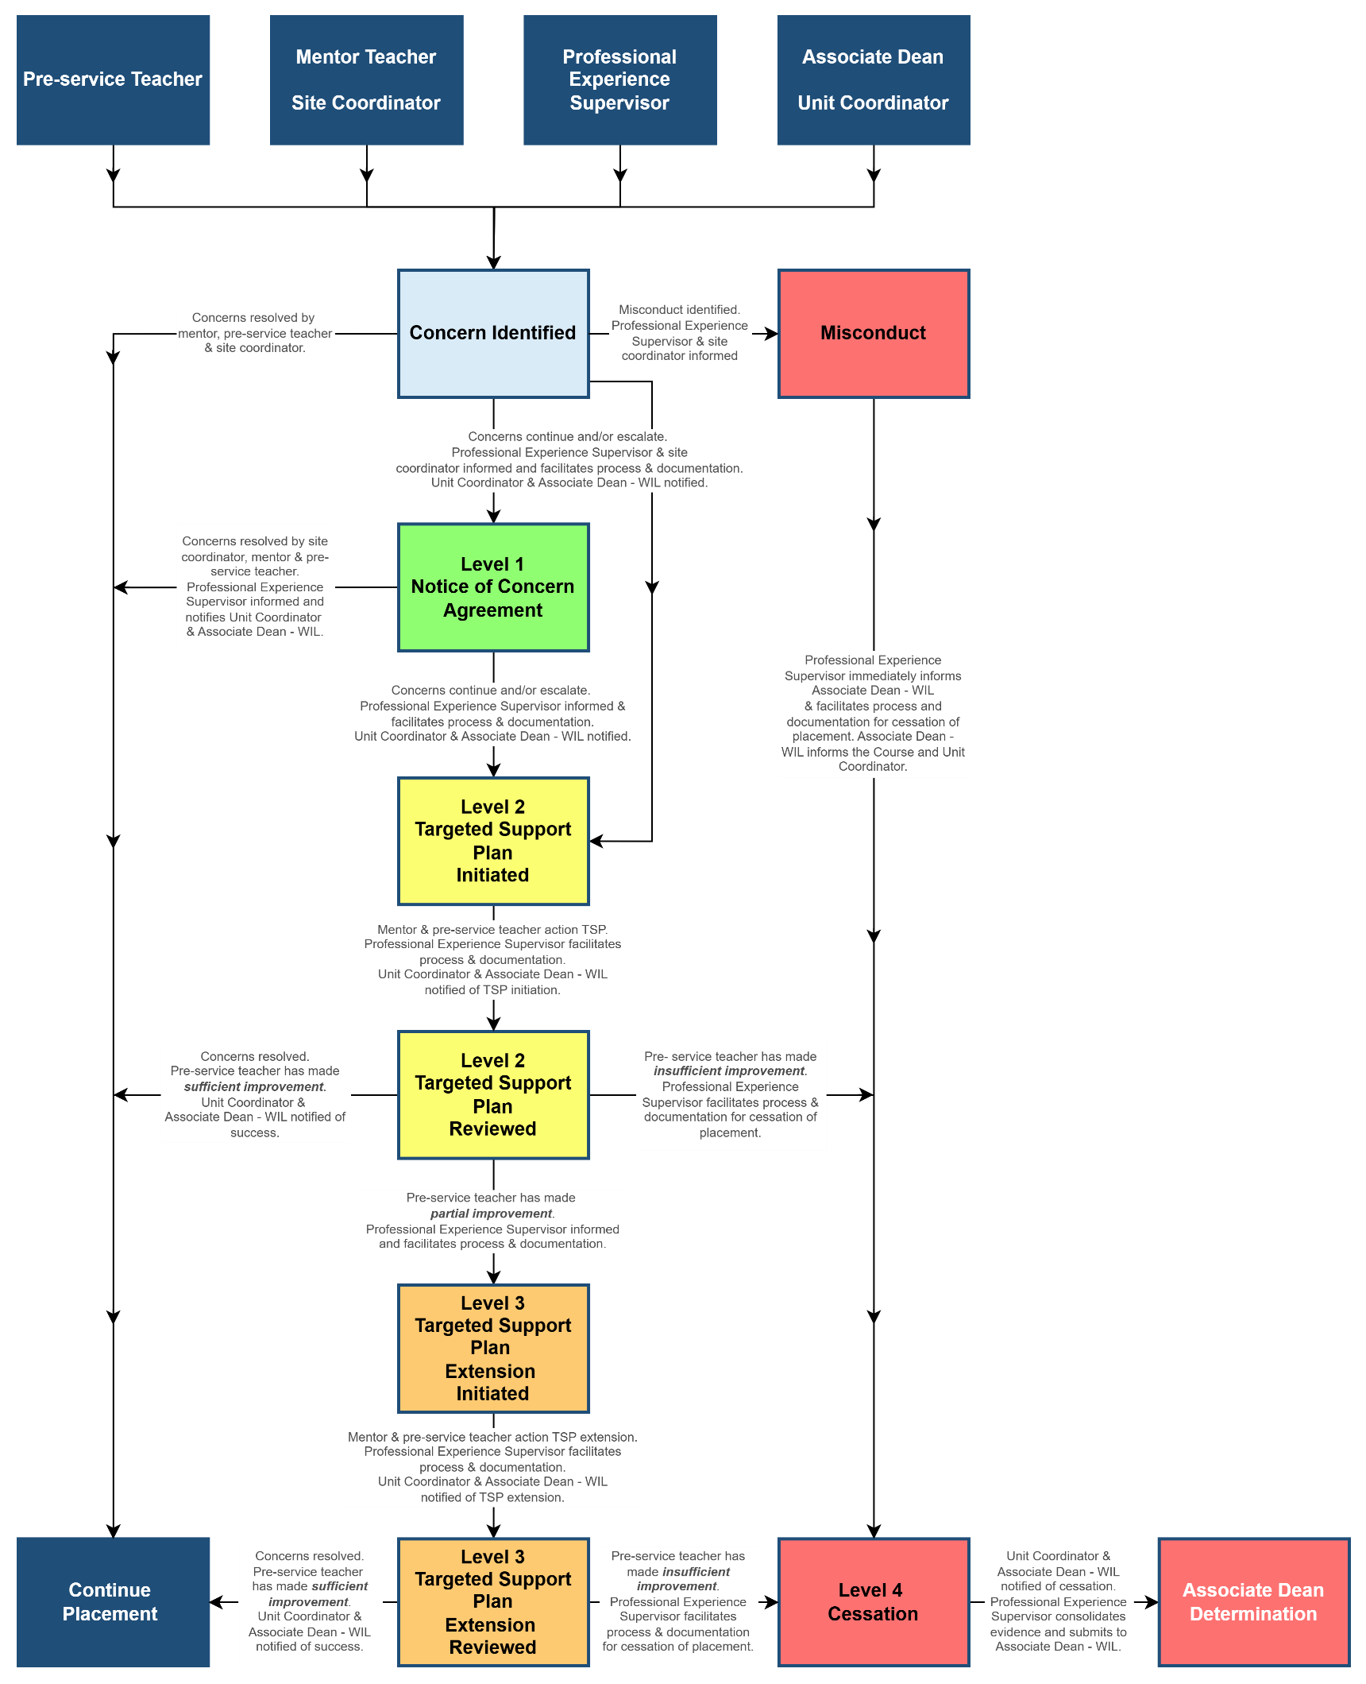
Diagram 1: Managing Concerns while on Placement
Concern Identified
Most concerns can be effectively managed within the school or setting through collaboration between the mentor, pre-service teacher, and site coordinator, with support from the Professional Experience Supervisor.
If there are any concerns regarding a pre-service teacher’s conduct or progress, they should be referred to the Professional Experience Supervisor immediately. The Professional Experience Supervisor will assist in facilitating the appropriate stages of support and overseeing the documentation and collection of evidence throughout the process.

Misconduct
Placement termination may occur immediately if a situation is deemed urgent or significantly serious. This includes instances where a pre-service teacher attends placement under the influence of drugs or alcohol or displays unprofessional behaviour that seriously compromises the learning or safety of students in host classes or schools.
Teaching professionals—including pre-service teachers, practising teachers, school leaders, and CDU staff—have a duty of care to report any unprofessional behaviour. If a pre-service teacher breaches the CDU Code of Conduct, the relevant regulator’s Code of Ethics for the state or territory, or demonstrates other significant unprofessional behaviour, the site coordinator or principal/director must immediately notify the pre-service teacher and the Professional Experience Supervisor.
If the school or setting assesses the behaviour as significantly serious, the principal/director may terminate the placement immediately. The Professional Experience Supervisor will assist with completing the Early Cessation of Placement Form.
As the primary contact for stakeholders during placements, the Professional Experience Supervisor must immediately notify the Associate Dean - WIL of any potential breach of the CDU Code of Conduct. The Associate Dean will inform the Unit Coordinator and Course Coordinator and advise on the next steps.

Level 1 Notice of Concern Agreement
LINK TO WEBSITE - Notice of Concern Agreement DOCUMENT
When Level 1 concerns are identified, the mentor and/or pre-service teacher must notify the site coordinator and the allocated Professional Experience Supervisor. The Professional Experience Supervisor will facilitate documenting developmental goals within the Notice of Concern Agreement.
By signing the Notice of Concern Agreement, the pre-service teacher agrees to:
- Upload the signed agreement to Learnline.
- Email the agreement to the Associate Dean – WIL, Placement Unit Coordinator, their mentor(s), Inschool@cdu.edu.au, and the Professional Experience Supervisor for validation.
N.B. Ensure the agreement is uploaded to Learnline before sending the email.
Table 1 outlines examples of Level 1 concerns. These issues are typically resolved after being formally identified, documented, and discussed between the mentor and the pre-service teacher. The Professional Experience Supervisor is responsible for notifying the Placement Unit Coordinator about the pre-service teacher's progress against the developmental goals.
The pre-service teacher has a five-day period to address the concerns. If concerns persist or escalate after the Notice of Concern Agreement is signed and actioned, the mentor must contact the Professional Experience Supervisor immediately to initiate a Level 2 Targeted Support Plan.
Level 2 Targeted Support Plan - Initiation
LINK TO WEBSITE Targeted Support Plan DOCUMENT
A Targeted Support Plan must be initiated when a pre-service teacher is at risk of not meeting the required Australian Professional Standards for Teachers or if Level 1 concerns have persisted or escalated. A successful outcome can often be achieved through careful planning, coaching conversations, and collaborative support involving the mentor, pre-service teacher, Professional Experience Supervisor, and Unit Coordinator.
Targeted Support concerns are not limited to the examples in Table 1. If a mentor teacher identifies that a pre-service teacher may not meet the requirements of the placement, they must:
- Immediately contact the allocated Professional Experience Supervisor
- Complete the Targeted Support Plan, available on the InSchool website, with assistance from the Professional Experience Supervisor.
Documentation and Process
The Targeted Support Plan is developed through consultation between the mentor teacher, site coordinator, pre-service teacher, and Professional Experience Supervisor. The plan supports and guides evidence collection over a five-day period using the Daily Progress Report.
The plan establishes:
- Key areas of concern presented as developmental goals.
- The relevant Australian Professional Standards for Teachers.
- Strategies and responsibilities to support the pre-service teacher in meeting these goals.
Once the plan is drafted, the Professional Experience Supervisor facilitates a meeting with all stakeholders to discuss, confirm, and sign the document, ensuring all parties are prepared to action the Daily Progress Report.
Pre-service Teacher’s Responsibilities
By signing the Targeted Support Plan, the pre-service teacher agrees to:
- Upload the signed Targeted Support Plan to Learnline before commencing the Daily Progress.
- Email the signed Target Support Plan to the Associate Dean – WIL, Placement Unit Coordinator and Cc their mentor(s), inschool@cdu.edu.au, and the Professional Experience Supervisor for validation before commencing the Daily Progress.
N.B. Ensure the Target Support Plan is uploaded to Learnline before emailing.
Monitoring Progress
The mentor and pre-service teacher will review progress towards the developmental goals at the end of each of the five days.
These discussions are guided by the Daily Progress Report, which includes:
- Written and verbal feedback addressing the evidence of progress against the goals
- An assessment rating recorded against evidence of the pre-service teacher’s practice.
- Signatures from both the pre-service teacher and the mentor in the Evidence of Progress each day.
N.B. The Daily Progress Report does not need to be uploaded to Learnline or emailed each day. The entire plan will be collated upon completing the five days, and a recommendation will be sent to the Unit Coordinator and Associate Dean – WIL in the Targeted Support Plan review phase.
The Professional Experience Supervisor will support the mentor and pre-service teacher throughout the process, facilitating evidence collection and addressing concerns. This structured approach ensures clear guidance and helps the pre-service teacher meet the required teaching standards.
Level 2 Targeted Support Plan - Review
The Level 2 Targeted Support Plan review determines whether a pre-service teacher has made sufficient progress, requires additional support, or must cease their placement. The mentor and site coordinator provide a recommendation to the Associate Dean – WIL and Unit Coordinator, which can result in one of the following outcomes:
- Sufficient Improvement
The pre-service teacher has made sufficient progress and is on track to meet the placement requirements. The concerns are resolved.

- Partial Improvement:
The pre-service teacher has made some progress but has yet to meet all developmental goals or new concerns have emerged. A second and final five-day support period may be recommended to the Unit Coordinator and Associate Dean – WIL.
- The Professional Experience Supervisor will facilitate a Targeted Support Plan Extension.
- If the pre-service teacher does not demonstrate sufficient improvement after two support periods (10 days total), they will be deemed unsuccessful in the placement, and the Professional Experience Supervisor will facilitate the Cessation process.

- Insufficient Improvement:
The pre-service teacher has not made adequate progress, and it is determined that an additional five days would not enable them to meet the required standards. In this case, the placement will be deemed unsuccessful, and the Professional Experience Supervisor will facilitate the Cessation process.
Next Steps
By signing the Targeted Support Plan Recommendations, the pre-service teacher agrees to one of the following outcomes:
- Continue with the placement on track to meet the Unit Requirements and Guidelines
- Continue with the placement with a Targeted Support Plan extension
- Cease the placement
The pre-service teacher must:
- Upload the entire signed Targeted Support Plan to Learnline.
- Email the entire signed Targeted Support Plan to the Associate Dean – WIL, Placement Unit Coordinator and Cc their mentor(s), inschool@cdu.edu.au, and the Professional Experience Supervisor for validation
N.B. Ensure the Targeted Support plan is uploaded to Learnline before emailing.
The Level 2 Targeted Support Plan Review determines if a Pre-Service Teacher has made sufficient progress, requires additional support through an extension, or ceases the placement due to insufficient improvement.

Level 3 Targeted Support Plan - Extension
The Targeted Support Plan extension follows the same documentation and process outlined in the Targeted Support Plan – Initiation phase. There is only one change in the process, and this occurs at the Review phase, where the next steps available are:
- Continue with the placement on track to meet the Unit Requirements and Guidelines
- Cease the placement
The Targeted Support Plan extension provides one final opportunity for improvement, after which the placement continues or ceases based on progress.
Level 4 Cessation
LINK TO WEBSITE Early Cessation of Placement DOCUMENT
Cessation of placement is a serious matter and may occur in various circumstances. The process ensures procedural fairness and is typically a last resort, implemented after thorough consultation and support planning.

Cessation can occur because of:
- Misconduct
- Insufficient Improvement during a Targeted Support Plan
- Pre-service teacher voluntary withdrawal
- School or setting withdrawal
- Other
When a stakeholder identifies a likely unsuccessful placement, they must inform the Professional Experience Supervisor immediately. The Professional Experience Supervisor is pivotal in facilitating the cessation process, ensuring all steps are carried out with transparency, fairness, and adherence to CDU policies.
The Education Placement Concerns Procedures should be referred to prior to completing an Early Cessation of Placement form. The procedures ensure a commitment to supporting pre-service teachers while maintaining professional standards and safeguarding educational environments.
Misconduct
Cessation due to misconduct encompasses actions that breach professional or ethical standards. Immediate termination of a placement may occur if a pre-service teacher demonstrates unprofessional behaviour, such as attending under the influence of drugs or alcohol or compromising student safety and learning. If the educational setting deems the behaviour significantly serious, the principal/director may terminate the placement immediately. All teaching professionals share a duty of care to report breaches of the CDU Code of Conduct or state/territory Codes of Ethics. Reports must be submitted to the Professional Experience Supervisor, who will promptly inform the Associate Dean – WIL, the Unit and Course Coordinators and oversee the Cessation process as detailed in Diagram 2.
Insufficient Improvement during a Targeted Support Plan
Cessation occurs when identified concerns remain unresolved despite tailored support and interventions. This includes scenarios where the pre-service teacher has not made adequate progress during an initial Targeted Support Plan, and it is determined that an additional 5 days would not enable them to meet the required standards. Similarly, the cessation process applies if a pre-service teacher fails to demonstrate sufficient improvement after a Targeted Support Plan Extension.
In either scenario, the placement will be deemed unsuccessful, and a recommendation to cease the placement will be submitted to the Unit Coordinator and Associate Dean – WIL. The Professional Experience Supervisor will oversee the Cessation process, as outlined in Diagram 2.
Pre-service Teacher Voluntary Withdrawal
Cessation occurs when a pre-service teacher chooses to discontinue the placement for personal or professional reasons. While such decisions may arise from unavoidable circumstances, pre-service teachers are encouraged to communicate openly and seek support before making a final decision.
It is critical that any withdrawal must be conducted with the knowledge and agreement of both the university and the educational setting, as outlined in Diagram 2. A pre-service teacher who withdraws from a placement without approval will be deemed to have failed both the placement and the unit, as all assessments must be passed to complete placement units.

School or Setting Withdrawal
Cessation may occur if the host school or setting determines that continuing the placement is untenable. This could result from, but not be limited to, unforeseen operational challenges, irreparable breakdowns in professional relationships, or concerns for student or staff welfare that make it impossible to proceed.
In such cases, the principal/director or designated site coordinator must notify the Professional Experience Supervisor immediately, providing a clear rationale for the withdrawal. The Professional Experience Supervisor will manage the cessation process, and then liaise with the Associate Dean – WIL and Unit Coordinator to determine the outcome of the placement and unit.
Other
Cessation under "Other" encompasses exceptional or unforeseen circumstances that make the continuation of the placement impractical or impossible. These may include natural disasters, personal emergencies, or situations not covered by the categories above.
In such instances, the Professional Experience Supervisor, in consultation with the Associate Dean – WIL and Unit Coordinator, will evaluate the situation and determine the appropriate course of action. The cessation process, as detailed in Diagram 2, will ensure transparency, fairness, and alignment with CDU policies to safeguard all stakeholders' interests.
Next Steps
After signing the Early Cessation of Placement form, the pre-service teacher must:
- Upload the commented, signed Early Cessation of Placement form to Learnline.
- Email the commented, signed Early Cessation of Placement form to the Associate Dean – WIL, Placement Unit Coordinator and Cc inschool@cdu.edu.au, and the Professional Experience Supervisor for validation
N.B. Ensure the Early Cessation of Placement form is uploaded to Learnline before emailing.

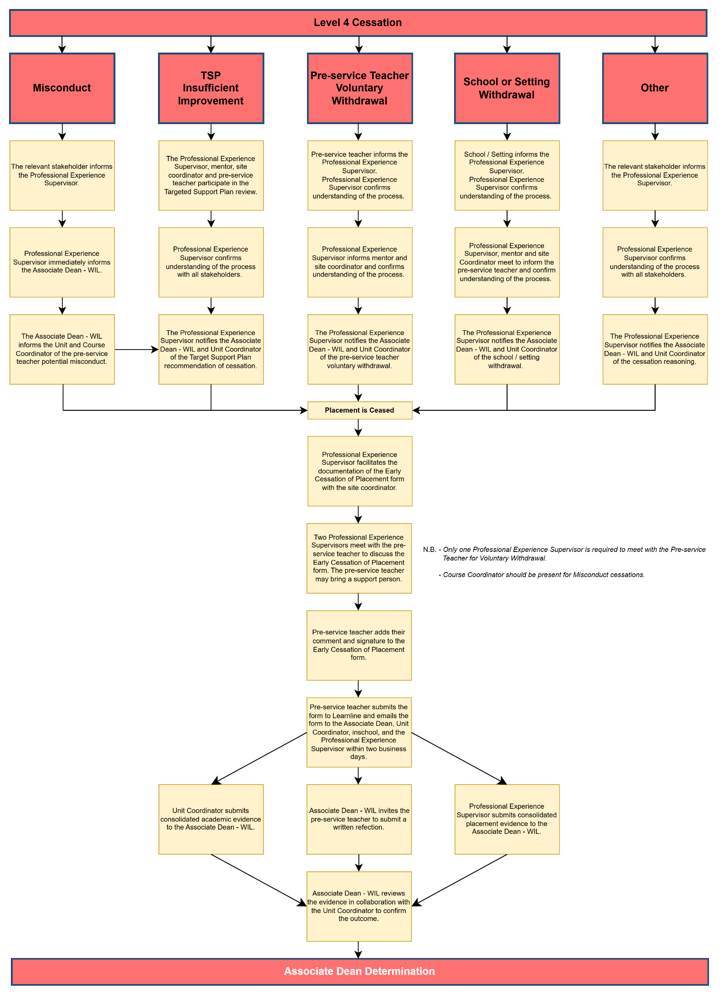
Diagram 2: Managing Cessations on Placement
Table 1: The Levels of Concern – Examples
Levels of Concern | Examples
Misconduct | A Level 4 Cessation of placement due to misconduct  - Breach of duty of care or the CDU Student Code of Conduct  - https://policies.cdu.edu.au/view-current.php?id=139
Level 1 Concerns | Notice of Concern Agreement support can include but is not limited to:  - Punctuality/absences  - Standard of dress  - Lack of initiative  - Limited understanding of placement requirements
Level 2 and 3 Concerns | Targeted Support can include but is not limited to:  - Plan lessons  - Teach effectively  - Demonstrate content knowledge  - Accept and use feedback  - Communicate professionally  - Manage classroom behaviour  - Differentiate for student learning  - Engage in inclusive and anti-discriminatory practice  - Complete full days and weeks where required/rectify continued absences or lateness  - Meet graduate standards as identified in assessment forms

