Writing Effective Professional Experience Reports

Purpose

This guide supports Mentor Teachers to write clear, evidence-based comments in Professional Experience Assessment Reports. Effective comments should describe the Pre-service Teacher's observed practice, align with the Australian Professional Standards for Teachers (APSTs), and identify professional strengths, progress and areas for continued development.

Principles of Effective Assessment Comments
When writing comments:
✓ Base comments on observed evidence rather than assumptions.
✓ Align feedback to the relevant APST Focus Areas.
✓ Describe what the Pre-service Teacher did.
✓ Explain the impact on children and students where appropriate.
✓ Identify strengths and opportunities for further development.
✓ Use professional, objective and constructive language.
✓ Support comments with specific examples from observed practice wherever possible.

A Simple Writing Framework
A useful structure for writing assessment comments is:
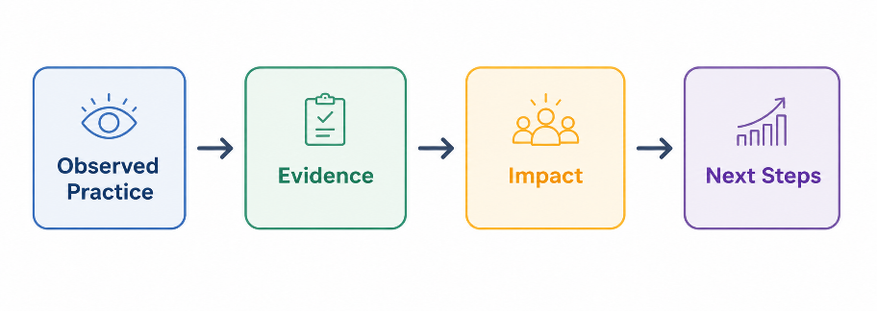
For example:
The Pre-service Teacher planned and implemented well-sequenced literacy lessons using clear learning intentions and success criteria. Students remained engaged throughout the lessons and demonstrated increasing confidence when applying new vocabulary. Continuing to develop questioning techniques will further strengthen opportunities for higher-order thinking.

Writing with Evidence
Strong assessment comments are based on what was observed, not general impressions.
Whenever possible, describe:
- What the Pre-service Teacher did
- What the children or students did in response
- What this demonstrates about their professional practice
This reinforces the evidence-based approach before mentors start writing.

Professional Language and Sentence Starters
Useful sentence starters include:
Professional Knowledge
- Demonstrates knowledge of...
- Applies knowledge of...
- Selects appropriate...
- Identifies the learning needs of...
Planning
- Plans and sequences...
- Develops learning experiences that...
- Designs lessons which...
- Aligns learning experiences with...
Teaching Practice
- Implements effective teaching strategies...
- Uses questioning to...
- Provides clear explanations...
- Differentiates learning by...
- Adjusts teaching in response to...
Learning Environment
- Establishes positive relationships...
- Creates a supportive learning environment...
- Maintains consistent classroom routines...
- Encourages student engagement by...
Assessment and Feedback
- Uses assessment information to...
- Monitors student progress...
- Provides timely and constructive feedback...
- Reflects on assessment evidence to...
Professional Engagement
- Demonstrates professionalism by...
- Reflects thoughtfully on practice...
- Responds positively to feedback...
- Collaborates effectively with colleagues...
- Maintains professional and ethical practice...

Focus on Growth
Assessment Reports should recognise growth throughout the placement and acknowledge the PSTs developing capability.
Strong comments acknowledge:
- increasing confidence
- developing independence
- improving consistency
- willingness to seek and apply feedback
- reflective practice
- readiness for increased responsibility
Examples of Constructive Language
Instead of...
Needs to improve classroom management.
Consider...
Is developing classroom management strategies and is becoming more confident establishing routines and maintaining student engagement. Continued practice and timely feedback will further strengthen this area.
Instead of...
Doesn't communicate well.
Consider...
Is continuing to develop confidence when communicating learning intentions and providing clear instructions to students. Ongoing opportunities to practise whole-class communication will support further growth.
Instead of...
Lesson planning lacks detail.
Consider...
Lesson planning has become increasingly organised throughout the placement. Continued development in sequencing learning experiences and anticipating opportunities for differentiation will further strengthen planning practice.
Before Submitting the Assessment Report
Before submitting your Assessment Report, consider the following:
- Are my comments based on observed evidence?
- Have I aligned my comments with the APSTs?
- Have I recognised the Pre-service Teacher's strengths?
- Have I identified areas for continued professional growth?
- Have I described the impact of the Pre-service Teacher's practice where appropriate?
- Are my comments professional, objective and constructive?
- Would another educator understand the evidence supporting my judgement?
- Have I provided comments that will support the Pre-service Teacher's ongoing professional growth?

